This is a test document containing images generated by AI. Below you will find a scenic mountain landscape.
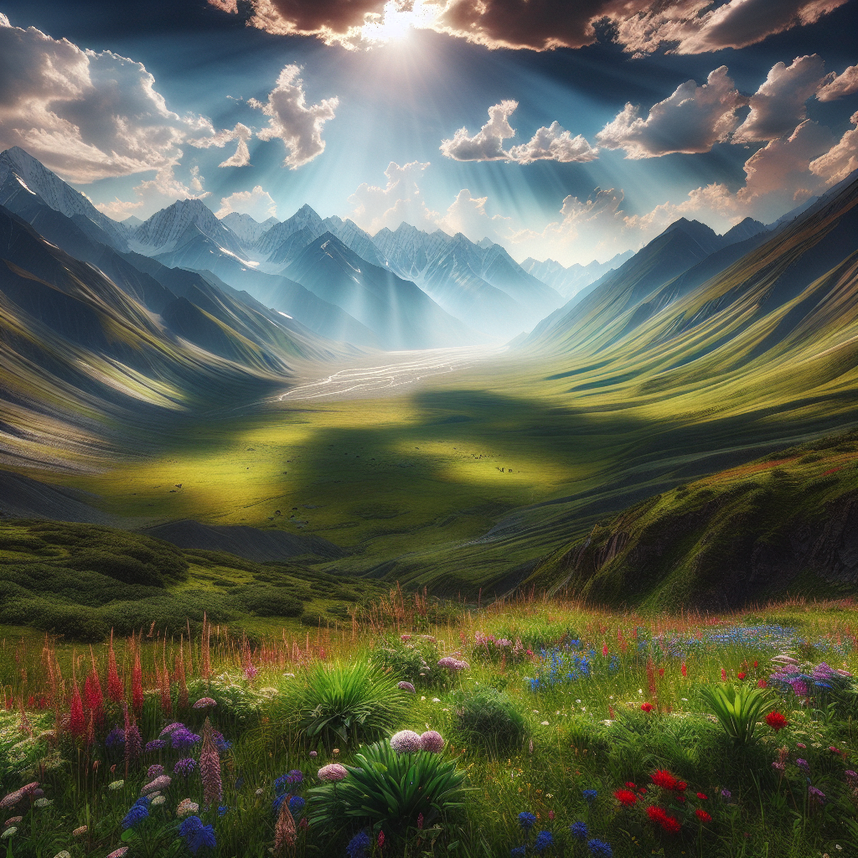
A scenic mountain landscape
In contrast, this image shows a calm beach at sunset, another serene and visually appealing landscape.

A calm beach at sunset

