CONEX.HUB

Navigation and Work Management UI System Design

STATUS  Approved |  | OWNER  CONEX.HUB |  | LAST UPDATED  July 22, 2026

Authors | Codex with CONEX.HUB project owner
Reviewers | CONEX.HUB project owner
Related docs | docs/superpowers/specs/2026-07-22-conex-hub-navigation-work-ui-design.md
Scope | Shared navigation and restored Work Management UI over the canonical data layer.

1. Abstract
CONEX.HUB will restore Work Management as distinct Overview, My Tasks, Board, Workspace, Project, and List experiences while retaining the stabilized Supabase hierarchy. A shared application shell and reusable task views will make product context, navigation, and work status clear without reintroducing legacy queries.
The design supports the current workspace, project, list, and task workloads with responsive desktop and mobile navigation. It excludes calendar, Gantt, timeline, real-time collaboration, and unrelated CRM rebuilds. All reachable Work screens must use canonical RLS-protected data and cached bounded queries.

2. Goals and Non-Goals
Goals | Non-goals
Clarify active product, route, workspace, project, list, and view. | Legacy project or task query restoration.
Provide List, Table, and Board views over one task collection. | Calendar, Gantt, timeline, automation, or document views.
Share bounded cached queries and avoid per-list dashboard requests. | A complete CRM feature redesign in this phase.
Verify safely in the isolated worktree before any integration. | Any database migration introduced only for presentation.

3. Background and Problem Statement
The former Work UI offered useful analytical and execution pages but relied on legacy project and task paths. The stabilization branch replaced those paths with a secure canonical hierarchy, then temporarily collapsed multiple menu destinations into one generic page. That solved data integrity but made the sidebar misleading and removed the dashboard, My Tasks, and Kanban workflows users recognized.
The shared product shell owns module selection and navigation. Work routes own page context; a shared view system renders List, Table, or Board from one normalized task collection; the Work query layer owns canonical Supabase access and cache invalidation. The invariant is that presentation may change, but data authority and authorization never leave the canonical RLS-protected hierarchy.

4. Proposed Architecture

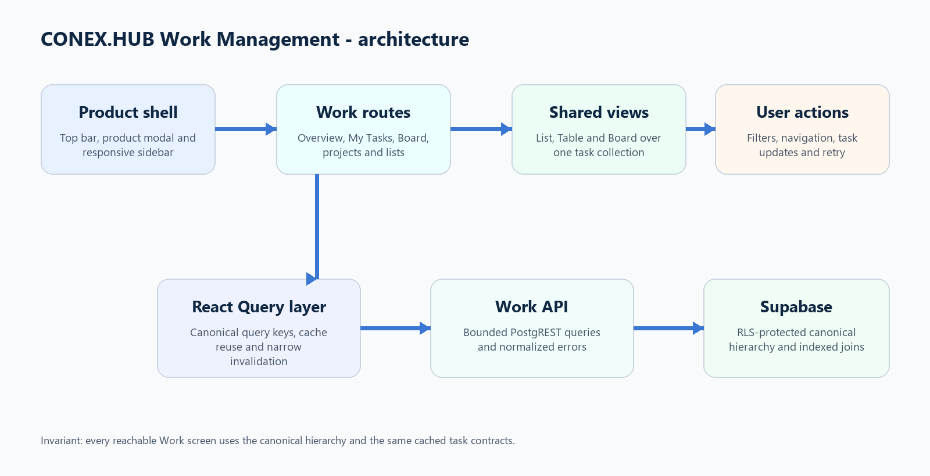
Figure 1. Proposed CONEX.HUB Work Management architecture.

Core components

Component | Responsibility | Primary storage | Failure behavior
Product shell | Top bar, product modal, responsive sidebar, user and theme controls. | Browser route and preference state | Stable fallback shell with explicit retry states.
Work navigation | Primary pages plus workspace, project, folder, and list context. | Canonical workspace tree cache | Loading skeleton, empty action, or normalized retry state.
Shared task views | Render List, Table, and Board from normalized filtered tasks. | React Query cache | View failure cannot corrupt or invalidate task data.
Work API | Bounded Supabase reads, canonical writes, mapping, and errors. | RLS-protected Supabase tables | One retry for reads; failed writes preserve UI input.
Verification | Tests, build, browser checks, API logs, and advisor review. | Repository and Supabase diagnostics | Branch remains isolated until all required gates pass.

5. Request Lifecycle
- 1. A Work route supplies page context, workspace or hierarchy identifier, filters, and an optional view query parameter.
- 2. The authenticated browser session reaches Supabase through the public client; RLS enforces workspace visibility and the API normalizes errors.
- 3. The shell resolves the active module, workspace preference, hierarchy tree, and saved view mode from validated route and browser state.
- 4. One bounded canonical task query loads the required list, workspace, or assignee collection into React Query.
- 5. Mutations write canonical task or hierarchy rows before any success state is shown.
- 6. Queries retry once; mutations keep form state on failure and invalidate only the affected query keys on success.
- 7. The page derives metrics, filters, grouping, and the selected view from cached normalized data and emits normalized diagnostic errors.

6. API and Data Contracts

Primary data contract

Field | Type | Required | Description
route_context | enum + UUID | Yes | Canonical route, page grain, and workspace/project/list identifier.
workspace_tree | WorkspaceTree | Yes | Visible workspace, spaces, folders, and lists from one cached query.
tasks | HierarchyTask[] | Yes | Normalized list, workspace, or assignee task collection.
filters | TaskFilters | No | Search, status, priority, assignee, project, tags, and date range.
view | list | table | board | No | URL preference with validated contextual browser fallback.
query_key | readonly tuple | Yes | Workspace/list/assignee grain plus normalized filters.
mutation_result | canonical entity | For writes | Server-confirmed entity used before narrow cache invalidation.

Contract guarantees

- 1. A valid authenticated session and RLS-visible context are required before Work data is returned.
- 2. UUID task identities remain stable; task position and updated_at define presentation ordering and freshness.
- 3. Route context, workspace or list ID, normalized filters, and query key identify each cached collection.
- 4. Supabase canonical tables are the source of truth; URL and localStorage values are presentation preferences only.
The versioned contracts are maintained in the repository at
src/types/hierarchy.ts, src/features/work/api, and the generated Supabase types.

7. Consistency, Idempotency, and Replay

View changes are idempotent presentation updates and never refetch by themselves. Task mutations use stable UUIDs and await the canonical write before invalidation. A failed mutation leaves cached data unchanged and preserves user input. Concurrent server state becomes authoritative after the narrow refetch.
Scenario | Expected behavior | Reasoning
Repeated view change | Render from the same cached collection without a data refetch. | View mode is presentation state, not a new data contract.
Canonical write fails | Show a recoverable error and preserve form or task state. | No optimistic state is presented as durable success.
Read timeout or API error | Retry once, then show a stable retry control. | Failures are bounded, visible, and diagnostically normalized.
Preference changes during load | Latest valid URL mode wins without altering the task query. | Data authority and presentation preference remain separate.

8. Security and Privacy Considerations

- 1. Supabase authentication and RLS enforce workspace membership and tenant boundaries.
- 2. Queries select only fields needed by the active UI; user-facing errors never expose database details.
- 3. The browser uses only the public Supabase client; service-role credentials are prohibited.
- 4. Destructive actions require confirmation and permission checks; this UI phase adds no migration.
- 5. Existing database retention and audit boundaries remain unchanged; diagnostics use normalized error codes.

9. Operational Readiness
Signal | SLO or alert | Owner | Launch gate
Automated checks | All scoped tests, TypeScript, and production build pass. | Frontend | Required
Work API correctness | No new Work 400/404 responses in local browser flow. | Frontend + database | Required
Query efficiency | No per-list task fan-out for Overview or My Tasks. | Frontend | Required
Security boundary | No legacy hook use, service role, or permissive Work policy. | Frontend + database | Required
Responsive usability | Desktop, collapsed sidebar, and mobile drawer verified. | Frontend | Required
Rollout constraint: implement and verify only in codex/work-management-stabilization; main remains untouched until explicit review.

10. Alternatives Considered

Alternative | Why it was considered | Why it was not selected
Exact restoration | Fastest path to the familiar screenshots. | Would restore legacy hooks and route ambiguity.
Single hierarchy screen | Simple canonical data surface. | Makes multiple menu destinations indistinguishable.
Full redesign | Maximum visual and architectural freedom. | Larger scope, higher regression risk, less familiarity.
Controlled evolution | Restores useful pages while improving clarity and reuse. | Selected; best balance of familiarity, safety, and quality.

11. Open Questions
- No blocking design questions remain. Product switching stays in the modal, and Work provides List, Table, and Board views.

12. Decision and Next Steps
Proceed with controlled evolution on the isolated branch: establish shared view contracts, extend canonical workspace and assignee queries, restore Work routes and pages, then validate tests, builds, desktop/mobile navigation, and Supabase API behavior locally. The stable main branch remains untouched until explicit review.
Milestone | Deliverable | Exit criteria
M1 | Shared view contracts and canonical workspace task queries. | Unit tests prove view resolution and bounded query behavior.
M2 | Sidebar, routes, Overview, My Tasks, and Board restoration. | No reachable legacy imports; scoped checks pass.
M3 | Project/list views plus desktop and mobile browser validation. | Local flows pass with no new Work API errors.
M4 | Branch review and explicit integration decision. | All gates pass and stable main remains recoverable.

Use footnotes for definitions, assumptions, or terms that need precision without interrupting the main narrative.

