**Real Time Digital Signal Processing**

**Lab 3 report**

**Jiabo Zhou, Hao Ding**

**04.02.2015**

**Part 1. Lab 3 Quiz Answer**

The full rectified waveform is observed to be centred at around 0V, instead of always being above 0V as expected (Figure 1). This is because the DC offset is removed by the high pass filter attached to the AIC 23 output port (Figure 2).

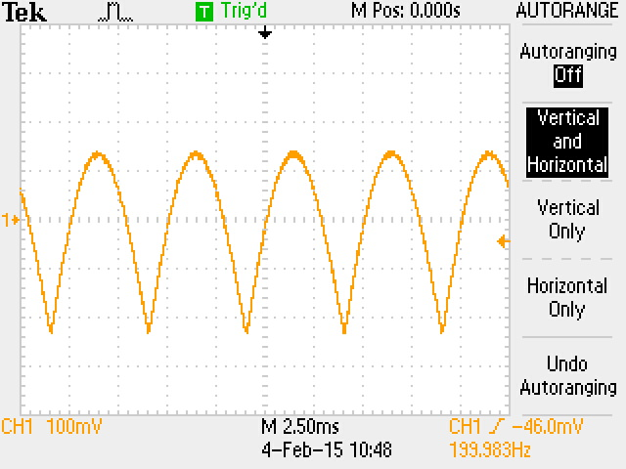

**Figure 1**. Rectified Waveform centred around 0 V

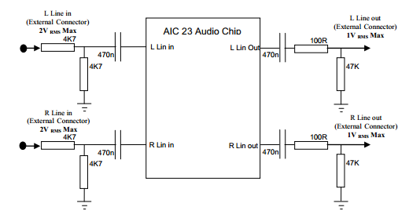

**Figure 2**. High pass filter at output port

The output waveform is a full-wave rectified only when input signal is below a certain frequency. This happens due to the non-linearity of rectification process, which changes the spectrum of input signal. As input is a sine wave, full-wave rectification yields even harmonics of input wave, i.e. 0f, 2f 4f, etc. 0f wave is shown as the DC offset and fundamental frequency is doubled (Figure 3). When frequency is getting higher, aliasing happens at higher harmonics.

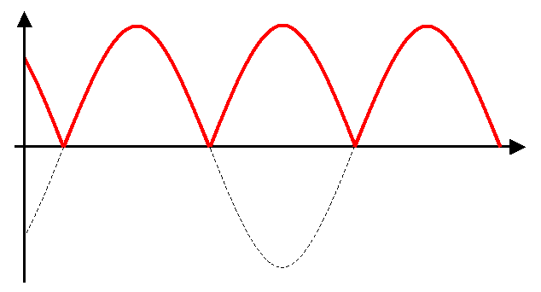

**Figure 3**. Fundamental frequency doubled after rectification

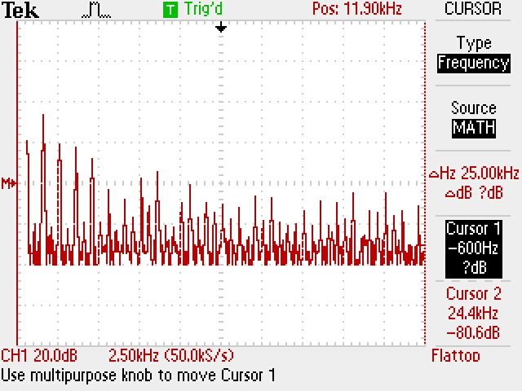

**Figure 4**. Frequency Spectrum after rectification, basic frequency 500 Hz

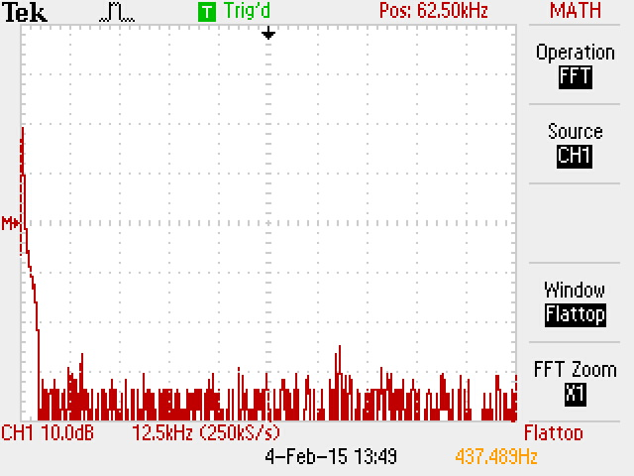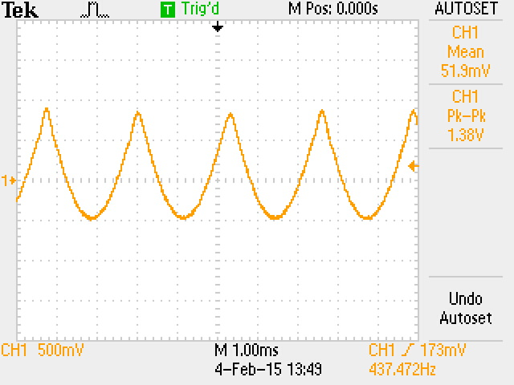When input signal is 3.8 kHz, a stable waveform with frequency around 400 Hz is shown on oscilloscope (Figure 5 & Figure 6).

**Figure 5**. Waveform with input frequency 3.8 k Hz

**Figure 6**. Frequency spectrum with input frequency 3.8 k Hz

A 3.8 kHz sine wave yields a combined harmonics of 0 Hz, 7.6 kHz, 15.2 kHz, etc. After the high-pass filter with cut-off frequency at 7.1 Hz, only 0 Hz wave, that is the DC offset, is removed. After sampling the wave at 8 kHz, periodic components are shown around multiples of 8 kHz, since multiplying of rectified waveform and delta function train is equivalent to convolution in frequency domain. The 7.6 kHz peak around 8 kHz sampling frequency, therefore, corresponds to a 400 Hz peak at baseband due to aliasing.

**Part 2. Code Explanation**

In exercise 1, we are required to write an interrupt function which read, write and rectify samples.

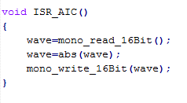

Signal is generated from software and passed to audio port. Interrupt event is set to IRQ_EVT_RINT1 and priority 4, which calls interrupt function when signal is received. In the interrupt function, signal is first read into a variable called wave, which is rectified using Abs function in math.h library. Wave is declared as type short, which is 16 bit integer. After that, wave is outputted to oscilloscope.

In exercise 2, we are required to write an interrupt function to rectify signal from a lookup-table. Interrupt event is set to IRQ_EVT_XINT1, which calls interrupt just before transmitting sample to audio output.

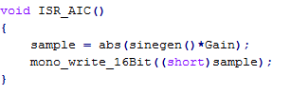

Sample is declared as float, which is assigned to the absolute value of sine wave in lookup table after amplified by Gain. Sample is then converted to short integer and passed to audio port.

The function sinegen() return a number between 1 and -1 but mono_write_16Bit() requires an argument with type Short, which is a 16bits integer. The maximum signed number can be represented within 16bits is 215-1= 32767. Therefore, gain is set to 32767 in order to maximise resolution.