

PROJECT REPORT

Car Insurance Management

Student Name | SE205362 - Dao Duy Hoang
Class | SE2011
Subject | LAB211 - OOP with Java Lab
Assignment | Car Insurance Management
Semester | FALL2026
Instructor | Vu Thanh Phong (PhongVT12)

Table of Contents
  - Introduction
  - Problem Analysis
  - Computational Thinking
3.1 Decomposition
3.2 Pattern Recognition
3.3 Abstraction
3.4 Algorithm Design
  - OOP Design (UML)
  - Flowchart
  - Conclusion
  - Conclusion and Reflection

PROJECT REPORT

1.Introduction
This Car Insurance Management system is built in Java. The Car Insurance Management system uses Object-Oriented Programming (OOP) principles to model real‑world things like cars and insurance. Two main entities, Car and Insurance are each a class with its attributes and behaviors. The Car Insurance Management system stores collections of objects in a Map<Key, Value> where the key's each objects unique identity. The Car Insurance Management system offers ten functions: adding cars finding cars updating cars deleting cars adding insurance statements listing insurance statements reporting uninsured cars saving data, loading data, from binary files and exiting the program. The program runs in the console shows a menu after each action and waits for the user to choose the option until the user decides to quit.
- Problem Analysis
2.1. Entities
The system manages two entities:
- Car. Represents a vehicle registered in the system.
- Insurance. Represents an insurance statement linked to Car.
2.2. Attributes and Constraints
Table 1: Car

Attribute | Data Type | Constraint
licensePlate | String | Not null, not empty, unique
carOwner | String | Not null, length 2–35
carBrand | String | Not null
value | BigDecimal | Not null, > 999
registrationDate | LocalDate | Not null, valid date, format MM/dd/yyyy
registrationPlace | String | Not null
vehicleType | int | Not null, ∈ {5, 7, 9}

Table 2: Insurance
Attribute | Data Type | Constraint
insuranceId | String | Not null, not empty, unique
establishedDate | LocalDate | Not null, valid date, format MM/dd/yyyy
licensePlate | String | Not null, must exist in Car collection
customerName | String | Not null
insurancePeriod | int | Not null, ∈ {12, 24, 36}
insuranceFees | BigDecimal | Not null, positive, calculated automatically
Formula for insuranceFees:
- Period = 12 → Fees = 0.25 × value

- Period = 24 → Fees = 0.20 × value × 2

- Period = 36 → Fees = 0.15 × value × 3
- Computational Thinking
  - Decomposition
Decomposition is the process of breaking down a large problem into smaller, manageable parts. In this project, the problem is decomposed in three ways: by data, by function, and by class (OOP view).
    - Data Decomposition
File | Entity | Role
carInfo.dat | Car | Stores vehicle information: license plate, car owner, car brand, value, registration date, registration place, vehicle type
insurances.dat | InsuranceStatement | Stores insurance contract information: insurance id, established date, license plate, customer name, insurance period, insurance fees
-Relationship:

- One Car → many InsuranceStatements (a vehicle can be insured multiple times over different years).

- InsuranceStatement depends on Car through the licensePlate field.

-Data management:

- Read / write from two binary files: carInfo.dat and insurances.dat.

- Save changes when the user selects "Save data" or when exiting the program (if the data has been modified)
    - Functional Decomposition
The system is divided into five functional groups:

Group | Functions
File I/O | Read /Write binary data (Save data, Load data)
Car | Add, Find, Update, Delete, Display
Insurance | Add, List by year (with sort), Report uninsured cars (with sort)
Validation | License plate unique, valid date, value > 999, vehicle type ∈ {5, 7, 9}, insurance period ∈ {12, 24, 36}
UI | Menu display, Table display, Sort ASC / DESC

    - Class Decomposition (OOP View)
Based on the data and functional decomposition above, the following classes are required:
Package | Class | Responsibility
entity | Entity (abstract) | Declares abstract toString(); implements Serializable
entity | Car | Model class representing a vehicle; extends Entity
entity | InsuranceStatement | Model class representing an insurance contract; extends Entity
manager | AbstractManager<T> (abstract) | Abstract base class for managers; provides protected Map field, findById(String), and listAll()
manager | IReportable (interface) | Defines the generateReport() method for managers that support reporting
manager | CarManager | Manages the Car Map; performs add, update, remove; generates uninsured cars report; extends AbstractManager<Car>; implements IReportable; holds a reference to InsuranceManager to check whether a car is insured
manager | InsuranceManager | Manages the Insurance Map; performs add, isInsured(String), generateReport; extends AbstractManager<InsuranceStatement>; implements IReportable
io | FileWriter | Writes any serializable object to a binary file; overwrites if the file exists
io | FileReader | Reads any serializable object from a binary file; returns null if the file is missing or empty
utils | Constants | Stores all constants: file paths, regex patterns, param keys
utils | Validation | Provides pure static validation methods (no input, no output)
utils | Inputter | Reads input, normalizes data, re-prompts until valid; prints error messages during input
utils | Formatter | Provides centralized date (LocalDate) formatting and currency (BigDecimal) formatting utilities across the application
view | ConsoleView | Displays tables and result messages that come with tables (view only, no business logic)
controller | ProgramController | Dispatches menu choice to managers; prints messages that do not come with tables; tracks dataChanged flag
app | Main | Program entry point; contains main() method
3.2 Pattern Recognition
Pattern Recognition identifies recurring patterns in a problem so that a single reusable solution can be applied in multiple places. In this project, four patterns are identified:

- Data format (regex-based validation)

- CRUD operations across entities

- Validation logic across input fields

- File I/O across data files
3.2.1 Pattern in Data Format (Regex)
Observation
Two fields follow a fixed format and can be validated efficiently using Regular Expressions.
Entity | Field | Example | Format Description
Car | licensePlate | 50H3-123.45 | 2 digits, 1 uppercase letter, 1 digit, dash, 3 digits, dot, 2 digits
InsuranceStatement | insuranceId | 0006 | Exactly 4 digits
Regex Patterns
The regex patterns are declared as constants in Constants so that they can be reused and modified in one place.
Constant Name | Regex | Meaning
LICENSE_PLATE_REGEX | ^\d{2}[A-Z]\d-\d{3}\.\d{2}$ | 2 digits, 1 uppercase letter, 1 digit, dash, 3 digits, dot, 2 digits
INSURANCE_ID_REGEX | ^\d{4}$ | Exactly 4 digits
Important Notes
Auto-format before validation. The user may enter the license plate without separators, for example 50h312345. The Inputter normalizes the input before validation: it inserts the dash and dot at the correct positions and converts all letters to uppercase. The result is 50H3-123.45. Because of this normalization, the regex only needs to match uppercase letters.
The user enters the insurance id directly. The system validates the id in two steps:

Step 1: Check that the id matches the regex ^\d{4}$ (exactly 4 digits).

Step 2: Check that the id does not already exist in the Insurance Map.

If either check fails, an error message is shown and the user is asked to re-enter the id.
Solution
Static validation methods are placed in Validation:

-isValidLicensePlate(String)

-isValidInsuranceId(String)

Both use value.matches(regex).

3.2.2 Pattern in CRUD Operations
Observation
Both entities are stored in a Map and require Create, Read, Update, and Delete operations. However, they do not require the same set of operations.

Pattern Table:

Operation | Car | InsuranceStatement
List | Required | Required (report by year)
Add | Required | Required
Search | Required | Not required
Update | Required | Not required
Remove | Required | Not required
Reason. Car is the primary entity of the system and needs full CRUD. InsuranceStatement is used only for reporting (Function 6) and for checking whether a car is already insured (Function 4 and Function 7). As a business rule, a car cannot be deleted if it has at least one insurance statement, to prevent orphan insurance records.
Recurring Template
Both managers follow the same structure when adding a new object:

- Check whether the id already exists in the Map.

- If it exists, return failure.

- Otherwise, create the object, put it into the Map, and return success.

For Car, the id is licensePlate. For InsuranceStatement, the id is insuranceId.
Design Problem:
If a single interface contained all five operations, InsuranceManager would be forced to implement search, update, and remove, even though it never uses them. This produces dead code and violates the Interface Segregation Principle.
To avoid unused methods, the design uses three layers
Table 2. The three abstract types.
Layer | Type | Purpose
Entity | Abstract class | Declares abstract toString(); implements Serializable
AbstractManager<T> | Abstract class | Provides common findById(String) and listAll() for any entity type
IReportable | Interface | Declares generateReport(Map<String, Object> params) for managers that support reporting
Table 3. How each concrete class uses the abstraction layer.
Class | Extends | Implements | Methods it defines
Car | Entity | — | toString(),fields,getters/setters
InsuranceStatement | Entity | — | toString(),fields,getters/setters
CarManager | AbstractManager<Car> | IReportable | add,update,remove,  generateReport
InsuranceManager | AbstractManager<InsuranceStatement> | IReportable | add, generateReport
Result. No method is left unused. Both managers reuse findById and listAll from AbstractManager<T>. Both managers can be referenced through IReportable when report generation is needed.
3.2.3 Pattern in Validation Logic
Observation
Several input fields share the same validation rule types. Instead of duplicating the validation code for each field, common methods are placed in Validation.
Pattern Table
Rule Type | Applied to Fields | Validation Method
Not null / not empty | All input fields | isNotEmpty(String)
Length range | carOwner (2–35), customerName (2–35) | isValidLength(String, int, int)
Regex match | licensePlate, insuranceId | isValidLicensePlate(String), isValidInsuranceId(String)
Numeric range | value (> 999) | isGreaterThan(BigDecimal, BigDecimal)
Value in a set | vehicleType in {5, 7, 9}, insurancePeriod in {12, 24, 36} | isInSet(int, int[])
Solution
- All validation methods are static and pure: no input, no output, no loop.
- Inputter calls these methods inside a loop and re-prompts the user until the input is valid.
Note on Business Rules
Some validations require access to the Map and belong to the manager layer, not to Validation:
Business Rule | Handled by
licensePlate must be unique in the Car Map | CarManager
insuranceId must be unique in the Insurance Map | InsuranceManager
licensePlate in Insurance must exist in the Car Map | InsuranceManager
Car cannot be deleted if it has any insurance | CarManager
3.2.4 Pattern in File I/O
Observation
The system stores data in two binary files using the same technique: object serialization. Only the file path and the object type differ.

File | Object Type | Operation
carInfo.dat | Map of String and Car | Save and Load
insurances.dat | Map of String and InsuranceStatement | Save and Load
Save and Load Workflow
Save: open an ObjectOutputStream on the file path, write the object, close the stream.

Load: check whether the file exists (return null if missing), open an ObjectInputStream, read the object, cast it to the expected type, close the stream.
Solution — Generic I/O Layer
Instead of writing the save and load logic twice, the logic is placed in a generic io package with two classes that do not depend on any entity:

Class | Method | Description
FileWriter | boolean save(Object obj, String path) | Writes any serializable object to a file; overwrites if the file exists
FileReader | Object read(String path) | Reads any serializable object from a file; returns null if the file is missing or empty
Usage. ProgramController calls FileWriter.save(...) and FileReader.read(...) with the corresponding Map and file path. The cast from Object back to the correct Map type is performed by ProgramController, not by the io package.
Notes.

1.Entity implements Serializable, so both Car and InsuranceStatement can be written to and read from binary files.

- The io package does not import any entity class; it works only with Object.

- If a new entity is added later, the io package does not need any modification.

3.3 Abstraction
Abstraction identifies the core attributes and behaviors of a problem while removing unnecessary details. In this project, abstraction is applied in two directions: data abstraction and functional abstraction.
3.3.1 Data Abstraction
Each entity keeps only the attributes required by the specification.
Table 1. Core attributes of each entity:
Entity | Core Attributes
Car | licensePlate, carOwner, carBrand, value, registrationDate, registrationPlace, vehicleType
InsuranceStatement | insuranceId, establishedDate, licensePlate, customerName, insurancePeriod, insuranceFees

-Common behavior between entities. Both entities share one common behavior: each entity has a unique identifier. Car uses licensePlate, InsuranceStatement uses insuranceId. In addition, both entities must be written to and read from binary files.

-This common behavior is abstracted into an abstract class Entity.

Table 2. The Entity abstract class.
Abstract Class | Provides
Entity | Abstract method toString(); implements Serializable
- Car extends Entity — toString() returns the car's information.

- InsuranceStatement extends Entity — toString() returns the insurance statement's information
3.3.2 Functional Abstraction
Each function is treated as an independent small problem. For example, Function 1 (Add a car) consists only of three steps: validate, add, and return a message. The menu display is handled elsewhere.
By reviewing all ten functions, three common behaviors appear in the manager layer.
Table 3. Common behaviors in the manager layer.
Common Behavior | Used by | Abstracted into
Find an object by id | Function 2, 3, 4 | findById(String) in AbstractManager<T>
List all objects | Function 6, 7 | listAll() in AbstractManager<T>
Generate a report | Function 6, 7 | generateReport(Map<String, Object> params) in IReportable
These three common behaviors are extracted into the abstraction layer described in section 3.2.2 (see Table 2 and Table 3 in that section). The abstraction layer consists of:

Entity — abstract base class for domain objects (described in section 3.3.1)
- AbstractManager<T> — abstract class providing findById and listAll.

- IReportable — interface declaring generateReport().

Each concrete class uses this abstraction layer as shown in section 3.2.2, Table 3.
3.3.3 Benefit of This Design
- No unused methods. InsuranceManager does not define update or remove because the specification does not require them. Each manager implements only the operations it needs.

- Reusability. findById and listAll are written once in AbstractManager<T> and reused by both managers.

- Polymorphism. Both managers can be referenced through the IReportable interface when report generation is needed, without the caller knowing the concrete type.

- Extensibility. If a new entity is added later, it only needs to extend Entity and create a manager that extends AbstractManager<T>.
3.4 Algorithm Design
This section describes the processing steps for each function. Validation rules and input/output handling are defined in sections 3.1 and 3.2.3, and are not repeated here.

No. | Function | Input / Fields | Output / Result | Process Steps
1 | Add car information | licensePlate, carOwner, carBrand, value, registrationDate, registrationPlace, vehicleType | A new Car in the Car Map; success or error message | - Read car data.  - Validate each field (not null, license plate unique, car owner length 2–35, valid date, value > 999, vehicle type ∈ {5, 7, 9}).  - If valid → add to the car list.  - Show result.  - Ask the user whether to continue.
2 | Find a car | licensePlate | Car information if found; "Unregistered vehicle" otherwise | 1.Read license plate.  - Search for the car in the collection.  - If found → display car information. Otherwise → display "Unregistered vehicle".
3 | Update a car | licensePlate; new values for fields (blank = keep old) | Updated Car object; success/error message | - Read license plate.  - Search for the car. If not found → display "Unregistered vehicle", stop.  - License plate cannot be changed.  - For each remaining field, allow the user to enter a new value or leave it blank to keep the old one.  - Validate new values if provided (same rules as Function 1).  - Update the car in the collection.  - Show result.
4 | Delete a car | licensePlate, confirmation Y/N | Success or failure message | - Read license plate.  - Search for the car. If not found → display "Unregistered vehicle", stop.  - Check whether the car is already insured. If insured → display "Cannot delete", stop.  - Ask for confirmation.  - If confirmed → remove the car from the collection and show result.
5 | Add an insurance statement | insuranceId, establishedDate, licensePlate, customerName, insurancePeriod | A new InsuranceStatement in the Map; success or error message | - Read insurance data.  - Validate each field (not null, insurance id unique, valid date, license plate exists, insurance period ∈ {12, 24, 36}).  - Calculate insurance fees based on vehicle value and period:  - 12 months → 25% × value  - 24 months → 20% × value × 2  - 36 months → 15% × value × 3  - If valid → add to the insurance collection.  - Show result.  - Ask the user whether to continue..
6 | List of insurance statements | year, sortField, sortType | Sorted table of insurance statements for that year | - Read year, sort field, and sort type.  - Filter insurance statements by year.  - Sort the result by the chosen field and direction.  - Display the table with header:  Report: INSURANCE STATEMENTS  From: 01/01/yyyy To: 12/31/yyyy  Sorted by: <field> Sort type: <ASC/DESC>
7 | Report uninsured cars | sortField, sortType | Sorted table of cars with no insurance | - Read sort field and sort type.  - Filter cars that have no insurance.  - Sort the result by the chosen field and direction.  - Display the table with header:  Report: UNINSURED CARS  Sorted by: <field> Sort type: <ASC/DESC>
8 | Save data | (none) | Two binary files: carInfo.dat, insurances.dat; success/failure message | - Save the car collection to file carInfo.dat.  - Save the insurance collection to file insurances.dat.  - Show result.
9 | Load data | (none) | Two Maps loaded; success or failure message | - Load the car collection from file carInfo.dat. If the file does not exist → keep empty.  - Load the insurance collection from file insurances.dat. If the file does not exist → keep empty.  - Show result.
10 | Quit | confirmation Y/N | Program exits; data saved if changed | - Ask for confirmation.  - If not confirmed → return to the menu.  - If confirmed → save data if there are changes.  - Show "Goodbye" and exit the program
4.OOP Design (UML)
This section presents the class design of the system using UML class diagrams. Two diagrams are provided: one focuses on the OOP core (entity layer and manager layer), and the other shows the overall architecture across all packages.
4.1 Entity Layer and Manager Layer
Description: This diagram shows the OOP core of the system. The abstract class Entity declares an abstract toString() method and implements Serializable. Car and InsuranceStatement extend Entity and override toString() to return their own information. This design allows any entity to be printed uniformly through the Entity type.

The abstract class AbstractManager<T> provides the common map-based operations findById and listAll for all managers. Both CarManager and InsuranceManager extend this class. The interface IReportable declares the generateReport(Map<String, Object> params) method, which is implemented by both managers. CarManager additionally defines update and remove, while InsuranceManager does not because the specification does not require them.
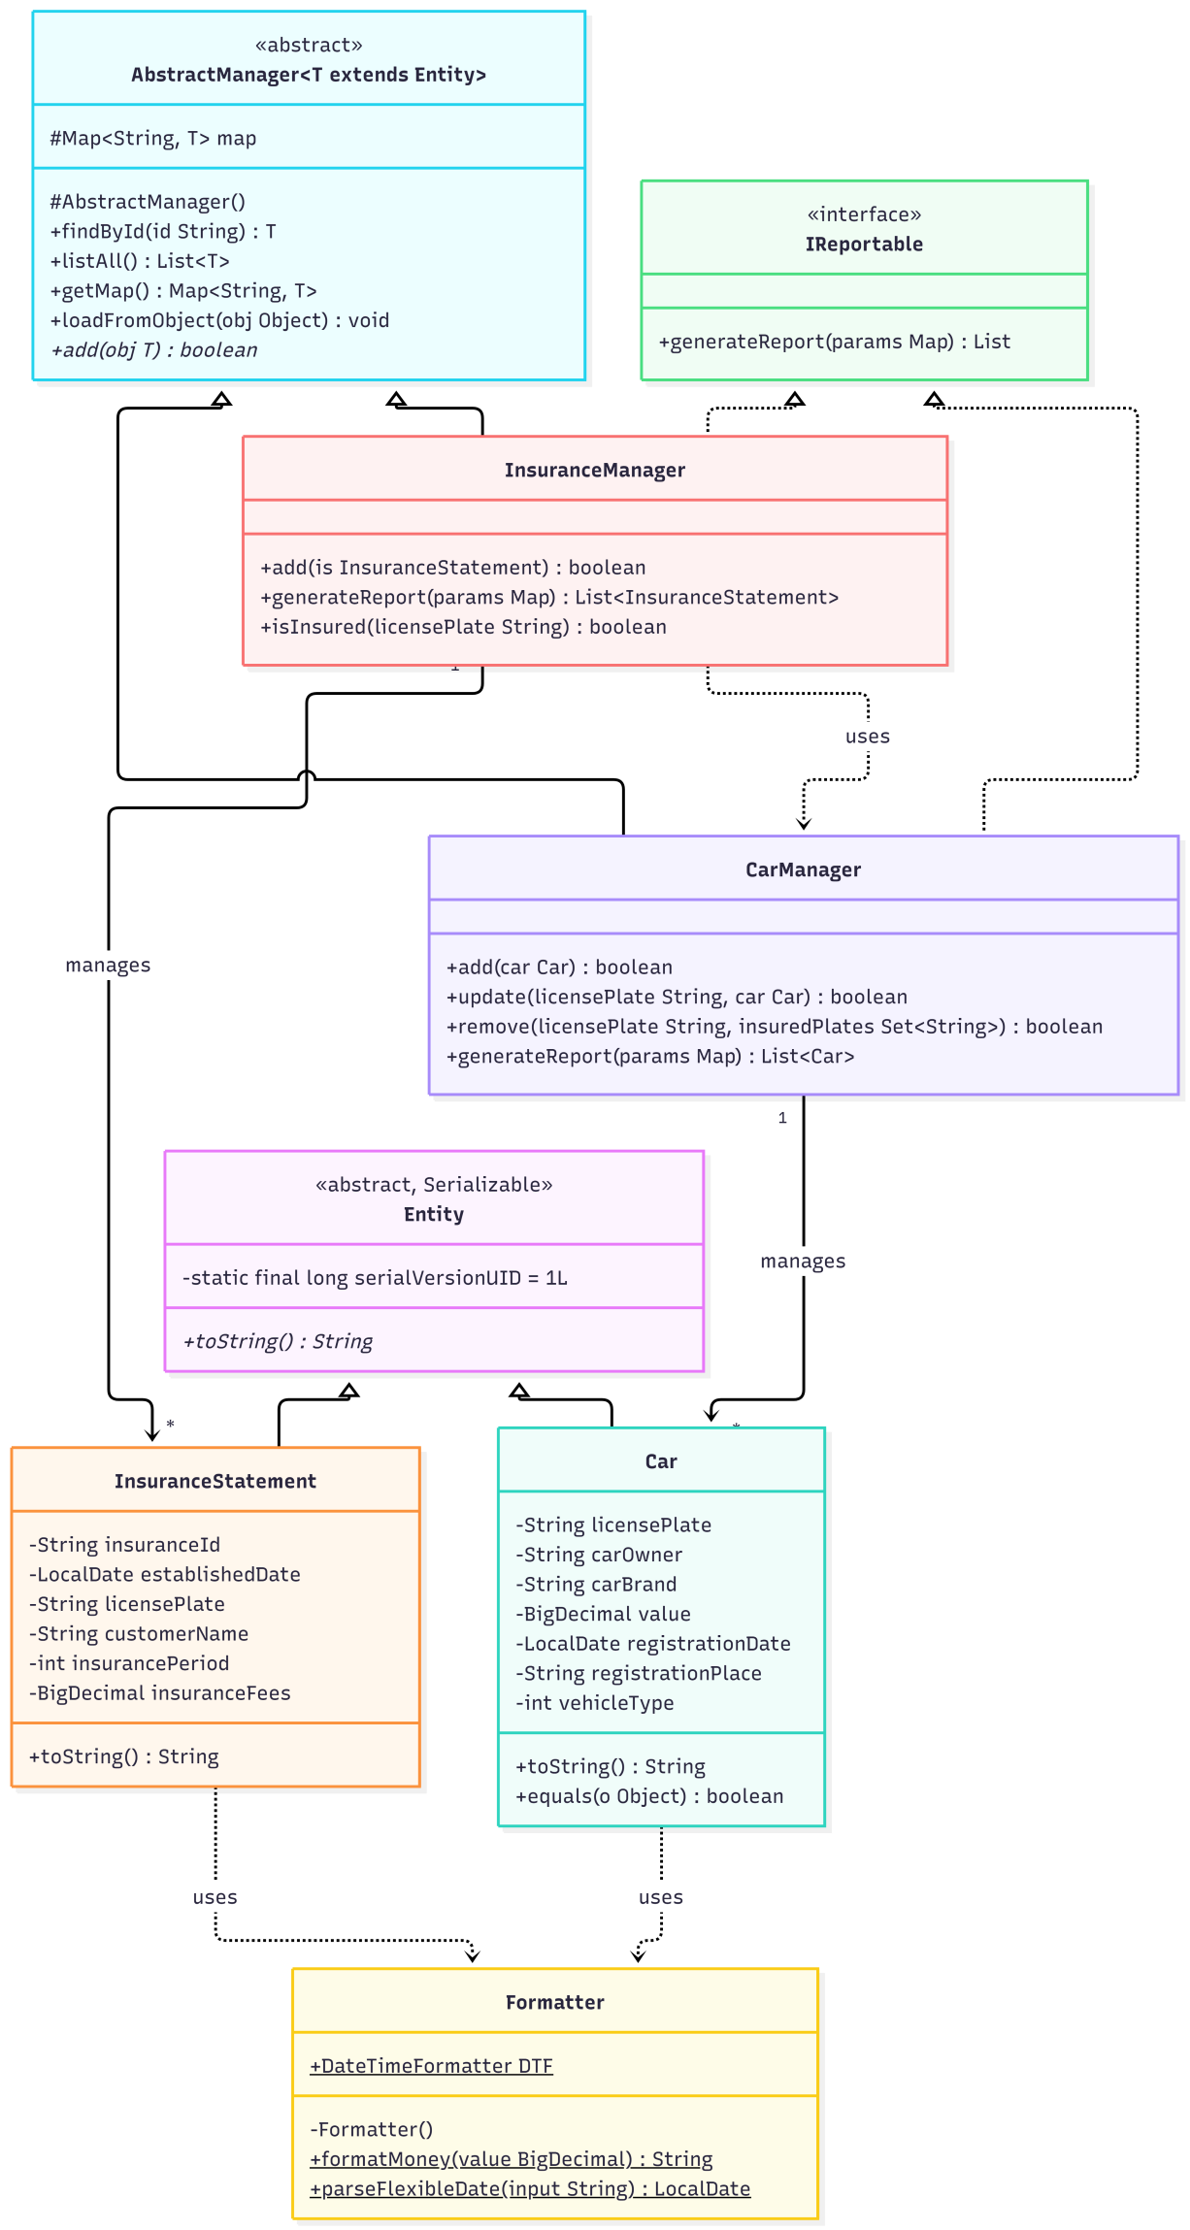

4.2 Overall Architecture
Description: This diagram shows all classes of the system organized by package. The Main class creates ProgramController, which coordinates all operations. The controller delegates to CarManager and InsuranceManager for business logic, to Inputter for reading user input, to ConsoleView for displaying output, and to FileWriter and FileReader for file I/O. Validation provides pure validation methods used by Inputter. Constants stores shared constants used across packages. Formatter provides centralized date and currency formatting used by Car and InsuranceStatement.

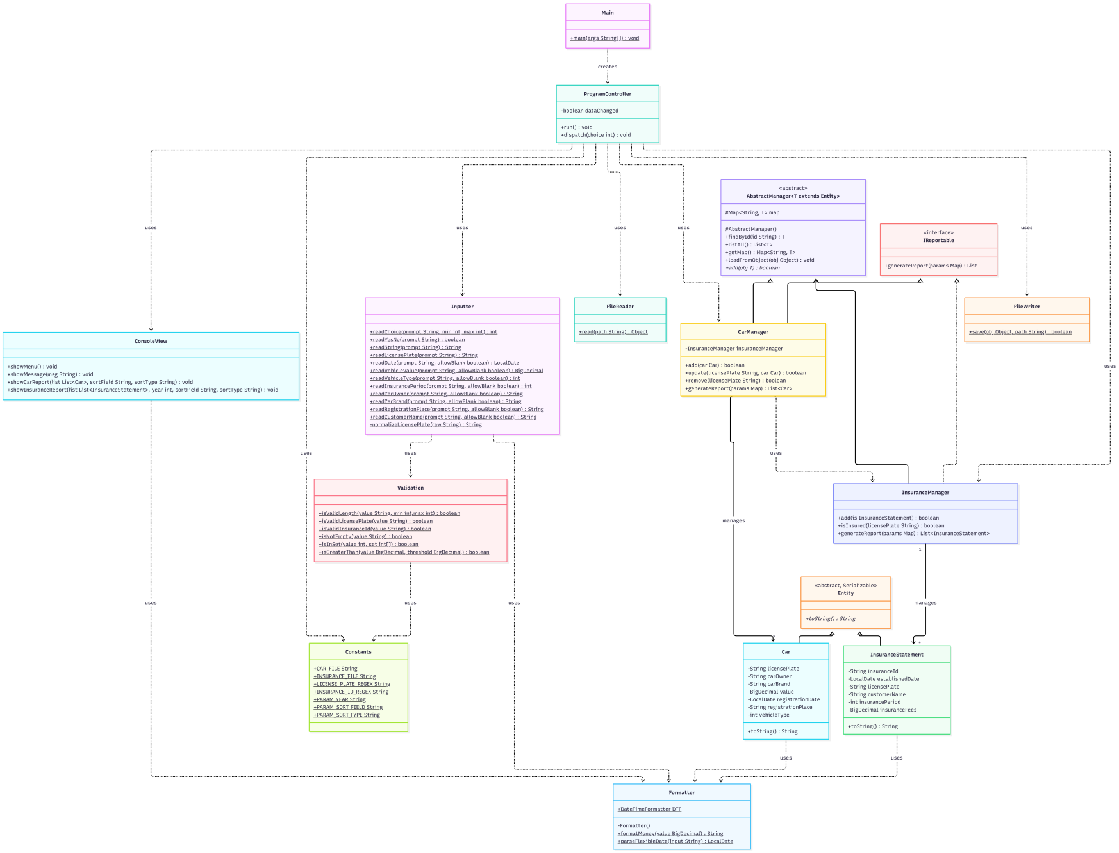
- Flowchart
A flowchart visualizes the control flow of the program. It shows how the program moves from one step to another, including decision points and loops. In this project, flowcharts are provided for the main program loop and for three key functions: Add Car Information, Delete Car, and List Insurance Statements. These three functions are selected because they contain the most complex logic (validation loop, business rule check, and sorting respectively).
  - Main Flow
The main flow describes the overall loop of the program. After starting, the program initializes the managers and utility classes, loads any existing data from files, then enters a loop: display menu, read the user's choice, dispatch to the appropriate function, and return to the menu. The loop continues until the user chooses to quit. On quit, the program asks for confirmation, saves data if there are changes, and exits.
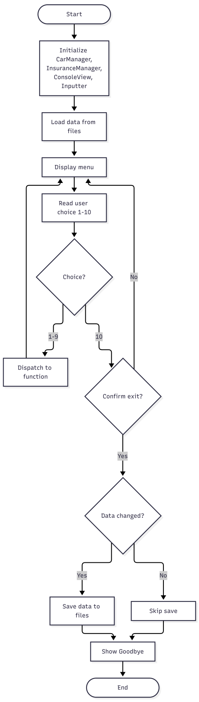
  - Function 1 — Add Car Information
Function 1 contains a loop that allows adding multiple cars. For each car, the program reads each field and validates it in turn. If a field is invalid, the program shows an error and re-prompts the user until a valid value is entered. After all fields pass validation, the program creates a Car object, adds it to the collection, shows a success message, and asks whether to continue.
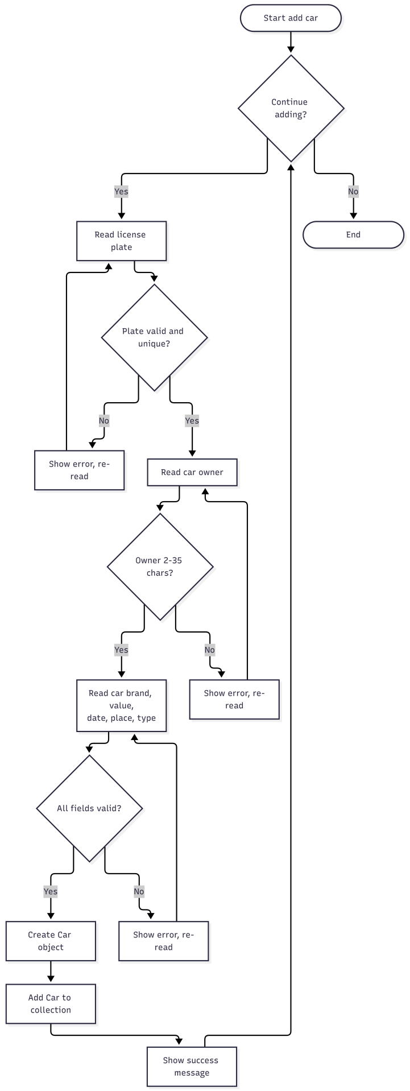
5.3 Function 4 — Delete Car
Function 4 first searches for the car by license plate. If the car does not exist, the program shows "Unregistered vehicle" and stops. If the car exists, the program checks whether it has any insurance. If it does, the program shows "Cannot delete: car is already insured" and stops. Otherwise, the program asks the user for confirmation. If confirmed, the car is removed from the collection and a success message is shown.
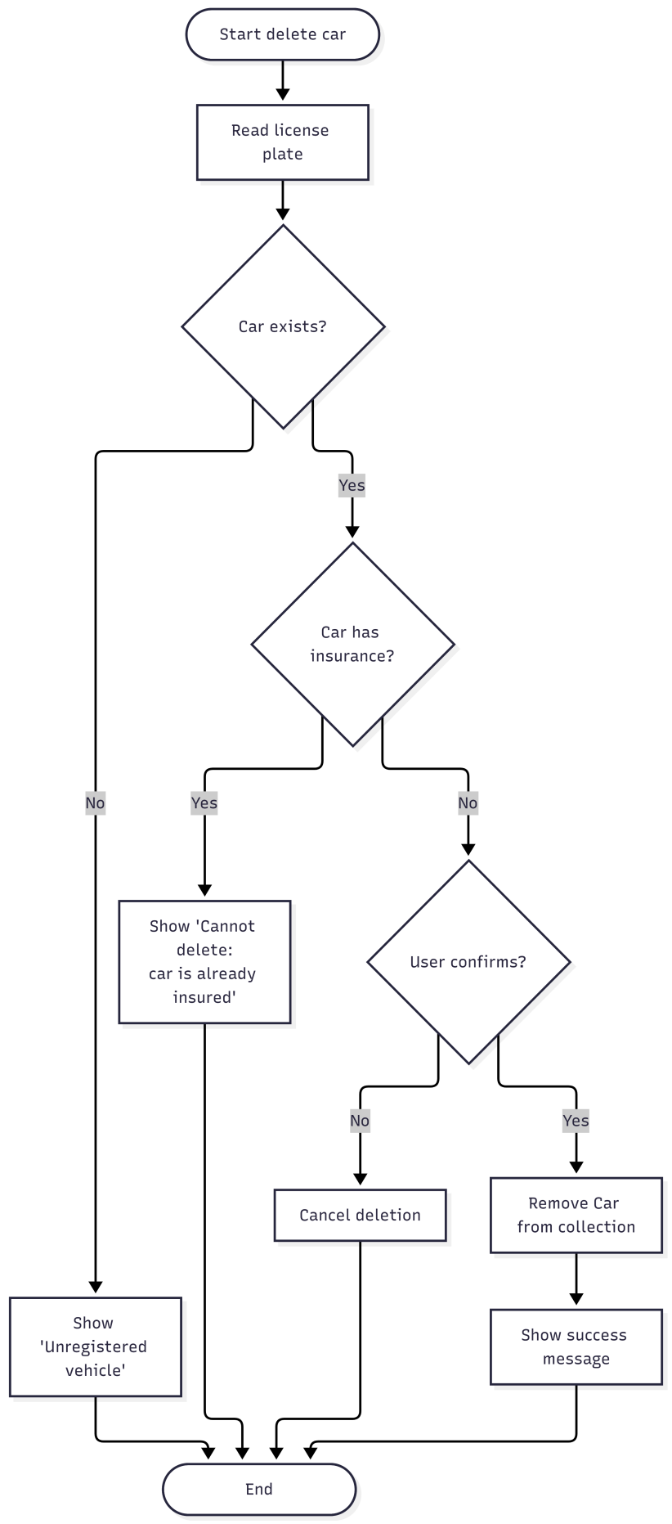
5.4 Function 6 — List Insurance Statements
Function 6 reads the year, sort field, and sort type from the user. It then filters the insurance collection to keep only the statements whose established date is in the given year. If no statements match, the program shows "No insurance statements found". Otherwise, it sorts the result by the chosen field and direction, then displays the table with a header that includes the year range and sort information.
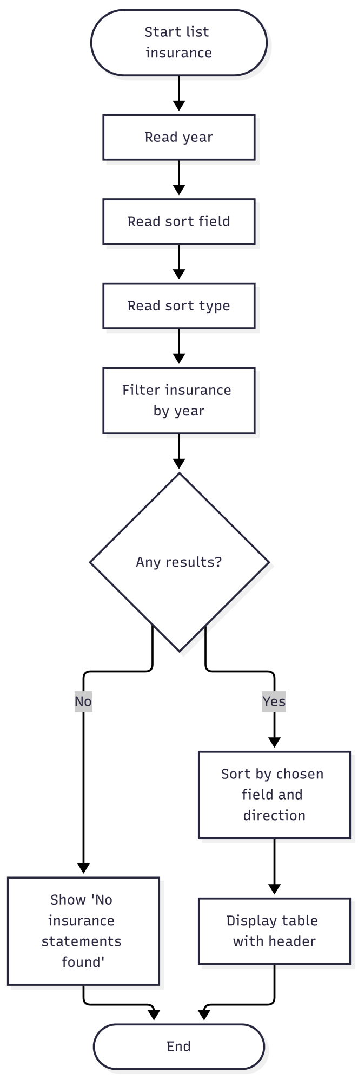
- Conclusion
This project built a Car Insurance Management system in Java using Object-Oriented Programming principles. The system manages two main entities, Car and InsuranceStatement, stored in Map collections for efficient lookup and manipulation. It provides ten functions: adding, finding, updating, and deleting cars; adding and listing insurance statements; reporting uninsured cars; saving and loading data from binary files; and quitting the program.

The project applied the four components of Computational Thinking. Decomposition broke the problem into data, functional, and class modules. Pattern Recognition identified recurring patterns in data format (regex), CRUD operations, validation rules, and file I/O. Abstraction extracted common behaviors into abstract classes Entity and AbstractManager<T>, and interface IReportable. Algorithm Design defined processing steps for each function before implementation.

On the OOP side, the design used inheritance (Car and InsuranceStatement extend Entity; managers extend AbstractManager), interfaces (IReportable), polymorphism, and encapsulation. Validation was centralized in a static utility class, input handling was separated into an Inputter class, and file I/O was made generic to work with any serializable object.

Limitations. The system runs on the console only and does not support multiple users. Insurance statements cannot be updated or deleted, as the specification does not require these operations.

Future development. If extended, the system could add a graphical user interface, support updating and deleting insurance statements, generate statistical reports, or migrate data storage from binary files to a database.

