Android Reversing
Reverse Engineering

Pedro Costa
Henrique Dias
Jorge Saénz
Índice
1. Executive Summary 3
1.1 User Perspetctive 3
1.2 Organization Perspective 3
2. Background 3
3. Static Analysis 3
4. AndroidManifest.xml 5

Executive Summary

User Perspetctive

Organization Perspective

Background
Date – 2026/02/27
File Name by VirusTotal: com.phone.junk.clean.smart.apk

Static Analysis
File Hash by VirusTotal:
MD4 - 6848658879f8c35d6c3252bef794daec
MD5 - eb3b881048f49355a2d3a9493ab50eba
SHA-1 - 7e40795e3884109ae87348ca700b4c04dc8751c8
SHA-256 4e819b297c4f1a77a29ebf744df05ad9977e704c54fec73a65c219aa78dfb889
SHA-512 ca8013005bcb1f47c95a737d48eab7116ae45aa1c0d01e983b8b95d32df24795db6b929e916c8f04ec87fe076ca2ac58a3e75db451ea051b893631f495114c6a
VHASH -
4ce2832a29aaa75f13fc01a63c88b160
SSDEEP - 393216:rPLgXiODT06HXAi8C8IbE7iV6UhTLsoBB2Bhg7hJkjfs6ByYmZheN1D/R:DLODo6wNJEEOsUhPBYzgtJkjVByYmCnV
TLSH -
T1F02733A7F328A42FD87330B18EBB421385995D4682436F63E915B21D1DB79C48F5AFC8
File Size – 21398921 bytes (20.41 MB)
File Type – APK
Certificate:
Valid From: 2026-02-25 08:51:21
Valid To: 2056-02-25 08:51:21
Serial Number:
754d71c472a3be7037e7b7bf143abe1628e05cdb
Thumbprint:
3d2847dbc4282ccab49cd6f62777de0a6a927272
Issuer: C:US, CN:Android, L:Mountain View, O:Google Inc., ST:California, OU:Android
Version (VirusTotal) – Internal Version: 1
Displayed Version: 1.0.8.1
Minimum SDK Version: 24
Target SDK Version: 36
File Header Characteristics: 50 4b 03 04 (PK)
Language (DetectitEasy) – Kotlin
Entropy:
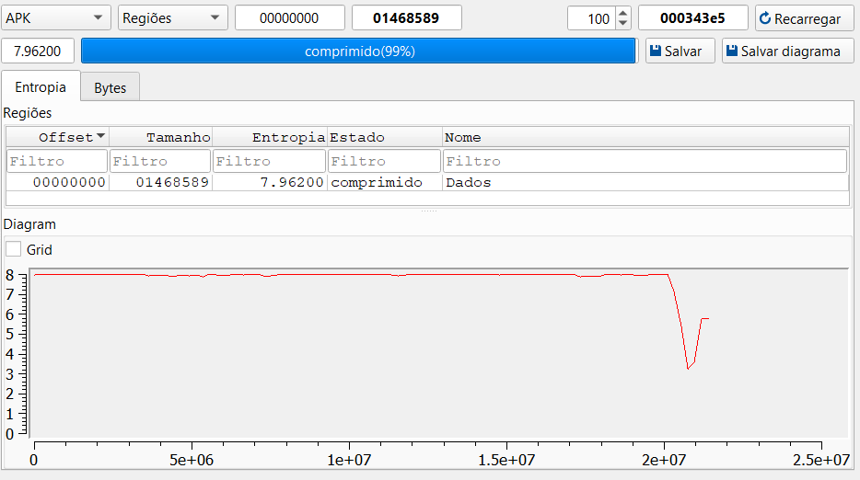

AndroidManifest.xml
One of the files that DetectitEasy was able to obtain was the AndroidManifest.xml. This is a file that is critical for the application, defining information like permissions, activities, intents and services. In our application, the following permissions were found:
Permissions:
- android.permission.POST_NOTIFICATIONS
- android.permission.READ_EXTERNAL_STORAGE
- android.permission.WRITE_EXTERNAL_STORAGE
- android.permission.PACKAGE_USAGE_STATS
- com.phone.junk.clean.smart.DYNAMIC_RECEIVER_NOT_EXPORTED_PERMISSION
- android.permission.MANAGE_EXTERNAL_STORAGE
- android.permission.REQUEST_DELETE_PACKAGES
- android.permission.ACCESS_ADSERVICES_AD_ID
- android.permission.RECEIVE_BOOT_COMPLETED
- com.google.android.providers.gsf.permission.READ_GSERVICES
- android.permission.ACCESS_ADSERVICES_ATTRIBUTION
- android.permission.ACCESS_NETWORK_STATE
- com.google.android.gms.permission.AD_ID
- android.permission.FOREGROUND_SERVICE
- android.permission.CHANGE_NETWORK_STATE
- android.permission.ACCESS_ADSERVICES_TOPICS
- android.permission.INTERNET
- com.google.android.finsky.permission.BIND_GET_INSTALL_REFERRER_SERVICE
- com.android.vending.CHECK_LICENSE
- android.permission.WAKE_LOCK

