vHai Dang

2/20/17

CIS 3344: Lab 5

1. User Table: scientist

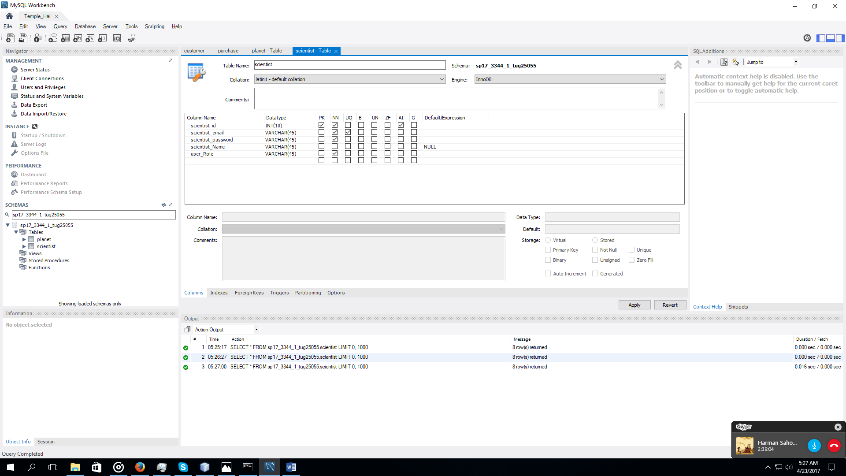

1. Other Table: planet

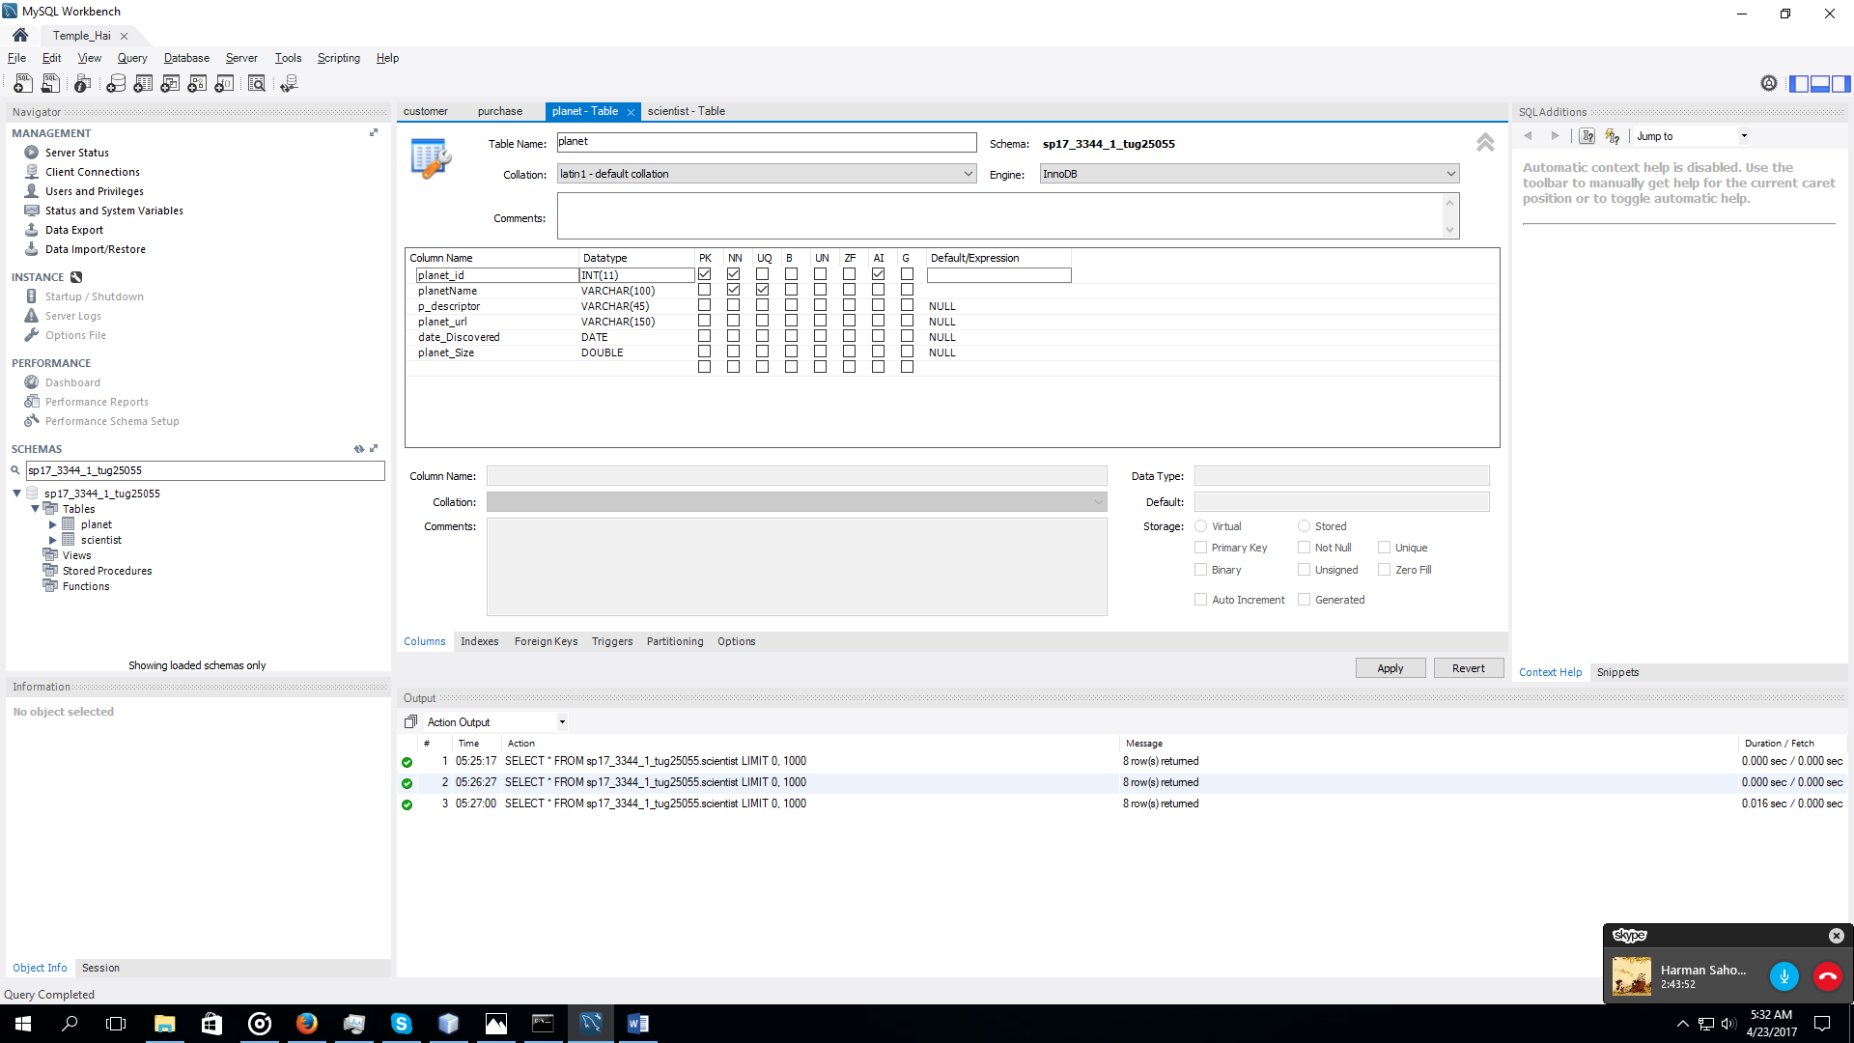

1. 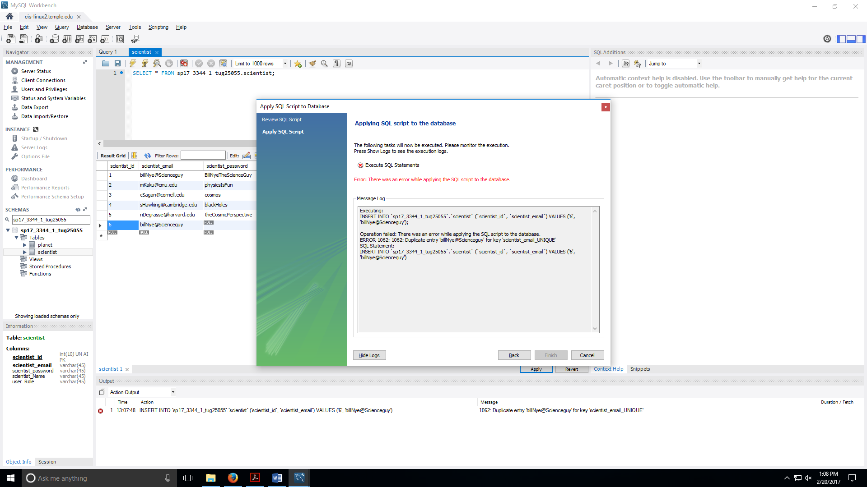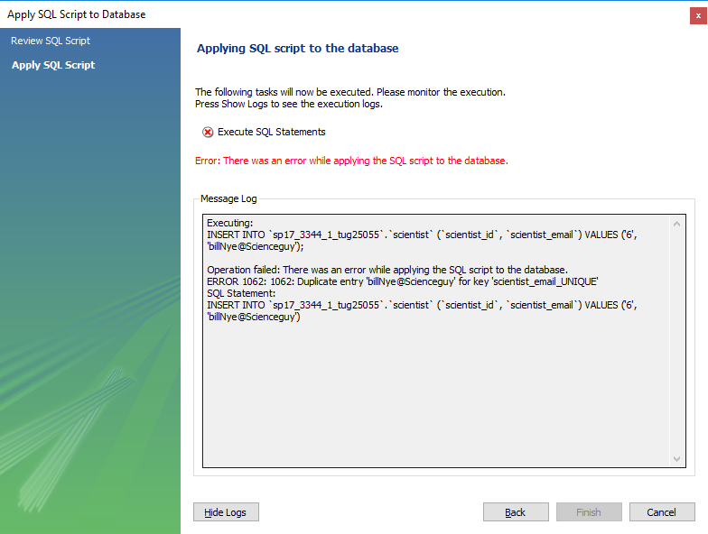Get a screen capture from MySql Workbench of error message that you get when you try to ***insert*** a record into your ***User*** table that has the same descriptor field as some record that already exists in the table. Your web application will get this same database exception error message (if your user tries to do such an insert), so try to get familiar with how the database management system works in this regard.

1. Get a screen capture from MySql Workbench of error message that you get when you try to ***update*** a record from your ***"Other"*** table so that it has the same descriptor field as some record that already exists in the table. Your web application will get this same database exception error message (if your user tries to do such an update).

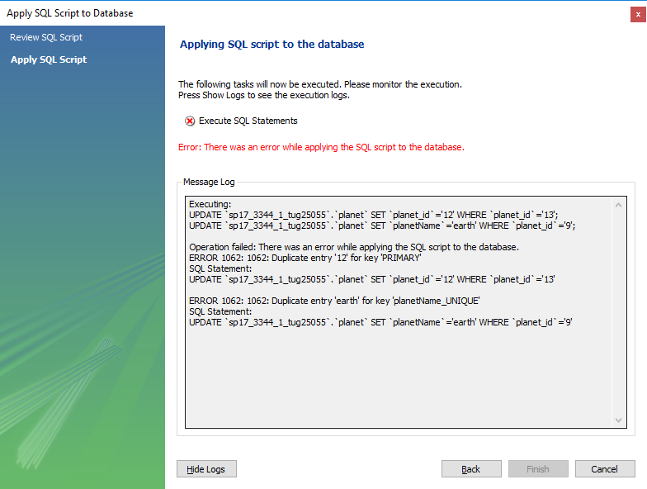

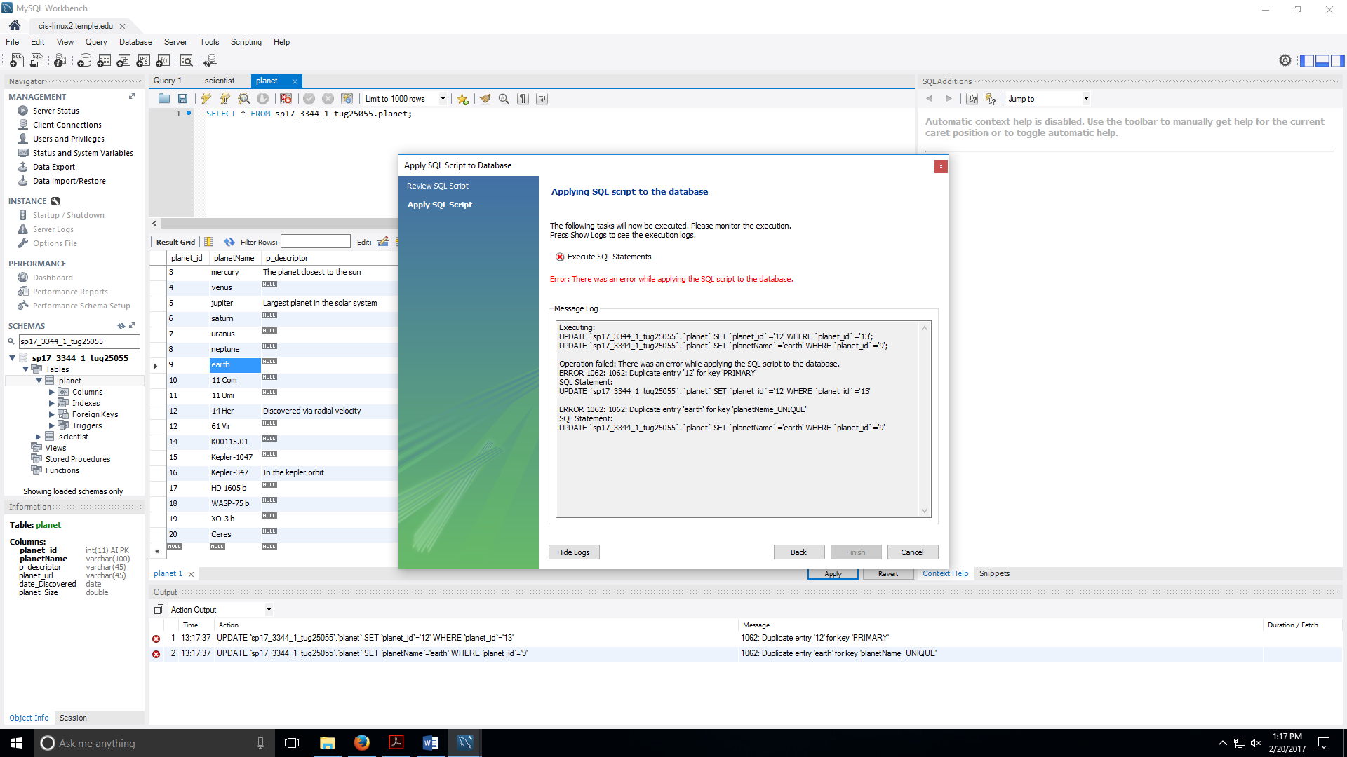

1. Write and execute the following three **SQL SELECT statements**, then copy/paste a screen capture (sql query area, result set area, plus output area, as shown below) into a document (doc, rtf, or pdf). Get a good (legible) screen capture as mentioned before, by selecting out just the parts that are needed.
   1. **First select statement:** All the fields of all records in your User table, ordered by email address. Select the column names individually (don't use SELECT *). Since users expect the first column to be in order, make the email address be the first column and display the rest of the columns as you think your users (Administrators) would want to see it on the web page you will be creating later in the semester. Even though user passwords should never be displayed to any user (even administrator), we are doing this anyway, for ease of testing and grading.

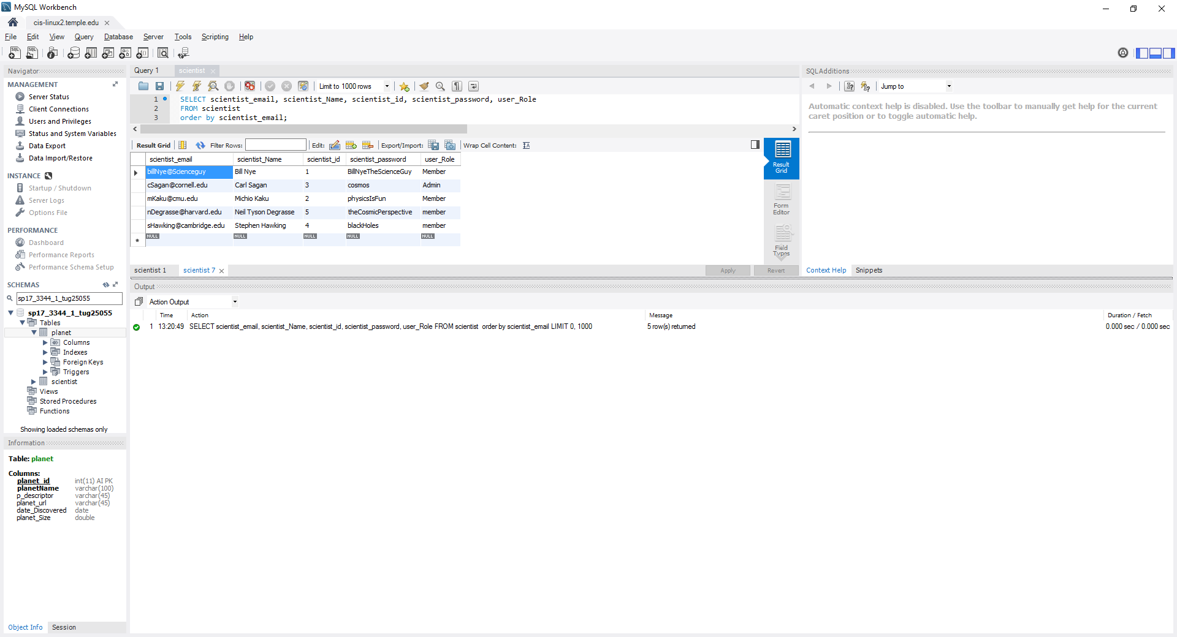

* 1. **Second select statement:** All the fields of all records in your Other table, ordered by the unique descriptor field. Select the column names individually (don't use SELECT *). Since users expect the first column to be in order, make the descriptor field be the first column and display the rest of the columns as you think your users would want to see it on the web page you will be creating later in the semester. It is likely that you will not be able to get all 20+ records to show on a single screen capture, so just get the first records on one screen capture and the last records on another screen capture. If you are unable to get all the fields to show in the screen capture, just put the long URLs as the last columns of your select statement and it is OK if we cannot see them.

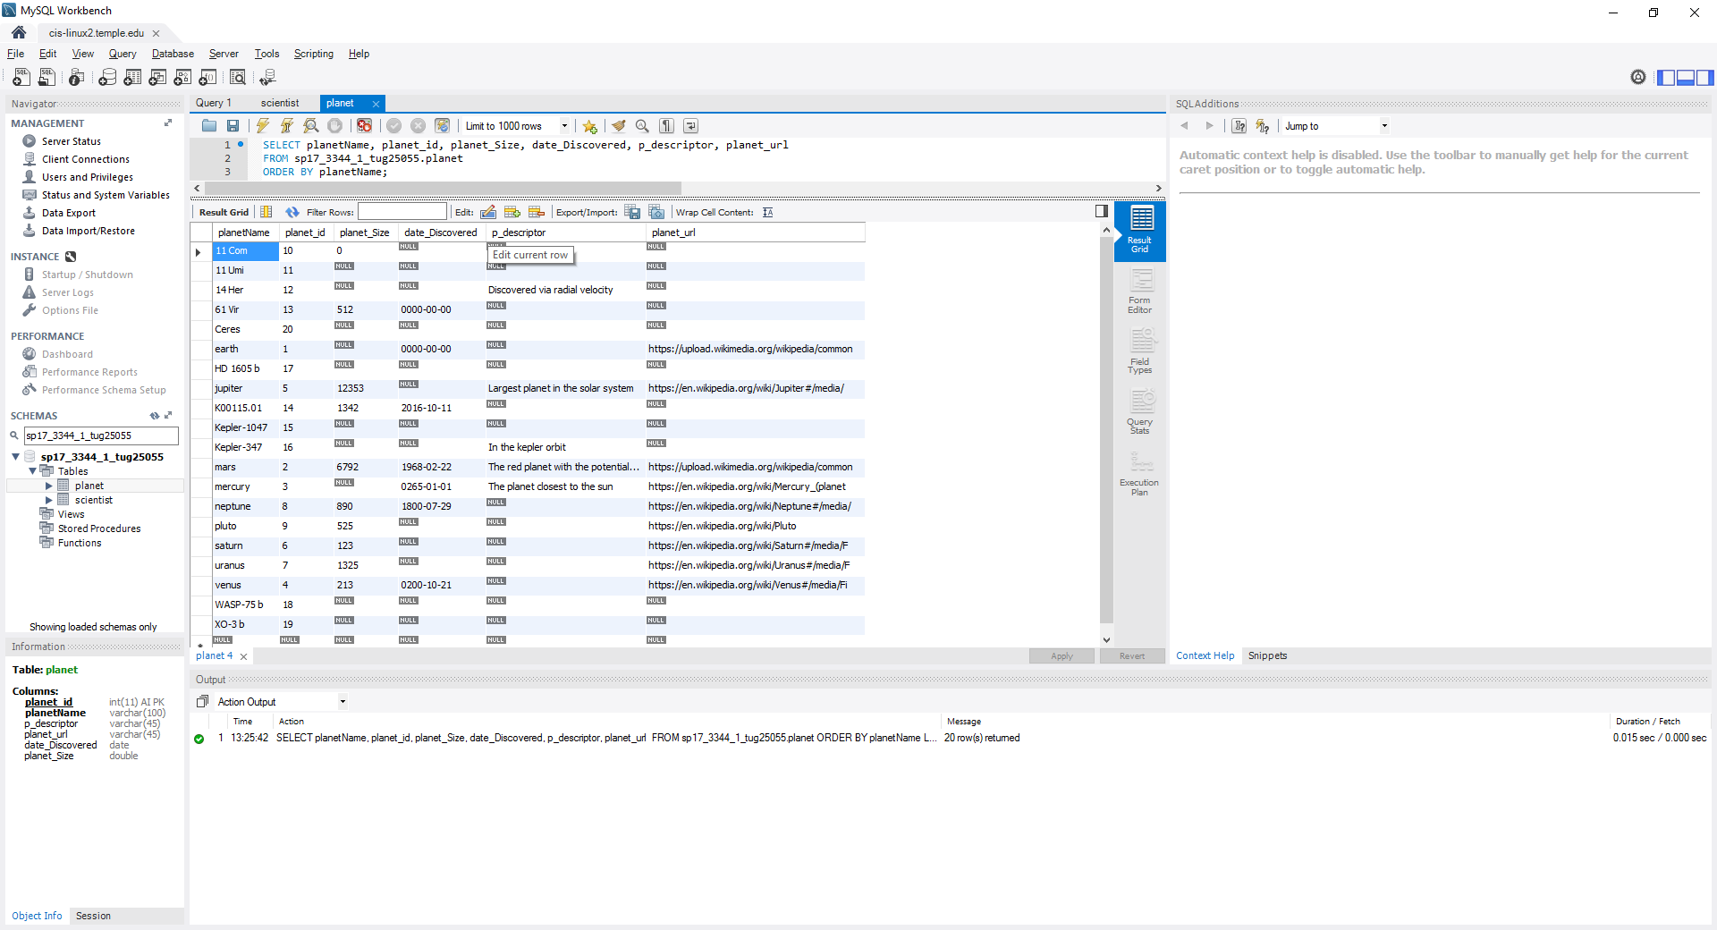

* 1. **Third select statement:** The same columns and order as the second select statement, but having an additional condition in the WHERE clause that uses the SQL LIKE keyword and % for wild card match. Choose your WHERE clause so that you get at least several rows in your result set (but not more than can fit in one screen capture). Here is an example using the LIKE SQL keyword that returns all records where user_email starts with "S": SELECT * FROM web_users WHERE user_email LIKE 'S%';

