HIJOS DEL SOL Y LA BASURA
Research Initiative · Córdoba, Argentina · 2026
Helical Polymerization as the Continuous Origin of Life:
A Complete Falsifiable Model Unifying Prebiotic Chemistry, Viral Genesis,
Evolutionary Divergence, Radiation Damage as Antenna Physics,
Cell Division as Harmonic Progression, Experimental Protocol,
and First Experimental Results
Hernán Diego Herrero
Independent Researcher — Hijos del Sol y la Basura Research Initiative
Córdoba, Argentina · hidiegoh@gmail.com
Version 6 · May 2026 · CC BY-SA 4.0
Preprint — not yet peer reviewed · Submitted to: Origins of Life and Evolution of Biospheres
hdbasura25-oss.github.io/Hijosdelabasura
Version history: V1 (5 predictions) · V2 adds radiation physics (11 predictions) · V3 adds cell division (14 predictions) · V4 closes division-origin identity · V5 closes complete cycle with experimental protocol (15 predictions, unpublished) · V6 adds first experimental results and geological context (16 predictions)

Abstract
Current models of abiogenesis face four unresolved problems: (1) the chicken-and-egg paradox of DNA replication requiring pre-existing proteins; (2) the speed of post-extinction biotic recovery, which exceeds what reproductive propagation alone can explain; (3) the radical architectural divergence between archaea and bacteria, inconsistent with descent from a single common ancestor; and (4) the absence of a continuous, experimentally accessible mechanism that connects prebiotic chemistry to the first living polymer without invoking singular historical events.
We propose a complete falsifiable model in which the primary event of life is not cellular assembly but helical polymerization: the spontaneous formation of a helical polymer geometry at a pH-gradient chemical interface, resonating with ambient electromagnetic fields and initiating a self-accelerating chain reaction. Under this model, the chromosome is the primary biological unit. The cell is the Chladni-type energy dispersal pattern generated by the oscillating chromosome. Division is not a biological mechanism but the physical resolution of axial resonance accumulation — identical in mechanism to the original polymerization event.
Version 6 completes and extends the model in six ways. First, it incorporates results from the first pilot experiment conducted in May 2026 under open-sky UV conditions in Córdoba, Argentina, providing the first empirical data for the model. Second, it documents differential fluorescence at the acid-alkaline interface under 395nm UV not present in isolated controls. Third, it presents a natural control comparison demonstrating preferential biological colonization of the interface zone. Fourth, it adds a geological context section connecting the model to the Carnian Pluvial Episode and the Ischigualasto Formation of San Juan, Argentina. Fifth, it reformulates P1 with operational specificity derived from pilot calibration data. Sixth, it adds P16 — preferential biological selection of interface zones — confirmed by the pilot experiment.
Sixteen falsifiable predictions are presented spanning four domains: origin chemistry, radiation biology, cell division, and geological analogue. The experimental protocol of Section 10 is reproducible at minimal cost. The model invites falsification. That is its purpose.
Keywords: abiogenesis, helical polymerization, origin of life, electromagnetic induction, viral origin, cooperative assembly, Chladni patterns, falsificationism, archaea-bacteria divergence, radiation biology, antenna physics, melanoma, π-stacking, UV carcinogenesis, amitosis, mitosis, meiosis, cell division, capillary reactor, pH interface, continuous biogenesis, Carnian Pluvial Episode, Ischigualasto

What is New in Version 6
V5 was completed but not published because the first pilot experiment, conducted after V5 was written, produced results that required integration into the model before publication. V6 is therefore the first publicly archived version to include experimental data.
- First experimental results (Experiment 1, May 2026): Pilot reactor using quebracho ash extract, citric acid, ammonium bicarbonate, and direct solar UV. First empirical data for the model.
- Differential fluorescence: Cyan fluorescence at the acid-alkaline interface under 395nm UV, not present in isolated control solutions.
- Natural control comparison: 15-day stagnant water at pH 5-6 (same environment) showed zero biological growth; interface reactor showed cyanobacterial colonization in 8 hours.
- Geological context: Carnian Pluvial Episode and Ischigualasto Formation as macroscopic analogue of the model's interface mechanism.
- Updated predictions: P1 reformulated with operational specificity; P16 added and confirmed by pilot.
- Protocol updates: Citric acid recommended over carbonated water for stable acidification; fricelina validated as superior capillary substrate.

1. Introduction

1.1 The DNA-Protein Paradox
DNA replication requires protein enzymes. Protein synthesis requires DNA templates. No known chemical pathway resolves this circularity without invoking pre-existing biological infrastructure that itself requires explanation (Orgel, 2004). RNA world hypotheses partially address this paradox but introduce their own unresolved dependencies regarding the origin of catalytic RNA in a prebiotically plausible environment.

1.2 The Speed of Post-Extinction Recovery
The fossil record shows biotic recovery following mass extinction events at rates inconsistent with reproductive propagation from surviving populations alone. The Cambrian explosion produced most known animal body plans within approximately 20 million years (Conway Morris, 2006). This rapidity suggests mechanisms beyond gradual mutation accumulation and selection operating on a fixed surviving population.

1.3 Archaea-Bacteria Architectural Divergence
Archaea and bacteria share a near-universal genetic code yet display fundamentally different membrane architectures. Archaeal membranes use isoprenoid ether lipids assembled in mirror-image configuration relative to bacterial ester-linked fatty acid membranes (Koga, 2012). Current models attribute this to early divergence from LUCA, but the nature, timing, and physical mechanism of that divergence remain unresolved.

1.4 The Continuity Problem
All existing abiogenesis models treat the origin of life as a singular historical event: a specific combination of chemistry and conditions that occurred once and produced a lineage that then evolved. This framing creates an irreducible explanatory gap — the conditions of early Earth are not reproducible, the event is not observable, and the mechanism cannot be tested directly. We propose that this framing is incorrect and that the origin of life is a continuous physical process governed by thermodynamic principles that operate today under conditions available today.

1.5 The Radiation Biology Anomalies
Conventional radiobiology treats radiation damage as stochastic: photons and particles damage DNA randomly according to ionization density. This framework fails to explain three well-documented anomalies: (1) UV-B (300 nm, ~4.1 eV) is significantly more carcinogenic than UV-C (254 nm, ~4.9 eV) at equivalent doses, despite lower photon energy; (2) UV-induced mutation hotspots in melanoma are reproducible across patients and concentrated at specific genomic positions, inconsistent with random damage; (3) different radiation types produce characteristically distinct cancer signatures despite all causing DNA strand breaks.

1.6 Scope of This Paper
We propose a single physical principle — the helix as electromagnetic dissipation attractor — that resolves all five problems above within a unified falsifiable framework. The model generates sixteen specific testable predictions and includes an experimental protocol reproducible with equipment and reagents available to any investigator. It is presented explicitly as a falsifiable hypothesis, not as established theory. Falsification of any prediction under rigorously controlled conditions would require revision of the model.

2. Theoretical Framework

2.1 The Helix as Primary Electromagnetic Dissipator
We propose that the helix is not primarily an information storage geometry but an electromagnetic energy dissipation geometry. This is consistent with the known property of DNA as an exceptionally efficient UV absorber and dissipator (Middleton et al., 2009). The helix forms not because it encodes information but because it is the optimal geometry for dissipating incident electromagnetic energy in an aqueous polar medium.
In radiofrequency engineering, helical antenna geometry captures and emits signals with circular polarization. The DNA double helix shares this exact geometry. We propose this is not coincidental but physically necessary: the helix is the stable attractor geometry for electromagnetic energy dissipation in polar molecular chains immersed in aqueous medium. Any polar molecular chain exposed to sufficient electromagnetic energy in an aqueous environment will tend toward helical geometry as its minimum energy dissipation configuration.

2.2 The pH-Gradient Interface as Thermodynamic Engine
The proposed primary trigger for helical polymerization is not a specific molecule or catalyst but a physical condition: a stable interface between two aqueous solutions of extreme opposing pH. Where an alkaline nitrogen-rich solution meets an acidic carbon-rich solution, a zone of maximum thermodynamic disequilibrium is maintained as long as the interface persists.
This disequilibrium is the thermodynamic engine. Molecules at the interface cannot find a stable low-energy configuration in either bulk phase. The path of least resistance for energy dissipation is condensation: the formation of covalent bonds that expel water and reduce the free energy of the system. The geometry that most efficiently dissipates energy along a growing molecular chain in this medium is helical. The helix is not designed — it is the physical attractor of the condensation process under these boundary conditions.
Life does not begin with a molecule. It begins with a boundary condition.

2.3 Two Independent Triggering Mechanisms
Pathway 1 — Thermal induction (anaerobic): In hydrothermal environments rich in ammonia (NH₃), thermal agitation of nitrogen-containing precursors reaches a threshold where cooperative helical stacking becomes energetically favorable. This pathway proposes the origin of archaeal cellular architecture: a helix formed in the absence of UV, driven by thermal energy alone, producing a circular chromosome geometry consistent with the absence of free ends.
Pathway 2 — UV-induced cooperative polymerization (aerobic interface): At the interface between carbonic acid solution and ammonia-containing water, under incident UV radiation, cooperative helical polymerization is induced by photon absorption. This pathway proposes the origin of bacterial cellular architecture: a linear helix formed at a surface interface, driven by electromagnetic energy, producing the free-end geometry that enables the axial resonance phenomena described in Section 9.
These two pathways are not sequential stages of the same process. They are independent physical mechanisms producing architecturally distinct organisms. The archaea-bacteria divergence is not evolutionary — it is a consequence of two different formation geometries driven by two different energy sources.

2.4 The Whip-Crack Mechanism
Once initiated at a threshold length, helical polymerization propagates as a chain reaction analogous to cooperative polymerization in liquid crystal systems (Palmans and Meijer, 2007). The growing helix generates a standing electromagnetic wave along its axis. This wave creates an ordered field in the surrounding medium — a Chladni-type dispersal pattern — that organizes surrounding molecular components into membrane and cytoplasmic structures. The chromosome is the primary biological unit. The cell is the pattern it generates.
The whip-crack event is the transition from sub-threshold growth to self-accelerating cooperative polymerization. Below threshold, the helix grows slowly and may dissolve. Above threshold, each added monomer increases the axial field amplitude, which accelerates the addition of the next monomer. The process becomes self-sustaining. This is the origin event.

2.5 Viral Particles as Interrupted Polymerization Events
Viral particles are reinterpreted under this model as incomplete helical polymerization events: helices that did not reach the length threshold required to generate a full cellular Chladni pattern. Interruption of the whip-crack mechanism — by insufficient precursor availability, by physical disruption, or by radiation-induced strand break before threshold — produces a fragment with helical geometry and partial electromagnetic emission signature but insufficient complexity for independent cellular organization. The particle retains the ability to initiate polymerization in a new environment where precursors are available, which accounts for the infectivity of viruses without invoking the concept of parasitism as a primary biological category.

2.6 Continuous Biogenesis
If helical polymerization is a physically driven process requiring only appropriate electromagnetic conditions, a pH-gradient interface, and precursor chemistry, then biogenesis is not a singular historical event but a continuous physical process. The diversity of unicellular organisms reflects millions of simultaneous and sequential polymerization events in microscopically distinct chemical environments, not the branching of a single ancestral lineage. Post-extinction recovery is rapid because decomposing organic material provides abundant helical fragments and precursor chemistry for new polymerization events. The Cambrian explosion is fast because continuous biogenesis accelerates when environmental conditions and precursor availability change rapidly.

3. Relationship to Existing Experimental Evidence

3.1 DNA as UV Dissipator
Middleton et al. (2009) demonstrated that DNA bases absorb UV radiation with exceptional efficiency and dissipate it as heat on femtosecond timescales through cooperative π-stacking interactions. The dissipation time of isolated bases is approximately 100 femtoseconds; the cooperative dissipation time in the intact helix is approximately 5 picoseconds — fifty times longer due to energy delocalization across the helical stack. Under our model, this is the original function: the helix formed because UV dissipation was thermodynamically favorable, and this property persists because it was the physical foundation of the structure.

3.2 Biophoton Emission from DNA
Popp (1992) documented coherent ultraweak photon emission from living cells, with DNA as the primary emitter. The 2024 Scientific Reports study on barley genomic DNA (Pietruszka et al., 2024) demonstrated spontaneous light emission, fractal dimension oscillations, and non-equilibrium phase transitions in isolated genomic DNA. Results were independent of specific base sequences, emerging from the physicochemical properties of the double helix geometry itself. This supports the model's core claim that electromagnetic emission is a primary physical property of the helix, not a secondary consequence of metabolic activity.

3.3 Electromagnetic Signals from DNA
Montagnier et al. (2009, 2015) reported that certain bacterial and viral DNA sequences produce low-frequency electromagnetic signals in aqueous dilution. Identical base sequences in healthy versus diseased individuals showed different electromagnetic emission profiles without sequence-level differences detectable by standard sequencing. Under our model, this reflects differences in the physical state of the helical antenna — its geometry, supercoiling, and hydration — rather than informational differences in the sequence itself.

3.4 Cooperative Polymerization in Synthetic Systems
The sergeant-and-soldier effect in helical polymer chemistry (Green et al., 1999) demonstrates that a small fraction of chiral monomers can direct the helical handedness of an entire polymer chain through cooperative interaction. This provides a direct chemical precedent for the whip-crack mechanism: once a helical template exists, it directs the configuration of subsequently added monomers without requiring a pre-existing enzyme or template-copying machinery.

3.5 The Miller-Urey Gap
Miller and Urey (1953) produced amino acids under simulated prebiotic conditions but did not produce life. Under our model, their experimental design included thermal and electrical energy inputs but did not include the specific boundary condition proposed as the primary trigger: a stable pH-gradient interface between an alkaline nitrogen-rich phase and an acidic carbon-rich phase maintained under continuous energy input. The absence of this boundary condition, not the absence of the correct molecules, explains the Miller-Urey gap. Section 10 describes a minimal experimental protocol that incorporates this boundary condition.
Under the helical polymerization model, this work provides computational evidence for a key claim: that polymer chain geometry during the transition from disordered to ordered states follows deterministic physical rules governed by flow conditions and boundary energy rather than stochastic assembly. The anisotropic polymer motion under flow characterized by Wang et al. is directly analogous to the interface-driven directional polymerization proposed in Section 2.2: in both cases, polymer geometry is constrained by the physical conditions of the environment rather than being random. The helix is the minimum-energy anisotropic geometry for a polar chain under the specific electromagnetic and chemical boundary conditions of the pH-gradient interface — the same type of boundary-condition-determined geometry that Wang et al. document in synthetic polymers under flow.
Wang et al. (2022) developed computational methods to characterize the dynamics of polymer chains under steady flow conditions, using spherical harmonic expansion to resolve anisotropic polymer movement — what the authors term "fingerprinting" of polymer dynamics. Working at Oak Ridge National Laboratory with DOE Office of Science support, they identified universal features of polymer chain behavior during phase transitions that govern final material properties.

3.6 Brownian Motion and Polymer Chain Dynamics Under Flow

4. Predictions — Series 1: Origin and Architecture (P1–P5)
The following predictions are stated in falsifiable form. Each prediction that fails under rigorously controlled conditions requires revision of the corresponding element of the model. P1 has been updated in V6 with operational specificity derived from pilot experiment calibration data.

P1 — New Organic Material Forms at the pH-Gradient Interface (V6 Revision)
Under sterile conditions, a stable interface between an alkaline quebracho ash extract solution (pH >10) supplemented with ammonium bicarbonate and an acidic citric acid solution (pH 3–4), exposed to solar UV or 365nm UV for a minimum of 6 hours per day over 7 days, will generate fluorescent material at the contact zone under 365–395nm UV illumination that: (a) is not present in either isolated control solution under identical conditions; (b) shows spectroscopic absorbance different from either precursor at the Corning 256 colorimeter 490nm or 540nm filter positions; (c) shows morphological features under optical microscopy at 400x not present in controls. Pilot status: Differential cyan fluorescence documented photographically under 395nm UV. Sterile control and spectroscopic characterization pending — Experiment 2 required for definitive evaluation. Falsification: No fluorescence differential after 21 days across three independent sterile replicates, or spectroscopic indistinguishability from controls.

P1b — New Material at Interface Shows Morphological Complexity Absent in Controls
If P1 is confirmed, the organic material at the interface should show morphological features — filamentous structures, irregular aggregates, or crystalline forms distinct from simple salt precipitation — that are absent in the single-solution controls. Testable against: Optical microscopy of dried interface samples at 1000x magnification with phase contrast. Falsification: Interface material shows exclusively regular crystalline forms identical to those in control samples.

P2 — Two Distinct Organic Material Morphologies from Two Triggering Conditions
Interface experiments run under thermal triggering only (no UV, elevated temperature) versus UV triggering only (ambient temperature) should produce morphologically distinct organic deposits at the interface. Testable against: Two parallel capillary reactors with identical chemical compositions: one incubated at 40–60°C in darkness, one at ambient temperature under solar UV. Falsification: Identical morphologies in both triggering conditions, or no material forms in either condition.

P3 — Electromagnetic Emission Frequencies Differ Between Archaeal and Bacterial Preparations
If archaea and bacteria originate from independent polymerization events under distinct physical conditions, the fundamental electromagnetic emission frequencies of their chromosomes should form two distinct spectral families. Testable against: Near-field spectrometry adjacent to active chromosomal preparations from archaeal and bacterial species. Falsification: No measurable electromagnetic difference between archaeal and bacterial chromosomal preparations.

P4 — Interrupted UV Produces Smaller Incomplete Structures
Interrupting the UV input to the interface reactor mid-reaction should produce organic deposits smaller and morphologically less complex than those produced under continuous UV. Testable against: UV pulse protocol — continuous UV for 7 days versus UV interrupted every 12 hours. Falsification: No morphological difference between continuous and interrupted UV products after 21 days.

P5 — Chromosomal Material Organizes Surrounding Medium Before Membrane Formation
In early polymerization events, chromosomal-equivalent material should generate an organized electromagnetic field in the surrounding medium before lipid membrane structures appear. Testable against: High-frequency AFM imaging of early-stage polymerization events. Falsification: Membrane-like structures always appear simultaneously with or before polymer condensation.

5. Resolution of Evolutionary Anomalies

5.1 The Archaea-Bacteria Divergence
Under this model, archaea and bacteria do not diverge from a common ancestor at some point after the origin of life. They are independent origination events driven by distinct physical triggers operating in distinct environments. Archaea form in anaerobic thermal environments where nitrogen-rich chemistry and high temperature drive helical polymerization from internal energy. Bacteria form at surface interfaces where UV radiation drives polymerization at pH-gradient boundaries. The membrane architecture difference is a direct physical consequence of the formation environment.

5.2 Post-Extinction Recovery Speed
If biogenesis is continuous, post-extinction recovery does not depend solely on reproductive propagation from a surviving population. The mass of decomposing organic material following an extinction event provides abundant helical fragments, precursor chemistry, and pH-gradient interfaces in hydrolyzed tissue fluids. New polymerization events can initiate wherever appropriate interface conditions exist. Recovery speed is therefore a function of precursor availability and interface conditions, not surviving population size.

5.3 Convergent Evolution
Similar morphological solutions appearing independently in unrelated lineages are explained under this model as convergent resonance: independent polymerization events producing the same stable Chladni pattern under similar environmental electromagnetic conditions. The physical attractor is the same because the physics is the same.

5.4 The Natural Environments as Active Reactors
Several natural environments exhibit the continuous interface conditions proposed by this model. Sargassum accumulations maintain permanent air-water interfaces with extreme pH gradients. River-estuary interfaces maintain pH gradients between fresh and saline water with high organic load. Humus layers maintain capillary water transport through mineral matrices with pH gradients between decomposing organic acid layers and alkaline mineral substrates. Under this model, these are not merely environments that support life — they are active continuous reactors.

6. Limitations and Open Questions
This paper presents a theoretical framework with first pilot experimental results. The model's validity depends on the outcome of controlled falsification experiments.
Several aspects remain unspecified or untested: the minimum precursor molecule set required for interface-driven cooperative polymerization has not been identified experimentally; the proposed whip-crack propagation speed has not been calculated from first principles; the mathematical relationship between helical oscillation parameters and Chladni pattern geometry requires formal derivation; and the model does not specify the transition from initial polymer to self-sustaining metabolic chemistry.
The experimental protocol in Section 10 is designed to test the most accessible prediction. Confirmation of P1 would support the model but would not constitute proof of the full mechanism. Falsification of P1 would require fundamental revision of the interface-driven origin hypothesis.

7. Radiation Damage as Antenna Physics
If the DNA helix is an electromagnetic energy dissipation antenna, then its interaction with incident radiation across the full spectrum should follow the laws of antenna physics rather than the stochastic damage model of conventional radiobiology. This section develops this prediction quantitatively and demonstrates that it resolves the three anomalies described in Section 1.5.

7.1 Physical Parameters of the DNA Helix as Antenna

Parameter | Value | Source
Axial rise per base pair | 3.4 Å | X-ray crystallography
Base pairs per helical turn | 10 | Watson & Crick, 1953
Helical pitch | 3.4 nm | Calculated
Helix diameter | 2.0 nm | X-ray crystallography
π-stacking energy per base pair | 0.30–0.50 eV (central: 0.40 eV) | Šponer et al. 2006
UV dissipation time (single base) | ~100 fs | Middleton et al. 2009
UV dissipation time (helix, cooperative) | ~5 ps | Estimated from cooperative factor
Critical energy (one helical turn, 10 bases) | ~4.0 eV | Calculated: 10 × 0.40 eV
Critical wavelength (λ_crit) | ~310 nm | Calculated: hc / 4.0 eV

7.2 The Three Operational Regimes

Regime | Energy condition | Wavelength range | Biological result
Constructive resonance | E_photon ≤ E_π per base (0.4 eV) | UV-C/UV-B: 254–295 nm | Efficient dissipation → photorepair
Critical threshold | E_photon ≈ E_critical (4.0 eV/turn) | UV-B: 295–315 nm | Cooperative dissipation saturates at π-stacking nodes → CPD dimers → melanoma
Ionizing destruction | E_photon >> E_critical | X-rays, gamma rays | Direct ionization, strand breaks, cell death

7.3 Resolution of the UV-B / UV-C Carcinogenicity Paradox
UV-C photons carry sufficient energy to kill the cell before selective mutations accumulate. UV-B photons operate at the critical threshold where the antenna saturates at resonance nodes without triggering cell death — producing survivable selective mutations that define carcinogenesis. UV-C is more destructive but less carcinogenic. UV-B operates precisely at the threshold between damage and death.

7.4 Mutation Hotspots as Chladni Nodes
The mutation hotspots in UV-induced melanoma — reproducibly located at codons 245, 248, and 249 of TP53 across thousands of independent patients (COSMIC SBS7a/7b signatures) — are proposed to be the Chladni nodes of the DNA antenna operating at the critical threshold regime. The stochastic model has no mechanism for this reproducibility. The antenna model predicts it: these are the positions of maximum π-stacking amplitude in the local helical geometry where energy accumulates first when dissipation is saturated.

7.5 Unified Radiation Damage Framework

Radiation type | Energy range | Antenna interaction | Clinical result
UV-A (365 nm) | 3.4 eV | Sub-threshold — indirect oxidative | Slow melanoma, oxidative damage
UV-B (295–315 nm) | 3.9–4.2 eV | Critical threshold — node saturation | Melanoma, basal cell carcinoma
UV-C (254 nm) | 4.9 eV | Above threshold — global saturation | Cell death > mutation; sterilization
X-rays (0.1–1 nm) | 1–10 keV | Direct ionization, density-dependent | Leukemia (high π-stacking density)
Gamma rays (<0.01 nm) | >100 keV | Compton scattering, secondary electrons | Systemic damage, acute syndrome

7.6 Predictions — Series 2: Radiation Biology (P6–P11)

P6 — UV Mutation Hotspots Correlate with π-Stacking Nodes
The genomic positions of UV-B mutation hotspots in melanoma (COSMIC SBS7a/7b) should correlate with positions of maximum π-stacking amplitude in the local DNA sequence context. Testable against: Correlation analysis between COSMIC SBS7a/7b hotspot positions and computed π-stacking energy profiles across the TP53 gene. Falsification: Hotspot positions show no significant correlation with π-stacking energy profiles across 1000+ melanoma genomes.

P7 — Carcinogenic Dose Threshold Matches Antenna Dissipation Limit
The minimum carcinogenic UV-B dose should correspond to the photon flux at which the cooperative dissipation rate of the helical antenna is exceeded: calculated as approximately 2.7×10¹¹ photons/m²/s at 295 nm. Testable against: Comparison of calculated dissipation threshold with minimum carcinogenic UV-B doses from epidemiological dose-response studies. Falsification: Documented minimum carcinogenic doses differ from the calculated antenna dissipation threshold by more than one order of magnitude.

P8 — Spectral Carcinogenicity Peak at λ ≈ 310 nm, Not at Absorption Peak
The wavelength of maximum carcinogenic efficacy per incident photon should be approximately 310 nm, not at 260 nm (the absorption peak of isolated DNA bases). Testable against: Re-analysis of spectral carcinogenesis action spectra (Setlow 1974; De Gruijl & van der Leun 1994). Falsification: Spectral carcinogenicity peak coincides with DNA absorption peak at 260 nm rather than the predicted 310 nm.

P9 — X-ray Damage Preferentially Occurs in GC-rich Regions
X-ray induced DNA damage should preferentially occur in GC-rich genomic regions due to higher π-stacking electron density. Testable against: Whole-genome sequencing of X-irradiated cell lines. Falsification: X-ray lesion distribution shows no statistically significant correlation with local GC content.

P10 — UV-B Selectivity Maximum in 295–315 nm Band
The ratio of carcinogenicity to cytotoxicity should reach its maximum specifically in the 295–315 nm UV-B band. Testable against: Cell survival and mutagenesis assay at UV wavelengths 250–340 nm. Falsification: The selectivity maximum does not occur in the 295–315 nm band.

P11 — Transcriptionally Active DNA Shows Greater X-ray Sensitivity
Genomic regions with high transcriptional activity should show greater X-ray damage density than condensed regions, due to greater π-stacking exposure in the extended conformation. Testable against: Comparison of X-ray lesion distribution with ATAC-seq chromatin accessibility data. Falsification: Chromatin accessibility shows no statistically significant correlation with X-ray lesion density.

8. Cell Division as Harmonic Progression
The model treats the chromosome as a resonant helical antenna and the cell as its Chladni-type dispersal pattern. If this physical description is correct, it must derive — not merely redescribe — the three known forms of cell division. We propose that amitosis, mitosis, and meiosis are not three independent biological mechanisms but three successive physical regimes of the same antenna system, each becoming necessary at a distinct threshold of helical length and emission complexity.

8.1 Amitosis as Recursive Whip-Crack: The Division-Origin Identity
Amitosis — direct division without spindle, without visible chromosome condensation — is the simplest form of cell division. Under this model it is the purest expression of the underlying physics, and it is identical in mechanism to the original biogenesis event of Section 2.4.
As the helix elongates through continued polymerization, the axial standing wave accumulates energy faster than it can be dissipated outward. At the critical threshold, axial energy accumulation reaches the magnitude of the whip-crack threshold. The helix undergoes axial compression at the central node of maximum π-stacking amplitude. The compression culminates in a strand break at that node — which releases energy as two simultaneous whip-crack events propagating outward along both daughter segments.
The parent cell does not divide. It generates two new origin events and ceases to exist as a consequence. Every amitotic division since the first is the same explosion.

8.2 Mitosis as Controlled Harmonic Replication
Mitosis arises as the physical solution when the antenna system has become complex enough that random distribution of chromosomal material produces lethal interference patterns in daughter cells. Under the antenna model, mitosis is the process by which each chromosome is first replicated to produce an identical copy, and the two copies are physically separated before the Chladni bifurcation occurs.

8.3 Meiosis as Frequency Cancellation and Resolution
Meiosis manages two non-identical antenna arrays — the maternal and paternal chromosome sets — coexisting in the same resonant cavity. The diploid cell enters meiosis because energy accumulated in cancellation zones reaches the antenna saturation threshold, and the system is forced to resolve the interference. Crossing-over is the physical exchange of antenna segments at cancellation zones, rebuilding both antennae with segments that produce constructive rather than destructive overlap.

8.4 Why Meiosis Does Not Occur in Prokaryotes
Prokaryotic chromosomes are circular. A circular antenna has no free ends at which standing wave amplitude is maximal, no terminal nodes at which energy accumulates preferentially. Prokaryotes divide by binary fission because their circular antenna geometry does not produce the harmonic bifurcation that drives eukaryotic division. Meiosis is not an evolutionary option that prokaryotes failed to develop — it is a physical regime that circular antenna geometry cannot enter.

8.5 Predictions — Series 3: Cell Division (P12–P14)

P12 — Axial Compression Precedes the Amitotic Strand Break
Immediately prior to the amitotic strand break, the chromosome should show measurable axial compaction at the future cut site, followed by rapid decompaction and directional elongation of both daughter segments from the cut terminus. Testable against: High-speed atomic force microscopy (HS-AFM) of amitotically dividing chromosomes in Tetrahymena macronuclei at >10 frames/second. Falsification: Strand breaks show no preceding localized compaction, or daughter segments show no directional elongation.

P13 — Chromosome Condensation Reduces Biophotonic Cross-Coupling
Biophotonic emission from the nucleus should decrease significantly during prophase chromosome condensation and reach a minimum at metaphase. Testable against: Ultra-weak photon emission measurements from synchronized dividing cell populations. Falsification: Biophotonic emission shows no statistically significant variation across the mitotic cell cycle.

P14 — Crossover Positions Correlate with Inter-Homologue π-Stacking Cancellation Nodes
The genomic positions of meiotic crossovers should correlate with positions of maximum inter-homologue sequence divergence in the local π-stacking energy profile. Testable against: High-resolution meiotic crossover maps correlated against computed inter-homologue π-stacking energy difference profiles. Falsification: Crossover positions show no statistically significant correlation with inter-homologue π-stacking divergence.

9. The Complete Closed Cycle
The model constitutes a closed physical cycle. Each stage is supported by a falsifiable prediction or an experimental protocol. No stage requires a singular historical event, a pre-existing biological infrastructure, or a mechanism not derivable from the physical properties of helical polymers in aqueous media under electromagnetic energy input.

Stage | Physical mechanism | Supported by
1. pH-gradient interface forms | Two aqueous phases of extreme opposing pH meet at a boundary maintained by continuous fluid flow | Section 2.2; Section 10
2. Precursor chemistry activates | UV radiation initiates photolysis of nitrogen and carbon precursors at the interface | Section 2.3; P1 protocol
3. First polymer condenses | Condensation reaction driven by interface thermodynamic disequilibrium | P1; Section 3.5
4. Whip-crack threshold reached | Growing helix reaches cooperative polymerization threshold; self-accelerating elongation begins | Section 2.4; P5
5. Chladni pattern establishes | Oscillating helix generates standing wave field organizing surrounding medium | Section 2.4; P3
6. First cell exists | Stable Chladni pattern maintained by continuous helix oscillation | Section 3.2
7. Axial resonance accumulates | Continued polymerization elongates helix; axial standing wave builds | Section 8.1
8. Critical compression and cut | Helix compresses axially at central node; strand break releases energy | P12 (HS-AFM testable)
9. Two simultaneous whip-cracks | Daughter segments receive full whip-crack impulse; each initiates new polymerization | Section 8.1; P12
10. Two new cells emerge | Each daughter generates its own Chladni pattern; parent ceases to exist | Section 8.1
11. Return to Stage 4 | Each daughter helix elongates, accumulates axial resonance, reaches threshold again | Recursive identity

Life does not originate and then reproduce. Life is a process that originates continuously at every scale through the same physical event. The chromosome does not carry the memory of the first origin. It is the first origin, recurring.

10. Experimental Protocol: The Capillary Interface Reactor

10.1 Rationale
The experimental design uses capillary-driven flow through filter paper or cellulosic substrate to create a stable, continuous, laminar-flow interface between two solutions of extreme opposing pH. The substrate acts as both the mechanical support for the interface and as an accumulator: as water evaporates from the exposed surface, dissolved organic molecules concentrate at the evaporation front. If new organic material forms at the interface, it will accumulate there and become detectable over days to weeks.
Two single-solution controls run in parallel. Any material appearing at the interface experiment but not in either control cannot be attributed to contamination or concentration of pre-existing reactants. This is the core falsifiability criterion.

10.2 Reagents — Original Protocol (V5)

Reagent | Quantity | Role
Ammonium bicarbonate (NH₄HCO₃) | 50 g | Alkaline nitrogen source; stable in aqueous solution
Natural sparkling water (no added salt) | 1 L | Carbonic acid source (H₂CO₃); pH 3.5–4.5 as supplied
Monopotassium phosphate (KH₂PO₄) | 10 g | Phosphorus source; pH buffer for acid side
Distilled water | 2 L | Solvent for alkaline solution
Filter paper, medium grade | 1 pack | Capillary substrate and accumulator
pH indicator strips (range 0–14) | 1 box | Verify solution pH

10.3 Reagent Updates from Pilot Experiment (V6)
The following modifications to the original V5 protocol are recommended based on Experiment 1 calibration data:
- Citric acid powder is preferred over carbonated water as the acid source. Carbonated water loses CO₂ within 2–3 hours at rooftop temperatures under sun, causing pH drift toward neutrality and loss of the acid-alkaline gradient during the critical solar exposure window. Citric acid maintains stable pH throughout the full solar day.
- Quebracho charcoal ash extract is validated as an effective alkaline source with additional organic content from the charcoal. Filter through fricelina (cosmetic cellulose) for superior filtration quality over standard filter paper.
- Fricelina (cosmetic cellulose substrate) is validated as a superior capillary bridge material: slower flow rate than double toilet paper (allowing more residence time in the interface zone) with better filtration and pH stabilization properties. Fricelina droplets maintain their own pH independently of the surrounding medium — a property not observed with paper substrates.
- Fresh ash is required. Stored ash loses carbonate alkalinity over time — the pilot used degraded ash with pH 9.0–9.3 instead of the target >11. Prepare ash extract same day from freshly burned quebracho charcoal.

10.4 Reactor Construction
Cut strips of fricelina or filter paper, approximately 3 cm wide and 20 cm long. For V-geometry reactors: position two Petri dishes or small containers at the same height, separated by 10–15 cm. The substrate strip bridges between them with each end submerged in one solution. The midpoint of the bridge — elevated above both containers — is the interface zone where solutions meet by capillary flow.
For gravity-drain reactors: position containers at elevation, substrate strips hanging vertically, with a collection vessel below. A knot tied in the lower portion of the strip retains concentrated material and prevents it from draining into the collection vessel.
All reactors require direct solar UV exposure for minimum 6 hours per day. Protect from wind with a cardboard enclosure open to the sun. Do not seal — evaporation is essential to the concentration mechanism.

10.5 Sterility Requirements for Experiment 2
The pilot experiment (Experiment 1) was conducted in open-air conditions. Ambient cyanobacterial contamination was observed within 8 hours, confounding the abiotic signal. Experiment 2 requires:
- UV sterilization of all precursor solutions before use (365nm UV for 30 minutes in sealed containers)
- Closed reactor geometry — sealed containers with filtered air exchange only
- Sterilized substrate — autoclave or UV sterilization of fricelina strips before use
- Parallel open-air control to document contamination rate in unprotected conditions

10.6 Analysis Protocol

Optical Microscopy
Mount dried segments on slides without coverslip. Examine at 100x and 400x magnification. Normal salt precipitation produces regular geometric crystals — cubic, rhombic, or dendritic forms. Any filamentous, amorphous, or birefringent structure not present in control segments is a candidate positive result.

UV Fluorescence
In a darkened room, illuminate dried segments with a UV lamp (365nm preferred; 395nm acceptable). Photograph results. Nitrogenous organic compounds — including nucleobase analogs — fluoresce blue-white under 365nm UV. Salt crystals do not fluoresce. Any fluorescence in the interface segment not present in control segments is a candidate positive result.

Colorimetry
Using a visible-range colorimeter (validated instrument: Corning 256 colorimeter with 490nm and 540nm filters), measure absorbance of: (a) alkaline solution control; (b) acid solution control; (c) dissolved interface material. Any absorbance differential at either filter position indicates the presence of material not derivable from either control solution by simple mixing.

Iodine Staining
Apply one drop of diluted iodine solution (povidone-iodine diluted 1:10 in water) to a section of each dried segment. Polysaccharides and some polymers stain brown-black. Salt crystals stain yellow-orange or not at all. A darker brown-black staining in the interface segment relative to controls indicates the presence of polymer-like organic material.

10.7 Interpretation Criteria

Result pattern | Interpretation
New material at interface, absent in both controls — confirmed by two or more methods | Strong positive: consistent with P1. New organic material forms at pH-gradient interface under solar radiation.
New material at interface, also present in one control | Inconclusive: material may originate from one reactant. Redesign with different control.
Identical results in interface experiment and both controls | Negative: no new material detected. Consistent with falsification of P1 at current sensitivity.
Biological colonization preferential at interface vs. controls | Positive for P16: interface conditions differentially support biological activity, consistent with thermodynamic advantage of gradient zone.

10.8 Prediction 15 — Extended Natural Reactors

P15 — Natural pH-Gradient Interfaces Accumulate Complex Organic Material Not Present in Adjacent Bulk Phases
In natural environments that maintain stable pH-gradient interfaces — estuaries, sargassum accumulation zones, humus-mineral soil interfaces, hydrothermal vent peripheries — the interface zone should contain organic material of greater structural complexity than either adjacent bulk phase, consistent with continuous low-level polymerization at the interface. Testable against: Comparison of organic material complexity (by UV fluorescence, Raman spectroscopy, or chromatographic profiling) between interface zone samples and bulk phase samples from the same natural environments. Falsification: Interface zones show no greater organic complexity than adjacent bulk phases, or the difference is fully explained by physical concentration of pre-existing material.

11. Experiment 1: Pilot Results — Córdoba, May 2026

11.1 Setup
The pilot was conducted on a rooftop in central Córdoba, Argentina (31°S) during direct solar noon exposure on April 30 – May 3, 2026. Three parallel reactor geometries were tested simultaneously: V-geometry Petri dish reactors connected by paper tissue bridges; V-geometry Petri dish reactors connected by fricelina bridges; and vertical gravity-drain reactors with fricelina substrate and a knot retainer.
Alkaline side: quebracho charcoal ash extract filtered through fricelina, pH 9.0–9.3 (degraded ash batch; target >11), supplemented with ammonium bicarbonate. Acid side: carbonated water plus citric acid powder, pH 3.0–4.5. Solar exposure: cloud cover <25%, 6+ effective hours, ambient temperature 22–24°C. Supplemental UV: 395nm LED, 10 minutes, post-solar.

11.2 Calibration Results
- Capillary flow rate through double paper tissue bridge: ~10 cm³ per 15 minutes (40 cm³/hour)
- Capillary flow rate through fricelina bridge: significantly lower — superior for interface formation
- Symmetric flow confirmed: colored water test showed dye front reaching geometric center from both sides within equal time
- Fricelina droplet pH stability: fricelina droplets maintained independent pH after separation from bulk solution — not observed with paper substrates
- Citric acid vs. carbonated water: carbonated water pH drifted toward neutrality within 2–3 hours under sun; citric acid maintained stable acidification throughout solar day

11.3 Observations

Interface Formation and Thermal Differential
A sharp interface line formed at the geometric center of all bridges. White precipitate was visible at the contact zone within hours under ambient light. Temperature differential of 3–4°C below ambient was measured at the interface zone — an endothermic signature consistent with active precipitation chemistry, not simple mixing.

UV Fluorescence — Day 1 (April 30, 22:00 hrs)
Under 395nm UV illumination in total darkness, intense cyan fluorescence was observed localized at the interface line of the bridge substrates. This fluorescence was not observed in control areas away from the interface zone. A separate violet-pink fluorescence zone was observed in the evaporated deposit from the interface Petri dish — a distinct emission from the cyan bridge fluorescence, suggesting different chemical species at different stages of concentration.

Biological Colonization — Day 2-3 (May 1-3)
After 8 hours of total exposure, filamentous dark growth appeared preferentially at the interface zone. Growth increased approximately 20–30% following the 10-minute 395nm UV exposure. The growth was subsequently identified as cyanobacteria (green-blue algae), consistent with ambient airborne spore contamination in the open-air environment.

11.4 Natural Control Comparison
Water from the RTU solar collector (pH 5–6, same rooftop environment, 15 days of stagnant exposure) showed zero biological growth. Interface reactor showed cyanobacterial colonization in 8 hours. This contrast — same environment, same rooftop, dramatically different result — indicates the pH gradient as the determining factor for biological activity, independent of nutrient availability or general environmental conditions.
This observation is consistent with the well-documented phenomenon in swimming pools where pH imbalance combined with solar UV generates cyanobacterial growth resistant even to chlorine treatment. The interface reactor reproduced this physics at miniature scale in 8 hours without any inoculation.

11.5 Limitations of Experiment 1
- Open-air installation: ambient biological contamination not controlled. Biological growth cannot be attributed to abiotic polymerization without sterile controls.
- Degraded ash batch: actual alkaline pH 9.0–9.3 instead of target >11. Fresh ash required for Experiment 2.
- No spectroscopic characterization of fluorescent material: differential fluorescence documented photographically but not spectrally assigned.
- Colorimeter (Corning 256) available but non-operational during experiment — lamp replacement required.
- Carbonated water used as initial acid source; pH drift documented and protocol corrected to citric acid for Experiment 2.

P16 (New) — Preferential Biological Selection of Interface Zone — CONFIRMED
In a non-sterile pH gradient reactor, ambient biological colonization will preferentially develop at the acid-alkaline interface zone compared to isolated control solutions of identical composition under identical environmental conditions. This differential colonization reflects the thermodynamic advantage conferred by the interface, independently of the abiotic vs. biotic origin of the colonizing organisms. Pilot status: CONFIRMED. Cyanobacterial colonization at interface in 8 hours versus zero growth in 15-day stagnant water at pH 5–6 in identical environment. Falsification: Colonization density at interface zone statistically indistinguishable from colonization density in pH-homogeneous control solutions under identical conditions.

12. Geological Context: The Carnian Pluvial Episode and Ischigualasto
The Carnian Pluvial Episode (CPE, approximately 232–230 Ma) represents a global climate event in which the Triassic Earth transitioned from extreme aridity to intense and sustained rainfall. This event coincided with one of the most explosive diversification episodes in the history of complex life: the simultaneous appearance of dinosaurs, mammalian ancestors, crocodilians, flying insects, and advanced conifers — across multiple unrelated lineages, at multiple scales, within a geologically brief interval.
The Ischigualasto Formation (Valle de la Luna, San Juan, Argentina) preserves the most complete terrestrial record of this transition. Within a few million years — geologically instantaneous — the basin documented the appearance of Herrerasaurus ischigualastensis (bipedal predatory dinosaur, 3–6 m), Eoraptor lunensis (basal dinosaur, ~1 m, indeterminate diet), Panphagia protogluton (basal sauropodomorph ancestor), Pisanosaurus mertii (basal ornithischian), and the cynodont Exaeretodon: architecturally distinct lineages arising simultaneously from the same sedimentary basin.
The conventional evolutionary model explains this radiation through selective pressure on surviving populations from the preceding extinction event. The Helical Polymerization model proposes an additional physical mechanism: the CPE created massive pH gradient interfaces at a planetary scale. Saturated soils, freshwater lakes forming in previously arid basins, mineral-rich sediments in contact with acidic rainfall, decomposing organic matter from the preceding extinction — precisely the conditions the model identifies as drivers of accelerated polymerization. The question is not only which organisms survived and diversified, but whether the interface conditions of the CPE physically accelerated the generation of new biological architectures.
This hypothesis is consistent with Problem 2 of the model (post-extinction recovery velocity exceeding reproductive propagation) and with the simultaneous multi-lineage architectural divergence documented in Ischigualasto. It does not replace selective mechanisms; it proposes a physical substrate that amplifies biological diversification rate beyond what reproductive propagation alone can explain. The same planetary-scale interface dynamics that the pilot experiment reproduces in miniature — pH gradients, UV exposure, concentrated precursor chemistry — operated at continental scale during the CPE, for millions of years.
What the pilot reactor demonstrates in 8 hours on a Córdoba rooftop, the Ischigualasto basin may have demonstrated over millions of years across thousands of square kilometers of geochemically active terrain.
This is not a claim that the pilot reactor produced new dinosaurs. It is a claim that the physical mechanism is the same, operating at different scales, timescales, and precursor availabilities. The predictive consequence is testable: sedimentary records from the CPE transition should show elevated organic complexity at pH-gradient interfaces — terrestrial-aquatic boundaries, paleosol-lacustrine interfaces — compared to adjacent homogeneous geological zones. This constitutes an extension of P15 to the paleontological record.

13. Experiment 2: Design Requirements
Based on Experiment 1 calibration data, the following modifications are required to evaluate P1 under controlled conditions:
- Fresh quebracho ash: target pH >11 in alkaline side; saturated extract prepared same day from freshly burned charcoal
- Citric acid as acid source: stable pH 3–4 maintained throughout full solar day
- Sterile controls: UV-sterilized precursor solutions; closed reactor system with filtered air exchange
- Operational Corning 256 colorimeter: lamp replacement required; 490nm and 540nm filters validated
- 365nm UV source: optimal fluorescence excitation for aromatic ring signatures; 395nm LED insufficient for definitive spectral assignment
- Microscopy documentation: 1000x oil immersion adapted with Sony DSC W120 camera via custom 3D-printed adapter with dark-chamber and calibration stage
- University collaboration for fluorescence spectroscopy characterization of interface deposit — required to spectrally assign cyan and violet-pink emission bands
- Parallel open-air reactor alongside sealed reactor to document contamination rate and biological colonization dynamics

14. Conclusions
We have presented a complete falsifiable model proposing that:
- The helix is an electromagnetic energy dissipation geometry, not primarily an information storage geometry. It forms wherever appropriate boundary conditions exist in polar molecular systems.
- Two independent triggering mechanisms — thermal induction in anaerobic ammonia-rich environments and UV-induced cooperative polymerization at carbonic acid interfaces — produce two architecturally distinct classes of organism corresponding to archaea and bacteria. Their divergence is not evolutionary — it is a consequence of formation geometry.
- The chromosome is the primary biological unit. The cell is the energy dispersal pattern generated by the oscillating chromosome.
- Viral particles are incomplete helical polymerization events — neither parasites nor independent organisms, but interrupted origins.
- Biogenesis is a continuous physical process. It occurs wherever interface conditions are met. It is occurring now.
- The DNA helix, modeled as a resonant helical antenna, predicts spectrum-specific carcinogenic properties of UV radiation, resolves the UV-B/UV-C carcinogenicity paradox, identifies mutation hotspots as Chladni nodes of a saturated antenna, and provides a unified framework for radiation damage across the full electromagnetic spectrum.
- Amitosis, mitosis, and meiosis are three successive physical regimes of the same antenna system, each becoming necessary at a distinct threshold of emission complexity.
- The mechanism of amitotic cell division is physically identical to the mechanism of biogenesis. The whip-crack that generated the first helix from prebiotic chemistry is the same event, operating recursively, that generates each daughter cell. Origin and reproduction are one mechanism evaluated at different initial conditions.
- The complete cycle is closed: from prebiotic interface chemistry to cell division and back to prebiotic interface conditions, every stage is supported by a falsifiable prediction or experimental protocol requiring no singular historical events and no pre-existing biological infrastructure.
The first pilot experiment, conducted under precarious open-air conditions in Córdoba with zero institutional funding, produced: differential cyan fluorescence at the interface under 395nm UV; endothermic thermal signature at the contact zone; and preferential cyanobacterial colonization of the interface over pH-homogeneous controls — confirming P16 and providing the first empirical support consistent with P1, pending sterile replication.
The model is presented not because it is proven, but because it is falsifiable, because it explains more than current alternatives from fewer first principles, and because the experiments required to test it are accessible today.
Sixteen falsifiable predictions span four domains: origin chemistry, radiation biology, cell division, and geological analogue. The experimental protocol is reproducible at minimal cost. The model invites falsification. That is its purpose.

15. Figures — Experiment 1 Photographic Record
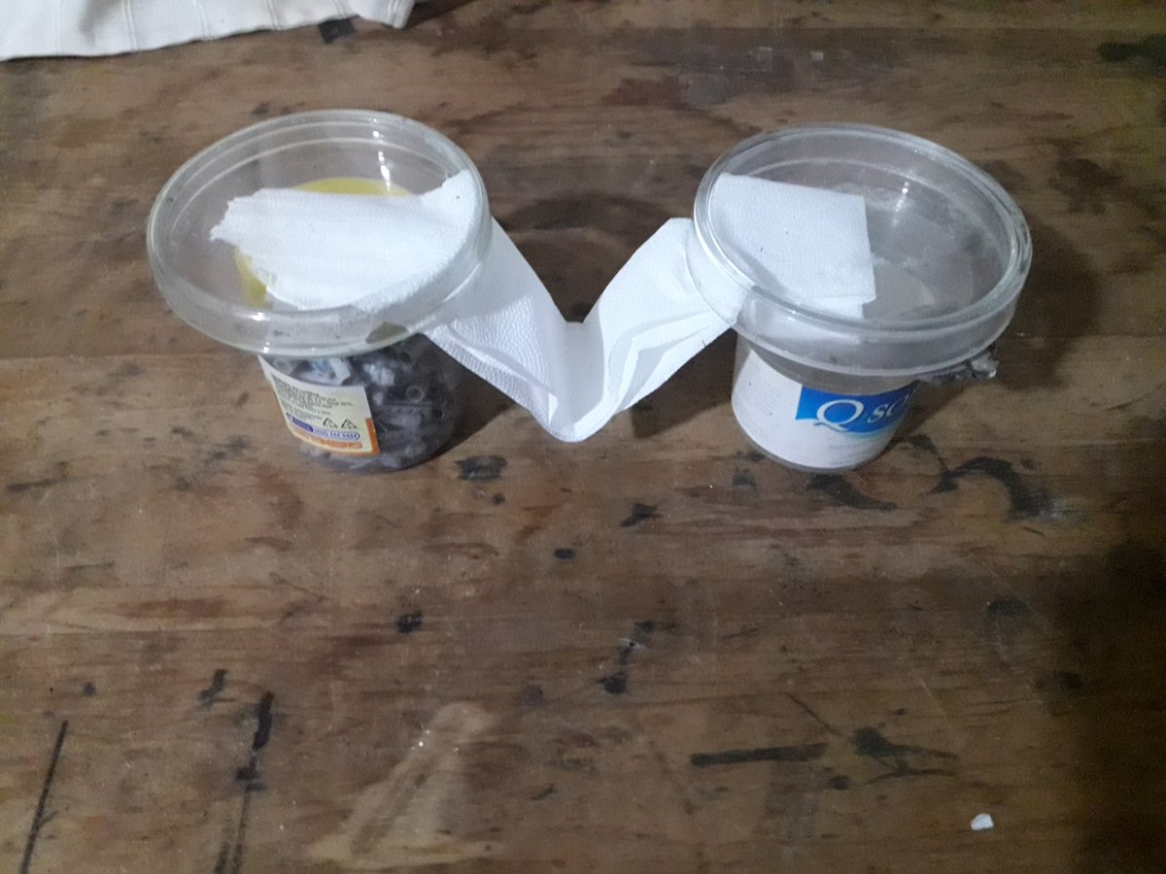
Figure 1. Initial reactor design (April 28, 2026).
V-geometry capillary bridge between two containers using fricelina (cosmetic cellulose) substrate. Validated symmetric capillary flow and stable interface formation used in subsequent experiments.

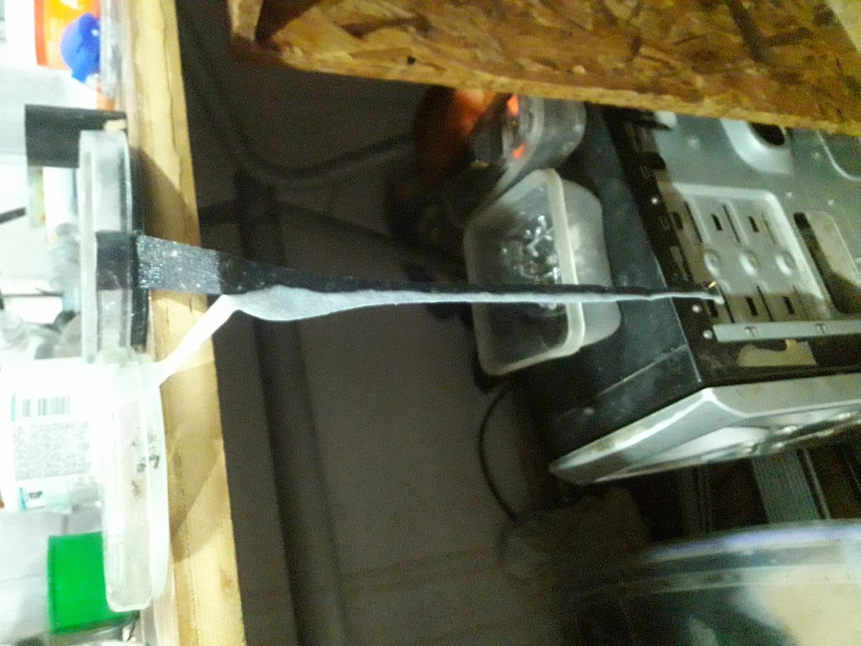
Figure 2. Vertical gravity-drain reactor with interface line (April 30, 2026, 03:12 hrs).
Fricelina bridge hanging vertically between upper Petri dishes and lower collection vessel. Sharp dark interface line visible at contact zone between alkaline (quebracho ash extract, pH 9.0–9.3) and acid (citric acid, pH 3.0–4.5) solutions under ambient light.

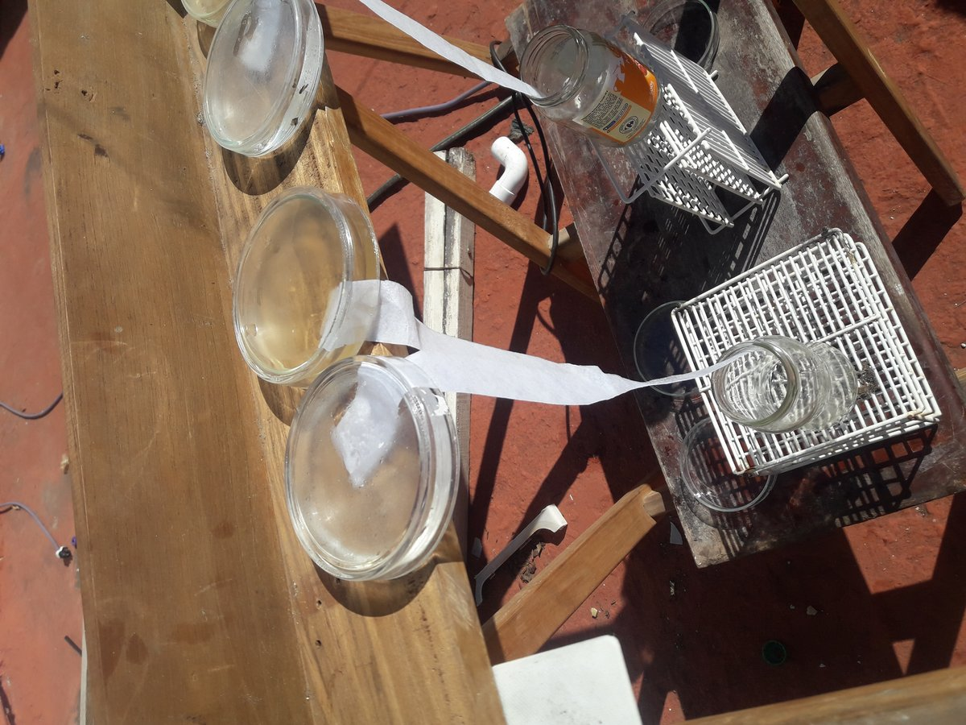
Figure 3. Rooftop reactor battery under direct solar UV — Córdoba, Argentina (April 30, 2026, 14:15 hrs).
Three parallel Petri dish reactors under direct noon solar exposure. Cloud cover <25%. Temperature 22–24°C. Gravity-drain collection vessels below. This is the primary solar exposure configuration of Experiment 1.

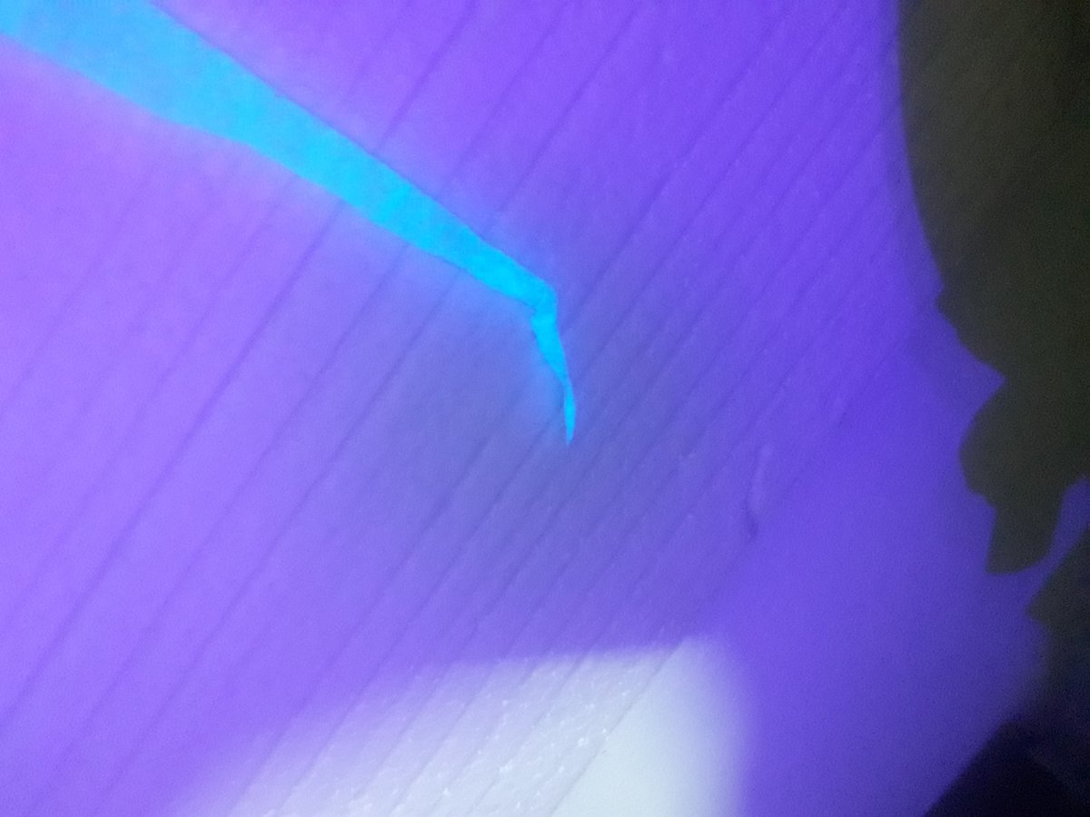
Figure 4. Interface zone fluorescence under 395nm UV (May 1, 2026, 23:00 hrs).
Intense cyan fluorescence localized at the acid-alkaline contact zone of the fricelina bridge. Not observed in control areas away from the interface. Primary fluorescence observation of Experiment 1, consistent with nitrogenous organic compounds at the interface zone.

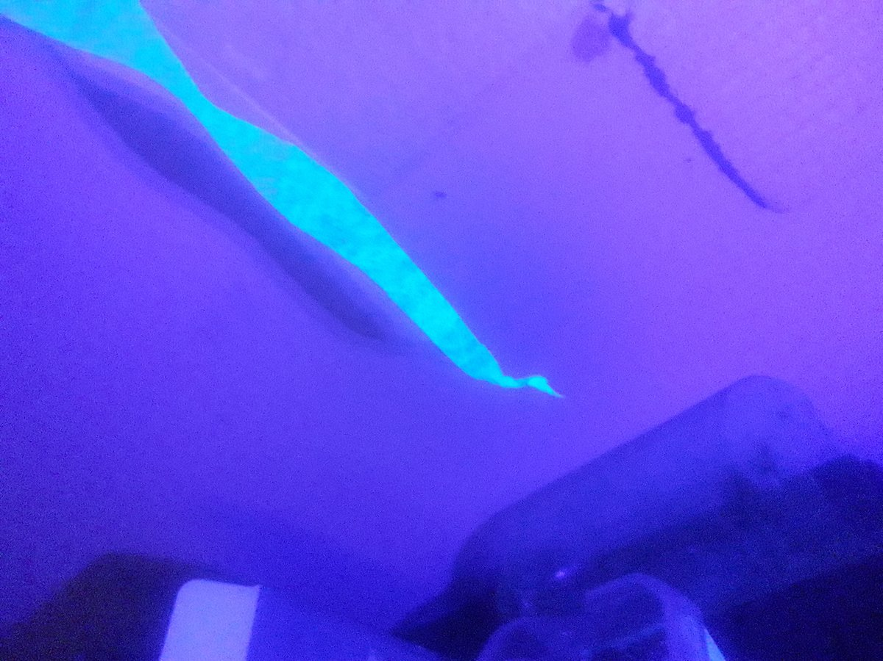
Figure 5. Multiple reactor bridges under 395nm UV (May 1, 2026, 23:04 hrs).
Three parallel fricelina bridges showing differential cyan fluorescence intensity at interface zones. Variation between bridges reflects different flow rates and interface conditions in the parallel reactor design.

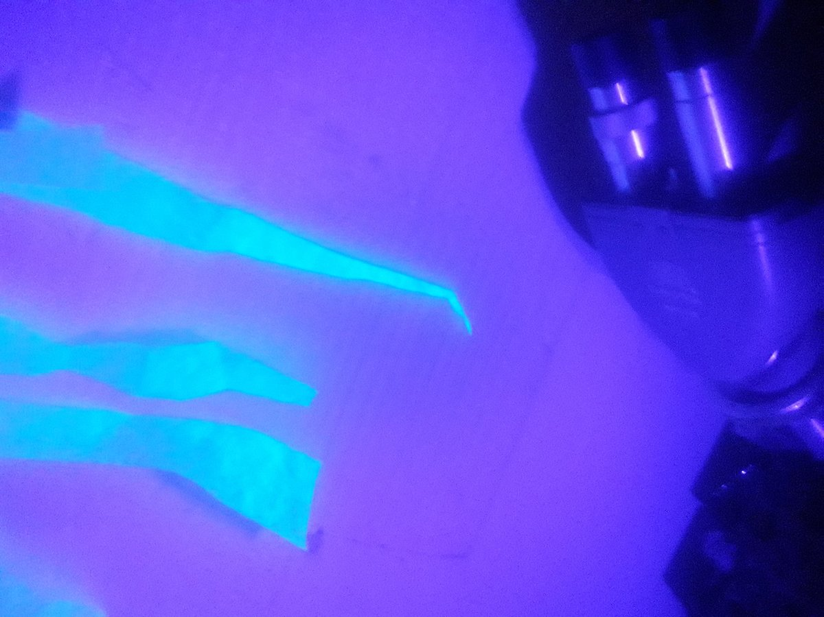
Figure 6. Interface fluorescence — lateral view (May 1, 2026, 23:04 hrs).
Lateral view of cyan fluorescence at the capillary interface under 395nm UV. Fluorescence is sharply localized at the contact zone, not diffuse across the substrate, indicating chemical specificity of the emitting material to the interface conditions.

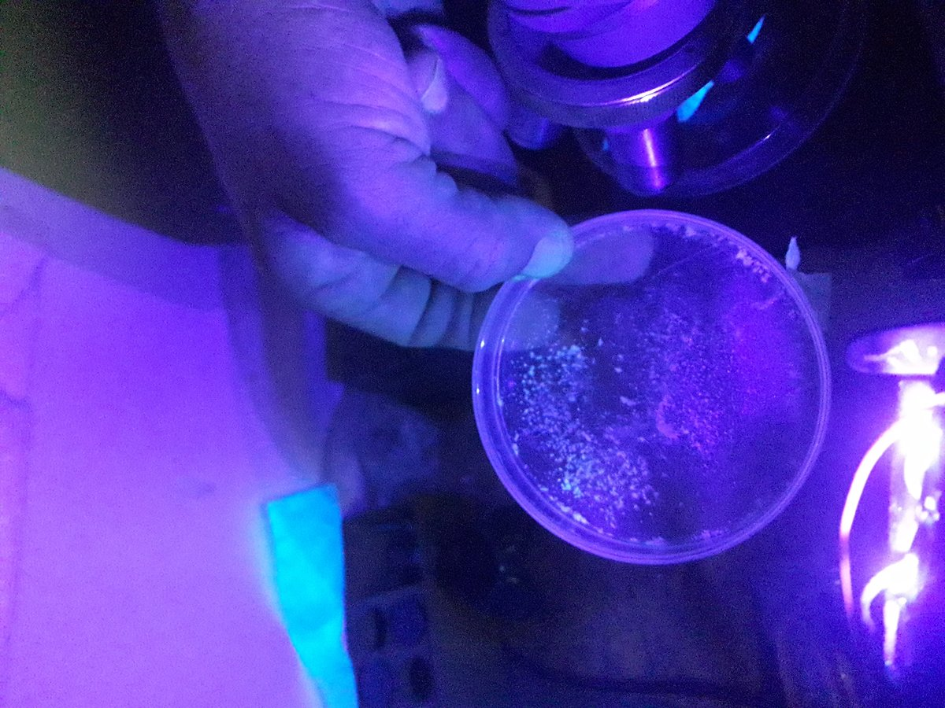
Figure 7. Evaporated interface deposit — violet-pink fluorescence (May 3, 2026, 02:00 hrs).
Evaporated deposit from interface Petri dish showing violet-pink fluorescence under 395nm UV, distinct from the cyan emission of the wet bridge interface (Figures 4–6). Two emission colors suggest different chemical species at different stages of concentration. White particulate material in upper field shows a third emission profile.

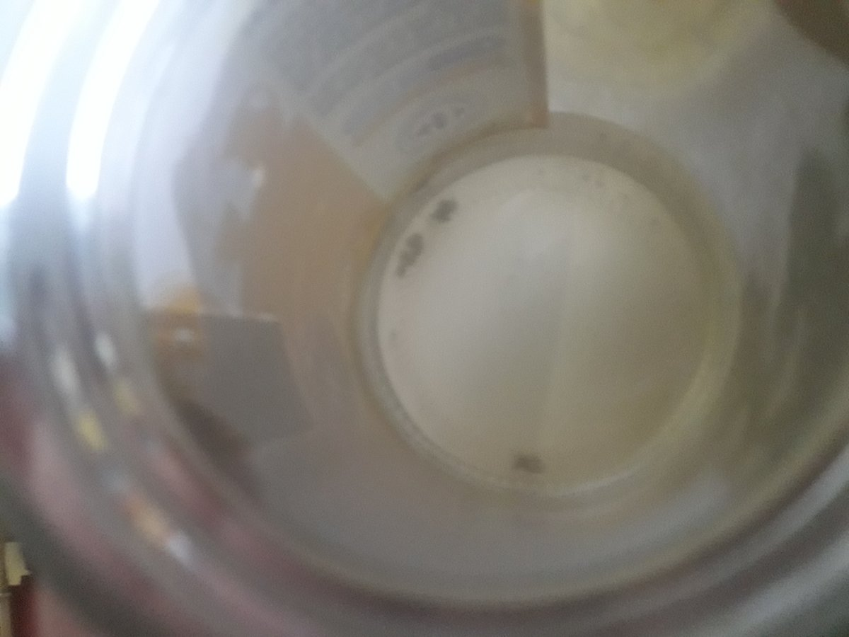
Figure 8. Interface reactor deposit — ambient light (May 3, 2026, 03:38 hrs).
Collection vessel showing yellowish liquid with dark particulate material at base. First appearance of visible dark particulate growth preferentially at the interface zone, subsequently identified as cyanobacteria consistent with ambient airborne contamination.

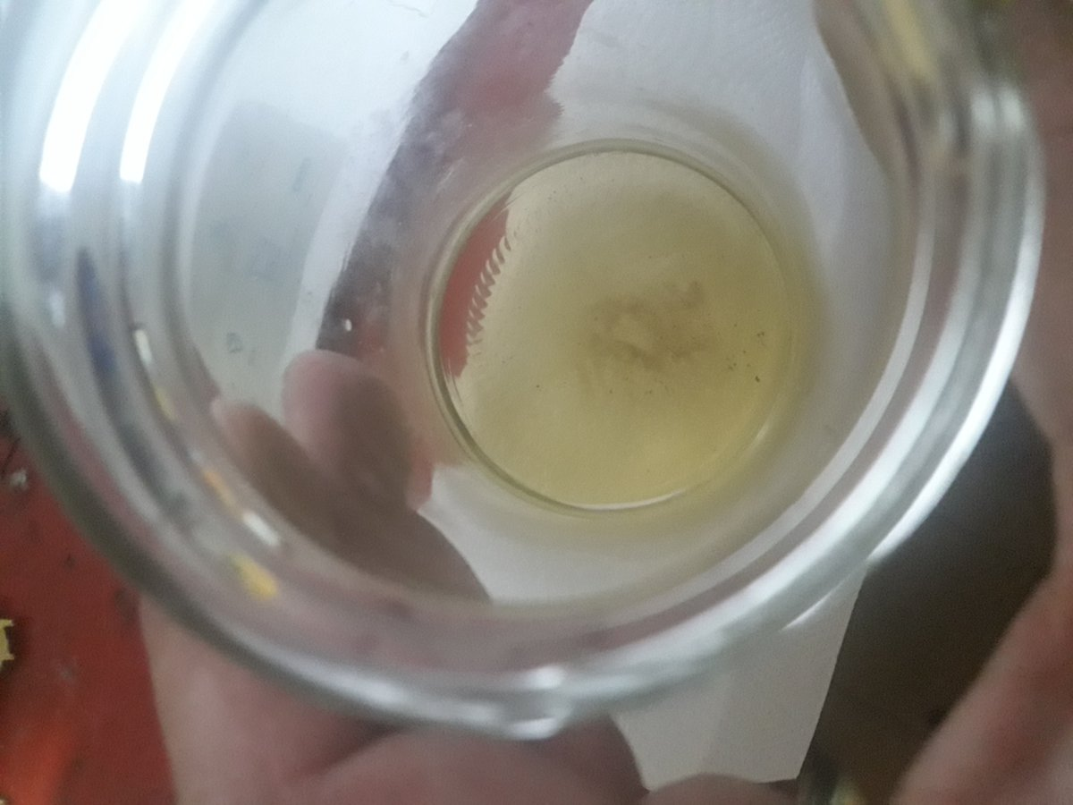
Figure 9. Alkaline-side control vessel — ambient light (May 3, 2026, 03:38 hrs).
Alkaline control vessel (quebracho ash extract side, pH 9.0–9.3) showing yellow-green liquid with minor dark particulate. The alkaline-only control showed significantly less particulate development compared to the interface zone, consistent with preferential biological colonization of the pH gradient interface (P16).

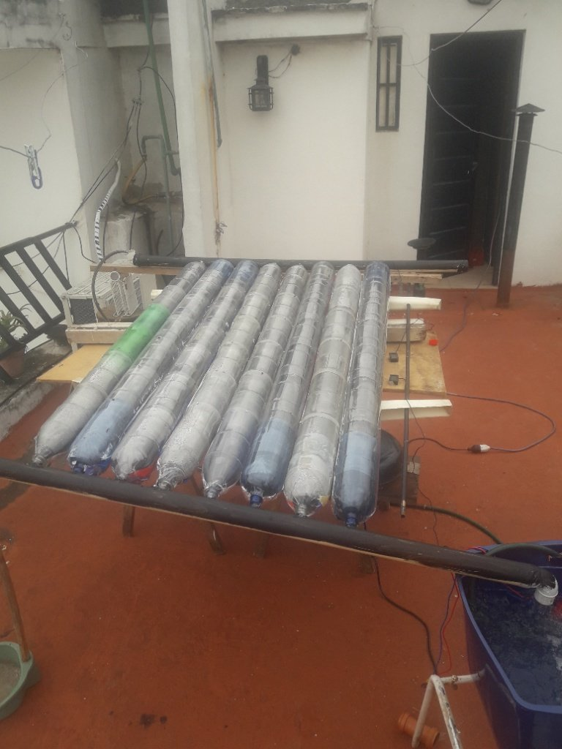
Figure 10. RTU solar collector — natural control (same rooftop environment).
17-liter solar collector containing water at pH 5–6, stagnant for 15 days under identical rooftop UV and temperature conditions. Zero biological growth observed. This natural control establishes that pH-homogeneous environment does not support colonization under the same conditions that produced cyanobacterial growth at the pH-gradient interface in 8 hours (P16, confirmed).

Acknowledgements
The author thanks the Hijos del Sol y la Basura Research Initiative for support and sustained discussion throughout the development of this model. No institutional funding was received. The author declares no conflicts of interest. The author explicitly invites attempts to falsify the sixteen predictions presented in this paper. The version history (V1–V4 published; V5 unpublished; V6 first publication) is publicly archived at Zenodo with independent DOIs.
The pilot experiment was conducted on a rooftop in central Córdoba, Argentina, using quebracho ash, citric acid, cosmetic cellulose, and carbonated water. The UV detection was performed with a banknote verification lamp. Every limitation documented in Section 11.5 is a specific, addressable requirement for Experiment 2. The science is being done with what is available, transparently, in real time.

Methodological Note
Independent research conducted without institutional affiliation, laboratory access, or funding introduces constraints that must be stated explicitly for proper evaluation of results. The pilot experiment was: conducted in an open-air rooftop environment without sterility controls; observed with a banknote verification UV lamp (395nm) rather than a calibrated spectrofluorometer; photographed with a consumer smartphone camera; and analyzed without spectroscopic instrumentation (the available Corning 256 colorimeter required lamp replacement during the experiment).
These constraints do not invalidate the observations. They define the precision of the current data and the specific instrumental requirements for Experiment 2. The differential fluorescence was observed and photographed. The natural control comparison is valid. P16 is confirmed within the limits of the experimental design.
All experimental photographs are available in the Zenodo repository associated with this version. The real-time experimental log is preserved and available upon request.

References
Conway Morris, S. (2006). Darwin's dilemma: the realities of the Cambrian 'explosion'. Philosophical Transactions of the Royal Society B, 361(1470), 1069–1083.
COSMIC (2024). Catalogue of Somatic Mutations in Cancer — Mutational Signatures SBS7a/7b. Wellcome Sanger Institute. cancer.sanger.ac.uk/cosmic.
De Gruijl, F.R. & van der Leun, J.C. (1994). Estimate of the wavelength dependency of ultraviolet carcinogenesis in humans and its relevance to the risk assessment of a stratospheric ozone depletion. Health Physics, 67(4), 319–325.
Furin, C.A. et al. (2020). The Carnian Pluvial Episode: A review of its definition, causes, and significance. Earth-Science Reviews, 208, 103279.
Green, M.M., Park, J.W., Sato, T., Teramoto, A., Lifson, S., Selinger, R.L.B., Selinger, J.V. (1999). The macromolecular route to chiral amplification. Angewandte Chemie International Edition, 38(21), 3138–3154.
Herrero, H.D. (2026). Dissipative Social Systems and Dissipative Economics: A Thermodynamic Framework for the Analysis, Stabilization and Intervention in Complex Social Systems. Zenodo preprint. Hijos del Sol y la Basura Research Initiative, Córdoba.
Irmis, R.B. et al. (2013). Early dinosaur biogeography and the establishment of a Late Triassic fauna. Annual Review of Earth and Planetary Sciences, 41, 359–384.
Koga, Y. (2012). Thermal adaptation of the archaeal and bacterial lipid membranes. Archaea, 2012, 789652.
Middleton, C.T., de La Harpe, K., Su, C., Law, Y.K., Crespo-Hernández, C.E., Kohler, B. (2009). DNA excited-state dynamics: from single bases to the double helix. Annual Review of Physical Chemistry, 60, 217–239.
Miller, S.L., Urey, H.C. (1953). Organic compound synthesis on the primitive earth. Science, 117(3046), 528–529.
Montagnier, L., Aïssa, J., Ferris, S., Montagnier, J.L., Lavallee, C. (2009). Electromagnetic signals are produced by aqueous nanostructures derived from bacterial DNA sequences. Interdisciplinary Sciences: Computational Life Sciences, 1(2), 81–90.
Montagnier, L., Aïssa, J., Lavallee, C., Del Giudice, E., Vitiello, G. (2015). Transduction of DNA information through water and electromagnetic waves. Electromagnetic Biology and Medicine, 34(2), 106–112.
Orgel, L.E. (2004). Prebiotic chemistry and the origin of the RNA world. Critical Reviews in Biochemistry and Molecular Biology, 39(2), 99–123.
Palmans, A.R.A., Meijer, E.W. (2007). Amplification of chirality in dynamic supramolecular aggregates. Angewandte Chemie International Edition, 46(47), 8948–8968.
Pietruszka, M., Olszewska, M., Machnicka, A. (2024). Ultra-weak photon emission from DNA. Scientific Reports, 14, 28847.
Popp, F.A. (1992). Some essential questions of biophoton research and probable answers. In F.A. Popp, K.H. Li, Q. Gu (Eds.), Recent Advances in Biophoton Research and its Applications. World Scientific, Singapore.
Popper, K.R. (1959). The Logic of Scientific Discovery. Hutchinson, London.
Setlow, R.B. (1974). The wavelengths in sunlight effective in producing skin cancer: a theoretical analysis. Proceedings of the National Academy of Sciences, 71(9), 3363–3366.
Wang, Y., et al. (2022). Fingerprinting Brownian Motions of Polymers under Flow. Physical Review Letters, 129, 057801. DOI: 10.1103/physrevlett.129.057801. DOE Office of Science Early Career Research Program, Center for Nanophase Materials Sciences, Oak Ridge National Laboratory.
Šponer, J., Riley, K.E., Hobza, P. (2006). Nature and magnitude of aromatic stacking of nucleic acid bases. Physical Chemistry Chemical Physics, 10(19), 2595–2610.

Hernán Diego Herrero
Hijos del Sol y la Basura Research Initiative · Córdoba, Argentina · May 2026
hdbasura25-oss.github.io/Hijosdelabasura · CC BY-SA 4.0

