Habtamu Debele

ITEC 225

Prof. Freeman Lo

February 26, 2020

Homework 4

Developing HTML styled Resume of myself.

1. HTML Validation for form using <https://validator.w3.org/nu/>

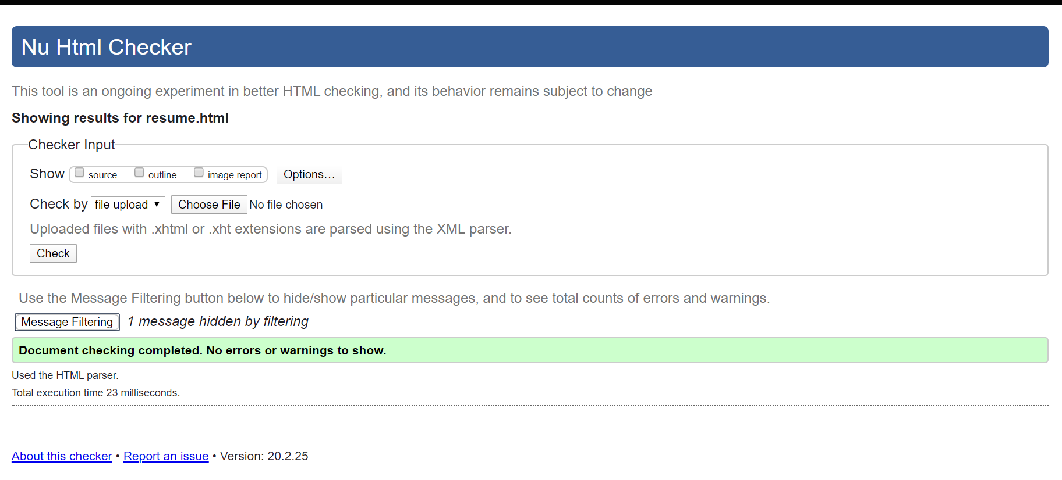

2. CSS Validation using <https://jigsaw.w3.org/css-validator/>

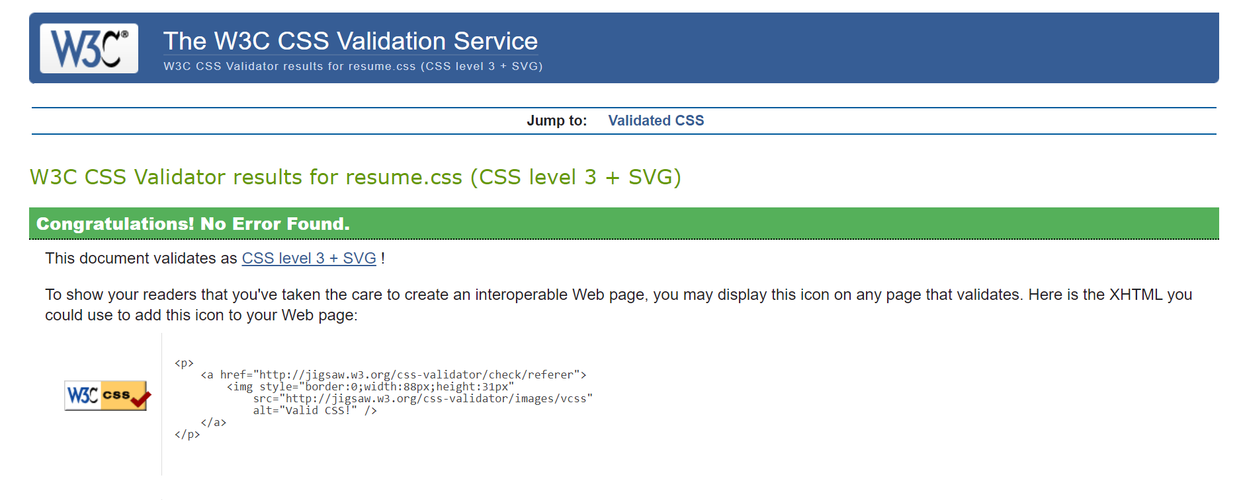

1. Form HTML source code

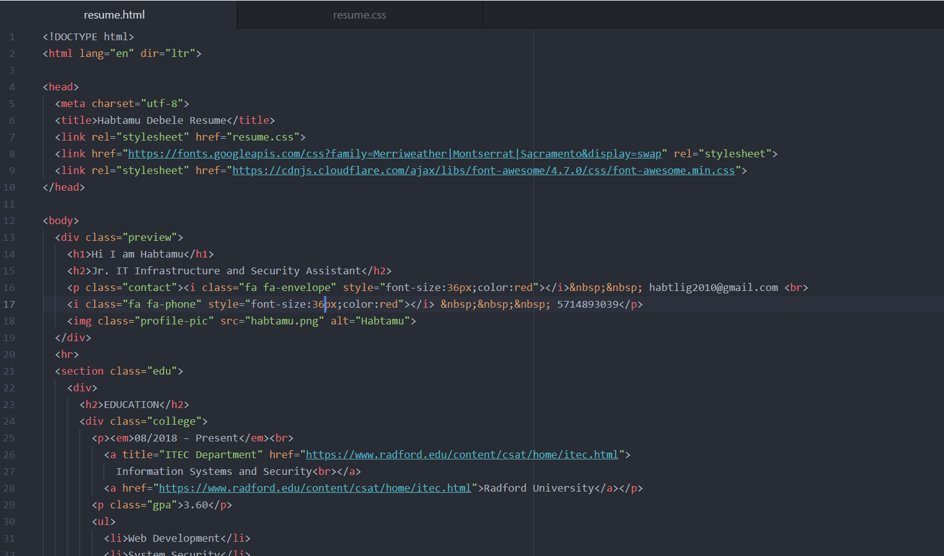

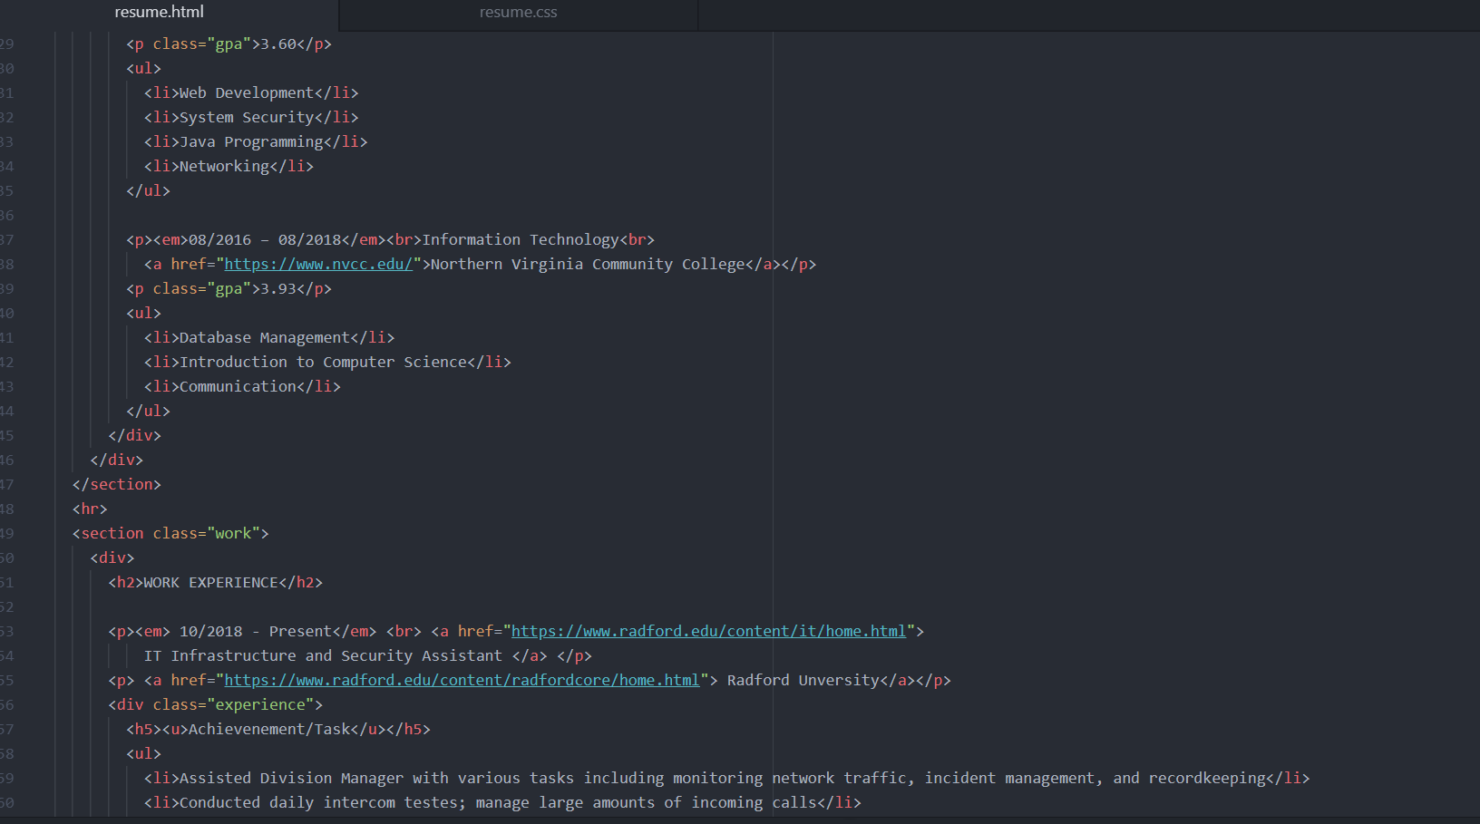

1. Resume.css a CSS stylesheet that is included in the same folder

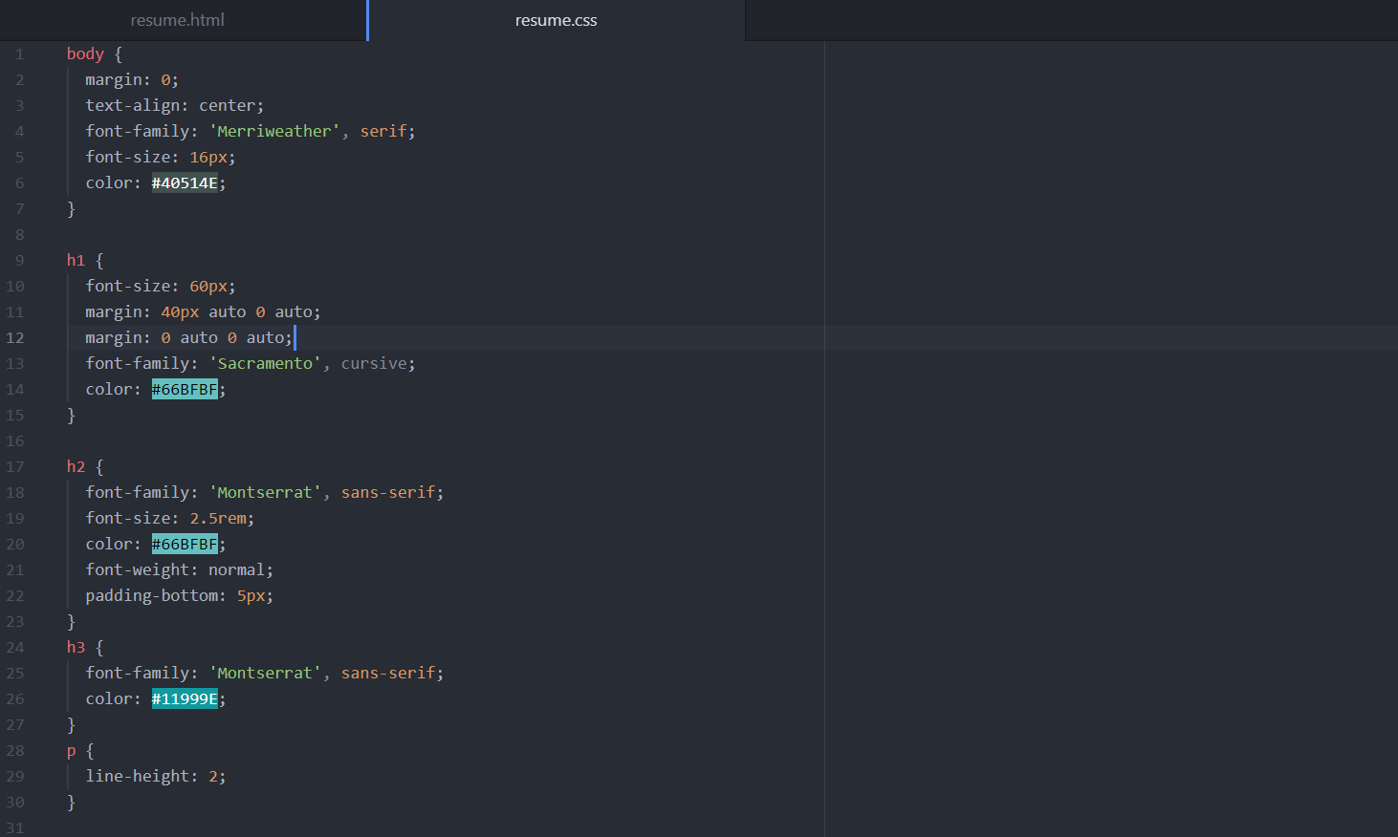

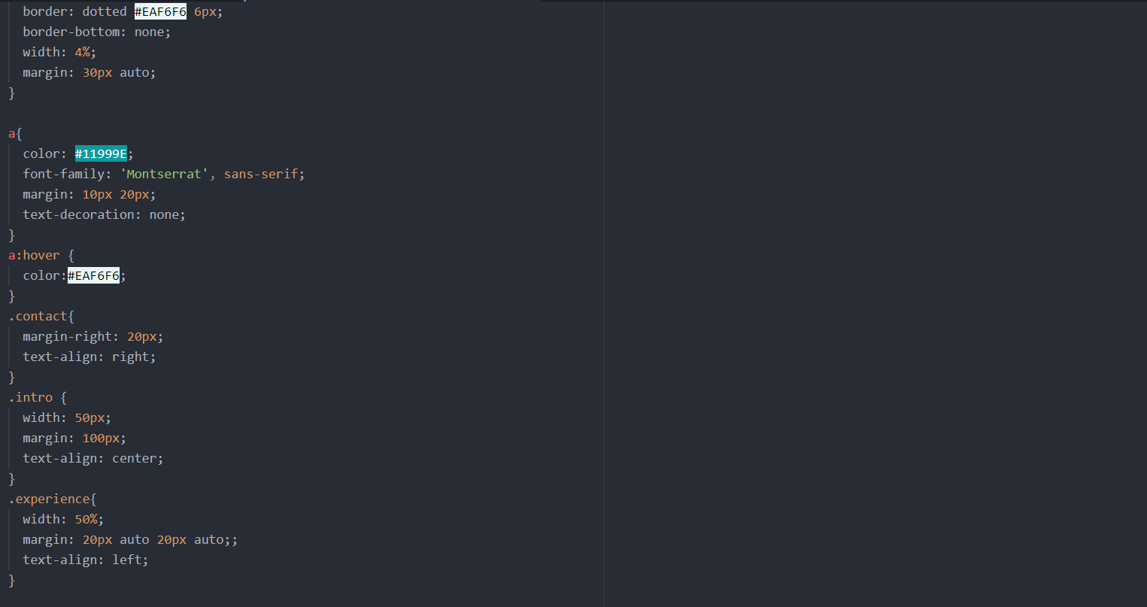

1. Resume.html example displayed on google chrome browser



1. HTML <a> tag used with **title** **attribute**

