Andy M | WebTools User Manual Rev. 1.6 | September 1, 2016

WebTools
v2.4 Release
  - User Manual


Contents
Contents 1
1. Getting Started 1
2. Choose Module Menu 1
3. Options Menu 1
4. Help Menu 1
5. Subtitle Management 1
6. Log Viewer 1
7. Unsupported AppStore 1
7a. The Buttons 1
7b. The Channel/App list box 1
8. Find Media 1
9. Customizing Themes 1
Credits 1

Preface
Welcome to the WebTools User Manual. This manual aims to inform and guide you through the many features of the WebTools Channel/App for Plex Media Server.
WebTools is a graphical user interface that allows you to keep track of subtitle files associated with your Home Movies, Movies and TV Shows in your Plex Media Server libraries. It also allows you to view your Plex Media Server log files easily and download and prepare them for submission in the Plex forums when you are diagnosing those rare issues with the wonderful Plex Media Server.
You will also find a comprehensive tool, the Unsupported AppStore that allows you to add, remove and update third party Channels/Apps that are produced by many talented authors, to your Plex Media Server for one of the best media experiences you will find anywhere.

1. Getting Started
You will find easy WebTools installers for Windows and QNAP, Synology or Asustor NAS units at the following address:
https://github.com/ukdtom/WTInstaller/releases/tag/1.2
After completing the installation of WebTools you will need to open the interface by typing the following into your browser address bar:
http://your-device-IP-Address:33400 or https://your-device-IP-Address:33443
Note: WebTools will be displayed under Channels on the home page in the Plex/Web interface and you may click on the icon shown there and the address to use will be shown, but due to a limitation of the Plex Programming API, a true link cannot be provided there.
After pressing enter, your browser will open the login page where you can then enter your Plex Account details.
After clicking Sign In, you should now be presented with the WebTools Main page.
You will find the following on the Main Page:
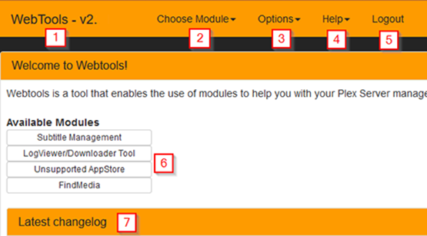
1. On the Main Menu Bar you will find the WebTools title and version number. If you click on the WebTools title from any page, you will always be returned to the main page shown in the image above.
2. The Choose Module menu allows you to choose one of the available modules to use. This is available from any page and is a convenient way of accessing the various modules without needing to return to the main page. You are also able to reload the current module in order to refresh the modules output.
3. The options menu provides options for you to choose from. See 3. Options Menu.
4. The help menu will help when you have a question or if you encounter an issue of some kind.
5. When you click on the logout button you will be signed out of WebTools and you will be returned to the login page.
6. When you click on one of the Available Module buttons, you will be taken to the appropriate module operations page.
7. Shows the latest changes made to WebTools. For a more comprehensive changelog, see the Options Menu.

2. Choose Module Menu

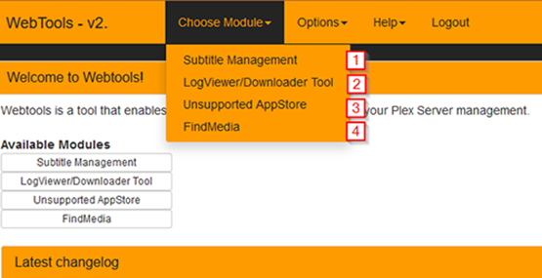

1. Subtitle Management. Selecting this item will take you to the subtitle management page and allow you to manage all of the available subtitles you may have.
2. Log Viewer/Downloader Tool. Selecting this item will take you to the Log Viewer page where you are able to view any of the Plex logs and it will also allow you to download your Plex logs for inclusion in error or bug reports.
3. The Unsupported AppStore. Selecting this item will take you to the Unsupported AppStore page where you will be able to install/uninstall and manage all of your third party plug-ins.
4. Find Missing. Selecting this item will take you to the Find Missing where you will be able to check all of your Plex libraries for missing files or files that exist within your media folders but are not found in your Plex library.

3. Options Menu

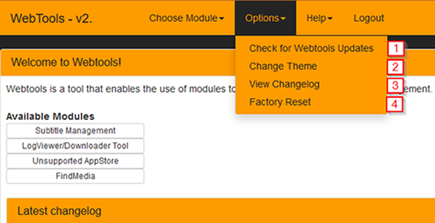

1. Check for WebTools Updates. This item allows you to check for any WebTools updates and it will allow you to update WebTools automatically.
2. Change Theme. This item allows to select one of the custom color themes that are available for you to use. If you wish to customize a theme, then see 9. Customising Themes.
3. View Changelog. This item will display a comprehensive log of changes made to WebTools from its inception until the current release.
4. Factory Reset. This item will reset WebTools to the ‘out of the box’ state and allow you to start over.
5. Not Shown. When you have selected a Module to use, if you then check the options menu you will find a new entry called preferences. This will then take you to the preferences page for the module you have selected.

4. Help Menu

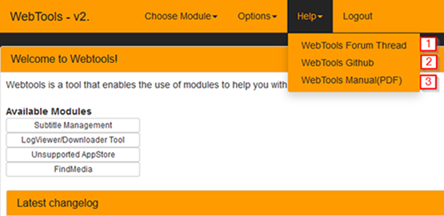

1. WebTools Forum Thread. This item will take you to the [REL] WebTools 2.x forum page where you can ask questions, request new features and report issues with WebTools.
2. WebTools Github. This item will take you to the Github developer’s page. You are able to manually download Webtools from this page or if you are a developer, you may ‘fork’ the WebTools project to your own Github page and develop WebTools on your own.
You will also find a useful link to the WebTools Wiki page where you will find a lot of information pertaining toWebTools.
3. WebTools Manual(PDF). This item will download the current WebTools Manual (the one you are reading right now) in PDF file format. You can then pass it along to friends and family to help them get started with Plex and WebTools.

5. Subtitle Management
When entering the Subtitle Management page you will be presented with a welcome message and an instruction to help get you started.
You will notice the Menu bar now also has a Subtitle Management drop down menu which will allow you to refresh the Subtitle Management page or switch to another module.
Beside the Subtitle Management link is the Libraries menu where you can select the library you wish to view. Under Options, you will also find a Preferences menu item that will open the preferences page for Subtitle Management, as shown below.

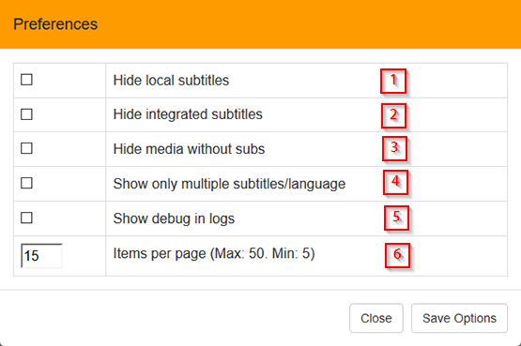

1. This option will hide any local subtitle files from the list.
2. This will hide any integrated subtitles from the list.
3. This will hide all files that do not have any subtitles associated with them.
4. This will show only files with multiple subtitles and languages in the list.
5. This will include debug information in the WebTools logs.
6. This allows for the number of items to be displayed on the page.

After selecting a library to view you will be presented with a list of your files and the subtitles associated with each of your files.
You will also be able to search your files by name by entering your search terms into the search box provided at the top of the page. The current library name is listed above the search box.
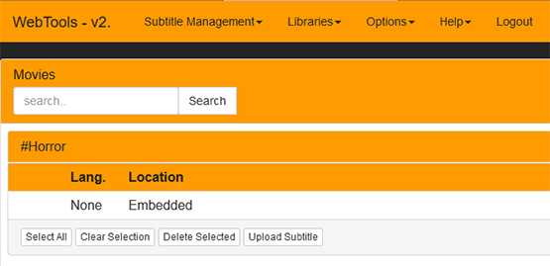
The following columns will also be shown for each item in the list that contains a subtitle.
Lang. - the language of the subtitle will be shown, if it is known.
Location - This describes where the subtitle will be found. Sidecar means it is an external file. Embedded means the subtitle file is a part of the video file itself. Subtitles that are ‘burned’ into the video stream cannot be displayed.
Codec - this describes the format that the subtitle uses.
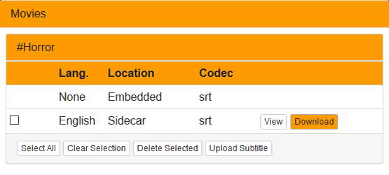

1. Select all will checkmark all external subtitles listed under the file name.
2. Clear selection will clear all check marked subtitles under the file name.
3. Delete selected will delete all subtitles that have been check marked.
4. Upload Subtitle will allow you to upload a subtitle file to your Plex media folder for inclusion in your Plex library.
Note: You should ensure that the subtitle file is correctly named (exactly like your video file name) and is in a supported format before you upload it to your Plex folder.
If you fail to do that, then Plex may not be able to recognize the file correctly and you may have issues locating the subtitle to use in Plex.
If in doubt or if you spot an issue with the file you just uploaded, you may delete it by selecting the file in the list and then clicking on the Delete Selected button.
5. View will open and display the contents of the subtitle file where possible. This button will not be visible if the subtitle file is embedded or the subtitle is in a graphical format.
6. The download button will appear when you have an external subtitle file that you have uploaded or one that has been added by a Plex agent. This will allow you to download the subtitle file to your local file system.
Note: At the bottom of the page there will be a popup selector that will allow you to select the files to display alphabetically, allowing you to navigate long lists of files quickly and easily.
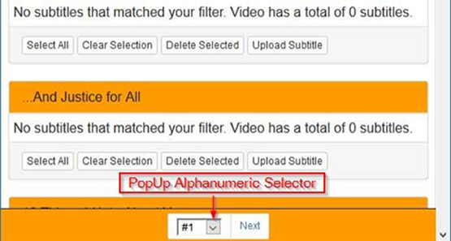

6. Log Viewer
When entering the Log Viewer/Downloader Tool page you will be presented with the contents of the default Plex log file.
The default log file will normally be the Plex Media Server.log as it contains the most relevant information pertaining to the general operation of Plex Media Server.
At the top of the page you will see a drop down menu and by clicking on the down arrow box you will see a list of all available log files for your Plex Media Server.
Besides the drop down menu you will see two links, the first link, 'Download selected log file', will download the log file that is currently displayed in your window.
The second link, 'Download all as zip', will archive (.zip) and then download ALL of the Plex log files. This is particularly useful if you are asked for log files by a Plex employee or Plex Ninja in the support forums.
Note: You should send this file or a link to this file in a private message to the person requesting your logs as your logs do contain information, such as Public IP addresses, which should be kept private.
At the bottom of the Log Viewer window you will also notice a very useful search box and associated buttons that allows you to quickly search for and view keywords in the log file you are currently viewing.
There is also a 'Jump To Top' button that will quickly take you back to the first line in the log file you are currently viewing.

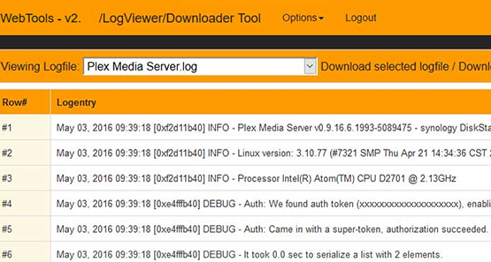

7. Unsupported AppStore
When entering the Unsupported AppStore you are presented with a welcome message at the top of the page. You should read that message carefully as it contains important information about how to use the UAS.
Just below the welcome message you will find the manual app installer. By entering the GitHub address of a Plex Channel/App into the address bar and then clicking on install, you can add any Plex Channel you wish.
The Main Menu Bar will now show Unsupported AppStore and clicking on that link will allow you to reload the Unsupported AppStore or to change the module you wish to work with.
You may also notice a preferences option in the Options menu

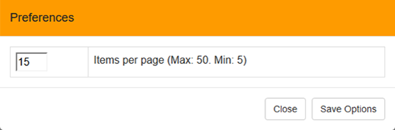

1. This will allow you to select the number of items to be displayed on the page at the same time.

7a. The Buttons
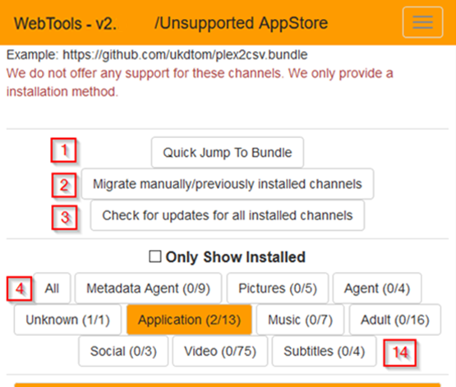

1. Quick Jump to Bundle
2. Migrate Manually/previously installed Channels
3. Check for updates for all installed channels
Only Show Installed checkbox
4. All
5. Metadata Agent
6. Pictures
7. Agent
8. Unknown
9. Application
10. Music
11. Adult
12. Social
13. Video
14. Subtitles
1. When clicking on the ‘Quick Jump to Bundle’ button will present a dialogue containing a drop down menu. From the menu you may select any of the listed Channels/Apps and WebTools will quickly take you directly to that Channels/Apps Details box.
2. When clicking on the ‘Migrate Manually/previously installed Channels' button will open a small dialog detailing any Channels/Apps that were installed before you installed WebTools. Those Channels/Apps will now be displayed on the UAS page as a part of WebTools.
3. Clicking on the 'Check for updates for all installed channels' button will open a dialog that searches for updates to all known Channels/Apps and 3rd party apps in the UAS. From there you can update individual Channels/Apps or update them all at once.
- By selecting the 'Only Show Installed' Checkbox, only those Channels/Apps that are installed in your Plex Media Server will be shown.
4. The 'All' button will display all Channels/Apps in a continuous list based on the number of Channels/Apps you have set in the preferences to be listed on each page. You will also find a page selector at the bottom of the page consisting of a number of numbered buttons with each button representing a page of Channels/Apps.
5 to 14. The remaining buttons will display only the Channels/Apps associated with the title or category of the button.

7b. The Channel/App list box
Each Channel/App is listed by name in a lined display box which consists of the following lines:
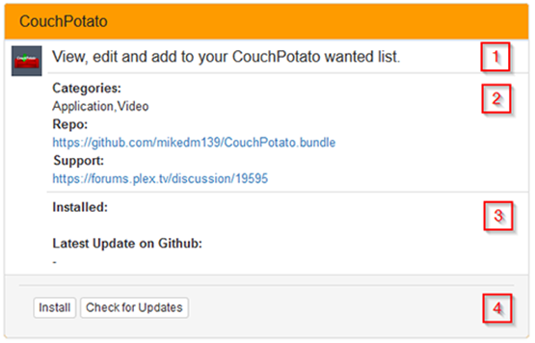
1. The first line lists a general description of the Channel/App.
2. The second line displays the Category of the Channel/App, the GitHub address for the Channel/App and a support link when it is supplied.
3. The installed date, and the latest available package date.
4. An Install button, Check for Updates button or when the Channel/App is already installed, a Re-install with latest available button, Check For updates button and Uninstall Bundle button. The function of each of these buttons should be self-explanatory.
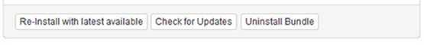

8. Find Media

When you enter the Find Media function you will be greeted to a list of your Plex libraries as shown in the image below.
This can be a very useful tool as it will show you any files that are present on your hard drives and not present in your Plex library for one reason or another.
Quite often you will find that file permissions are responsible for the files to go missing from Plex. Depending on your OS, you should rewrite your media file permissions, preferably using the recursive function.
Linux users (including NAS owners) may consult this guide: https://support.plex.tv/hc/en-us/articles/200288596-Linux-Permissions-Guide
The next main issue you may face is file naming. The issues here may include misspelled file names or extensions, or foreign (Unicode) characters in the name, spaces that are not truly spaces and a number of other issues like formatting.
To ensure your file names are correct and that Plex can easily add and match your files, please follow this guide: https://support.plex.tv/hc/en-us/categories/200028098-Media-Preparation
To get started, click on the library you wish to check and wait for Find Missing to scan your library and report any missing files. This should not take very long, regardless of how many files you have.
You will also find Preferences under the Options menu which will take you to the preferences page where you can change a number of items that will assist with the file searching.
You are also able to select your library or to refresh your libraries in the list by selecting the relevant item in the Libraries menu.
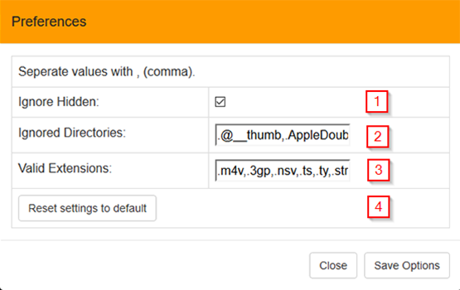

1. This checkbox allows you to ignore or hide any hidden system files from appearing in the list.
2. If you have any folders that you wish to be ignored and not included in the list, then you can add the name of the folder/s in this text box.
3. If you have any file types that you wish to include in the list, then add them here.
4. By clicking on this button you will reset all options back to their defaults.

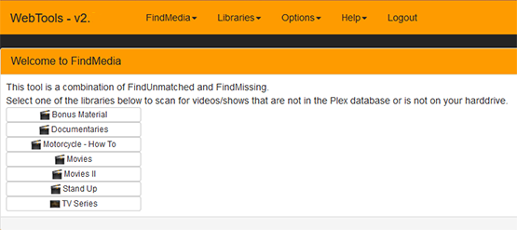
The image below demonstrates what you may see should you discover that one or more of your files are indeed missing from your Plex library. As you can see, in this case, a file has been inadvertently renamed and so Plex is unable to locate the file in question.
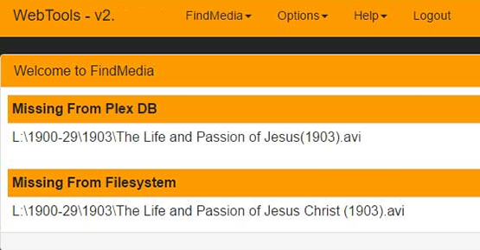
After checking your files for naming errors and file permissions you find that you are still unable to have Plex find the file/s correctly, you should ask questions in the Plex forums here: https://forums.plex.tv/
In all likelihood, the good folks on the forums will be able to help and point you in the right direction in order to solve your missing file issues.
Please try to post your questions in the appropriate forum. This is usually the forum that best matches the machine you are running Plex Media Server on.

9. Customizing Themes
If you wish to create your own custom theme you may start by copying an existing theme file in the /WebTools.bundle/http/custom_themes folder and rename the file to mycustomtheme.css or any descriptive name you desire. You must ensure that the file extension, .css remains.
Once you have done that, you may open the file in a text editor and proceed to change the color definitions for the various elements.
Note: you should be careful not to alter the format of the file in any other way. You are only allowed to edit the hexadecimal color values #242424.
Example:
.panel-default>.panel-heading {background-color: #FE9B00; color: #242424;}
The colors are defined by the hexadecimal numbers immediately following the # symbol.
In the line above, the text background color is set to #FE9B00 which is a gold color.
The text color is set to #242424 which is a very dark grey color.
By changing the number values, you are able to change the various elements to any color you desire.
Note: when editing your custom style sheet, you should refresh your browser page often, otherwise, you may not see the changes you have made to your custom style sheet/theme.
To give you some idea of the colors to use and to find their respective color number values, then visit this page: http://www.w3schools.com/colors/colors_picker.asp

Credits
Main Developers
Dagalufh (JS/HTML, Frontend)
Dane22 (Python, Backend)
Custom Themes
trumpy81
Documentation
trumpy81
Beta Testers
OttoKerner sa2000
trumpy81 Xandi92
Never Forget
The idea of an Unsupported AppStore was conceived by mikedm139, the original author of the Unsupported AppStore.
And Many Thanks To
The talented and hardworking authors/developers and staff at Plex. We are eternally grateful for your dedication and hard work.

