train station

|  |  |
| --- | --- |
| ID | Students Name |
| 2200002105 | Khaowlah Zakariya |
| 2200004362 | Fatimah ALharz |
| 2200001218 | Dema ALghamdi |
| 2200001746 | Amal ALotaibi |

Instructors :

L. Ezaz Aldahasi

TA. Fatimah Almuhammedsaleh

Academic year 1443-2022

How will the program work?

First : User enter his email and password to login or click on create account to create new account with user role:

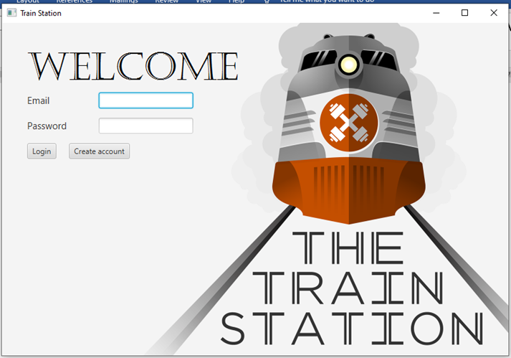

Here the user will insert an unique email and a password.

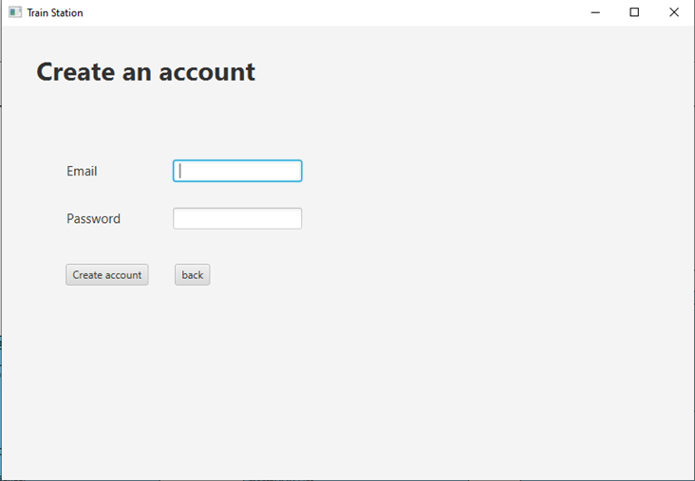

If user click on login button, then if either email or password incorrect, a message will appear

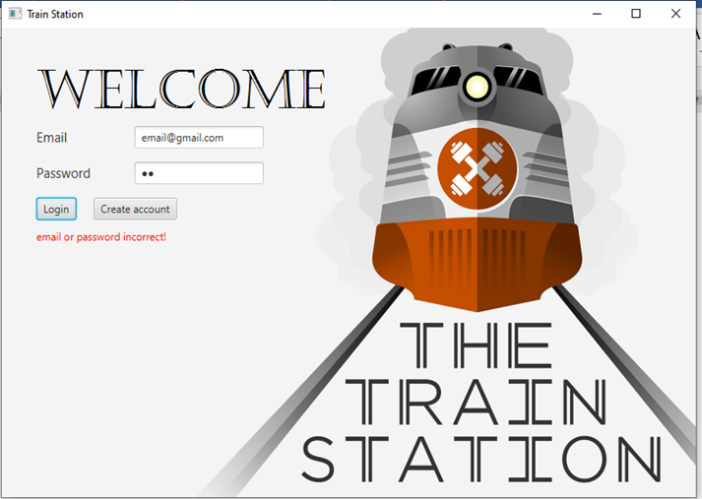

If both of email and password correct then the next interface will appear depending on user role:

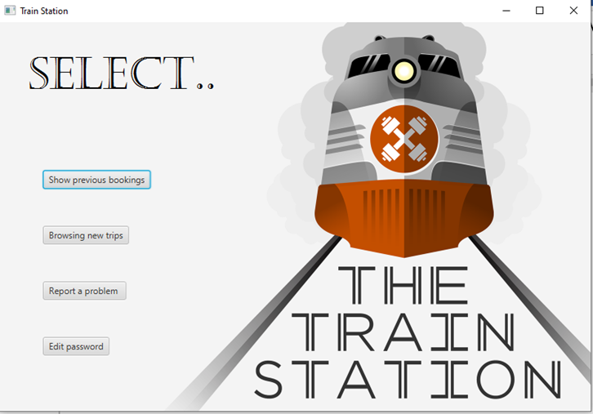

Admin role:

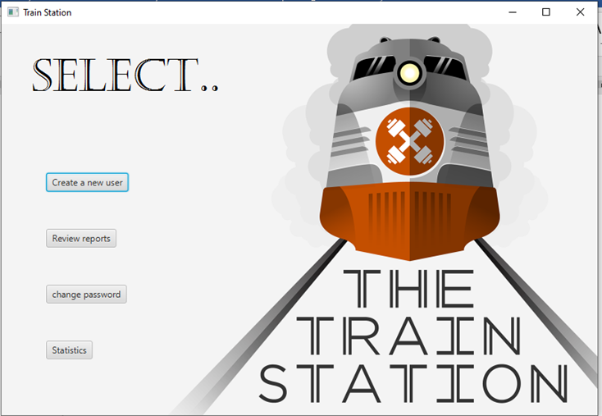

Employee role:

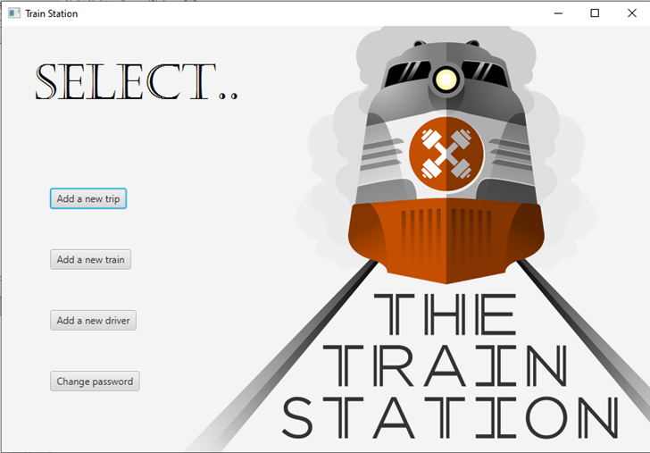

Employee interface:

If the employee click on “Add a new trip” then:



Here employee should fill fields .. when choosing classification of train then he can choose any train has same class..

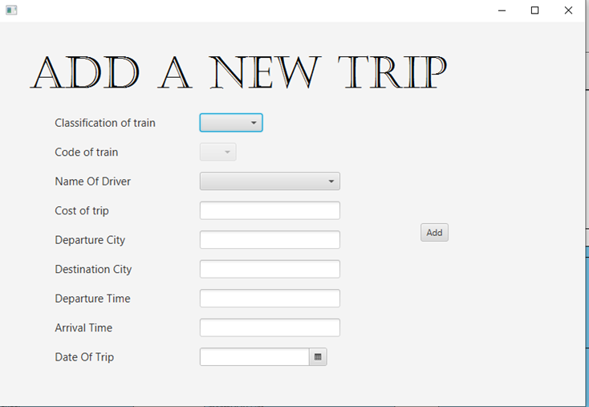

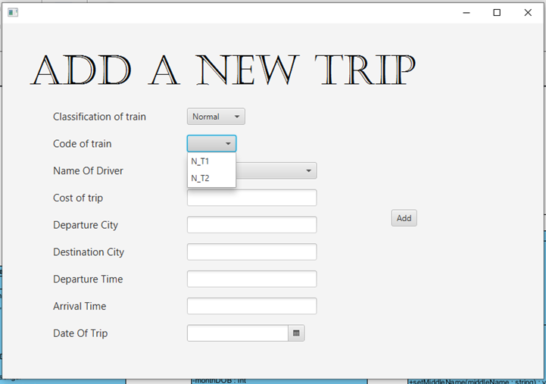

If any of fields not fill or any of box not chosen then a message will appear..

>>>>>>>>>>>>>>>>>>>>>>>>>>>>>>>>>>>>>>

In the same employee interface if employee click on add a new train:

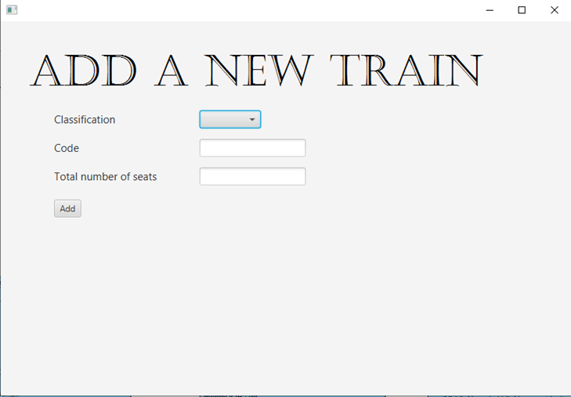

If the employee click on add a new driver:

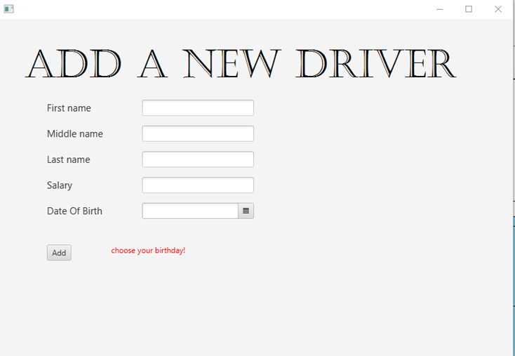

And of course employee can change his password by clicking on change password button

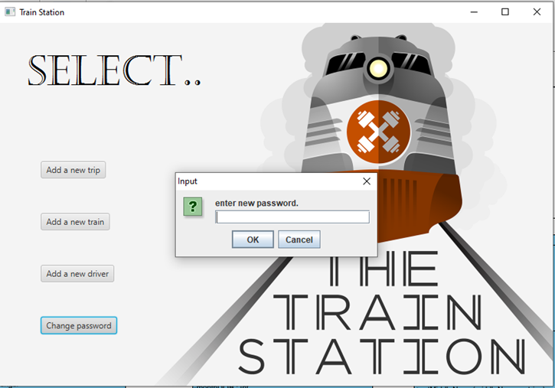

In the user interface:

Like employee can change his password

Can report any problem by clicking on “Report a problem” button:

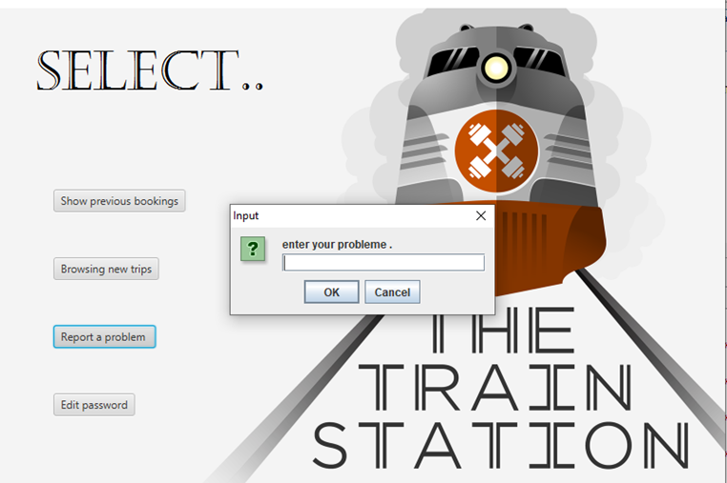

Can browsing new trips

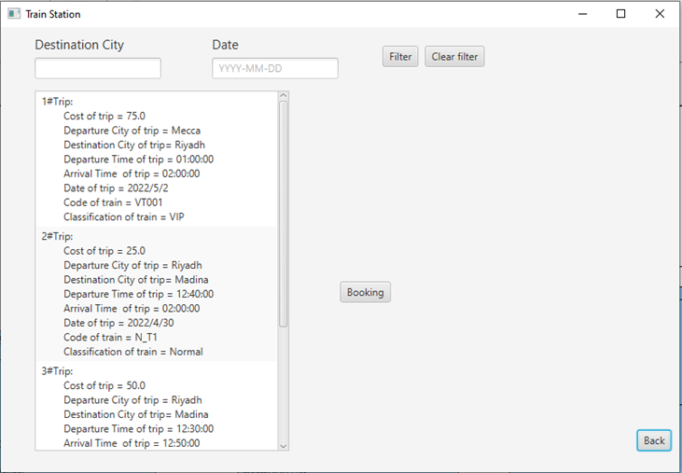

And can filter results by choosing destination city or date or both of them..

When user choose one of new trip .. he can click on booking button to book..

>>>>>>>>>>>>>>>>>

Here he should enter information of passenger and click on complete button to save booking .

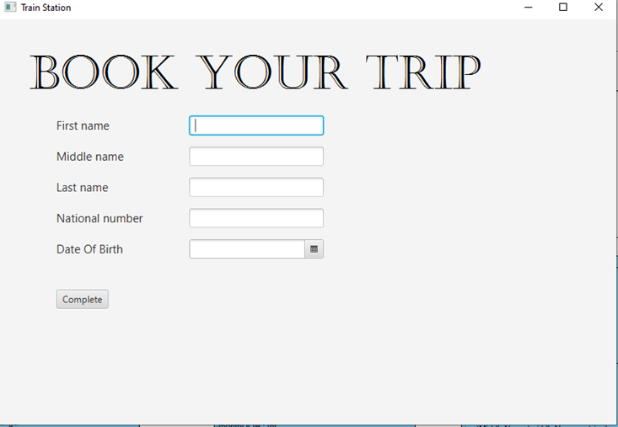

Here by clicking on “show previous bookings”

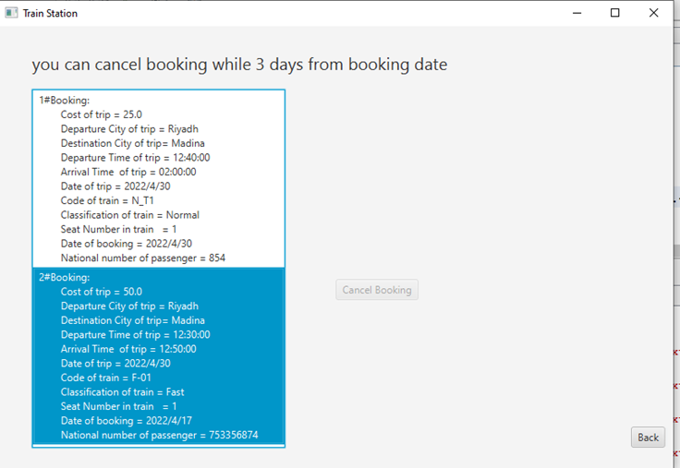

The user can cancel booking any trip just in while 3 days or he cannot.

In the admin interface:

By clicking on “Create a new user”

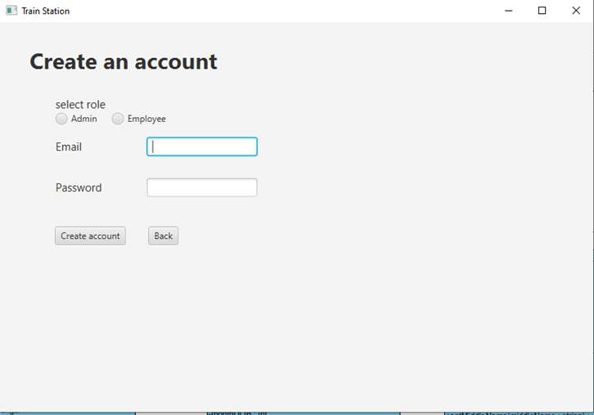Here admin can add a new user with admin/employee role..

View reports button:

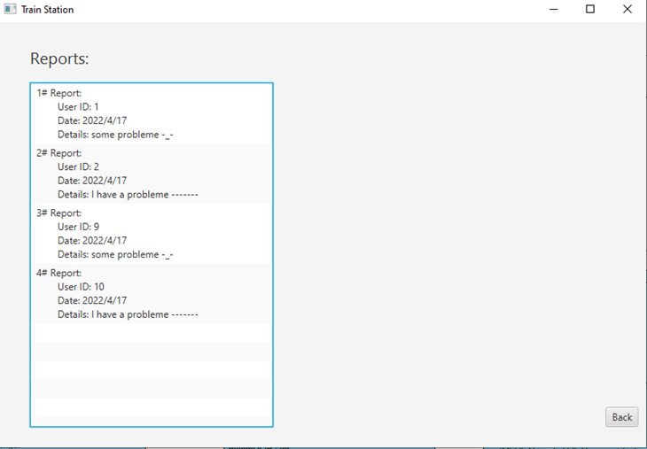

Statistics button:

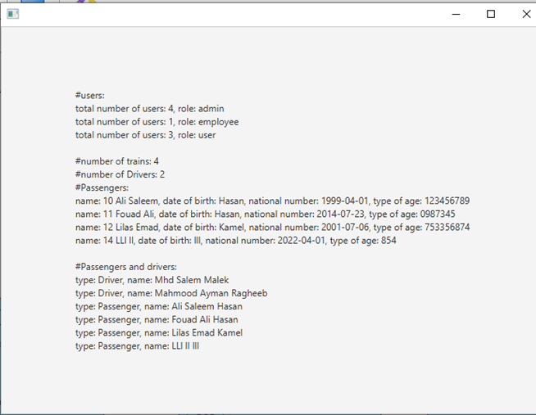

database

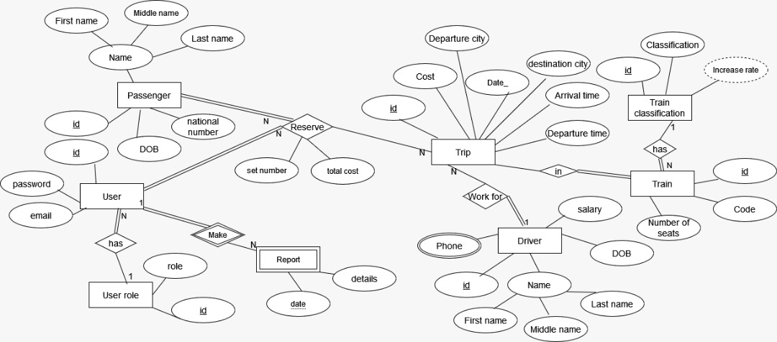ERD model:

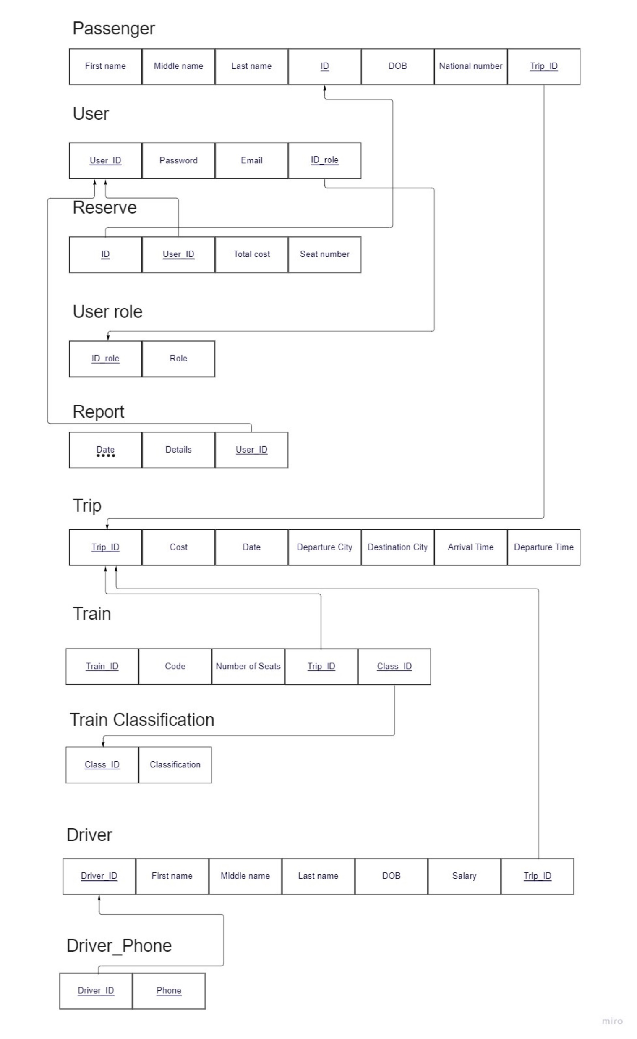

Relational schema:

user_role :

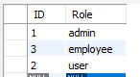

user_role :



User :

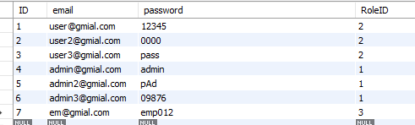

Driver :



train_classification :

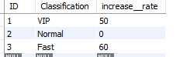

train_station.train :

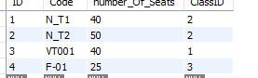

Trip :

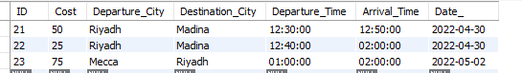

trip_train :

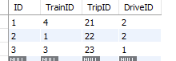

Passenger :

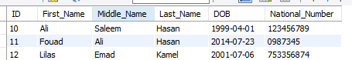

Ticket :

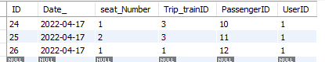

train_station.report :

