MLighter

Reference manual

Record of revisions

Rev Nº | Issue Date | Inserted
 |  | Date | By
Initial | 01 May 2022 |  | Gorka Sanchez

Table of contents

Introduction 4
User Interface 5
Code Blindspots 6
Code testing 6
Code Review 7
Bug Report 8
Model Blindspots 9
Dataset 9
Model 9
Evasion 10
Run 11
Report 12

Introduction

Welcome to the manual for MLighter, your holistic tool to test machine learning implementations.
There are two different options for testing:

- Code Blindspots for testing your code.
- Model Blindspots for testing your model.

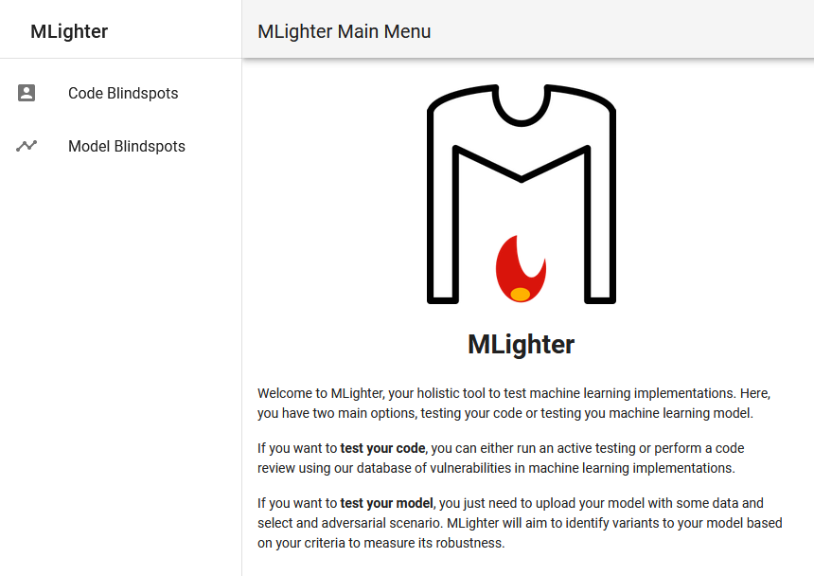MLighter main menu

User Interface

After conect with Mlighter servers the main window is showed in your browser. There are four main separated areas:
- The red area is the tab option title, where the selected tab option is showed
- The Magenta area is the main option title where the main option (code or model blindspost) is showed
- The blue area is the side bar where the main options are showed
- The green area is the tab and working area where the option tabs and upload options are showed.
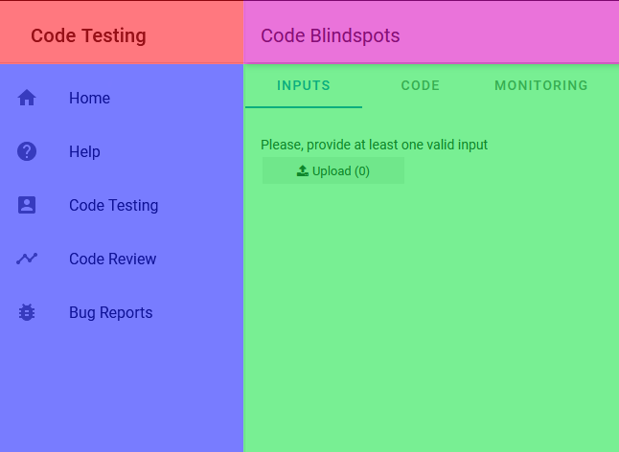Main user interface

Code Blindspots
Code Blindspots allows you test your code or review your code using our database of vulnerabilities.

Code testing
In the Inputs tab upload your inputs. The input should be ??  In the Code tab upload your code. The code should be in .CVS and press start testing  The monitoring tab | 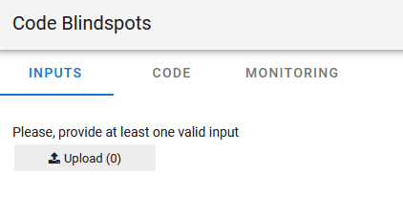

Code Review
For reviewing your code, upload your code. The code should be in .CSV and press review code. | 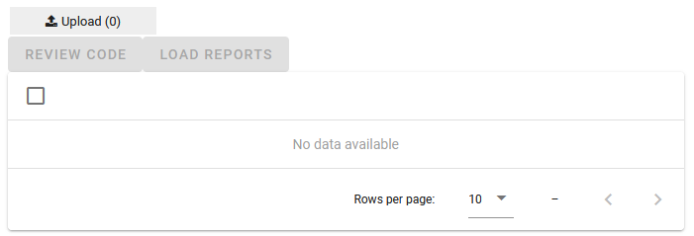

Bug Report
In the bug report option you can load the bug find in your code or select one from our database in order to create a report for it.  First you choose the bug in load bug tab and get the report in the Bug report tab. | 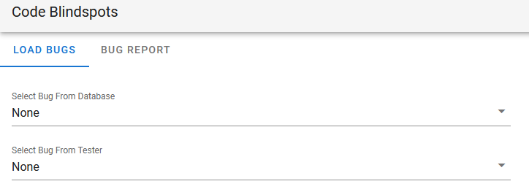

Model Blindspots

Model Blindspots allows you to test your model against a selected adversarial scenario. MLighter will aim to identify variants to your model based on your criteria to measure its robustness.

Dataset
Select data set in the side bar menu For testing your code first upload all the datasets that you want to test. The code should be in .CSV  In the Clean features tab, you can refine the test removing those classes that are not relevant for the model or you don´t want to test.  In the Select class tab you choose the feature that you want to predict such as target, etc. | 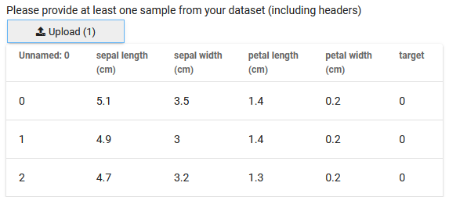

Model
In the model tab, upload the model that you want to test. The models should be compatibles with SkLearn.  In the pre evaluation tab, you can run the pre evaluation test and check the results. | 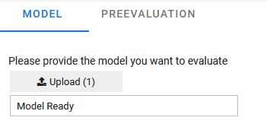

Evasion
In Evasion tab, you can choose the evasion strategies as well as the type of evasion.  Only Random noise works in the Lite version.  This mutation adds a random permutation of the selected features.  Choose between discrete which allows you use integers numbers and continuous which allows floating points numbers.  How many variants you want to generate per provided input.  Noise is the level of perturbation  Shift is where you centred your noise.  In the choose features tab you choose the features where the perturbation will be applied. | 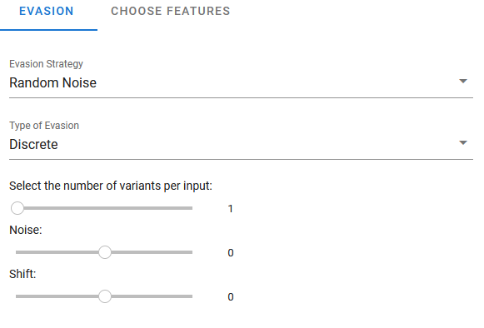

Run
The Run tab allows you run the test with the previous parameters in order to generate the evasive variants. | 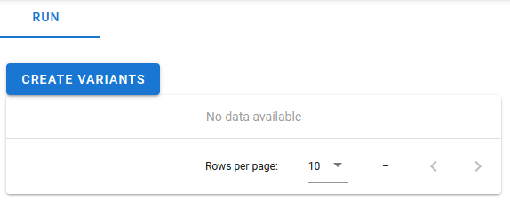

Report
The Report option allows you get information about model blindspot findings.  In the Selection tab you can select between the different running scenarios of the current session.  In the Current Report tab you can retrieve the reports of the selected scenario. | 