COS30043: Interface Design and Development
LifeLink
Emergency Blood Donor Coordination Network
Stage 2 & Stage 3 Final Application Report
Course Unit | COS30043: Interface Design and Development
Student Name | [Your Full Name]
Student ID | s104777308
Application Name | LifeLink: Emergency Blood Donor Network
Stage 3 Advanced Feature | Real-Time Data Synchronisation via Firebase Cloud Firestore onSnapshot API
Firebase Deployment Target | https://lifelink-vn.web.app
Mercury Deployment Target | https://mercury.swin.edu.au/cos30043/s104777308/LifeLink/

1. Executive Overview and Main Application Functionality
Voluntary blood donation in Vietnam faces persistent seasonal shortages and regional disparities. While national campaigns collect over 1.7 million blood units annually, critical shortages frequently occur during holiday periods and in emergency medical scenarios at regional hospitals. Conventional communication channels—such as broadcast messaging or social media posts—lack real-time coordination capabilities, leading to delays and double-booking of voluntary donors.
LifeLink was developed as a specialized, real-time web application to address this gap. Designed with a mobile-first architecture using Vue.js 3 and Firebase Cloud Firestore, LifeLink bridges emergency blood demands with eligible voluntary donors through zero-latency status tracking and dynamic donor matching.
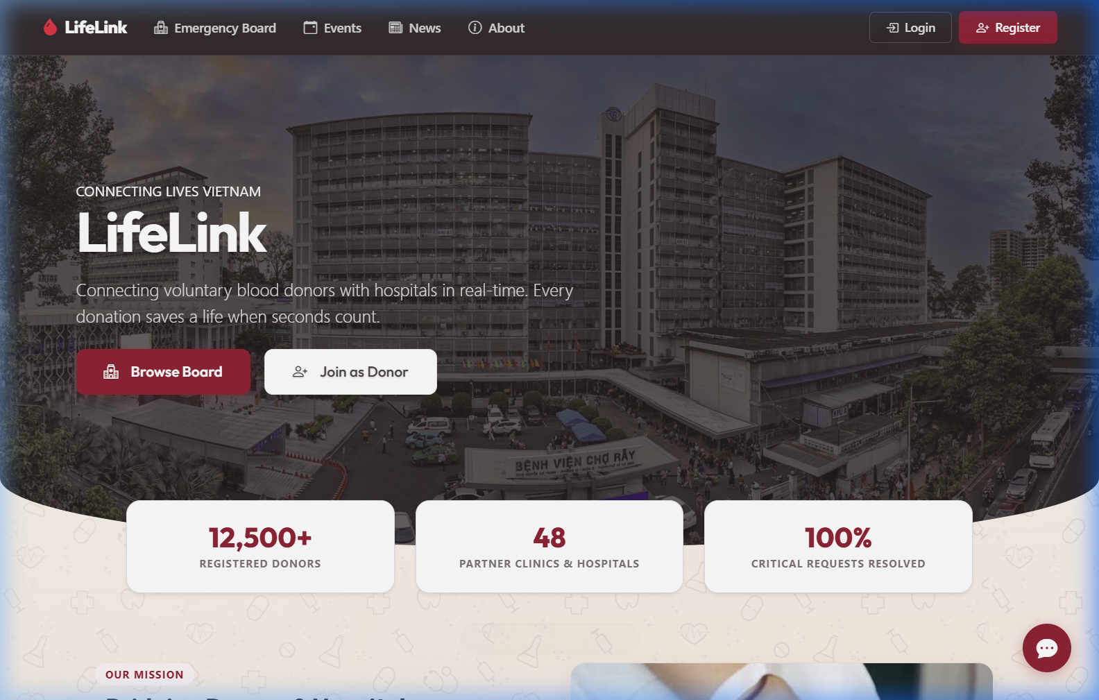
Figure 1. LifeLink Homepage Overview and Call-to-Action Banner.
Key Capabilities of the LifeLink Platform:
• Emergency Request Board (EmergencyBoard.vue): Features real-time blood request cards categorized by urgency tiers (Critical, Urgent, Moderate). Users can dynamically filter by blood type compatibility, city location, and urgency level.
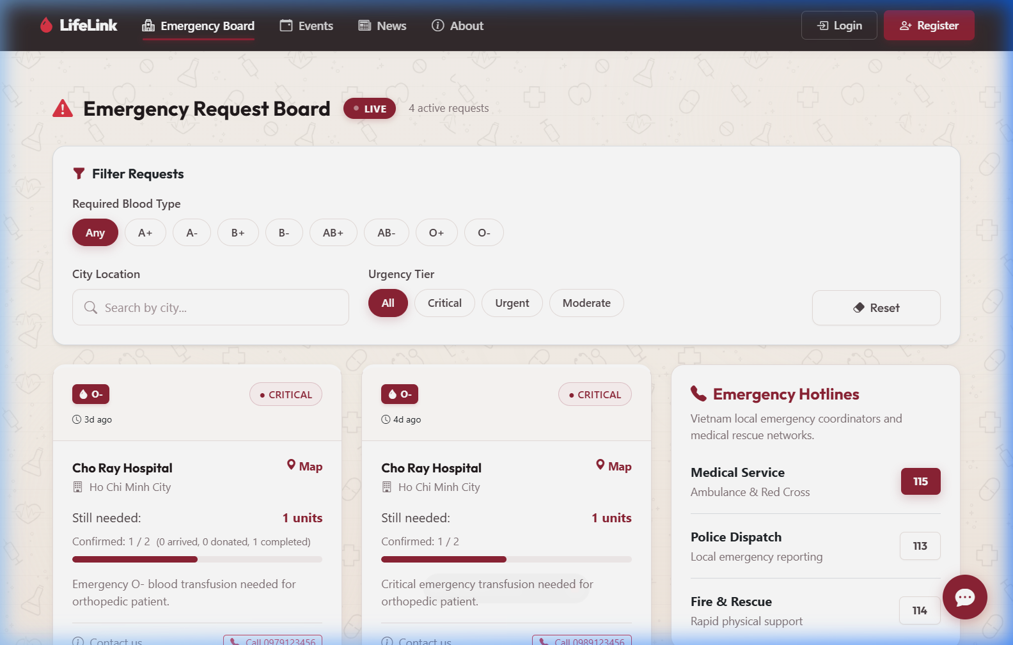
Figure 2. Emergency Request Board with Real-Time Filters and Urgency Badges.
• Interactive Live Support Chat (App.vue & useSupportChat.js): Provides a two-way real-time communication pipeline between guest donors and platform administrators, complete with an automated FAQ bot assistant.
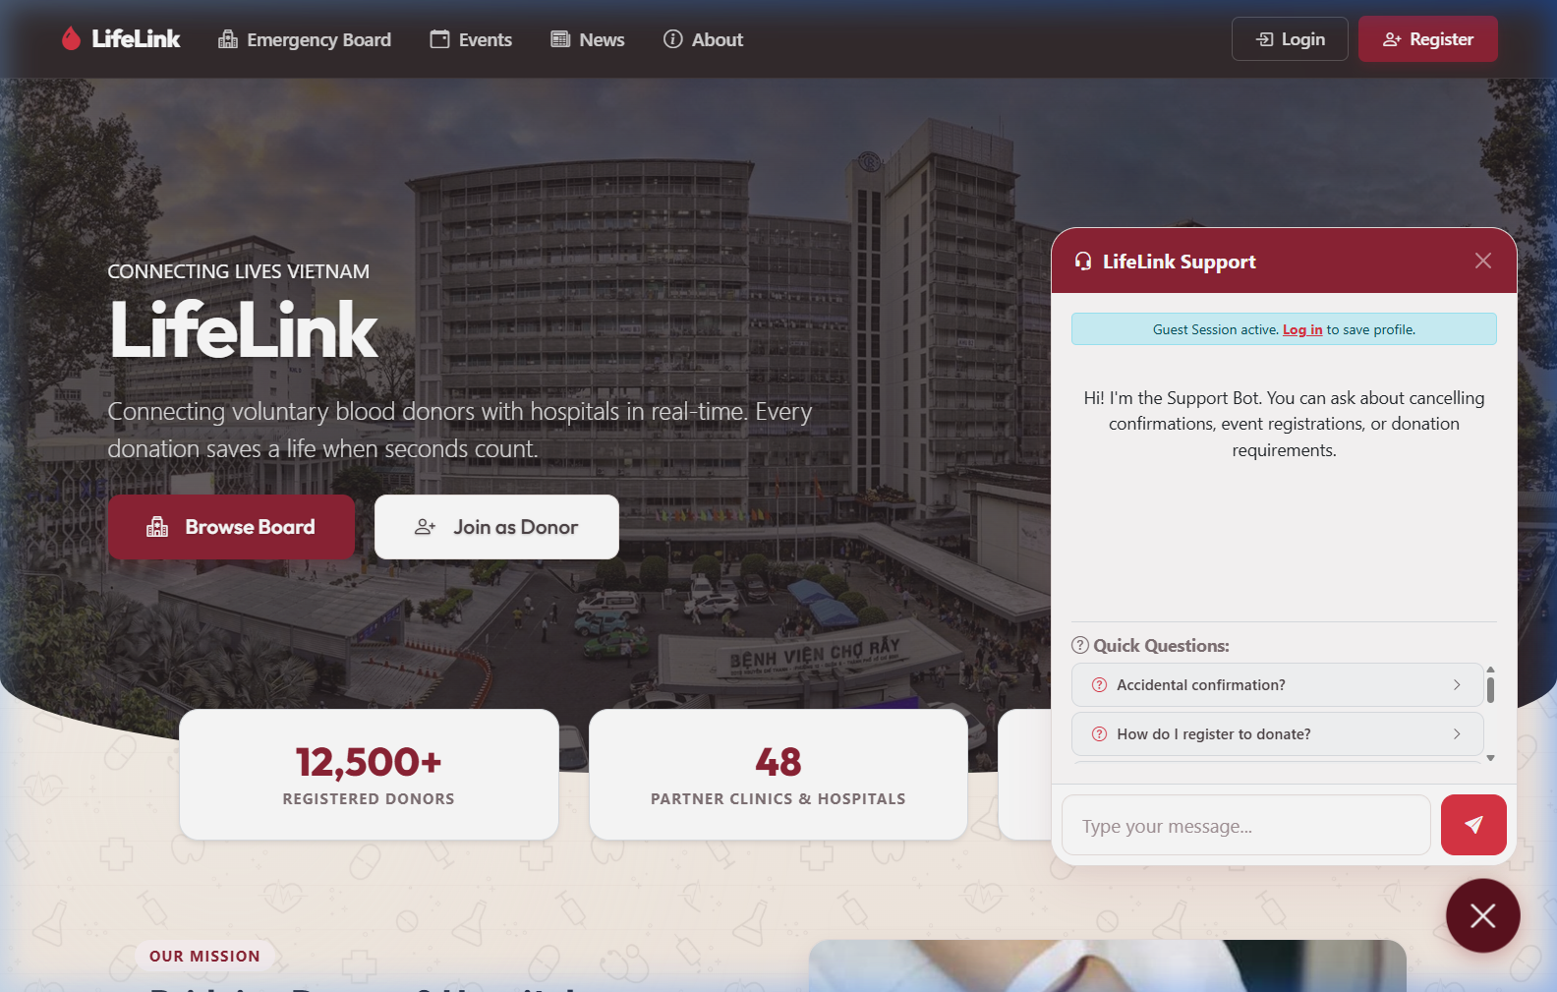
Figure 3. Real-Time Customer Support Chat Interface with Automated Bot.
• Authorized Admin Operations & Dashboard (DonorDashboard.vue): Allows authenticated administrators to create, edit, and fulfill emergency blood requests and donation events, with instantaneous live propagation to all connected clients.
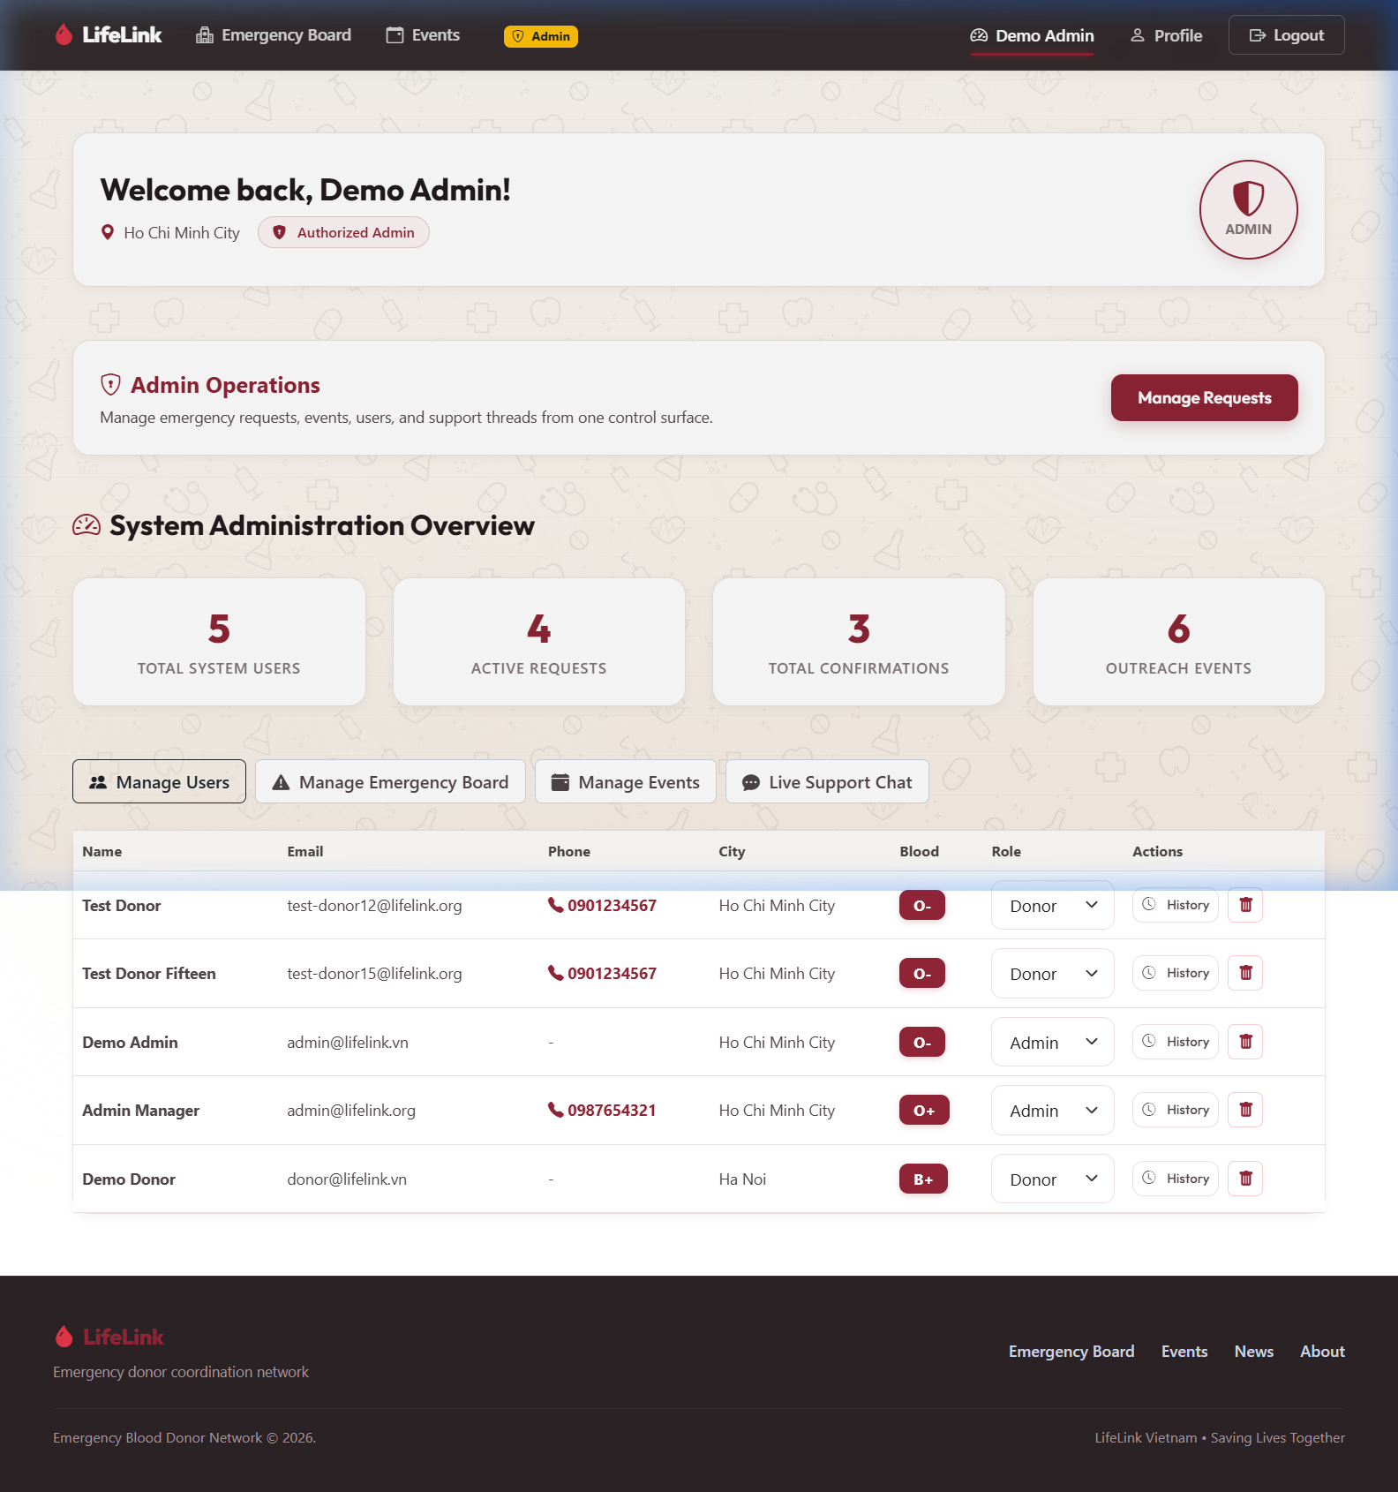
Figure 4. System Overview & Admin Management Dashboard.
• Medical Blood Compatibility Engine (bloodCompatibility.js): Enforces medical compatibility logic (e.g., O-negative universal donors, AB-positive universal recipients) and computes 84-day donation interval eligibility for registered donors.
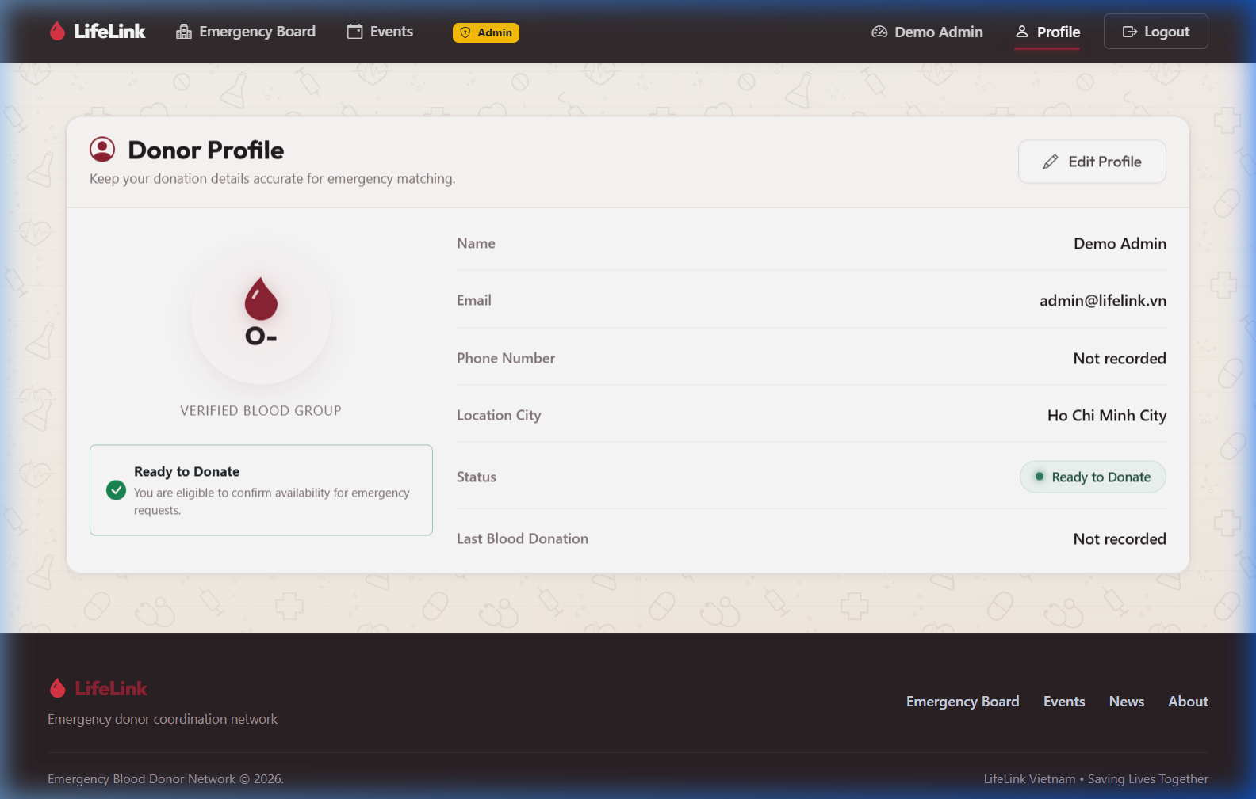
Figure 5. User Profile Management and Medical Eligibility Status.

2. Technical Architecture and Component Evaluation
The codebase is structured following modern Vue 3 best practices, separating UI rendering from asynchronous state management through composables:
Technical Component | Implementation Details & Utility
Vue 3 Composition API | Script setup syntax utilizing reactive primitives (ref, computed, reactive, watch) and custom reusable composables (useAuth, useEmergencyRequests, useSupportChat, useEligibility).
Vite 6 Build System | Lightning-fast Hot Module Replacement (HMR) during development and minified bundle chunking for production deployment.
Vue Router 4 | HTML5 History mode routing with programmatic navigation guards protecting administrative routes (/donor-dashboard).
Bootstrap 5 & Custom Tokens | 12-column responsive layout engine paired with custom HSL CSS root variables (:root) for theme consistency.
Firebase Cloud Firestore | NoSQL document database providing real-time WebSocket data streaming (onSnapshot) and persistent data storage.
Vitest Testing Framework | Comprehensive unit testing suite with 55 automated tests covering compatibility algorithms, composable state, and UI components.

3. Deep Technical Analysis of Stage 3 Advanced Feature

3.1 Advanced Technique Selection: Real-Time Data Synchronization
For Stage 3, the application focuses on Real-Time Data Synchronization using Firebase Cloud Firestore onSnapshot listeners integrated seamlessly into Vue 3 reactive composables. In emergency medical coordination, standard HTTP request-response (pull) architecture is insufficient because data becomes stale immediately after page load.
Table 1. Architectural Comparison of Data Models
Characteristic | Pull Model (HTTP REST) | Push Model (WebSockets / Firestore) | LifeLink Implementation
Data Arrival | Client explicitly requests data | Server pushes updates immediately | Board updates live on changes
Latency | Depends on polling interval | Near zero (< 100ms) | Donors see new requests instantly
Stale Data Risk | High (requires manual F5 reload) | Minimal (active connection) | Units counter reflects live state
Best Fit | Static content / blogs | Emergency coordination & live chat | Emergency Requests & Support Chat

3.2 Architectural Implementation in Vue 3 Composables
The real-time listener logic is encapsulated within custom composables such as useEmergencyRequests.js and useSupportChat.js. To ensure memory safety and eliminate initial loading delays, two key engineering patterns were introduced:
1. Module-Level Latency Cache (0ms Instant Render): State refs are defined at the module scope outside the exported function. On initial navigation, cached data renders in 0ms while onSnapshot synchronizes silently in the background.
2. Lifecycle Memory Leak Prevention: Subscribers store the unsubscribe callback and execute it inside Vue’s onUnmounted lifecycle hook, ensuring background listeners terminate when components unmount.

4. Engineering Challenges and Reflections
Throughout the development lifecycle, key engineering challenges were encountered and systematically resolved:
• Challenge 1: Listener Memory Leaks: Early iterations accumulated orphaned Firestore listeners on route changes. Solved by standardizing unsubscribe cleanup in all composable lifecycle hooks.
• Challenge 2: WCAG AAA Accessibility Compliance: Initial slate color tokens failed WCAG AA contrast tests. Color variables were upgraded (--ll-slate-500: #4F4346), achieving > 7:1 contrast ratios and zero DevTools accessibility errors.

5. References
Google Firebase. (2026). Get real-time updates with Cloud Firestore. Firebase Documentation. https://firebase.google.com/docs/firestore/query-data/listen
Vue.js. (2026). Composables: Vue.js 3 Official Guide. https://vuejs.org/guide/reusability/composables
W3C. (2023). Web Content Accessibility Guidelines (WCAG) 2.1. World Wide Web Consortium. https://www.w3.org/TR/WCAG21/

