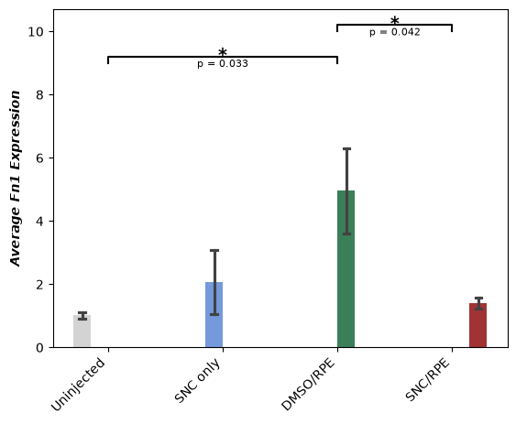
Figure 1. Average 2^-∆∆Ct of Fn1 gene expression of three replicates for each sample. DMSO/RPE samples have an increased expression compared to the uninjected control and SNC/RPE. The error bars represent the standard error of the mean. Statistical significance was determined by One way ANOVA with Tukey post hoc test to determine significance between groups. * with brackets represent statistically significant group with the p value shown below the bracket.

