# CS 5012: Foundations of Computer Science

**H. Diana McSpadden (hdm5s)**

**Module 0: EXERCISE: Relations and Functions**

## QUESTION 1

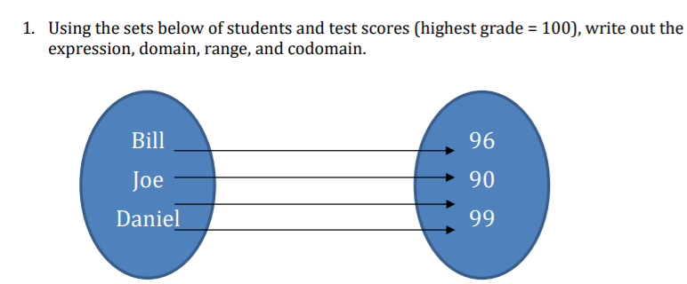

### ANSWER 1

**Expression**: R {(Bill,96),(Joe,90),(Daniel,99)}

**Domain**: {Bill, Joe, Daniel}

**Range**: {96,90,99}

**Codomain**: {x| 0 < x < 100}

## QUESTION 2

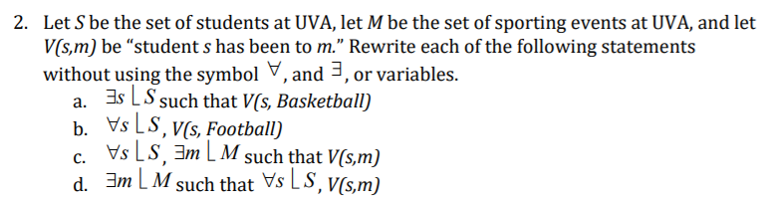

### ANSWER 2

1. There is a student who has been to a basketball game.
2. Every student has been to a football game.
3. All students have been to a sporting event.
4. There is a sporting event which all students have attended.

## QUESTION 3

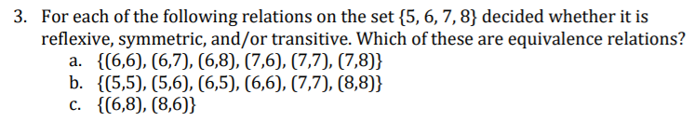

### ANSWER 3

1. NOT symmetric. NOT transitive. NOT reflexive. NOT equivalent.
2. YES symmetric. YES transitive. YES reflexive. YES equivalent.
3. YES symmetric. ?? transitive. NOT reflexive. NOT equivalent.

## QUESTION 4

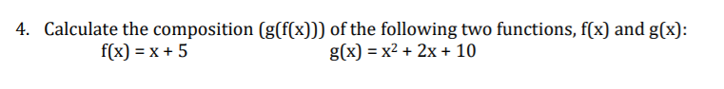

### ANSWER 4

(g(f(x)) = (x + 5)^2 + 2(x + 5) + 10 == x^2 + 10x + 25 + 2x + 10 + 10

**== $x^{2}+12x+45$**