# CS 5012: Foundations of Computer Science

## Module 00: Homework: Logic, Sets, Functions, and Relations

**H. Diana McSpadden (hdm5s)**

02/02/2021

## Q1. Given the following predicates and their meanings:

1. P(x,y) : x > y

2. Q(x,y) : x ≤ y

3. R(x) : x–7 = 2

4. S(x) : x > 9

If the universe of discourse is the real numbers, give the truth value (true or false) of each of the following propositions:

1. (∃x) R(x) –
2. (∀y)[¬S(y)] **–**
3. (∀x)(∃y) P(x,y) – **∞.**
4. (∃y)(∀x) Q(x,y) – **∞.**
   1. NOT counting infinity as a Real Number.
   2. 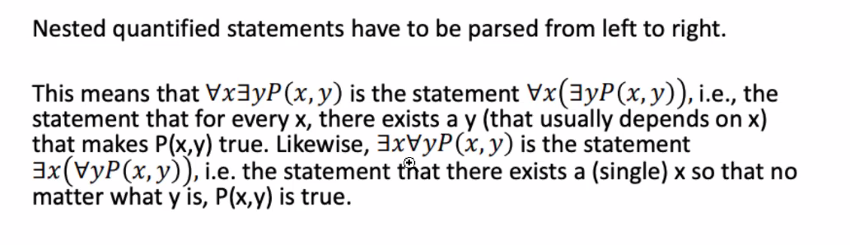
5. (∀x)(∀y)[P(x,y) ˅ Q(x,y)] –
6. (∃x) S(x) ∧ ¬(∀x) R(x) –
7. (∃y)(∀x)[S(y) ∧ Q(x,y)] –
8. (∀x)(∀y)[{R(x) ∧ S(y)} → Q(x,y)] –

Q2. Which of the following sentences …

has the logical form (p ∧ q) → r?

1. If you don’t attend the wedding, then Sam will be angry with you -

2. Matt is happy and so are Sam and Fae

**3. If it rains and it snows then flooding will result – . p = it rains. q = it snows. r = flooding**

**If it rains and snows that implies flooding.**

4. Students will play football or students will play soccer; but they will not attend classes

5. Gene is smart and strong, additionally he is a good swimmer.

## Q3. Which of the following formulas …

represents the sentence,

“If there are no fruit in the market then the farmers didn’t plant fruit trees or the farmers didn’t water the trees”

p means There are no fruit in the market

q means Farmers didn’t plant fruit trees

r means Farmers didn’t water the trees

1. p → q

**2. p → q ˅ r**

3. (p → q) ˅ not r

4. p → q ˅ not r -

5. p ˅ q → not r –

## Q4. Show [p ∧ (p → q)] → q is a tautology

**}**

Your statement p ∩ (p → q) == (p → q) ∩ (p → q) is not correct.  Correct statement is p ∩ (p → q) ==  (p ∩ p) → (p ∩ q) (Distributive Law)

## Q5. Argue that set A and set A’ (the compliment of A) are disjoint.

As stated in the ‘Set Theory Supplemental’ PowerPoint, “The complement of set B is the set of elements of set A that are not elements of set B,” and disjoint sets are “… two or more sets, having no members in common; having an intersection equal to the empty set”. By definition, A’ are elements that are not in A, and thus the intersection is equal to the empty set, which makes them disjoint. A Venn diagram makes this even more clear:

## } U

## A’

## A

## Q6. Which of the following is a one-to-one function?

1. { (1,2), (2,3), (3,4), (4,5), (3,7), (2,2) } – **No,** because (3,4) and (3,7) are

2. x = 5 – **No,** because no matter the x value, y always equals 5. This is infinity:1.

3. x=5, 10 < y < 25 – **No,** again, because x is always 5 for the values of y in the range.

4. { (1,2), (2,3), (3,4), (2,5), (3,7) } – **No,** because (2,3) and (2,5) are both in the set.

5. { (1,2), (2,4), (3,6), (4,8) } - **Yes**

## Q7. Let U = {x : x is an integer and 2 ≤ x ≤ 10}.

In each of the following cases, determine whether A ⊆ B, B ⊆ A, both or neither:

1. A = {x : x is odd } B = {x : x is a multiple of 3} –
   1. A = {3,5,7,9}
   2. B = {3,6,9}
2. A = {x : x is even} B = {x : x2 is even} -
   1. A = {2,4,6,8,10}
   2. B = {2,4,6,8,10}
3. A = {x : x is even } B = {x : x is a power of 2} -
   1. A = {2,4,6,8,10}
   2. B = {2,4,8}
4. A = {x : 2x + 1 > 7} B = {x : x2 > 20} -
   1. A = {4,5,6,7,8,9,10}
   2. B = {5,6,7,8,9,10}
5. A = {x : √x ∈ ℤ} B = {x : x is a power of 2 or 3} -
   1. A = {4,9}
   2. B = {2,3,4,8,9}
6. A = {x : √x ≤ 2} B = {x : x is a perfect square} -
   1. A = {2,3,4} (3 if we are working with real numbers and not only integers)
   2. B = {4,9}
7. A = {x : x2 − 3x + 2 = 0} B = {x : x + 7 is a perfect square} -
   1. A = {2}
   2. B = {2,9}

Note: ℤ denotes the set of all integers