# ICA : Sailors RA

**H. Diana McSpadden (hdm5s)**

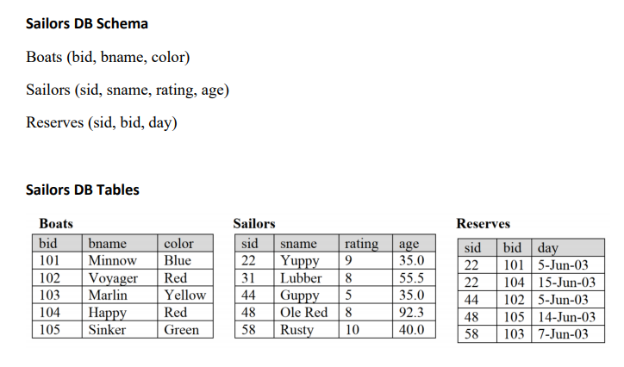

1. **Find the names of sailors who have reserved boat 103.**
$π_{\left(sname\right)}(σ_{\left(bid="103"\right)}(Sailors⋈Reserves))$

2. **Find the colors of the boats reserved by Yuppy.**
$π_{\left(color\right)}((σ_{\left(sname=^{}"Yuppy"\right)}(Sailors⋈Boats⋈Reserves))$

3. **Find the names of sailors who have reserved a red and a green boat.**
$\left(π_{\left(color, sname\right)}(\left(σ_{(color="\text{Red" }\text{⋁}\text{ color="Green"}\text{)}}(Boats)⋈Reserves\right)⋈Sailors\right))\% π_{\left(color\right)}(σ_{(color=^{'}Red^{'} ∨ color="Green' )}(Boats))$

4. **Find the names of the sailors who have reserved all the boats.**
$\left(π_{\left(bid, sname\right)}\left(Boats⋈Sailors⋈Reserves\right)\right)\% π_{\left(bid\right)}(Boats))$

5. **Find the names of sailors who have reserved a red boat.**
${π_{(sname)}((σ}_{color=^{'}Red^{'}}(Boats))⋈ Reserves⋈ Sailors)$

6. **Find the names of the sailors who have reserved a red or green boat.**
$π_{sname}((Sailors⋈ σ_{color="\text{Red}\text{" }\bigvee{color="Green"}}\left(Boats⋈Reserves\right))$

7. **Find the names of the sailors who have not reserved a boat.**
$π_{\left(sname\right)}\left(Sailors\right)- π_{\left(sname\right)}(Reserves⋈Sailors)$

8. **Find the sid’s of the sailors who have reserved a boat whose name begins with the letter ‘M’. (the boat’s name, not the sailor’s)**

$π_{\left(sid\right)}((Sailors⋈ σ_{\left(bname="\text{M\%}\text{"}\right)}(Reserves⋈Boats))$