**8.5 Module Exercise: Heroes and Villains**

**Caprill Wright (acw2et) and Diana McSpadden (hdm5s)**

Caprill and Diana met for ~90 minutes and talked over two different models for Heros and Villains that each allow different stories to be told about the entities and their relationships.

## **Model 1:**

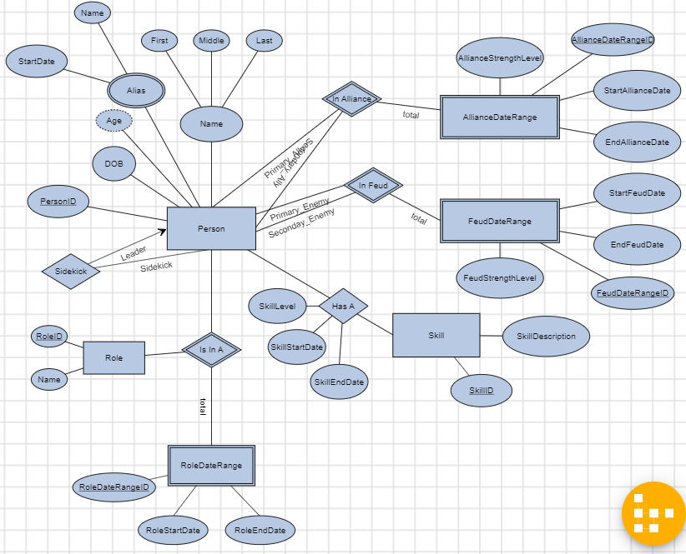

Model 1 allows for a person to change their role from Hero, to Villian, to “Civilian” over time. There is a weak entity, “RoleDateRange”, and weak relationship “Is In A (between Person, Role, and RoleDateRange) that allows a Person to have multiple roles over multiple date ranges. Business logic in the code layers (and/or stored procedures) will need to be implemented to prevent overlapping date ranges for a person and role (if we don’t want to support overlapping relationships). The RoleDateRangeID will allow for overlapping role date ranges if we do need to support that functionality.

The Ally and Feud weak entities and relationships also allow tracking different alliances and feuds (and their strength) over time. With this model one could track and growing/weakening alliance or feud. Again, business logic in code or stored procedures will be needed to restrict overlapping date ranges within alliances/feuds, and between alliances and feuds for the same two people.

People can have multiple skills, and the skill strength can be tracked over time with this model.

A person can have multiple sidekicks, but a sidekick can only have one leader.

End dates in this model will either need to be NULL or a sentinel value for relationships that are currently active.