# 8.7 Homework: ER Diagrams & DB Schemas

**H. Diana McSpadden (hdm5s)**

1. [30%] Create an ER diagram for the following database scenario. Make sure to include an indication of the cardinality of relationships and indicate any mandatory relationships (total participation). State any assumptions that you make!

Simple IMDB Database

* Movie stars obviously have names (real and screen in some cases).
* Movie stars star in movies.
* Movies have titles, the year they came out, a genre, a length, and a rating.
* A rating can be G, PG, PG-13, or R.
* Movies are produced by studios.
* There are various different studios around the world.
* Movie studios hire actors to be in their movies and pay them a great deal of money (salary).

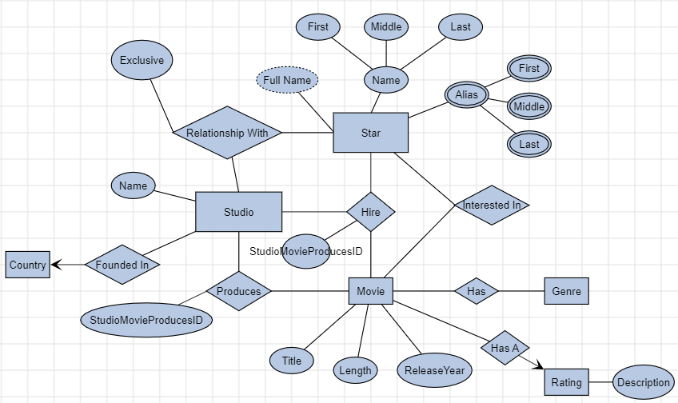

**Movies Database Assumptions**

1. Movies exist prior to a Studio starting to produce them.
2. Star and Movies can be interested in each other prior to being in a contract between the Producer/Star/Movie
3. Stars can be in relationships with Studios prior to, and outside of being in a contract for a Movie. Some Stars are in an exclusive relationship with one Studio, but not all Stars are, so this is handled by a relationship attribute instead of cardinality.
4. A Movie can have many Genres.
5. Several Producers can work together to Produce a Movie.
6. The ID “StudioMovieProducesID” is the unique identifier for the relationship “Produces” between Studio and Movie. This ID is a required attribute of the “Hire” relationship between Studio, Star, and Movie. The “StudioMovieProducesID” can be referenced in multiple Hire relationships, but is unique to one Produces relationship.
7. I do not have enough information in the description to determine if a Star could be under multiple contracts for a single Movie with multiple Producers, but this model will support that functional requirement if it needs to be supported.

2. [10%] Convert Task 1's ER diagram to a table.

3. [40%] Create an ER diagram for the following database scenario. Make sure to include an indication of the cardinality of relationships and indicate any mandatory relationships (total participation). State any assumptions that you make!

Hospital Database

* Hospital staff consists of doctors and nurses.
* All hospital staff have a hospital ID, name (first name, middle initial, and last name), and phone number.
* Doctors have an office and up to three specializations.
* Doctors have nurses that work with/assist them.
* Nurses have one specialization and belong to a specific department in the hospital.
* All nurses work with doctors (no exception). Many nurses can work with one doctor.
* Doctors sometimes consult with a colleague (who is another doctor).
* Doctors treat patients.
* Patient information is collected by the hospital and include SS# (social security number), name, insurance, date of admission, and date checked out.
* A patient can undergo a number of tests.
* Doctors perform tests.
* Tests have a unique ID, name, a result, and a date and time the test was performed.

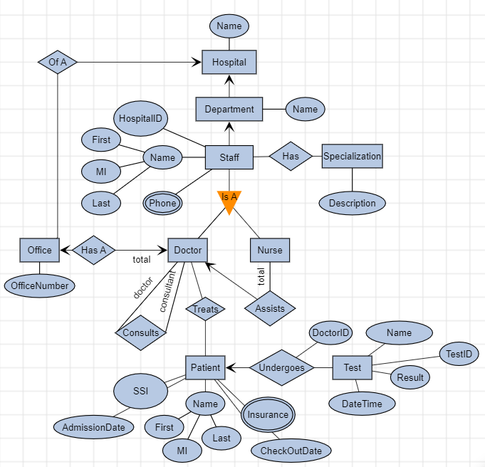

**Hospital Database Assumptions:**

1. Staff can only work for one hospital. This model will not work to track staff across multiple hospitals.
2. Each department is only for one hospital. This model will not work to track similar departments across hospitals as written; however, if DepartmentType become a reference table, and each Department was identified as a DepartmentType, then we could compare same department types across multiple hospitals.
3. It would be possible in this system, by SSI, to track a Patient across multiple hospitals.
4. All doctors have an office: as is implied by the “total” annotation on the “Doctor Has An Office” relationship.
5. The functional requirements for doctors having no more than three specializations, and nurses having one specialization will need to be handled in the Business Logic/Tier or programmatically in stored procedures.
6. The Doctor who orders a Test for a Patient is stored in the Undergoes relationship DoctorID attribute. This attribute is required (both the database and the Business Logic tier will need to enforce).
7. Patients can have multiple insurers.
8. Because OfficeNumbers may be duplicated across hospitals, a separate OfficeID, unique to the database, will need to be created for the table.

4. [20%] Convert Task 3's ER diagram to a table.