CSE 6730 Project 2 Modeling and Simulation Life Cycle

Dongmin Han, Shan Xiong, Chong Ye

*Project checkpoint.* By the time of the checkpoint you should have completed the problem

description (a more detailed version of the described here), **conceptual model, and simulation**

**model steps** of the simulation project life cycle. You should have some version of your

simulation models up and running, though it may not be the final version, and may not have

been fully verified or validated yet. These should be written up, and turned in. The project

checkpoint represents a large portion of the final report. You will add upon this document to

complete the final report, described below.

# Problem Statement

The goal of this project is to simulate and study the traffic flow on a portion of Peachtree Street (the corridor from 10th to 14th street) in midtown Atlanta. Peachtree St. is a major street in midtown and serious traffic congestion is a common problem during rush hours. To understand potential factors behind traffic congestions, traffic simulators based various discrete event simulation approaches will developed. These simulators will be validated with actual traffic records. Based on the simulation results, we will have a better understanding of the main factors that affect traffic conditions, such as traffic light timings, car density, and gap distances, and how individual car behavior will help or worsen the overall traffic flows.

In our simulation, the system under investigation (SUI) is the traffic flow on Peachtree Street from 10th street to 14th street, as shown in Figure 1a (from Google Map). A schematic representation of the corresponding road segments is shown in Figure 1b, which includes five intersections, as represented in red and yellow circles.

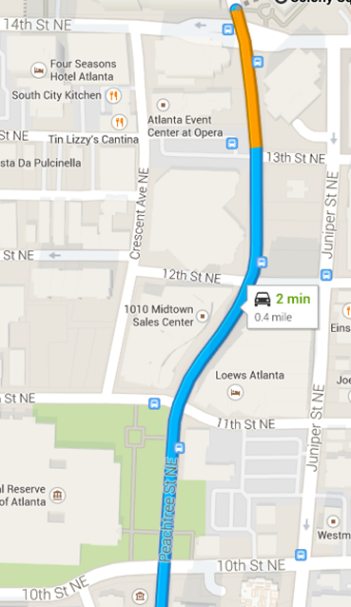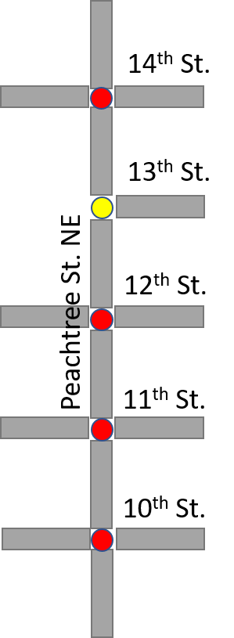

(a) (b)

**Figure 1**. (a) Map of Peachtree St. NE from 10th street – 14th street. (b) Schematic of the road under investigation

In Peachtree St., both north bound and south bound have two lanes. We will mainly focus on traffic flow travelling from south to north, using the actual lane setting in at least one model. Simplification with 1-lane model may be adopted for one or two simulators. With the two-lane setting, the governing rules of car behavior will include examination of neighboring lane environment and randomized lane-changing decision in addition to basic car-following models. Lane-changing is expected to affect surround cars and therefore the overall travel flows.

Our models will also include the traffic lights. There are four traffic lights in Northbound Peachtree St. At the intersections of 10th and 14th St., the traffic lights include left-turn-only signals for left-turn vehicle, whereas at the intersections of 11th and 12th, there are no left-turn signals. We may consider left and right turning behaviors for one simulator if possible.

In order to reflect as real traffic condition as possible, actual traffic records of cars entering the road of interest will be used as input. The output of the simulation will be compared with actual statics to validate and improve the models. Simplification is adopted to ease the initial implementation, such as only focusing on cars entering at 10th St intersection.

The goal of this simulation study is to assess the average travel time for vehicles to traverse northbound Peachtree Street from 10th to 14th St. under various car densities. We have developed simulators based on three different world views, namely cellular automata, event-oriented, and process-oriented queueing models. In each simulator, we will use the same sets of input to ensure consistent quality of simulation. Actual traffic records will be used to validate these simulators. We expect to provide a good estimate of the travel time for vehicles during various periods with a user-friendly interface. More importantly, we will have a better understanding of the modeling and simulation life cycle with hands-on experiments on an actual problem.

# Literature Review

# Conceptual Model

# Input analysis

# Simulation Model