**ABSTRACT FACTORY**

1. **DEFINITION**

As Factory Method Pattern, Abstract Factory Pattern is one of Creational patterns.

Considered as another layer of abstraction over factory pattern.

Work around a super factory to create other factories.

1. **SOLVE**

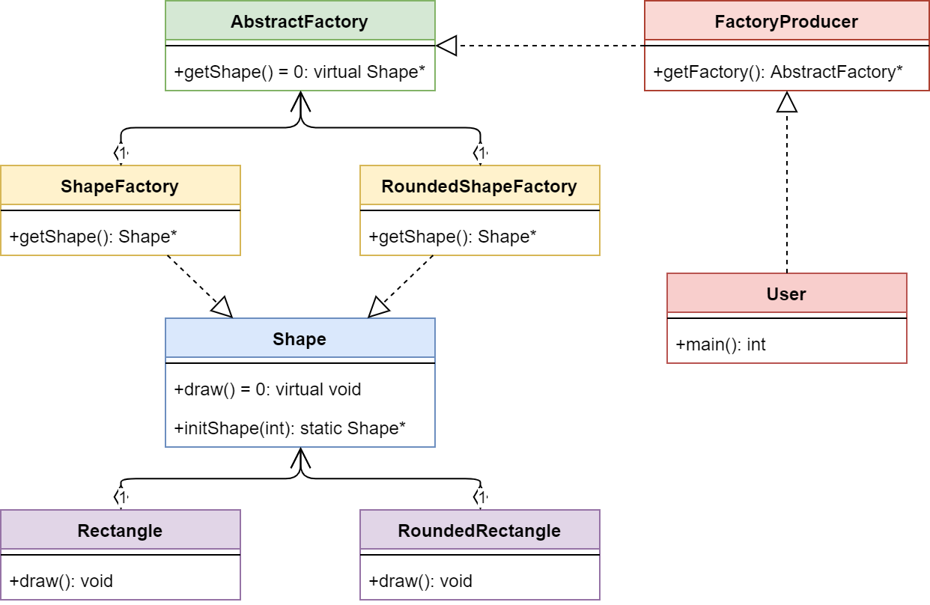

1. **STRUCTURE**

* AbstractFactory : Declares an interface for operations that create abstract product objects.
* ConcreteFactory : Implements the operations declared in the AbstractFactory to create concrete product objects.
* Product : Defines a product object to be created by the corresponding concrete factory and implements the AbstractProduct interface.
* Client : Uses only interfaces declared by AbstractFactory and AbstractProduct classes.

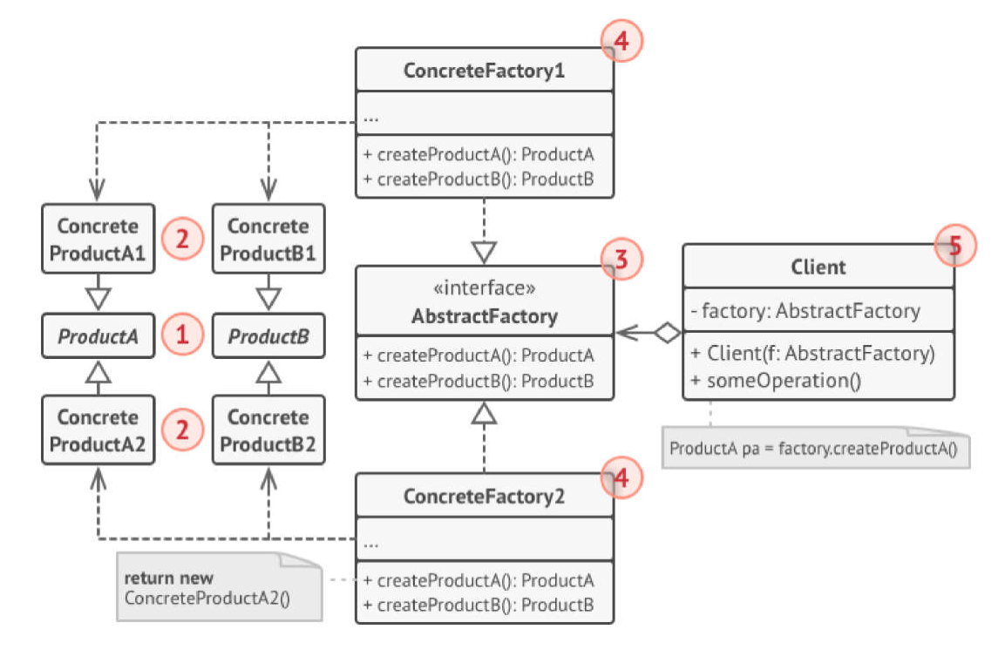

1. **ADVANTAGES & DISADVANTAGES**

|  |  |
| --- | --- |
| **ADVANTAGE** | **DISADVANTAGE** |
| * Ensure that all products you receive from a factory are compatible. * Cut down the dependence between creator and concrete products. * Create products into somewhere in the program 🡪 easy to track and manipulate. * Freely add many new products to the program without changing the existing code base. | * Code will be more complicated and must use a lot of classes. |