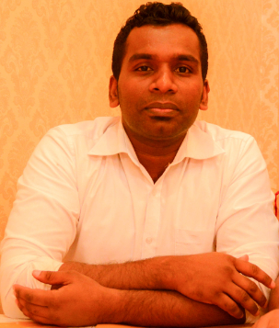

H.D.N.Sameera | 077 123 4567|sameerasl@gmail.com

# About me

I have been coding since 2007 and I love coding.

# Work Experience

**Management Systems Limited** *2007-2011*Software Engineer - AS400

**Hayleys PLC** *2011-2015*Software Consultant - AS400

**Hayleys Advantis Limited** *2015-2018*SAP ABAP/PI Developer

**Associated Motorways Limited** *2018-2019*SAP ABAP Process Specialist

# Skills

* AS400 RPG2, RPGILE
* SAP ABAP/PI Developments
* iOS Developments/Swift/SwiftUI
* Python