R Markdown Exercises from R4DS: Graphics

H. David Shea

4 Feb 2021

## Plot aesthetics

Here we demonstrate methods to improve communication efficacy by using various labeling and annotation options within **ggplot** (including references to options in the **ggplot** extension **ggrepel**).

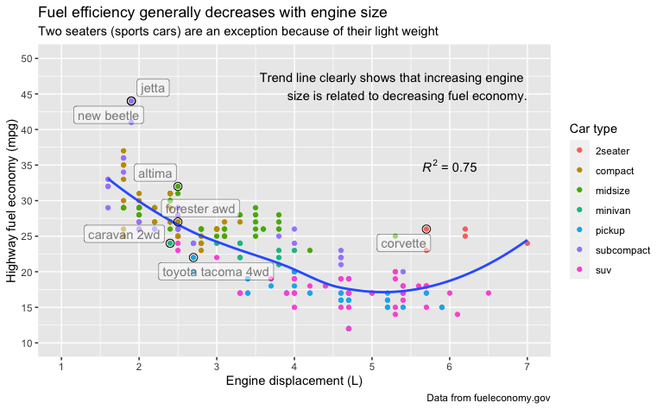

Some variable control over axis labels is demonstrated by scale_x_date() with breaks set to specific elements from a tibble - in this case breaks = presidential$start.

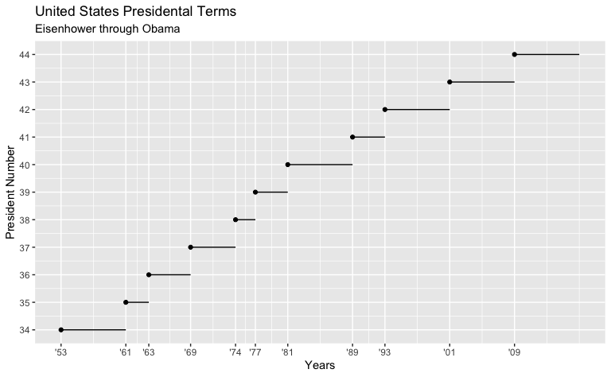

Below demonstrates some control over how legends are displayed. We also control here the layout of the four different plots within the document with setting of various chunk options.

{r legend_and_display_control, echo = FALSE, fig.asp = 1, fig.align = "default", out.width = "50%", fig.width = 4}

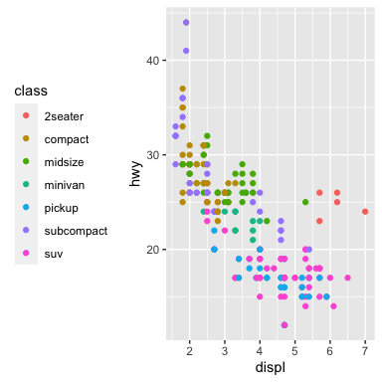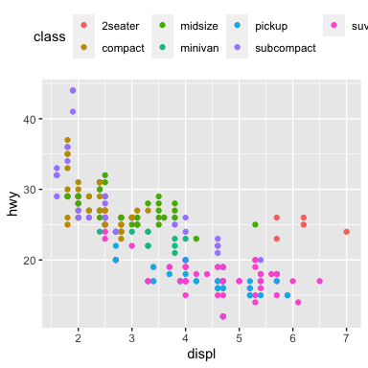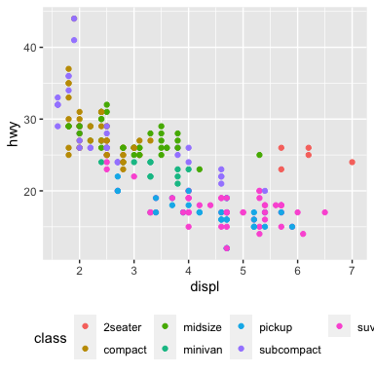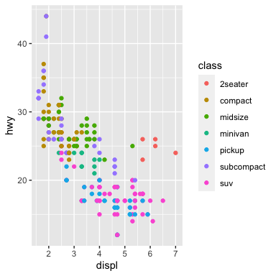

And, our aesthetically pleasing car plot again with legend control added.

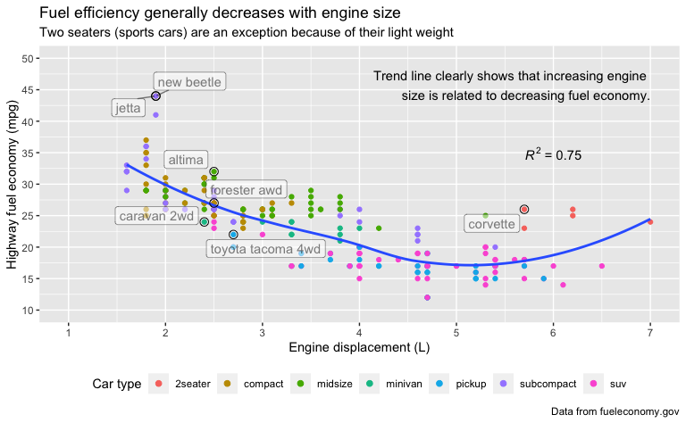

For plots that use log scale of underlying variable, it is a better - from a labeling perspective - to use the scale control geoms (e.g., scale_x_log10() and scale_y_log10()) versus the log adjusted variables (e.g., aes(log10(carat), log10(price))).

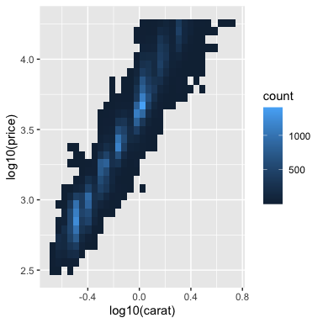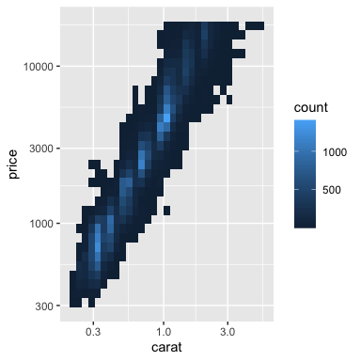

The latter plot is displayed in the log dimension space, but with the variable name and axis label markings preserved from the underlying data.

This is an *obvious* aesthetically pleasing addtion to our Presidential Terms plot which demonstrates some color control options.

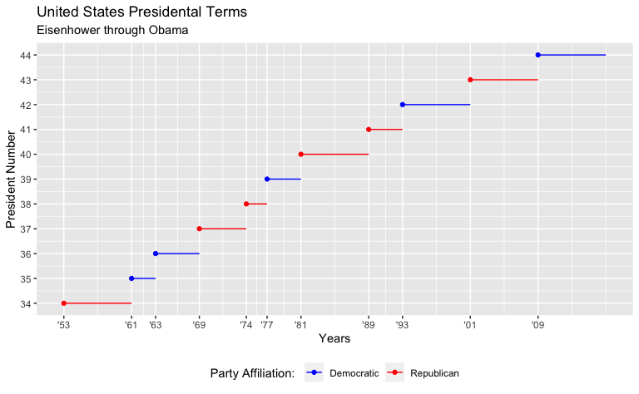

And this adds in all of the other Presidential Terms plot improvement from question 2 in the 28.4.4 Exercises.

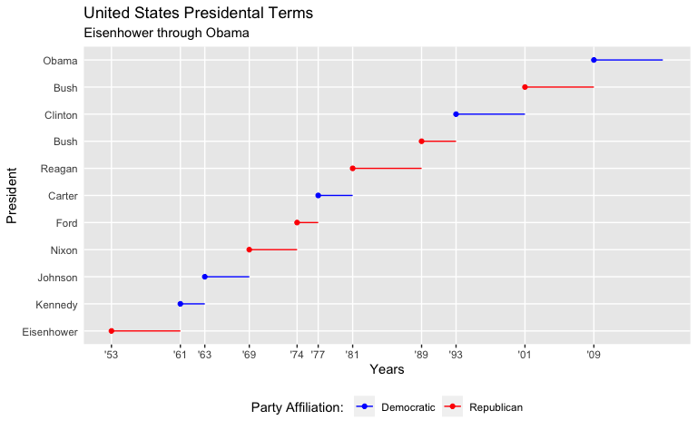

The following example shows the control of various aesthetics across sub-plots from similar data.

