**IT314**

**NAME: THAKOR HARSHAL DIPAKSINH**

**STUDENT ID:202001169**

**GROUP:14**

**LAB:5**

* **Static Analysis Tool used:**

**mypy**

* **Github repository used:**

<https://github.com/CT83/SmoothStream>

* **Files for which mypy tool used:**

**1. Stream.py**

**Command Prompt Output:**

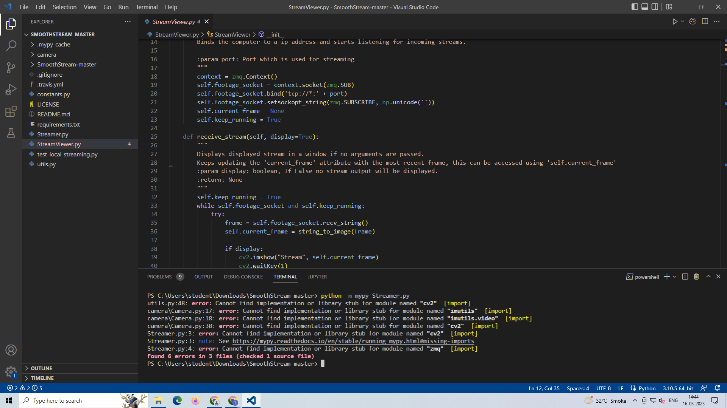

**Explanation of Errors:**

The errors are related to the cv2,imutils,imutils.video and zmq module. Mypy detected the errors because the those module hasn’t been installed in the computer and therefore the functions related to it cannot be accessed.

**2. StreamViewer.py**

**Command Prompt Output:**

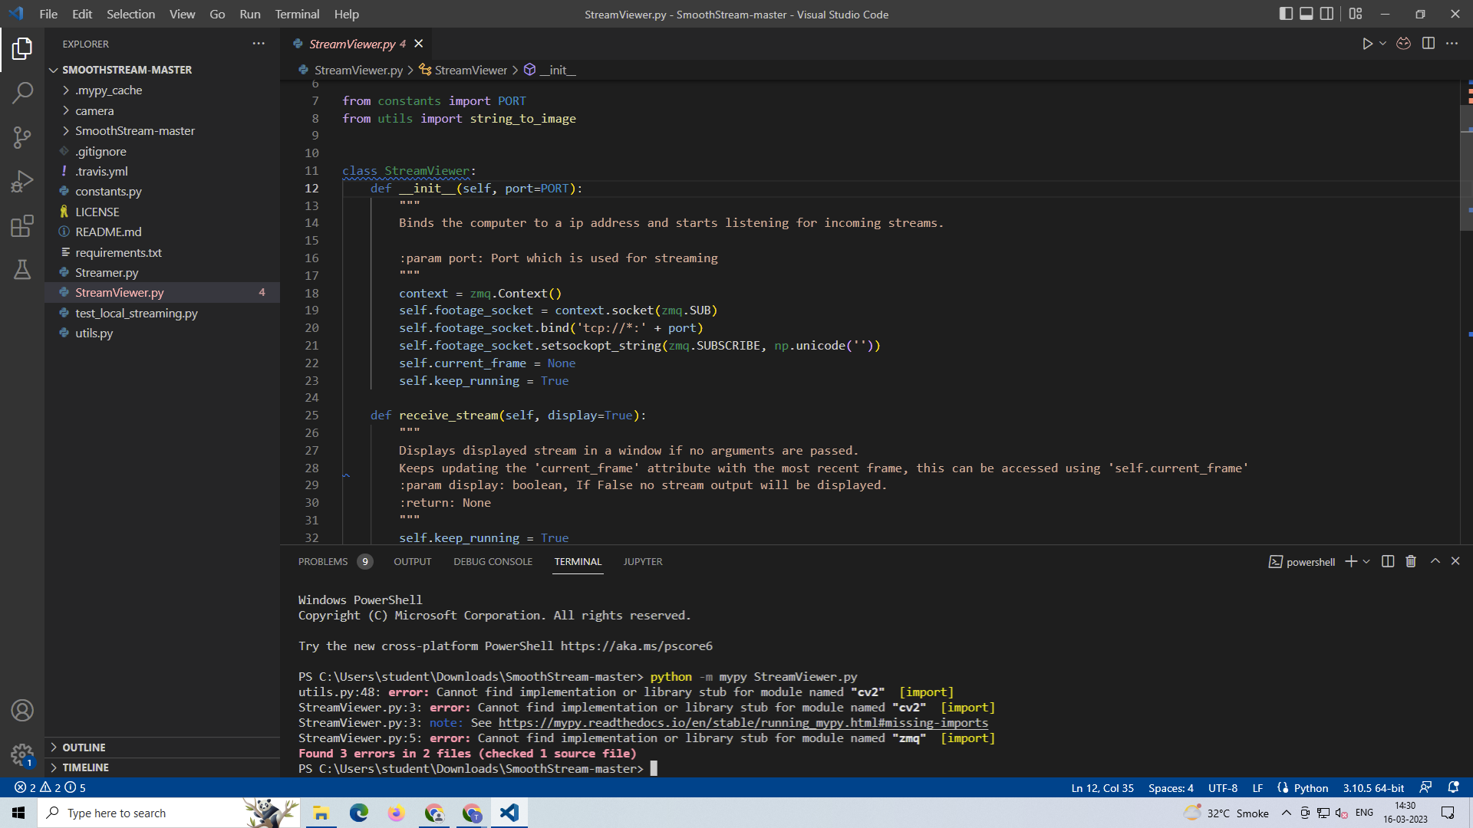

**Explanation of Errors:**

The errors are related to the cv2 and zmq module. Mypy detected the errors because the those module hasn’t been installed in the computer and therefore the functions related to it cannot be accessed.

**3. utils.py**

**Command Prompt Output:**

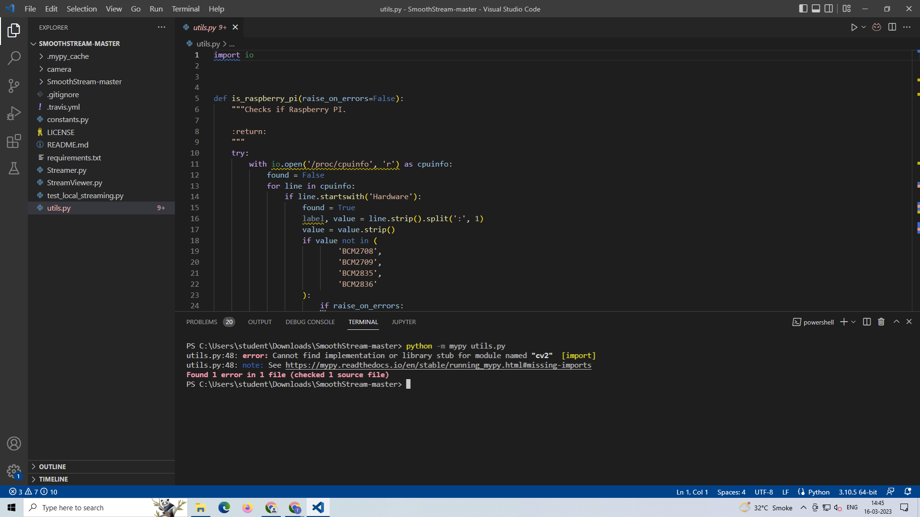

**Explanation of Errors:**

The errors are related to the cv2 module. Mypy detected the errors because the those module hasn’t been installed in the computer and therefore the functions related to it cannot be accessed.

**4. camera/Camera.py**

**Command Prompt Output:**

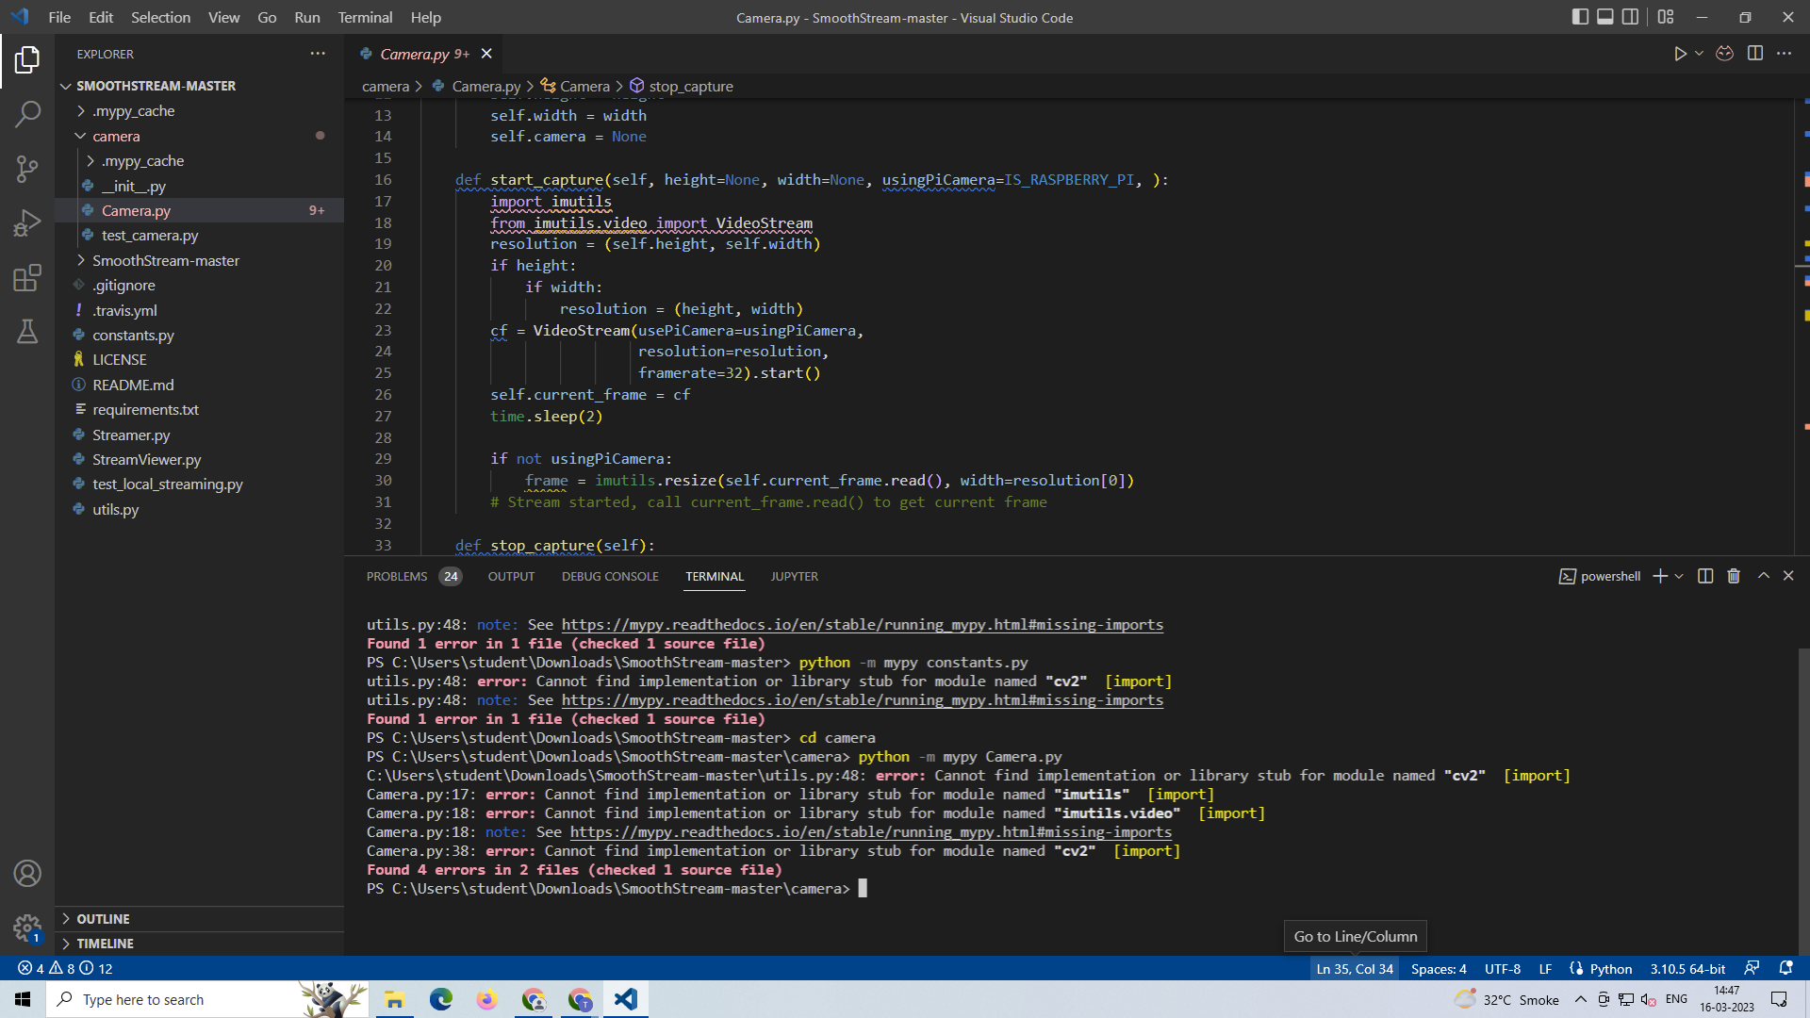

**Explanation of Errors:**

The errors are related to the imutils,imutils.video and cv2 module. Mypy detected the errors because the those module hasn’t been installed in the computer and therefore the functions related to it cannot be accessed.

**5. camera/__init__.py**

**Command Prompt Output:**

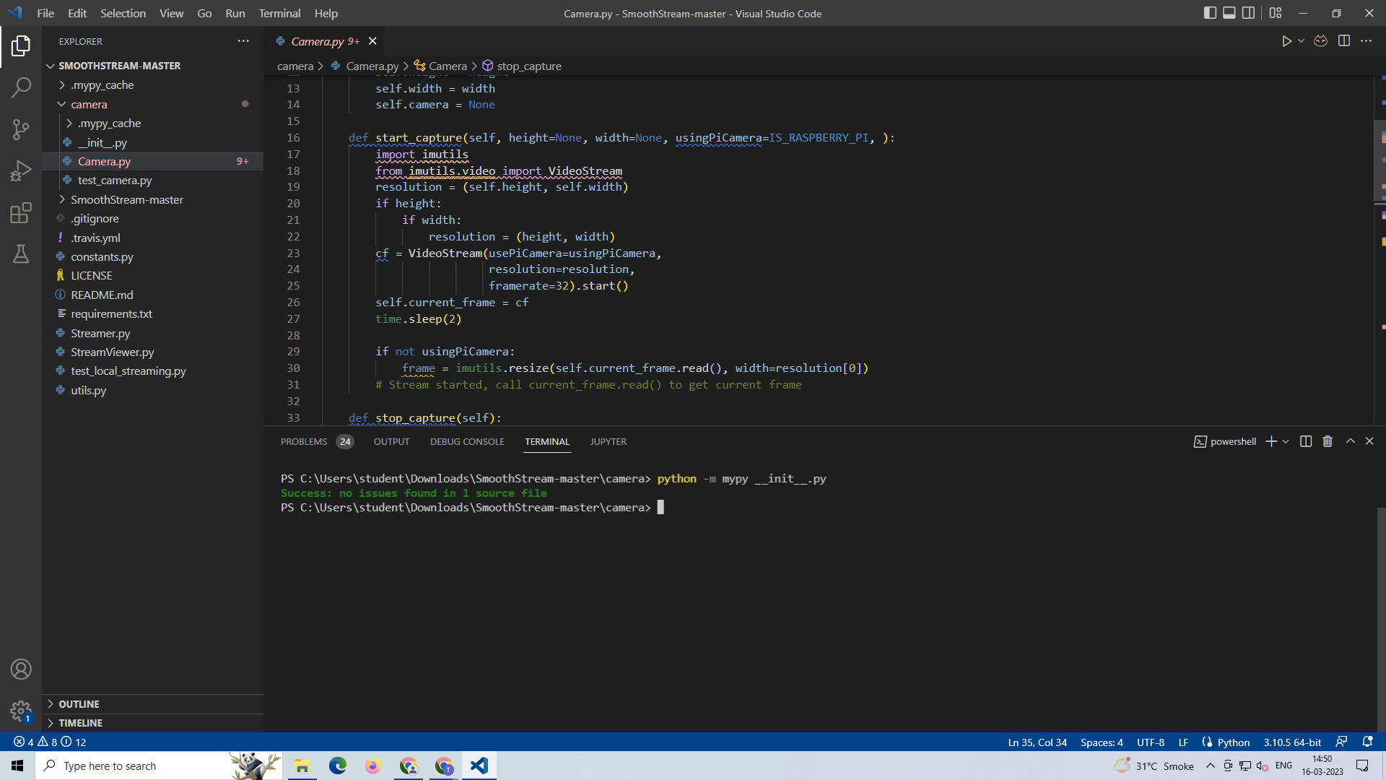

No errors detected by mypy.