
数据结构课程设计报告
（2017-2018-1）
学 院 | 计算机学院
专 业 | 软甲工程
班 级 | 二
学 号 | 16058228
姓 名 | 徐时越
完成日期 | 2017年11月

上机内容：哈夫曼树和图的存储

- 试写一算法，对输入的一个包括权重值的数组，构建其对应的哈夫曼树，并计算打印出WPL。

2. 试写出一算法，根据依次输入的顶点数据，边的数目，各顶点的信息和各条边的信息，建立一个无向图的邻接表。打印输出该邻接表。

将运行结果截屏和代码粘贴至本文档。邮件标题和Doc文档均以“学号+姓名+数据结构1107” 命名。作业发送到 j2ee5511@163.com。

=======================以下是提交的作业============
1.

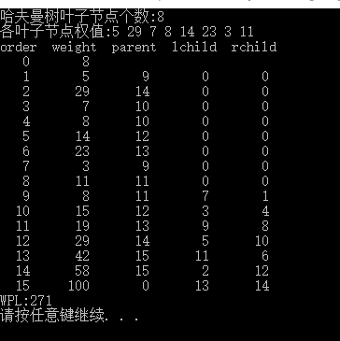

#include <stdio.h>
#include <stdlib.h>

#define OK 1
#define ERROR 0
#define OVERFLOW -2
#define MAX_TREE_SIZE 100
typedef int Status;

typedef struct
{
unsigned int weight;
unsigned int parent;
unsigned int lchild;
unsigned int rchild;
}HTNode;
typedef HTNode *HuffmanTree;

void InitTree_HT(HuffmanTree *HT)
{
*HT = NULL;
}

void CreateHuffmanTree_HT(HuffmanTree *HT)
{
int m, n;
int w[MAX_TREE_SIZE];
HuffmanTree p;
int s1, s2;
printf("哈夫曼树叶子节点个数:");
scanf("%d", &n);
printf("各叶子节点权值:");
for (int i = 1; i <= n; i++)
{
scanf("%d", &w[i]);
}
m = 2 * n - 1;
*HT = (HuffmanTree)malloc((m + 1) * sizeof(HTNode));
if (!(*HT)) exit(OVERFLOW);
(*HT)[0].weight = n;
for (int i = 1; i <= m; i++)
{
if (i <= n)
(*HT)[i].weight = w[i];
else
(*HT)[i].weight = 0;
(*HT)[i].parent = 0;
(*HT)[i].lchild = 0;
(*HT)[i].rchild = 0;
}
for (int i = n + 1; i <= m; i++)
{
Select_HT(*HT, i - 1, &s1, &s2);
(*HT)[s1].parent = (*HT)[s2].parent = i;
(*HT)[i].lchild = s1;
(*HT)[i].rchild = s2;
(*HT)[i].weight = (*HT)[s1].weight + (*HT)[s2].weight;
}
return OK;
}

Status Select_HT(HuffmanTree HT, int end, int *order_1, int *order_2)
{
HuffmanTree p;
int i, count;
int m, n, temp;
if (end < 2) return ERROR;
for (i = 1, count = 1; i <= end; i++)
{
if (HT[i].parent == 0)
{
if (count == 1) m = i;
if (count == 2) n = i;
count++;
}
if (count > 2) break;
}
if (HT[m].weight > HT[n].weight)
{
temp = n;
n = m;
m = temp;
}
i = (m > n ? m : n) + 1;
while (i <= end)
{
if (HT[i].parent == 0)
{
if (HT[i].weight < HT[m].weight)
{
n = m;
m = i;
}
else
{
if (HT[i].weight >= HT[m].weight &&HT[i].weight < HT[n].weight)
n = i;
}
}
i++;
}
*order_1 = HT[m].weight <= HT[n].weight ? m : n;
*order_2 = HT[m].weight > HT[n].weight ? m : n;
return OK;
}

void ShowHuffmanTree_HT(HuffmanTree HT)
{
printf("order weight parent lchild rchild\n");
for (int i = 0; i < 2 * HT[0].weight; i++)
{
if (i == 0)
printf("%4d %7d\n", i, HT[i].weight);
else
printf("%4d %7d %7d %7d %7d\n", i, HT[i].weight, HT[i].parent, HT[i].lchild, HT[i].rchild);
}
}

void WPL(HuffmanTree HT)
{
int wpl=0;
int n = HT[0].weight;
int N;
for (int i = 1; i <= n; i++)
{
if (HT[i].parent % 2 == 0)
{
N = (2 * n + 2 - HT[i].parent) / 2;
}
else
{
N = (2 * n + 1 - HT[i].parent) / 2;
}
wpl += HT[i].weight * N;
}
printf("WPL:%d\n", wpl);
}

void main()
{
void CreateHuffmanTree_HT(HuffmanTree *HT);
void InitTree_HT(HuffmanTree *HT);
void ShowHuffmanTree_HT(HuffmanTree HT);
void WPL(HuffmanTree HT);
HuffmanTree HT;
InitTree_HT(&HT);
CreateHuffmanTree_HT(&HT);
ShowHuffmanTree_HT(HT);
WPL(HT);
system("pause");
}

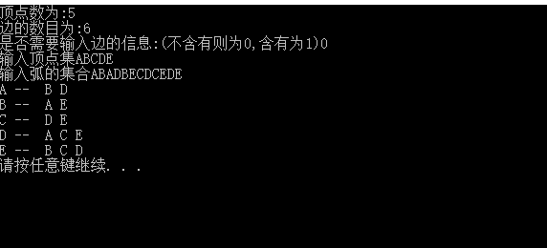
#include <stdio.h>
#include <stdlib.h>

#define OK 1
#define ERROR 0
#define OVERFLOW -2
#define MAX_TREE_SIZE 100
typedef int Status;
#define MAX_VERTEX_NUM 20

typedef struct
{
int info;
}InfoType;

typedef struct ArcNode
{
int adjvex;
struct ArcNode *nextarc;
InfoType Info;
}ArcNode;

typedef char VertexType;
typedef struct VNode
{
VertexType data;
ArcNode *firstarc;
}VNode;

typedef VNode AdjList[MAX_VERTEX_NUM + 1];

typedef struct
{
AdjList vertices;
int vexnum, arcnum;
int IncInfo;
}ALGraph;

Status CreateGraph(ALGraph *G)
{
int i, j, k;
char temp;
VertexType v1, v2;
ArcNode *p, *q;
ArcNode *r[MAX_VERTEX_NUM+1];
printf("顶点数为:");
scanf("%d", &((*G).vexnum));
printf("边的数目为:");
scanf("%d", &((*G).arcnum));
printf("是否需要输入边的信息:(不含有则为0,含有为1)");
scanf("%d", &((*G).IncInfo));
printf("输入顶点集");
scanf("%c", &temp);
for (i = 1; i <= (*G).vexnum; i++)
{
scanf("%c", &((*G).vertices[i].data));
(*G).vertices[i].firstarc = NULL;
r[i] = NULL;
}
scanf("%c", &temp);
printf("输入弧的集合");
for (k = 1; k <= (*G).arcnum; k++)
{
scanf("%c%c", &v1, &v2);
i = LocateVex(*G, v1);
j = LocateVex(*G, v2);
if (!i || !j) return ERROR;
p = (ArcNode *)malloc(sizeof(ArcNode));
if (!p) exit(OVERFLOW);
p->adjvex = j;
p->nextarc = NULL;
if ((*G).IncInfo == 1)
{
printf("输入其它信息");
scanf("%d", &(p->Info.info));
}
if (r[i] == NULL)
(*G).vertices[i].firstarc = p;
else
r[i]->nextarc = p;
r[i] = p;
q = (ArcNode *)malloc(sizeof(ArcNode));
if (!q)
exit(OVERFLOW);
q->adjvex = i;
q->nextarc = NULL;
if ((*G).IncInfo == 1)
q->Info = p->Info;
if (r[j] == NULL)
(*G).vertices[j].firstarc = q;
else
r[j]->nextarc = q;
r[j] = q;
}
return OK;
}

int LocateVex(ALGraph G, VertexType u)
{
int i;
for (i = 1; i <= G.vexnum; i++)
{
if (G.vertices[i].data == u)
return i;
}
return 0;
}

void OutputGraph(ALGraph G)
{
int i, j;
ArcNode *p;
if (!G.vexnum && !G.arcnum)
printf("此图为空图");
else
{
for (i = 1; i <= G.vexnum; i++)
{
printf("%c -- ", G.vertices[i].data);
p = G.vertices[i].firstarc;
while (p)
{
printf(" %c", G.vertices[p->adjvex].data);
p = p->nextarc;
}
printf("\n");
}
}
}
void main()
{
Status CreateGraph(ALGraph *G);
void OutputGraph(ALGraph G);
ALGraph G;
CreateGraph(&G);
OutputGraph(G);
system("pause");
}

