
数据结构课程设计报告
（2017-2018-1）
学 院 | 计算机学院
专 业 | 软件工程
班 级 | 二班
学 号 | 16058228
姓 名 | 徐时越
完成日期 | 2017年11月

上机内容：最短路径、最小生成树、关键路径

- 试写出一算法，以邻接表作存储结构实现求从源点到其余各顶点的最短路径的Dijkstra算法。

- 试写出一算法，实现Prim算法，生成图的最小生成树。

- 编写利用深度优先遍历有向图实现求实现求关键路径算法。

邮件标题和Doc文档均以“学号+姓名+数据结构1121” 命名。作业发送到 j2ee5511@163.com。

=======================以下是提交的作业============

1.
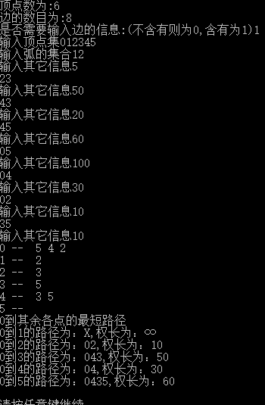
#include <stdio.h>
#include <stdlib.h>
#pragma warning(disable:4996)
#define OK 1
#define ERROR 0
#define OVERFLOW -2
#define MAX_TREE_SIZE 100
typedef int Status;
#define MAX_VERTEX_NUM 20

typedef struct
{
int info;
}InfoType;

typedef struct ArcNode
{
int adjvex;
struct ArcNode *nextarc;
InfoType Info;
}ArcNode;

typedef char VertexType;
typedef struct VNode
{
VertexType data;
ArcNode *firstarc;
}VNode;

typedef VNode AdjList[MAX_VERTEX_NUM + 1];

typedef struct
{
AdjList vertices;
int vexnum, arcnum;
int IncInfo;
}ALGraph;

Status CreateGraph(ALGraph *G)
{
int i, j, k;
char temp;
VertexType v1, v2;
ArcNode *p;
ArcNode *r[MAX_VERTEX_NUM + 1];
printf("顶点数为:");
scanf("%d", &((*G).vexnum));
printf("边的数目为:");
scanf("%d", &((*G).arcnum));
printf("是否需要输入边的信息:(不含有则为0,含有为1)");
scanf("%d", &((*G).IncInfo));
printf("输入顶点集");
scanf("%c", &temp);
for (i = 1; i <= (*G).vexnum; i++)
{
scanf("%c", &((*G).vertices[i].data));
(*G).vertices[i].firstarc = NULL;
r[i] = NULL;
}
scanf("%c", &temp);
printf("输入弧的集合");
char *temp2='\0';
for (k = 1; k <= (*G).arcnum; k++)
{
scanf("%c%c", &v1, &v2);
getchar(temp2);
i = LocateVex(*G, v1);
j = LocateVex(*G, v2);
if (!i || !j) return ERROR;
p = (ArcNode *)malloc(sizeof(ArcNode));
if (!p) exit(OVERFLOW);
p->adjvex = j;
p->nextarc = NULL;
if ((*G).IncInfo == 1)
{
printf("输入其它信息");
scanf("%d", &(p->Info.info));
getchar(temp2);
}
if (r[i] == NULL)
(*G).vertices[i].firstarc = p;
else
r[i]->nextarc = p;
r[i] = p;
}
return OK;
}

int LocateVex(ALGraph G, VertexType u)
{
int i;
for (i = 1; i <= G.vexnum; i++)
{
if (G.vertices[i].data == u)
return i;
}
return 0;
}

void OutputGraph(ALGraph G)
{
int i, j;
ArcNode *p;
if (!G.vexnum && !G.arcnum)
printf("此图为空图");
else
{
for (i = 1; i <= G.vexnum; i++)
{
printf("%c -- ", G.vertices[i].data);
p = G.vertices[i].firstarc;
while (p)
{
printf(" %c", G.vertices[p->adjvex].data);
p = p->nextarc;
}
printf("\n");
}
}
}
int GetInfo(ALGraph G, int i, int j)
{
ArcNode *r;
r = G.vertices[i].firstarc;
while (r && r->adjvex != j)
r = r->nextarc;
if (r && r->adjvex == j)
return r->Info.info;
return INT_MAX;
}

void Dijkstra(ALGraph G,int v0,int path[],int dist[])
{
int set[MAX_VERTEX_NUM + 1];
int min, i, j, v, k;
int tmp[MAX_VERTEX_NUM + 1];
for (i = 1; i <= G.vexnum; i++)
{
dist[i] = GetInfo(G, v0, i);
set[i] = 0;
if (GetInfo(G, v0, i) < INT_MAX)
path[i] = v0;
else
path[i] = -1;
}
set[v0] = 1;
path[v0] = -1;
for (i = 1; i <= G.vexnum; i++)
{
min = INT_MAX;
for (j = 1; j <= G.vexnum; j++)
{
if (!set[j] && dist[j]<min)
{
v = j;
min = dist[j];
}
}
set[v] = 1;
for (j = 1; j <= G.vexnum; j++)
{
if (!set[j] && min < INT_MAX && GetInfo(G, v, j) < INT_MAX && (min + GetInfo(G, v, j)) < dist[j])
{
dist[j] = min + GetInfo(G, v, j);
path[j] = v;
}
}
}
for (i = 1; i <= G.vexnum; i++)
{
if (v0 != i)
{
printf("%c到%c的路径为：", G.vertices[v0].data, G.vertices[i].data);
if (path[i] == -1)
printf("X");
else
{
tmp[0] = 0;
if (v0 != i)
{
k = i;
do
{
tmp[0]++;
tmp[tmp[0]] = k;
k = path[k];
} while (path[k] != -1);
}
printf("%c", G.vertices[v0].data);
if (tmp[0])
{
for (j = tmp[0]; j >= 1; j--)
printf("%c", G.vertices[tmp[j]].data);
}
}
printf(",权长为：");
if (dist[i] == INT_MAX)
printf("∞\n");
else
printf("%2d\n", dist[i]);
}
}
}

void main()
{
Status CreateGraph(ALGraph *G);
void OutputGraph(ALGraph G);
void Dijkstra(ALGraph G, int v0, int path[], int dist[]);
ALGraph G;
int path[MAX_VERTEX_NUM + 1];
int dist[MAX_VERTEX_NUM + 1];
int v0 = 1;
CreateGraph(&G);
OutputGraph(G);
printf("%c到其余各点的最短路径\n", G.vertices[v0].data);
Dijkstra(G, v0, path, dist);
printf("\n");
system("pause");
}

2.
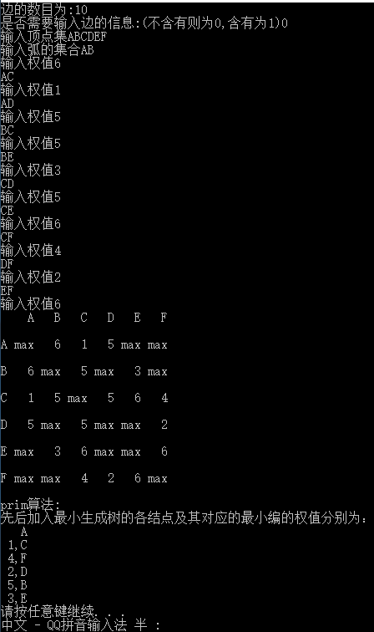
#include <stdio.h>
#include <stdlib.h>
#pragma warning(disable:4996)
#define OK 1
#define TRUE 1
#define ERROR 0
#define OVERFLOW -2
#define MAX_VERTEX_NUM 20
typedef int Status;
typedef struct
{
int info;
}InfoType;
typedef int VRType;
typedef struct ArcCell
{
VRType adj;
InfoType info;
}ArcCell;
typedef ArcCell AdjMatrix[MAX_VERTEX_NUM + 1][MAX_VERTEX_NUM + 1];
typedef struct
{
char vexs[MAX_VERTEX_NUM + 1];
AdjMatrix arcs;
int vexnum, arcnum;
int IncInfo;
}MGraph;

typedef struct
{
char adjvex;
VRType lowcost;
}Edge;
typedef struct
{
int a, b;
int w;
}EdgeSetType;

int LocateVex(MGraph G, char u)
{
int i;
for (i = 1; i <= G.vexnum; i++)
{
if (G.vexs[i] == u)
return i;
}
return 0;
}
Status CreateUND(MGraph *G)
{
int i, j, k;
char v1, v2;
VRType w;
char tmp;
printf("顶点数为:");
scanf("%d", &((*G).vexnum));
printf("边的数目为:");
scanf("%d", &((*G).arcnum));
printf("是否需要输入边的信息:(不含有则为0,含有为1)");
scanf("%d", &((*G).IncInfo));
printf("输入顶点集");
scanf("%c", &tmp);
for (i = 1; i <= (*G).vexnum; i++)
scanf("%c", &((*G).vexs[i]));
scanf("%c", &tmp);
for (i = 1; i <= (*G).vexnum; i++)
{
for (j = 1; j <= (*G).vexnum; j++)
(*G).arcs[i][j].adj = INT_MAX;
}
printf("输入弧的集合");
for (k = 1; k <= G->arcnum; k++)
{
scanf("%c%c", &v1, &v2);
getchar(tmp);
i = LocateVex(*G, v1);
j = LocateVex(*G, v2);
if (!i || !j) return ERROR;
printf("输入权值");
scanf("%d", &((*G).arcs[i][j].adj));
getchar(tmp);
if((*G).IncInfo == 1)
scanf("%d", &((*G).arcs[i][j].info));
(*G).arcs[j][i] = (*G).arcs[i][j];
}
return OK;
}

void OutputMGraph(MGraph G)
{
int i, j;
if (!G.vexnum && !G.arcnum)
printf("空表");
else
{
printf(" ");
for (i = 1; i <= G.vexnum; i++)
printf("%4c", G.vexs[i]);
printf("\n\n");
for (i = 1; i <= G.vexnum; i++)
{
printf("%c", G.vexs[i]);
for (j = 1; j <= G.vexnum; j++)
{
if (G.arcs[i][j].adj == INT_MAX)
printf("%4s","max");
else
printf("%4d", G.arcs[i][j]);
}
printf("\n\n");
}
}
}

int Minimum(Edge closedge[], int n)
{
int i, j;
int min = INT_MAX;
for (i = 1,j = 0; i <= n; i++)
{
if (closedge[i].lowcost)
{
if (closedge[i].lowcost <= min)
{
min = closedge[i].lowcost;
j = i;
}
}
}
return j;
}

void MinSpanTree(MGraph G,char u)
{
int i, j, k;
Edge closedge[21];
k = LocateVex(G, u);
for (j = 1; j <= G.vexnum; j++)
{
if (j != k)
{
closedge[j].adjvex = u;
closedge[j].lowcost = G.arcs[k][j].adj;
}
}
closedge[k].lowcost = 0;
printf(" %c\n", u);
for (i = 1; i <= G.vexnum-1; i++)
{
k = Minimum(closedge, G.vexnum);
printf("%2d,%c\n", closedge[k].lowcost, G.vexs[k]);
closedge[k].lowcost = 0;
for (j = 1; j <= G.vexnum; j++)
{
if (G.arcs[k][j].adj < closedge[j].lowcost)
{
closedge[j].adjvex = G.vexs[k];
closedge[j].lowcost = G.arcs[k][j].adj;
}
}
}
}

void main()
{
Status CreateUND(MGraph *G);
void OutputMGraph(MGraph G);
MGraph G;
CreateUND(&G);
OutputMGraph(G);
printf("prim算法:\n");
printf("先后加入最小生成树的各结点及其对应的最小编的权值分别为：\n");
MinSpanTree(G,'A');
system("pause");
}

3.
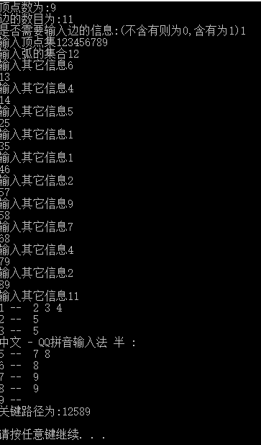
#include <stdio.h>
#include <stdlib.h>
#pragma warning(disable:4996)
#define OK 1
#define TRUE 1
#define ERROR 0
#define OVERFLOW -2
#define MAX_TREE_SIZE 100
typedef int Status;
#define MAX_VERTEX_NUM 20
#define STACK_INIT_SIZE 100
#define STACKINCREMENT 10
typedef struct
{
int info;
}InfoType;

typedef struct ArcNode
{
int adjvex;
struct ArcNode *nextarc;
InfoType Info;
}ArcNode;

typedef char VertexType;
typedef struct VNode
{
VertexType data;
ArcNode *firstarc;
}VNode;

typedef VNode AdjList[MAX_VERTEX_NUM + 1];

typedef struct
{
AdjList vertices;
int vexnum, arcnum;
int IncInfo;
}ALGraph;

typedef struct
{
int *base;
int *top;
int stacksize;
}SqStack;

int path[MAX_VERTEX_NUM + 1][MAX_VERTEX_NUM + 1];
int step;
SqStack S;

Status InitStack_Sq(SqStack *S)
{
(*S).base = (int *)malloc(STACK_INIT_SIZE * sizeof(int));
if (!(*S).base) exit(OVERFLOW);
(*S).top = (*S).base;
(*S).stacksize = STACK_INIT_SIZE;
return OK;
}

Status Push(SqStack *S, int e)
{
if ((*S).top - (*S).base >= (*S).stacksize)
{
(*S).base = (int *)realloc((*S).base, ((*S).stacksize + STACKINCREMENT) * sizeof(int));
if (!(*S).base) exit(OVERFLOW);
(*S).top = (*S).base + (*S).stacksize;
(*S).stacksize += STACKINCREMENT;
}
*(S->top) = e;
(S->top)++;
return OK;
}

Status Pop(SqStack *S, int *e)
{
if ((*S).top == (*S).base) return ERROR;
(*S).top--;
*e = *((*S).top);
return OK;
}

Status StackEmpty(SqStack S)
{
if (S.top == S.base)
return TRUE;
else
return ERROR;
}

Status CreateGraph(ALGraph *G)
{
int i, j, k;
char temp;
VertexType v1, v2;
ArcNode *p;
ArcNode *r[MAX_VERTEX_NUM + 1];
printf("顶点数为:");
scanf("%d", &((*G).vexnum));
printf("边的数目为:");
scanf("%d", &((*G).arcnum));
printf("是否需要输入边的信息:(不含有则为0,含有为1)");
scanf("%d", &((*G).IncInfo));
printf("输入顶点集");
scanf("%c", &temp);
for (i = 1; i <= (*G).vexnum; i++)
{
scanf("%c", &((*G).vertices[i].data));
(*G).vertices[i].firstarc = NULL;
r[i] = NULL;
}
scanf("%c", &temp);
printf("输入弧的集合");
char *temp2='\0';
for (k = 1; k <= (*G).arcnum; k++)
{
scanf("%c%c", &v1, &v2);
getchar(temp2);
i = LocateVex(*G, v1);
j = LocateVex(*G, v2);
if (!i || !j) return ERROR;
p = (ArcNode *)malloc(sizeof(ArcNode));
if (!p) exit(OVERFLOW);
p->adjvex = j;
p->nextarc = NULL;
if ((*G).IncInfo == 1)
{
printf("输入其它信息");
scanf("%d", &(p->Info.info));
getchar(temp2);
}
if (r[i] == NULL)
(*G).vertices[i].firstarc = p;
else
r[i]->nextarc = p;
r[i] = p;
}
return OK;
}

int LocateVex(ALGraph G, VertexType u)
{
int i;
for (i = 1; i <= G.vexnum; i++)
{
if (G.vertices[i].data == u)
return i;
}
return 0;
}

void OutputGraph(ALGraph G)
{
int i, j;
ArcNode *p;
if (!G.vexnum && !G.arcnum)
printf("此图为空图");
else
{
for (i = 1; i <= G.vexnum; i++)
{
printf("%c -- ", G.vertices[i].data);
p = G.vertices[i].firstarc;
while (p)
{
printf(" %c", G.vertices[p->adjvex].data);
p = p->nextarc;
}
printf("\n");
}
}
}

void DFS(ALGraph G, int w)
{
ArcNode *r;
int e;
int *p;
int count;
Push(&S, w);
for (r = G.vertices[w].firstarc; r; r = r->nextarc)
{
step += r->Info.info;
DFS(G, r->adjvex);
step -= r->Info.info;
}
if (!r)
{
if (G.vertices[w].firstarc == NULL)
{
path[0][0]++;
path[path[0][0]][0] = step;
for (p = S.base, count = 1; p < S.top; p++, count++)
path[path[0][0]][count] = *p;
}
Pop(&S, &e);
}
}

int FindOrigin(ALGraph G)
{
int k;
ArcNode *r;
int mark[21];
for (k = 1; k <= G.vexnum; k++)
mark[k] = 0;
for (k = 1; k <= G.vexnum; k++)
{
r = G.vertices[k].firstarc;
while (r)
{
mark[r->adjvex] = 1;
r = r->nextarc;
}
}
for (k = 1; k <= G.vexnum; k++)
{
if (!mark[k])
return k;
}
return 0;
}

void CMP(ALGraph G)
{
int i, j, start;
int max = 0;
for (i = 0; i <= G.vexnum; i++)
{
for (j = 0; j <= G.vexnum; j++)
path[i][j] = 0;
}
step = 0;
start = FindOrigin(G);
InitStack_Sq(&S);
DFS(G, start);
for (i = 1; i <= path[0][0]; i++)
{
if (path[i][0] > max)
max = path[i][0];
}
for (i = 1; i <= path[0][0]; i++)
{
if (path[i][0] == max)
{
for (j = 1; path[i][j] && j <= MAX_VERTEX_NUM; j++)
printf("%c", G.vertices[path[i][j]].data);
printf("\n");
}
}
}

void main()
{
Status CreateGraph(ALGraph *G);
void OutputGraph(ALGraph G);
ALGraph G;
CreateGraph(&G);
OutputGraph(G);
printf("关键路径为:");
CMP(G);
printf("\n");
system("pause");
}

