
数据结构课程设计报告
（2017-2018-1）
学 院 | 计算机学院
专 业 | 软件工程
班 级 | 二班
学 号 | 16058228
姓 名 | 徐时越
完成日期 | 2017年10月

上机内容：串的连接，稀疏矩阵的存储，二叉树的创建与遍历

1.试写一算法，在串的堆分配存储结构上实现串的连接操作Concat （习题集p29, 4.24）。

2.假设稀疏矩阵 A与B均以三元组顺序表作为存储结构。试写出矩阵相加的算法，另设三元组C存放结果矩阵。（习题集p35, 5.21）

3. 用链式存储构建一个二叉树，如下图
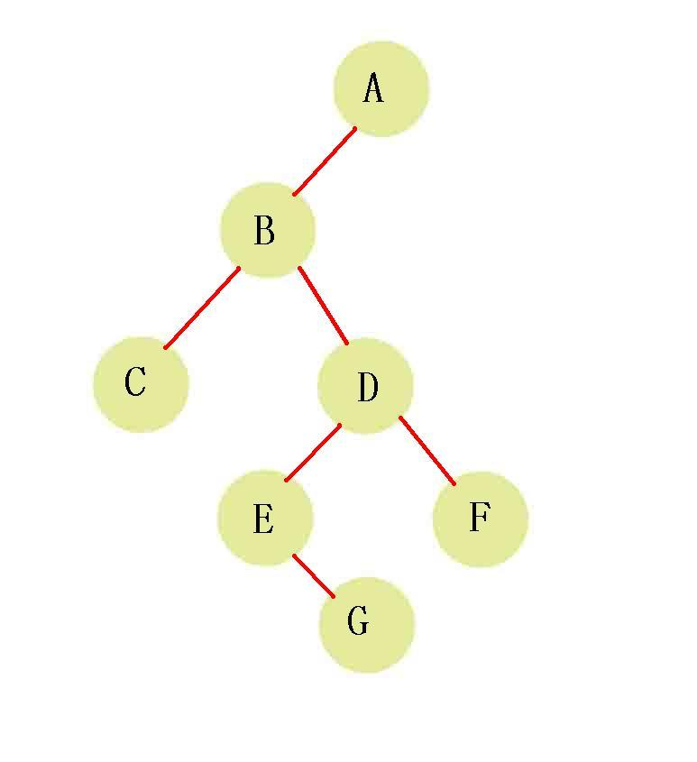
输入ABC##DE#G##F###，先构建二叉树后，然后使用非递归中序遍历的方法输出这个树。

将运行结果截屏和代码粘贴至本文档。邮件标题和Doc文档均以“学号+姓名+数据结构1024” 命名。作业发送到 j2ee5511@163.com。

=======================以下是提交的作业============
#include <stdio.h>
#include <stdlib.h>
#include <string.h>

#define OK 1
#define ERROR 0
#define OVERFLOW -2
typedef int Status;

typedef struct
{
char *ch;
int length;
}HString;

void InitString_H(HString *S)
{
(*S).ch = NULL;
(*S).length = 0;
}
int StrAssigh_H(HString *T,char *chars)
{
int i,j;
InitString_H(T);
i=strlen(chars);
if(!i)
return ERROR;
else
{
(*T).ch = (char*)malloc(i*sizeof(char));
if(!((*T).ch))
exit(OVERFLOW);
for(j=0;j<i;j++)
{
(*T).ch[j]=chars[j];
}
(*T).length=i;

}
return OK;
}
Status Concat_H(HString *T,HString S1,HString S2)
{
int i;
InitString_H(T);
(*T).length = S1.length+S2.length;
(*T).ch = (char*)malloc((*T).length*sizeof(char));
if(!(*T).ch)
exit(OVERFLOW);
for(i=0;i<S1.length;i++)
(*T).ch[i]=S1.ch[i];
for(i=0;i<S1.length;i++)
(*T).ch[S1.length+i]=S2.ch[i];
return OK;
}

void StrPrint_H(HString S)
{
int i;
for(i=0;i<S.length;i++)
printf("%c",S.ch[i]);
printf("\n");
}
void main()
{
void InitString_H(HString *S);
int StrAssigh_H(HString *T,char *chars);
Status Concat_H(HString *T,HString S1,HString S2);
void StrPrint_H(HString S);
char c1[100]="\0",c2[100]="\0";
HString H1,H2,H;
printf("String1:");
gets(c1);
printf("String2:");
gets(c2);
StrAssigh_H(&H1,c1);
StrAssigh_H(&H2,c2);
Concat_H(&H,H1,H2);
StrPrint_H(H);
system("pause");
}
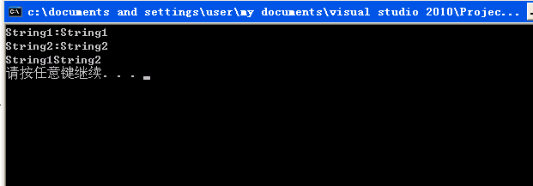

2.
#include <stdio.h>
#include <stdlib.h>
#include <string.h>

#define OK 1
#define ERROR 0
#define OVERFLOW -2
typedef int Status;

#define MAXSIZE 400

typedef struct
{
int i,j;
int e;
}Triple;
typedef struct
{
Triple data[MAXSIZE+1];
int mu,nu,tu;
}TSMatrix;

void PrintSMatrix_T(TSMatrix M)
{
int r,c;
int k=1;
for(r=1;r<=M.mu;r++)
{
for(c=1;c<=M.mu;c++)
{
if(r==M.data[k].i && c==M.data[k].j)
{
printf("%3d",M.data[k].e);
k++;
}
else
printf("%3d",0);
}
printf("\n");
}
}

int AddSMatrix_T(TSMatrix M,TSMatrix N,TSMatrix *Q)
{
int m,n,k;
if(M.mu!=N.mu || M.nu!=N.nu)
{
printf("两¢?矩?阵¨®不?能¨¹相¨¤加¨®");
return ERROR;
}
Q->mu=M.mu;
Q->nu=M.nu;
Q->tu=0;
m=n=k=1;
while(m<=M.tu && n<=N.tu)
{
if(M.data[m].i<N.data[n].i)
{
Q->data[k]=M.data[m];
m++;
}
else if(M.data[m].i>N.data[n].i)
{
Q->data[k]=N.data[n];
n++;
}
else
{
if(M.data[m].j<N.data[n].j)
{
Q->data[k]=M.data[m];
m++;
}
else if(M.data[m].j>N.data[n].j)
{
Q->data[k]=N.data[n];
n++;
}
else
{
if(M.data[m].e+N.data[n].e)
{
Q->data[k].i =M.data[m].i;
Q->data[k].j =M.data[m].j;
Q->data[k].e =M.data[m].e+N.data[n].e;
m++;
n++;
}
else
{
m++;
n++;
continue;
}
}
}
k++;
Q->tu++;
}
while(m<=M.tu)
{
Q->data[k] =N.data[m];
m++;
k++;
Q->tu++;
}
while(n<=N.tu)
{
Q->data[k] =N.data[n];
n++;
k++;
Q->tu++;
}
return OK;
}

void main()
{
void PrintSMatrix_T(TSMatrix M);
int AddSMatrix_T(TSMatrix M,TSMatrix N,TSMatrix *Q);
TSMatrix T1;
TSMatrix T2;
TSMatrix T;
T1.mu=3;
T1.nu=3;
T1.tu=2;
T1.data[1].i=2;
T1.data[1].j=2;
T1.data[1].e=2;
T1.data[2].i=3;
T1.data[2].j=3;
T1.data[2].e=3;
T2.mu=3;
T2.nu=3;
T2.tu=2;
T2.data[1].i=2;
T2.data[1].j=2;
T2.data[1].e=2;
T2.data[2].i=3;
T2.data[2].j=3;
T2.data[2].e=3;
AddSMatrix_T(T1,T2,&T);
printf("T1:\n");
PrintSMatrix_T(T1);
printf("T2:\n");
PrintSMatrix_T(T2);
printf("T1+T2:\n");
PrintSMatrix_T(T);
system("pause");
}

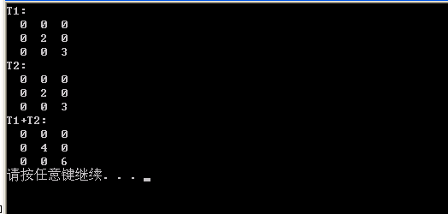
3.
#include<stdio.h>
#include<stdlib.h>
#define OK 1
#define ERROR 0
#define OVERFLOW -1
#define STACK_INIT_SIZE 100
#define STACKINCREMENT 10

typedef int Status;
typedef char ElemType;

typedef struct BiTNode {
char data;
struct BiTNode *lchild;
struct BiTNode *rchild;
}BiTNode, *BiTree;

typedef BiTree SElemType;

typedef struct {
SElemType *base;
SElemType *top;
int stacksize;
}SqStack;

BiTree CreateBiTree(BiTree T) {
char ch;
scanf("%c", &ch);
if (ch == '#') T = NULL;
else {
if (!(T = (BiTNode *)malloc(sizeof(BiTNode))))
exit(OVERFLOW);
T->data = ch;
T->lchild = CreateBiTree(T->lchild);
T->rchild = CreateBiTree(T->rchild);
}
return T;
}

Status InOrderTraverse(BiTree T, Status(*Visit)(ElemType e)) {
SqStack S;
SElemType p;
InitStack(&S); p = T;
while (p || !StackEmpty(S)) {
if (p) {
Push(&S, p); p = p->lchild;
}
else {
Pop(&S, &p); if (!Visit(p->data)) return ERROR;
p = p->rchild;
}
}
DestroyStack(&S);
return OK;

}

Status Visit(ElemType e) {
if (e == '\0') {
return ERROR;
}
else {
printf("%c", e);
}
return OK;
}

Status InitStack(SqStack *S) {
S->base = (SElemType *)malloc(STACK_INIT_SIZE * sizeof(SElemType));
if (!S->base)
{
printf("分配内存失败.\n");
exit(0);
}
S->top = S->base;
S->stacksize = STACK_INIT_SIZE;
return OK;
}

Status DestroyStack(SqStack *S) {
if (!S)
{
exit(0);
}
free(S->base);
return OK;
}

Status StackEmpty(SqStack S) {
if (S.top == S.base)
return 1;
else
return 0;
}

Status GetTop(SqStack S, SElemType *e) {
if (S.top == S.base) {
return 0;
}
else {
*e = *(S.top - 1);
return OK;
}
}

Status Push(SqStack *S, SElemType e) {
if (S->top - S->base >= S->stacksize)
{
S->base = (SElemType *)realloc(S->base, (S->stacksize + STACKINCREMENT) * sizeof(SElemType));
if (!S->base)
{
printf("重新申请空间失败.\n");
exit(0);
}
S->top = S->base + S->stacksize;
S->stacksize += STACKINCREMENT;
}
*S->top++ = e;
return OK;
}

Status Pop(SqStack *S, SElemType *e) {
if (S->top == S->base)
{
return ERROR;
}
*e = *(--S->top);
return OK;
}

int main()
{
BiTree CreateBiTree(BiTree T);
Status Visit(ElemType e);
BiTree T = NULL;
Status(*visit)(ElemType e) = Visit;
T = CreateBiTree(T);
InOrderTraverse(T, visit);
system("pause");
return 0;
}
