"Genshin Impact" had become a massively popular action role-playing game developed and published by miHoYo. Known for its stunning visuals, immersive open-world exploration, and diverse cast of characters, "Genshin Impact" has captured the hearts of gamers worldwide.

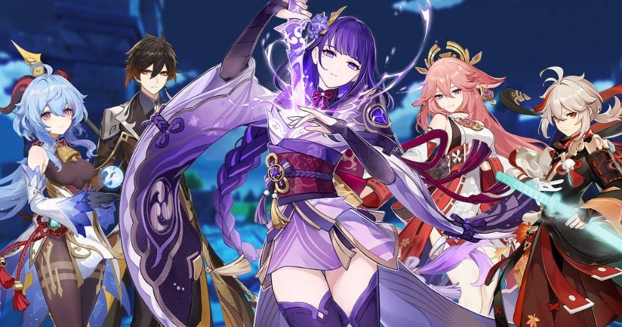

The release of the "Genshin Impact: Official Art Book Vol. 1" would likely be an eagerly anticipated addition for fans of the game. Artbooks like these often provide insights into the creative process behind the game's design, showcasing concept art, character designs, landscapes, and other visual elements that contributed to the game's rich and vibrant world.

Here are some things you might expect from the "Genshin Impact: Official Art Book Vol. 1":

Character Designs: One of the highlights of "Genshin Impact" is its diverse and colorful cast of characters. The artbook would likely feature early sketches, design iterations, and final artwork for characters such as the Traveler, Venti, Diluc, Jean, and many others. Fans would get a glimpse into how these characters evolved from concept to completion.

World and Environment Art: The world of "Genshin Impact" is vast and visually stunning, with diverse landscapes ranging from lush forests to snowy mountains and vibrant cities. The artbook would likely showcase concept art and illustrations of these environments, providing insight into the artistic inspiration behind each area of the game.

Creatures and Monsters: From adorable mascots like Paimon to fearsome bosses and monsters, "Genshin Impact" features a wide array of creatures. The artbook would likely include concept art and illustrations of these creatures, along with notes on their design and role within the game.

Behind-the-Scenes Commentary: Artbooks often include commentary from the game developers, artists, and designers, providing additional context and insights into the creative process. Fans can learn more about the inspirations, challenges, and decisions that went into creating the world of "Genshin Impact."

Exclusive Artwork: In addition to showcasing artwork from the game itself, the artbook may also include exclusive illustrations created specifically for the book. These could include special promotional artwork, holiday-themed illustrations, or artwork created by guest artists.