Mixue's marketing strategy is a delicious blend of affordability, accessibility, and a touch of buzz. At its core lies a focus on value. Mixue offers high-quality ingredients and tasty treats at prices significantly lower than many competitors. This value proposition positions them as a refreshing and affordable indulgence for a broad range of consumers. Their stores are strategically located in high-traffic areas, ensuring convenience and maximizing brand visibility.

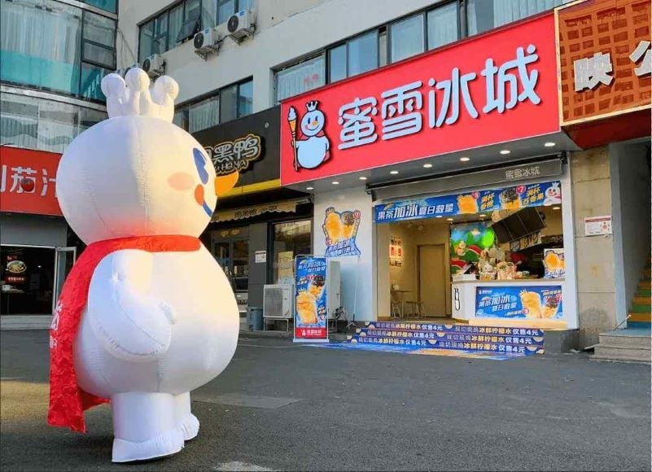

Beyond affordability, Mixue understands the power of buzz. Their mascot, Xue Bao (Snow Treasure), is a cute cartoon snowman with a surprisingly large social media following. Engaging online content featuring Xue Bao keeps the brand relevant and playful. Additionally, user-generated content featuring satisfied customers enjoying Mixue treats fuels a sense of community and encourages others to try their products.

Mixue also capitalizes on strategic franchising. Their standardized operations and comprehensive support system empower franchisees to establish successful outlets quickly. This rapid expansion strategy allows Mixue to saturate markets and become a familiar, trusted brand for tea and ice cream lovers worldwide.