Valheim is an indie survival and exploration game developed by Iron Gate Studio. Known for its procedurally generated worlds, cooperative multiplayer gameplay, and Viking-themed setting, Valheim has garnered a dedicated fanbase since its release in early 2021. Players are tasked with exploring the game's vast and mysterious world, crafting tools and weapons, building structures, and battling formidable creatures as they strive to conquer the game's challenges.

One of the key features of Valheim is its robust building system, which allows players to construct elaborate structures limited only by their imagination and available resources. This has led to players recreating iconic landmarks and structures from various media within the game, including movies like "Spirited Away," a beloved animated film by Studio Ghibli.

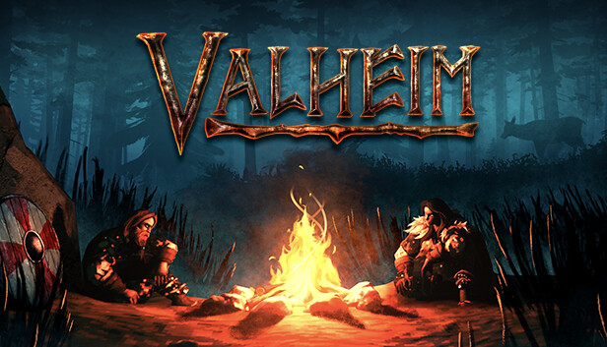

Yubaba's bathhouse, featured prominently in "Spirited Away," is a whimsical and enchanting location known for its intricate design and bustling atmosphere. Recreating such a location in Valheim is a testament to both the game's flexible building mechanics and the creativity of its players.

To build Yubaba's bathhouse in Valheim, players would likely need to gather a variety of resources, including wood, stone, and other building materials. The structure would need to incorporate elements such as the distinctive bathhouse architecture, intricate details like railings and decorative elements, and perhaps even interior spaces reminiscent of the film.

Players may also choose to add their own touches and interpretations to the build, customizing it to fit within the game's Viking-inspired world while still capturing the essence of Yubaba's bathhouse from "Spirited Away." This could involve experimenting with different building techniques, incorporating in-game decorations and furnishings, and paying close attention to the finer details that make the bathhouse so iconic.

Once completed, Yubaba's bathhouse would stand as a testament to the creativity and ingenuity of Valheim players, showcasing the game's ability to inspire imaginative and awe-inspiring creations within its expansive world. Whether it's recreating beloved landmarks from popular culture or crafting entirely original structures, Valheim offers players the opportunity to unleash their creativity and leave their mark on the game's ever-evolving landscape.