ChatGPT is an AI chatbot launched by OpenAI in late November 2022. It's based on large language models, which means it can communicate and generate human-like text in response to a wide range of prompts and questions. One of its strengths is the ability to tailor conversations to your needs. You can steer the discussion in a specific direction, choose the formality level, and even set the desired length and detail.

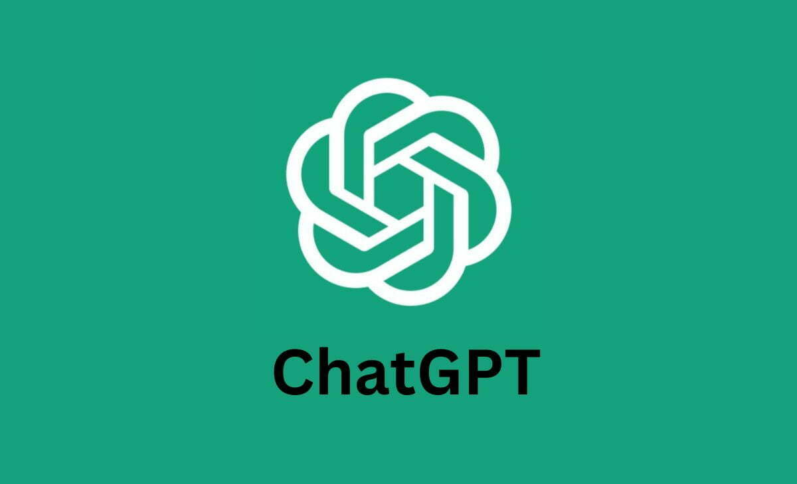

ChatGPT is free to use and offers a variety of features. You can have conversations with ChatGPT through text chat, or even use voice chat to interact with it more naturally. As of April 2024, there's also a new feature that allows you to show ChatGPT images and have a conversation based on them. This opens up new possibilities for using ChatGPT for things like brainstorming ideas or getting help with creative tasks.

Overall, ChatGPT is a powerful tool for anyone who wants to explore the potential of AI for conversation and creative text generation. It's constantly being updated with new features, making it a versatile and user-friendly option for interacting with AI technology.