Google's Gemini model is a powerful family of large language models (LLMs) designed for various tasks. Launched in early 2024, it quickly gained attention for its capabilities. Gemini comes in three sizes: Ultra, Pro, and Nano. Ultra is the largest and most powerful, tackling complex tasks. Pro offers a balance between power and efficiency, making it suitable for a wide range of applications. Finally, Nano is the most lightweight version, ideal for on-device use.

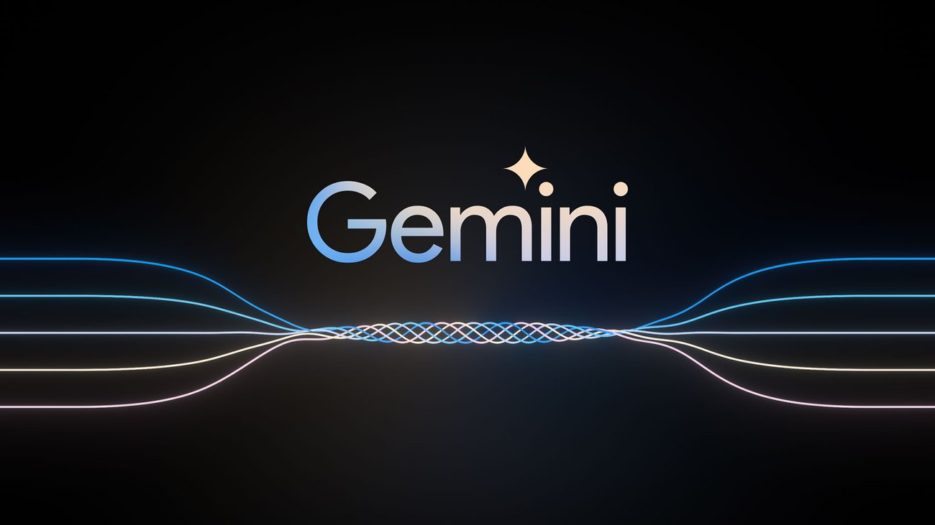

In February 2024, Google introduced Gemini 1.5, the next generation of the model. This version boasts significant performance improvements with a more efficient architecture. Notably, Gemini 1.5 Pro offers a groundbreaking feature in long-context understanding, allowing it to analyze and understand vast amounts of information. This improvement paves the way for even more sophisticated applications.

Gemini's reach extends beyond Google products. In January 2024, Google partnered with Samsung to integrate Gemini Nano and Pro into the Galaxy S24 lineup. Additionally, Google offers a free and open-source version called Gemma, making this powerful technology accessible to a broader audience. With its versatility and continuous development, the Gemini model is poised to play a significant role in the future of AI.