Valorant combines elements of traditional first-person shooter gameplay with unique character abilities, akin to games like Counter-Strike and Overwatch. The game features a diverse cast of characters known as "Agents," each with their own set of abilities that players can use strategically to gain an advantage over their opponents.

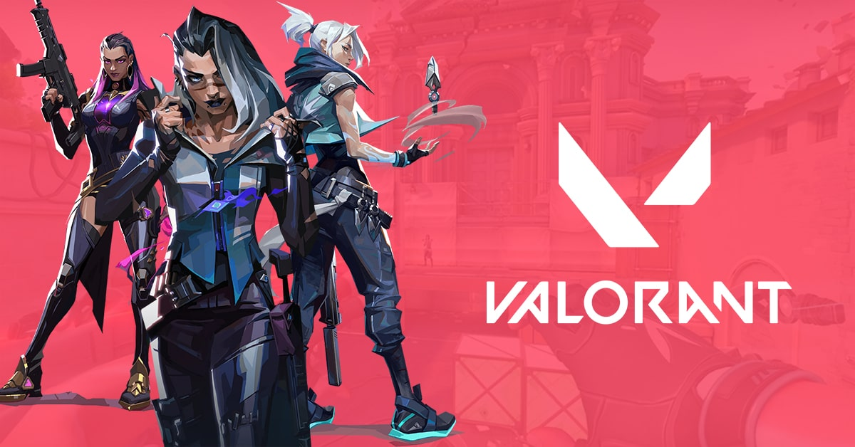

The gameplay revolves around two teams, each comprised of five players, competing in rounds of attacking and defending various objectives on the map. The primary game mode is called "Bomb Defusal," where one team attempts to plant a bomb while the other team tries to prevent it or defuse it if it's planted.

One of the distinguishing features of Valorant is its emphasis on precise aiming, tactical positioning, and teamwork. The game's gunplay mechanics are designed to reward skilled aiming and strategic decision-making.

In terms of content, Valorant regularly receives updates in the form of new Agents, maps, and gameplay tweaks to keep the experience fresh for players. Riot Games also organizes esports tournaments and events for Valorant, contributing to its competitive scene and overall longevity.

Overall, Valorant has become a prominent title in the FPS genre, attracting a dedicated player base and fostering a vibrant community of fans, content creators, and competitive players. If there have been any developments or new content released for Valorant since my last update, I would not be aware of it.