Recommendations to improve testability:

* The app currently has no unit tests. Need to work with the developers to add unit tests (and have this adopted as a practice), and use any code coverage tool to ensure build fails if coverage drops below a pre-set number.
* Use a linting tool (like eslint) and add this step to the build to ensure consistency in code style and to enforce following coding best practices.
* Id’s seem to be reused on the page. All task elements have the same id. Suggest using class for this instead of id.
* Make each root task element identifiable by giving it a class name, rather than a flat structure.
* Couldn’t get the framework to detect the appearance/disappearance of the loading spinner. Will need to work with a developer to see if this can be made easy to do.
* I’ve added one test instrumentation route `/reset` to delete all tasks so the tests can start from a clean slate. Will probably need more of these to bring the app to known states, for e.g., seeded with one task etc.

Test Automation notes:

* Have followed the practice of having the automated tests as part of the same code repo as the app. The tests are in the `*./tests*` folder. Instructions are in `***./tests/README.md***`
* Automated tests for the app are built using the same language ecosystem as the app under test. This is to facilitate having developers contribute to the tests too and fostering shared ownership.
* Have followed the Page Object Model to organise tests. This may be unnecessary if the app is only ever going to be a single page.
* Have followed the practice of user-journey based tests that cover a journey rather than separate BDD style acceptance tests for each functionality. This helps to keep the test run time low, test count low, but with the drawback that the tests aren’t independent. For e.g., if the task add functionality isn’t working, the test will fail, even if there’s nothing wrong with task delete. However, the upside is this will help prevent a maintenance nightmare of too many tests.
* In addition to the files under the `*./tests*` folder, I've also modified the below files of the app:
* `*docker-compose.yml*`: Added selenium container & read environment variables from a file `*.env*`
* Added task `*test*`, and webdriverIO dependencies in `*package.json*`. Currently the dependencies are added to the main dependencies block, as I couldn’t figure out why they are not installing when I had them in the devdependencies block.
* Added a route `*/reset*` which deletes all existing tasks. This is to enable the tests to bring the app to a known state before each test. This route is enabled only if ENVIRONMENT is set to development.
* Currently the test framework doesn’t handle updating tasks or deleting specific tasks. Will need to add these abilities in when future tests need it. As of now, it can only delete the first task.

Manual Exploratory testing notes:

Areas explored:

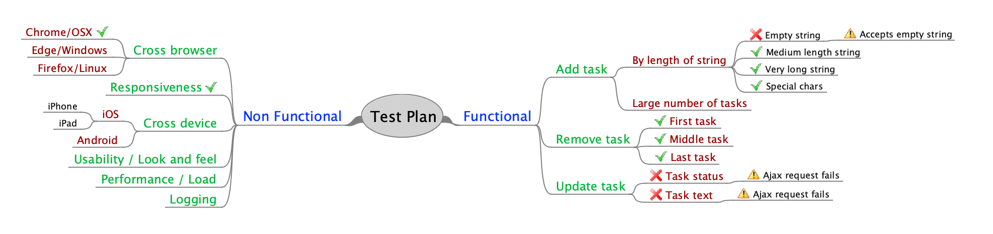

Legend:

-> Test Passed



 -> Test Failed

No icon -> Test not performed yet

Issues:

|  |  |
| --- | --- |
|  |  |
| 1 | Am able to add zero length or all whitespace strings: |
| 2 | Occasional HTTP 418 response if I add items while previous add is still being processed: |
| 3 | On updating status or text of a task, the status/text **does** get updated, however the ajax update request `*POST* [*http://localhost:8080/api/update/<task*](http://localhost:8080/api/update/%3ctask) *id>*` gets no response:    Server log showing no response code or response time for this request: |
| 4 | Alignment of the checkbox, textbox and the `X` not quite right: |
| 5 | The `*GET /api/all*` request seems quite slow, even with zero todo items. (I understand this is in my local environment, but still looks concerning enough to test this out in a real prod-like environment): |
| 6 | Intermittent issue where occasionally when I remove a task, the resultant page still shows the task, and I am able to remove it again. See network traffic below. Task `*5c3ca0c5742aa7e58a4c451e*` was removed, but the `*all*` request after that came back with a *304*, indicating no change, and I was able to delete it again, and this time the delete response was *304*, indicating it was already deleted: |

Values:

|  |  |
| --- | --- |
| **Stay open** | We are open and transparent. We set big goals and then work together to find the solution.  To me this represents transparency regarding project statuses, company direction, how the company is performing. And at a more granular level, having regular demos/walkthroughs with project teams so that everyone’s aware of what’s being built, what’s working, what’s coming next etc |
| **Fit for purpose** | We build for purpose, we always ask “why” and don’t embellish.  Aim for getting the most important/most requested functionalities built first and iterate on improving it. This enables early feedback from users, whether these are end users or developers using a framework you built. Also prevents building features that won’t get much use. |
| **People matter** | We value individuals and believe people are far more than a means to an end.  Important to ensure colleagues are being treated fairly, and there’s no expectation to continually give up weekends/own time to achieve company goals. Whilst this is fine occasionally, if this becomes the norm it’d lead to wearing out people. Keep in mind people’s aspirations too when making decisions. |
| **When it’s on it’s on** | We push hard when we need to, play hard as a team and celebrate hard when we win.  When there are deadlines to meet go all in, do whatever it takes. (Of course with the caveat that these crunch times are not a norm). Frequent team lunches, hackathons, brown bags etc to bring people closer and interacting on things other than work. |
| **Own it** | We each own our ideas and our happiness. We always speak up.  Having regular catch-up with my manager to discuss how things are going, getting feedback from them regarding areas I could work on, providing feedback to them on what I see as avenues for improvement from a test process/tooling perspective etc. |

**Lastly...**

* What is important to you in your career?
* Opportunities to learn new things
* Freedom to experiment with different frameworks, tools etc
* Working in a low bureaucracy, supportive environment
* Having competitive remuneration
* What excites you about Airtasker and the opportunity?
* I occasionally use Airtasker and find this a useful service. I can see this serving a real need.
* Like the big expansion plans that Airtasker has.
* Having checked out a few employee profiles on LinkedIn, I’m convinced this a group people with very technical skills, that I could learn from.
* What would you like us to know about you?
* My employment history, recent work experiences etc are on my resume
* Am off on vacation from tomorrow for a week.