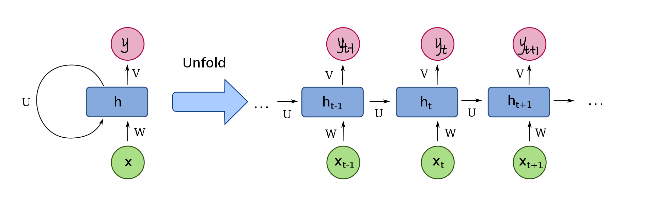

SimpleRNN 128

SimpleRNN 256

SimpleRNN 512

Relu 512

Relu 512

Relu 256

Relu 64

Relu 32

Softmax

Dropout 0.5

Dropout 0.2

Dropout 0.2

InputLayer

Rnn block

Full connect block