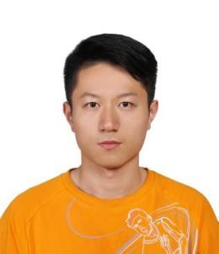

EXPERIENCE

**2021**

**Master of Science Mechanical Engineering**

**University of Hong Kong,**Hong Kong

**2019**

**Bachelor of Science Energy**

**Harbin Institute of Technology,**Harbin

**May 2021 to current**

**AI data Engineer Gemdale, Shenzhen,China**

* Developed and deployed structured testing and research processes among building components and rules groups.
* Set up structures for producing patents and work reports.
* Adept knowledge of the artificial intelligence field.
* Construct reinforce learning neural network to detect the small objects in CAD files.

**May 2020 to Sep 2020**

**Front-end Intership, Tencent, wepy project group, Shenzhen,China**

* Worked extensively with engineering staff to better understand Software-as-a-Service solutions and their benefits to projects.
* Contributed back-end experience and collaborated on APIs.
* Determined job priorities for multiple projects and communicated them with the entire team.

* Target-driven student with a record of academic success, eager to add value to the quality-focused Deep learning team while studying. Passionate about community service highlighted by volunteer experience in HICA.
* Master Python, C++ programming, use Numpy, Pandas, Scikit-learn, familiar with common data structures such as stacks, queues, linked lists, binary trees, etc., understand common algorithms such as top ten sorting, binary search, double pointer, monotonic stack, etc. Understand basic linux commands.

CONTACTS

SKILLS

Dezhen Huang

Objective : 2022 fall phd program

ACCOMPLISHIMENTS

30 Aug 1997

Taining Fujian

188-0042-9097

hdz18800429097@gmail.com

C++

Python

MySQL

Tensorflow

Pass the entrance exam of Tsinghua University Computer Postgraduate Entrance Examination in two and half month.

PROFILE

EDUCATION