
2 0 20

PYTHON


LOVELY PROFESSIONAL UNIVERSITY
SUBMITTED BY-
SHIKHAR RANJAN-53, 11906289
JUHI KUMARI-45, 11911927
HEMANT GIRASE-05, 11905614

CAR DEKHO – “The best software for price estimation”
PRICE ESTIMATION
OF USED CARS
MOIN HASSAN
SBMITTED TO-
GUI-PROJECT

Table of Contents

- Objective of project

- Introduction

- Working process

- Structure Of application

- GUI of application

- Database connectivity of application

- Formula used for finding price

- Conclusion and Learning Outcomes

- References

Objective

Objective of this project is to implement different learning of course of Python Programming Language and to develop a software which calculates the price of used cars with all required functionalities. Objective is to also provide user with an interactive and fully functional used Car price calculator. Through this project other objective is in order to implement the indispensable part of today’s modern technology world which is calculator using our knowledge of python programming language as this put’s our knowledge of python programming language to test and also helps to practically showcase skills.

CAR DEKHO is important software for an user who wants to find market value of his used cars. With the use of this project, user can find the price of his/her used cars by inputting some details of his/her car. This project also aims at improving knowledge of already known parts and modules of python and develop the understanding of additional modules and put our knowledge into use. This project aims at providing us with the confidence of skills on python programming language and with a sense of satisfaction that we can implement things practically we have learnt.

Introduction
As world is improving day by day in the technology field there are no limits on what we can achieve through this technological advancement going on. But as we heading forward some of the devices and the logics remain in a constant touch with us no matter how far we have progressed there are many instances in our day to day life that we use the devices that were developed and invented long back but are still in use although their functionality may be improved . One such gadget is price calculator. Everybody in their lives buy or sell their vehicles and no one want to waste their valuable time in finding a perfect price for their used Cars in present market. This software comes at rescue for this part and saves valuable amount of user.

Working Process
This software has only one working feature which is to calculate the price of used Cars, software contains few entry boxes which will take some details about user’s Car as input and then software will calculate the selling price of the car .searching will be done with the help of the inputs (Company Name, Mileage, Registration year, Engine type, Kilometers driven, Company Name and No. of gears) given by user after that software will calculate the price of car by performing the mathematical calculation on the basis of the user’s input. The final price of the car will be displayed via Check Price button.

Structure Of the application

Size of the root window is ("1500x800+0+0") which is resizable it means it can be maximized as full screen or can be minimized also in background part there is an image which covers the background and created a frame inside the root and main software is inside the frame there is some entry boxes which work as taking input from user and there is Check Price, show model and Exit button .Exit button is commanded with destroy function which will shut down the software when Exit button will be clicked.
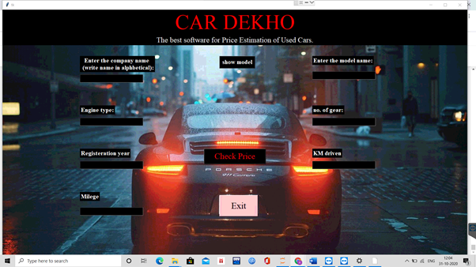

GUI of application
- Entry box

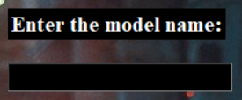


- Entry box is placed within the frame using place geometry manager.
- It’s thickness is highlighted.
- It’s relief is specified by the frame in which it is placed.
- Width of Entry box is adjusted according to the size of window.

- Buttons
There are total 3 buttons Each button instead of utilizing the conventional text format is assigned with a separate .png image for each. Using “PhotoImage” part of tkinter module image is imported from directory. Image is resized in order to fit button using “subsample”. Pixel size is used to specify x , y length
Buttons consist of command to insert value associated in them. Each button is placed in the frame using the grid geometry manger.
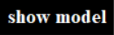
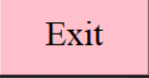


- main window

The main window (t) consists of title “CAR DEKHO”. Below it there are some entry boxes which takes details of cars and then there is SHOW MODEL button to show the available models of cars ,there is CHECK PRICE button to calculate the price of car and in the bottom one EXIT button is there which is commanded with destroy function it will close the program.

Price calculation method

As we know there is not any proved mathematical formula to find price of used cars originally it is done by Regression analysis method which comes under machine learning process in which we had to take all the details of cars and by analysis those values will come at one parameter which can give the price as output.
So we used normal local logical method which everyone does in real life we did a survey in between few markets and car sellers and buyers and from that survey we came to a conclusion that those people basically notice few points while buying or selling used cars and those are:-
- Brand and model
- Registered year of car
- Condition of engine
- Mileage given by car
- How much kms driven
These are the basic points noticed by people while checking their vehicle’s market value. So, we did the same thing in our software, our software is taking these values as input from user and based on user’s input we added different conditions and software will show output on satisfied conditions.
Example- TATA Company and its Cars

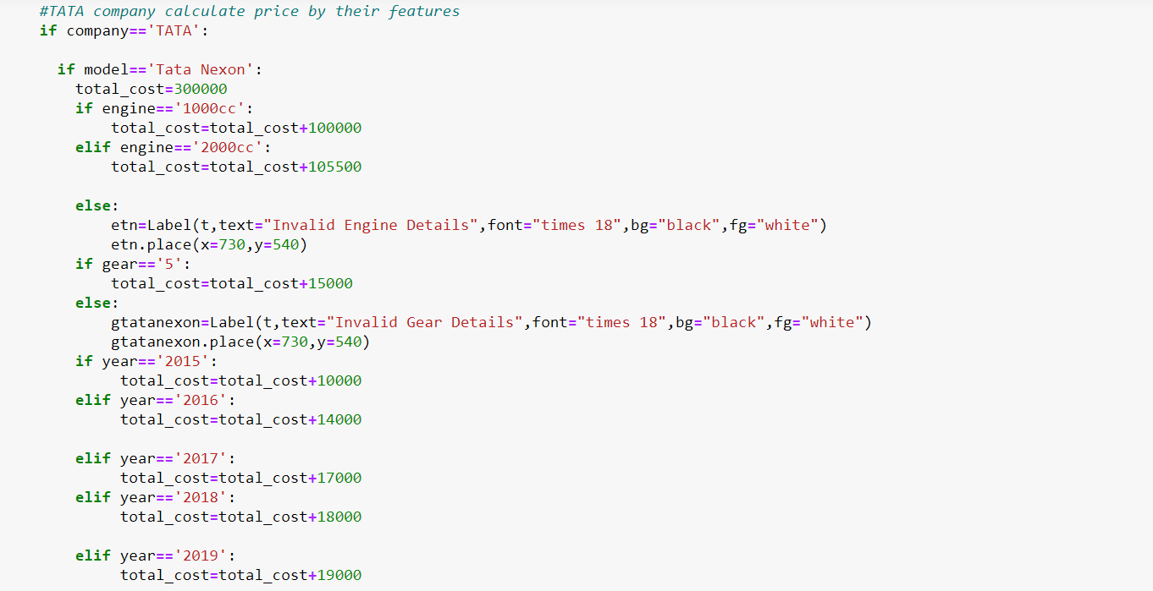
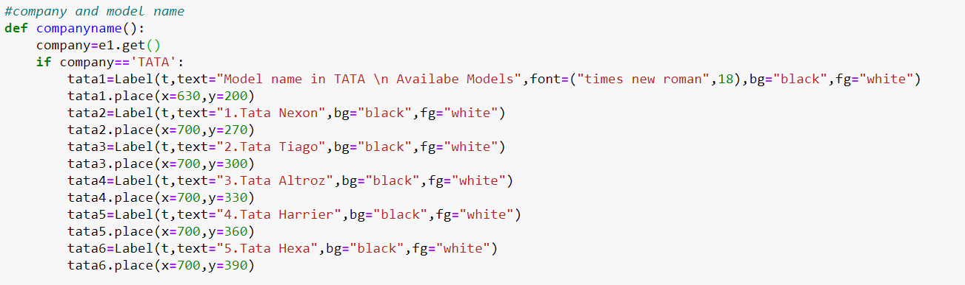
All the model names of TATA Company
Applying different conditions whichever will get satisfied by user’s input that will execute and its price will be displayed
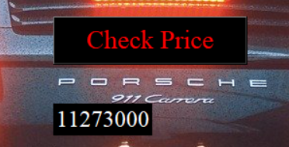
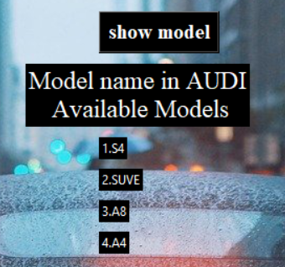
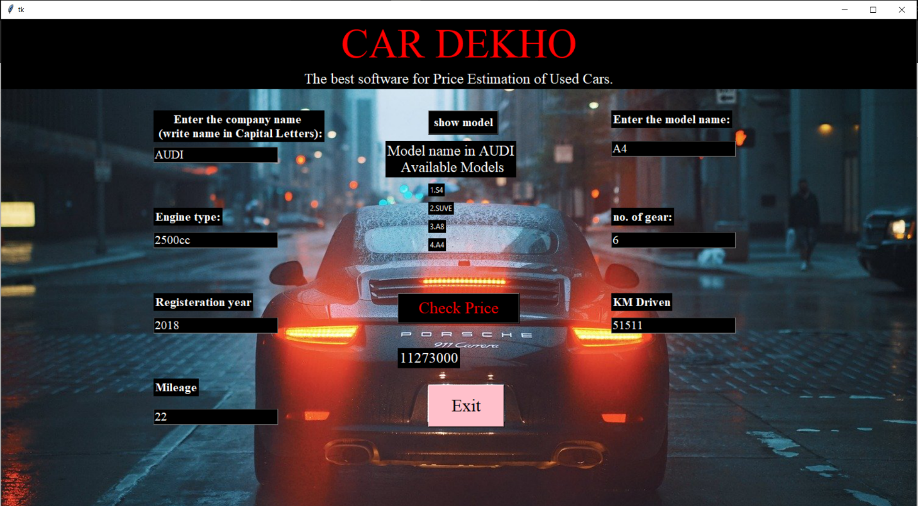
Price of Car Displayed based on different inputs given by user.
According to company name input these models are displayed.
Input Given by user

CONCLUSION AND LEARNING OUTCOME-

In this project we have created an complete Price Estimation of Used Cars. To implement it we have used tkinter module for GUI interface. From tkinter module we have used different widgets like – Buttons, Entry box. we have 3 buttons in total having different functionalities. For providing functionalities we have used math module.
To make our project more attractive we have used different attractive images for different buttons using PhotoImage() function. Our first interface is for blank form which is a kind of simple entry details. To find price user will have to enter all the details then click on Check price. Once, we will click the Exit button software will close.
We have gone through deep learning about python tkinter module and how to get started with it.
- Learned about different widgets of tkinter module .
- We have used different photos for different buttons.
- We have learned how to use different styles to make our project more attractive.

REFERENCES-
- https://www.w3schools.com/python/

- https://www.geeksforgeeks.org/sql-using-python/

- https://stackoverflow.com

- www.tutorialspoint.com

- www.google.com

- www.quora.com

==THE END==

