Code cleanliness report for <https://github.com/he-patil/Report/blob/main/ContactAppToTest.py>

1. **DRY:** Do not Repeat Yourself

There’s no repetition of code found. Though for find contact, find contact details, find use, a Function needs to be added to avoid repetition, whenever these modules would be developed.

1. **KISS:** Keep It Simple, Stupid

Code is state-forward and simple, though some functional mistakes are found. For example, the update class method only updates Name attribute of passed object.

1. **YAGNI:** You Aren’t Gonna Need It

No unrequired code found.

1. **SOC:** Separation Of Concerns

The CRUD on ContactDetails should be in Contact class as it’s the member of Contact class, as they are found in User class. The methods can be added in Contact class and can be invoked in User class as and when needed.

1. **TDA:** Tell, Don’t Ask

The CRUD operations are expected to find the object based on some hook parameter and then make the changes in that object. Current code only makes changes in object passed as parameter, not finding object itself. It creates dependency on calling function (which can be driver code) to find the object first on its own and then pass that to CRUD function as parameter for making changes.

For example: 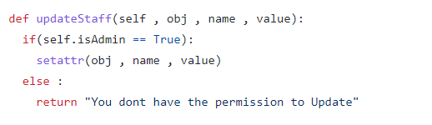

In this code, the object is only updated and finding which object to update is left on calling function.