学院信息服务APP需求分析报告

1 引言

本需求分析报告的目的是规范化学院信息服务APP的编写，旨在与提高软件开发过程中的能见度，便于对软件开发过程中的控制与管理，同时提出了校园学院信息服务APP的项目管理需求，便于程序员与客户之间的交流、协作，并作为工作成果的原始依据，同时也表明了本软件的共性，以期能够获得更大范围的应用。

2 主要模块

2.1天气预报模块

功能概述

天气预报模块主要对用户提供天气服务，主要包含了3-10天天气预报、实况天气、生活指数、空气质量实况和空气质量7天预报等，以便用户可以获取准确、有效的信息，方便出行和日常生活工作安排。

### 3-10天天气预报功能

用户通过此功能查询天气预报数据，包括：日出日落、月升月落、最高最低温度、天气白天和夜间状况、风力、风速、风向、相对湿度、大气压强、降水量、降水概率、露点温度、紫外线强度、能见度等数据。

**实现说明**

请求URL: <https://free-api.heweather.com/s6/weather/forecast?parameters>

请求方式（数字签名）：

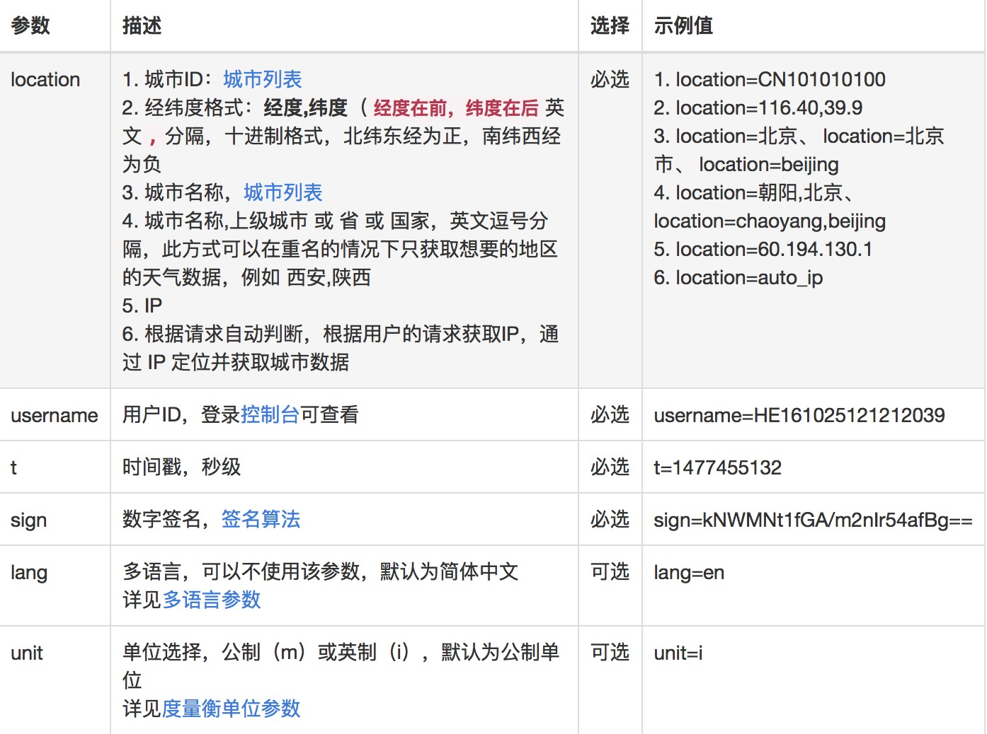

返回字段和数值说明

basic 基础信息

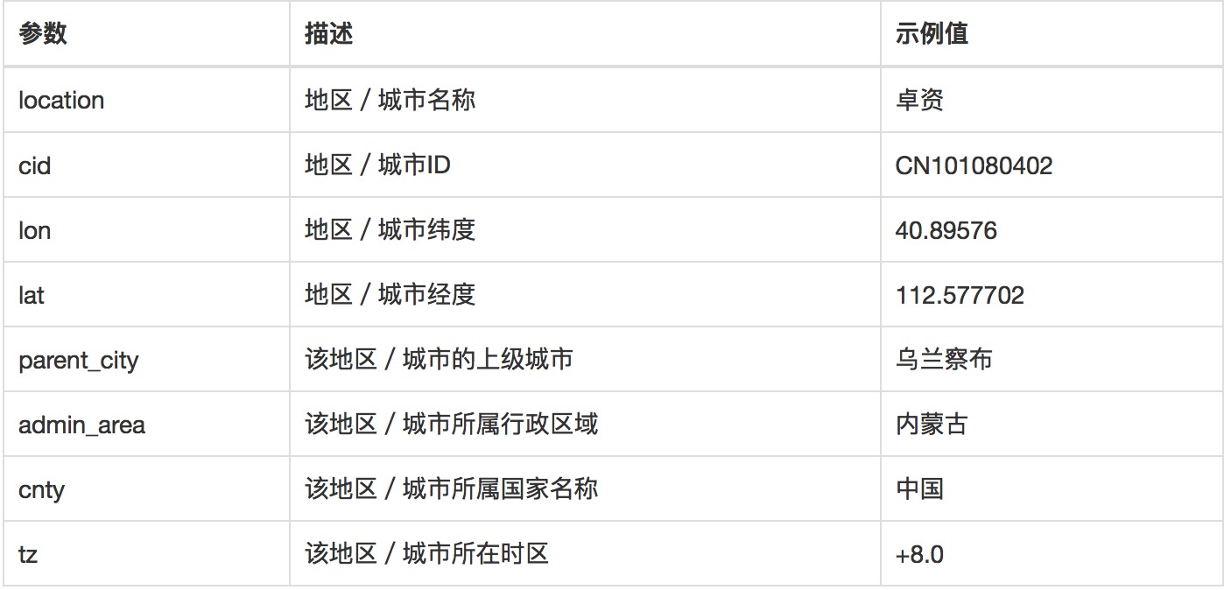

update接口更新时间

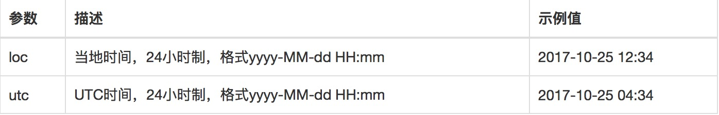

daily_forecast天气预报

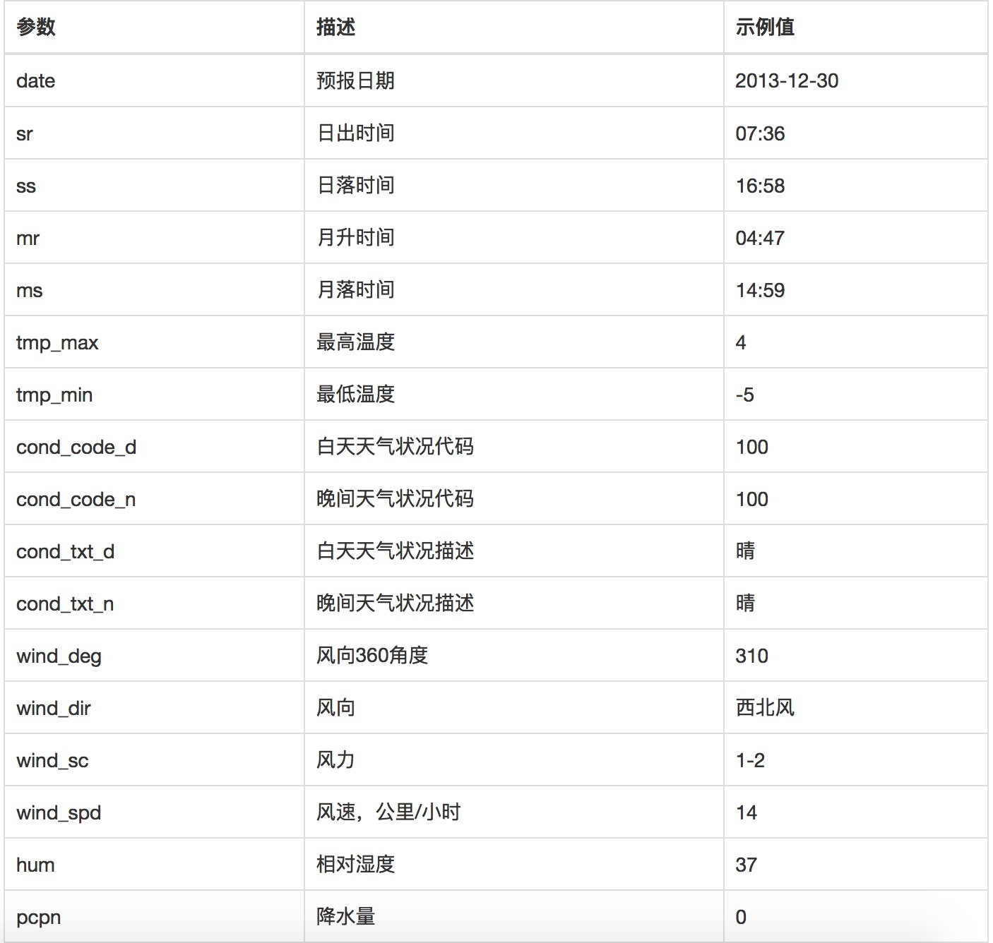

satuts 接口状态

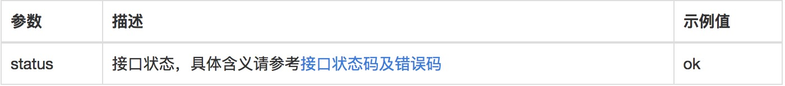

数据返回示例

{  
    "HeWeather6": [  
        {  
            "basic": {  
                "cid": "CN101010100",  
                "location": "北京",  
                "parent_city": "北京",  
                "admin_area": "北京",  
                "cnty": "中国",  
                "lat": "39.90498734",  
                "lon": "116.40528870",  
                "tz": "8.0"  
            },  
            "daily_forecast": [  
                {  
                    "cond_code_d": "103",  
                    "cond_code_n": "101",  
                    "cond_txt_d": "晴间多云",  
                    "cond_txt_n": "多云",  
                    "date": "2017-10-26",  
                    "hum": "57",  
                    "pcpn": "0.0",  
                    "pop": "0",  
                    "pres": "1020",  
                    "tmp_max": "16",  
                    "tmp_min": "8",  
                    "uv_index": "3",  
                    "vis": "16",  
                    "wind_deg": "0",  
                    "wind_dir": "无持续风向",  
                    "wind_sc": "微风",  
                    "wind_spd": "5"  
                },  
                {  
                    "cond_code_d": "101",  
                    "cond_code_n": "501",  
                    "cond_txt_d": "多云",  
                    "cond_txt_n": "雾",  
                    "date": "2017-10-27",  
                    "hum": "56",  
                    "pcpn": "0.0",  
                    "pop": "0",  
                    "pres": "1018",  
                    "tmp_max": "18",  
                    "tmp_min": "9",  
                    "uv_index": "3",  
                    "vis": "20",  
                    "wind_deg": "187",  
                    "wind_dir": "南风",  
                    "wind_sc": "微风",  
                    "wind_spd": "6"  
                },  
                {  
                    "cond_code_d": "101",  
                    "cond_code_n": "101",  
                    "cond_txt_d": "多云",  
                    "cond_txt_n": "多云",  
                    "date": "2017-10-28",  
                    "hum": "26",  
                    "pcpn": "0.0",  
                    "pop": "0",  
                    "pres": "1029",  
                    "tmp_max": "17",  
                    "tmp_min": "5",  
                    "uv_index": "2",  
                    "vis": "20",  
                    "wind_deg": "2",  
                    "wind_dir": "北风",  
                    "wind_sc": "3-4",  
                    "wind_spd": "19"  
                }  
            ],  
            "status": "ok",  
            "update": {  
                "loc": "2017-10-26 23:09",  
                "utc": "2017-10-26 15:09"  
            }  
        }  
    ]  
}

实况天气功能

实况天气即为当前时间点的天气状况以及温湿风压等气象指数，具体包含的数据：体感温度、实测温度、天气状况、风力、风速、风向、相对湿度、大气压强、降水量、能见度等。用户通过此功能查询实况天气。

**实现说明**

请求URL: <https://free-api.heweather.com/s6/weather/now?parameters>

请求方式（数字签名）

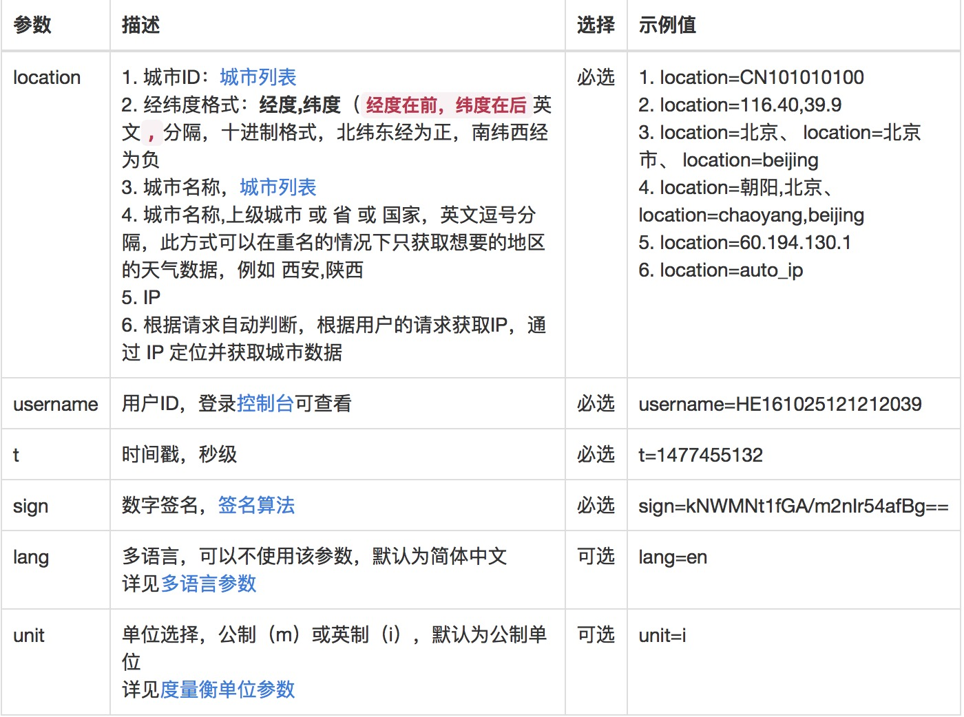

basic 基础信息



update 接口更新时间

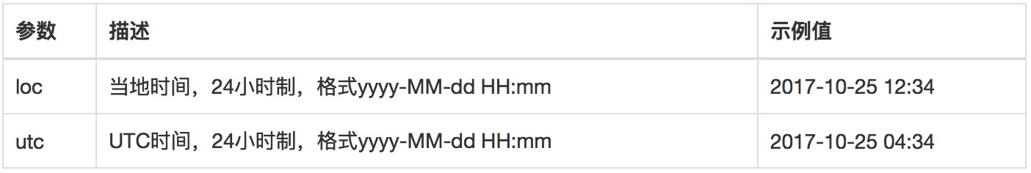

now 实况天气

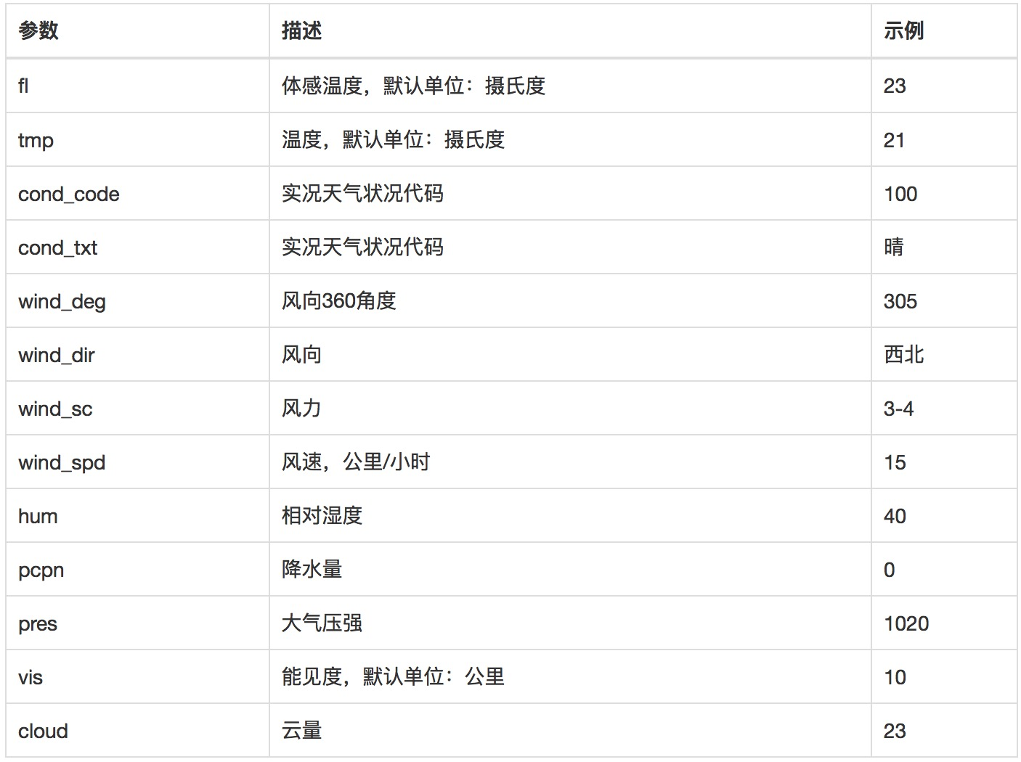

status 接口状态

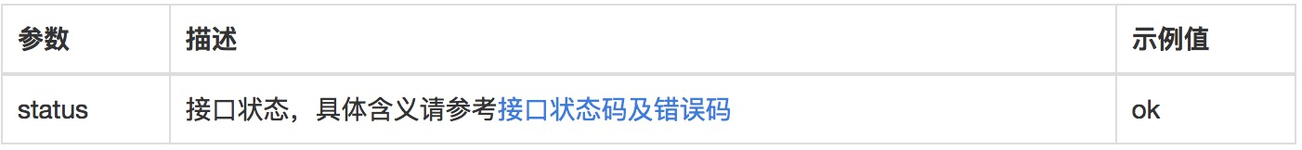

数据返回示例

{

"HeWeather6": [

{

"basic": {

"cid": "CN101010100",

"location": "北京",

"parent_city": "北京",

"admin_area": "北京",

"cnty": "中国",

"lat": "39.90498734",

"lon": "116.40528870",

"tz": "8.0"

},

"now": {

"cond_code": "101",

"cond_txt": "多云",

"fl": "16",

"hum": "73",

"pcpn": "0",

"pres": "1017",

"tmp": "14",

"vis": "1",

"wind_deg": "11",

"wind_dir": "北风",

"wind_sc": "微风",

"wind_spd": "6"

},

"status": "ok",

"update": {

"loc": "2017-10-26 17:29",

"utc": "2017-10-26 09:29"

}

}

]

}

生活指数功能

用户通过此空能查询穿衣、洗车、感冒、紫外线、运动、旅游等生活指数。

**实现说明**

lifestyle 生活指数

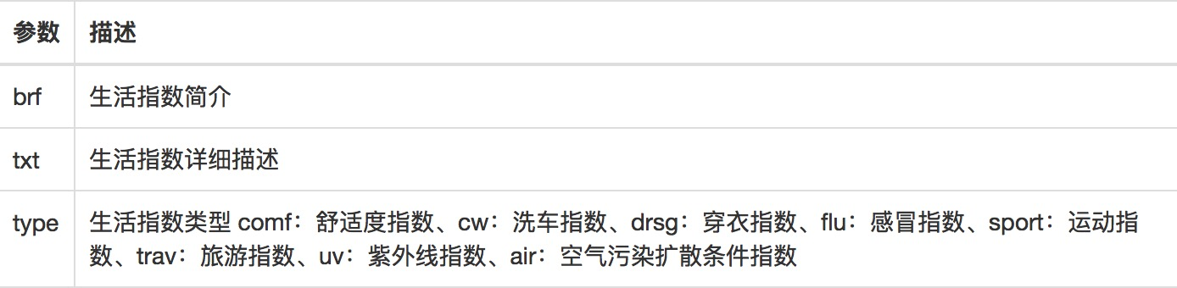

数据返回示例

{

"HeWeather6": [

{

"basic": {

"cid": "CN101010100",

"location": "北京",

"parent_city": "北京",

"admin_area": "北京",

"cnty": "中国",

"lat": "39.90498734",

"lon": "116.40528870",

"tz": "8.0"

},

"lifestyle": [

{

"brf": "舒适",

"txt": "今天夜间不太热也不太冷，风力不大，相信您在这样的天气条件下，应会感到比较清爽和舒适。",

"type": "comf"

},

{

"brf": "较舒适",

"txt": "建议着薄外套、开衫牛仔衫裤等服装。年老体弱者应适当添加衣物，宜着夹克衫、薄毛衣等。",

"type": "drsg"

},

{

"brf": "少发",

"txt": "各项气象条件适宜，无明显降温过程，发生感冒机率较低。",

"type": "flu"

},

{

"brf": "适宜",

"txt": "天气较好，赶快投身大自然参与户外运动，尽情感受运动的快乐吧。",

"type": "sport"

},

{

"brf": "适宜",

"txt": "天气较好，但丝毫不会影响您出行的心情。温度适宜又有微风相伴，适宜旅游。",

"type": "trav"

},

{

"brf": "弱",

"txt": "紫外线强度较弱，建议出门前涂擦SPF在12-15之间、PA+的防晒护肤品。",

"type": "uv"

},

{

"brf": "较不宜",

"txt": "较不宜洗车，未来一天无雨，风力较大，如果执意擦洗汽车，要做好蒙上污垢的心理准备。",

"type": "cw"

},

{

"brf": "较差",

"txt": "气象条件较不利于空气污染物稀释、扩散和清除，请适当减少室外活动时间。",

"type": "air"

}

],

"status": "ok",

"update": {

"loc": "2017-10-26 23:09",

"utc": "2017-10-26 15:09"

}

}

]

}

空气质量实况功能

用户通过此功能获取当前空气质量。数据来源： 环保部1500个监测站点实时空气质量（AQI）数据，以及目前唯一可提供的全国3181个城市的实时空气质量（AQI）数据。

**实现说明**

air_now_city AQI城市实况

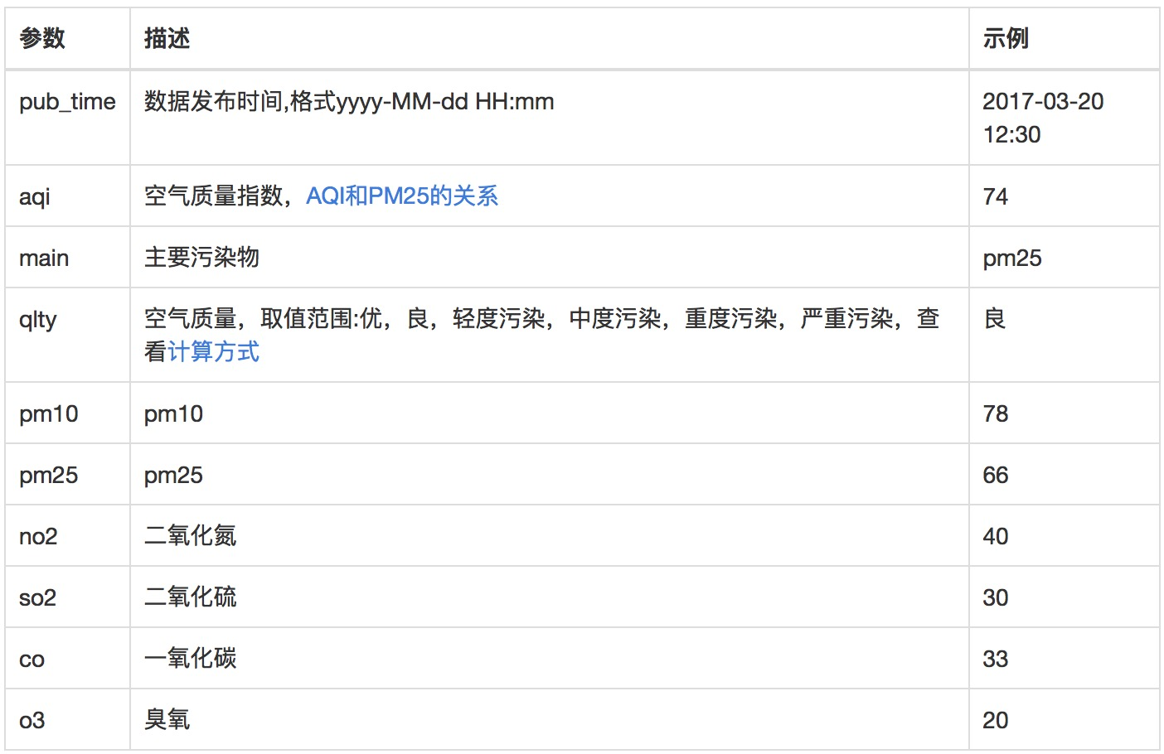

air_now_station AQI站点实况

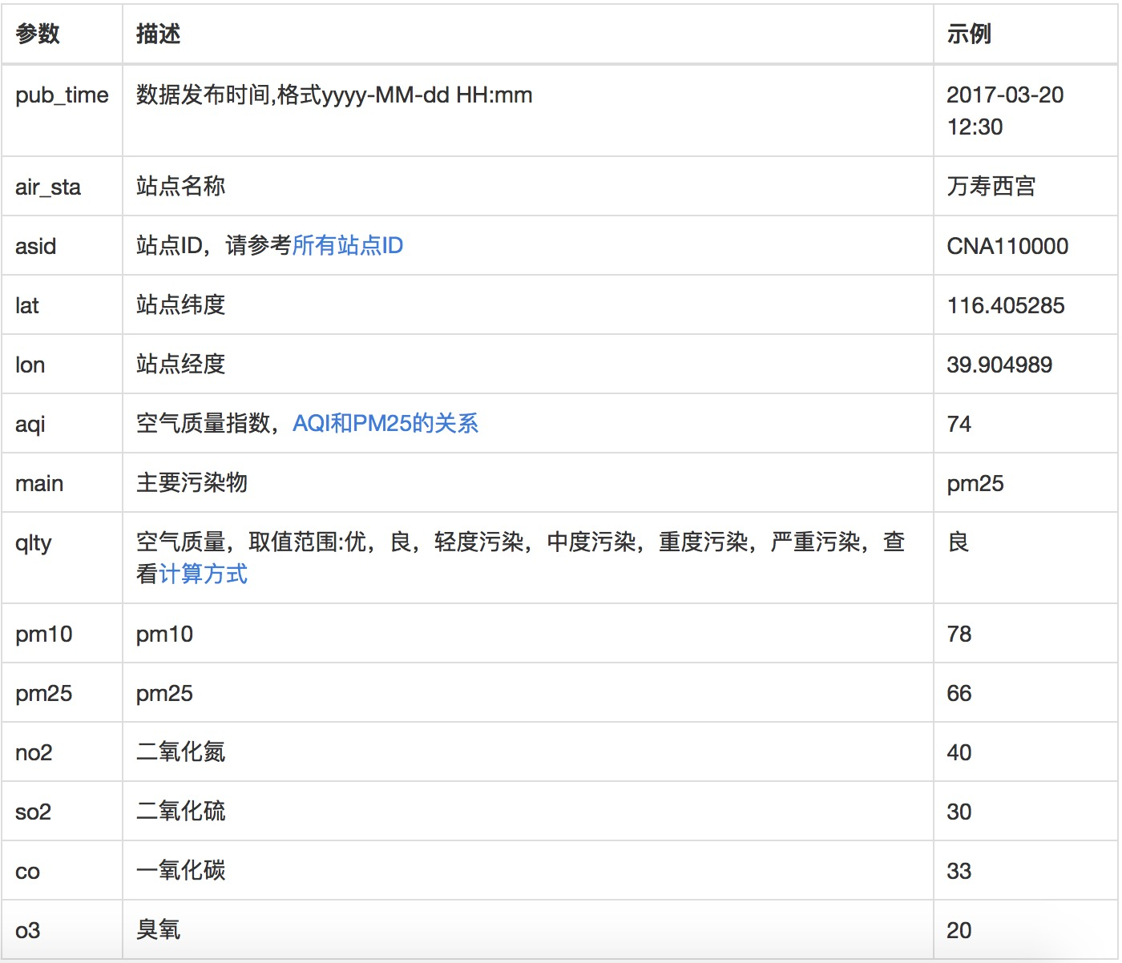

数据返回示例

{

"HeWeather6": [

{

"air_now_city": {

"aqi": "19",

"co": "0",

"main": "",

"no2": "34",

"o3": "31",

"pm10": "18",

"pm25": "8",

"pub_time": "2017-11-07 22:00",

"qlty": "优",

"so2": "2"

},

"air_now_station": [

{

"air_sta": "万寿西宫",

"aqi": "19",

"asid": "CNA1001",

"co": "0.4",

"lat": "39.8673",

"lon": "116.366",

"main": "-",

"no2": "37",

"o3": "29",

"pm10": "13",

"pm25": "5",

"pub_time": "2017-11-07 22:00",

"qlty": "优",

"so2": "3"

},

{

"air_sta": "定陵",

"aqi": "21",

"asid": "CNA1002",

"co": "0.4",

"lat": "40.2865",

"lon": "116.17",

"main": "-",

"no2": "7",

"o3": "66",

"pm10": "6",

"pm25": "1",

"pub_time": "2017-11-07 22:00",

"qlty": "优",

"so2": "3"

},

{

"air_sta": "东四",

"aqi": "16",

"asid": "CNA1003",

"co": "0.4",

"lat": "39.9522",

"lon": "116.434",

"main": "-",

"no2": "28",

"o3": "36",

"pm10": "16",

"pm25": "10",

"pub_time": "2017-11-07 22:00",

"qlty": "优",

"so2": "2"

},

{

"air_sta": "天坛",

"aqi": "22",

"asid": "CNA1004",

"co": "0.4",

"lat": "39.8745",

"lon": "116.434",

"main": "-",

"no2": "38",

"o3": "29",

"pm10": "22",

"pm25": "8",

"pub_time": "2017-11-07 22:00",

"qlty": "优",

"so2": "1"

},

{

"air_sta": "农展馆",

"aqi": "28",

"asid": "CNA1005",

"co": "0.6",

"lat": "39.9716",

"lon": "116.473",

"main": "-",

"no2": "56",

"o3": "15",

"pm10": "20",

"pm25": "12",

"pub_time": "2017-11-07 22:00",

"qlty": "优",

"so2": "2"

},

{

"air_sta": "官园",

"aqi": "25",

"asid": "CNA1006",

"co": "0.4",

"lat": "39.9425",

"lon": "116.361",

"main": "-",

"no2": "50",

"o3": "13",

"pm10": "15",

"pm25": "10",

"pub_time": "2017-11-07 22:00",

"qlty": "优",

"so2": "1"

},

{

"air_sta": "海淀区万柳",

"aqi": "31",

"asid": "CNA1007",

"co": "0.4",

"lat": "39.9934",

"lon": "116.315",

"main": "-",

"no2": "61",

"o3": "6",

"pm10": "28",

"pm25": "14",

"pub_time": "2017-11-07 22:00",

"qlty": "优",

"so2": "3"

},

{

"air_sta": "顺义新城",

"aqi": "16",

"asid": "CNA1008",

"co": "0.4",

"lat": "40.1438",

"lon": "116.72",

"main": "-",

"no2": "12",

"o3": "51",

"pm10": "16",

"pm25": "6",

"pub_time": "2017-11-07 22:00",

"qlty": "优",

"so2": "4"

},

{

"air_sta": "怀柔镇",

"aqi": "15",

"asid": "CNA1009",

"co": "0.3",

"lat": "40.3937",

"lon": "116.644",

"main": "-",

"no2": "21",

"o3": "48",

"pm10": "12",

"pm25": "5",

"pub_time": "2017-11-07 22:00",

"qlty": "优",

"so2": "3"

},

{

"air_sta": "昌平镇",

"aqi": "15",

"asid": "CNA1010",

"co": "0.5",

"lat": "40.1952",

"lon": "116.23",

"main": "-",

"no2": "20",

"o3": "48",

"pm10": "7",

"pm25": "3",

"pub_time": "2017-11-07 22:00",

"qlty": "优",

"so2": "2"

},

{

"air_sta": "奥体中心",

"aqi": "24",

"asid": "CNA1011",

"co": "0.4",

"lat": "40.0031",

"lon": "116.407",

"main": "-",

"no2": "48",

"o3": "21",

"pm10": "15",

"pm25": "9",

"pub_time": "2017-11-07 22:00",

"qlty": "优",

"so2": "3"

},

{

"air_sta": "古城",

"aqi": "32",

"asid": "CNA1012",

"co": "0.4",

"lat": "39.9279",

"lon": "116.225",

"main": "-",

"no2": "36",

"o3": "20",

"pm10": "32",

"pm25": "3",

"pub_time": "2017-11-07 22:00",

"qlty": "优",

"so2": "1"

}

],

"basic": {

"cid": "CN101010100",

"location": "北京",

"parent_city": "北京",

"admin_area": "北京",

"cnty": "中国",

"lat": "39.90498734",

"lon": "116.40528870",

"tz": "+8.0"

},

"status": "ok",

"update": {

"loc": "2017-11-07 22:46",

"utc": "2017-11-07 14:46"

}

}

]

}

空气质量7天预报功能

用户通过此功能获取当前空气质量。数据来源：结合环保部最新排放污染清单以及WRF-CHEM模型算法，获取出全国首家且唯一的未来7天空气质量预报数据。

**实现说明**

air_forecast 空气质量 AQI 7天预报

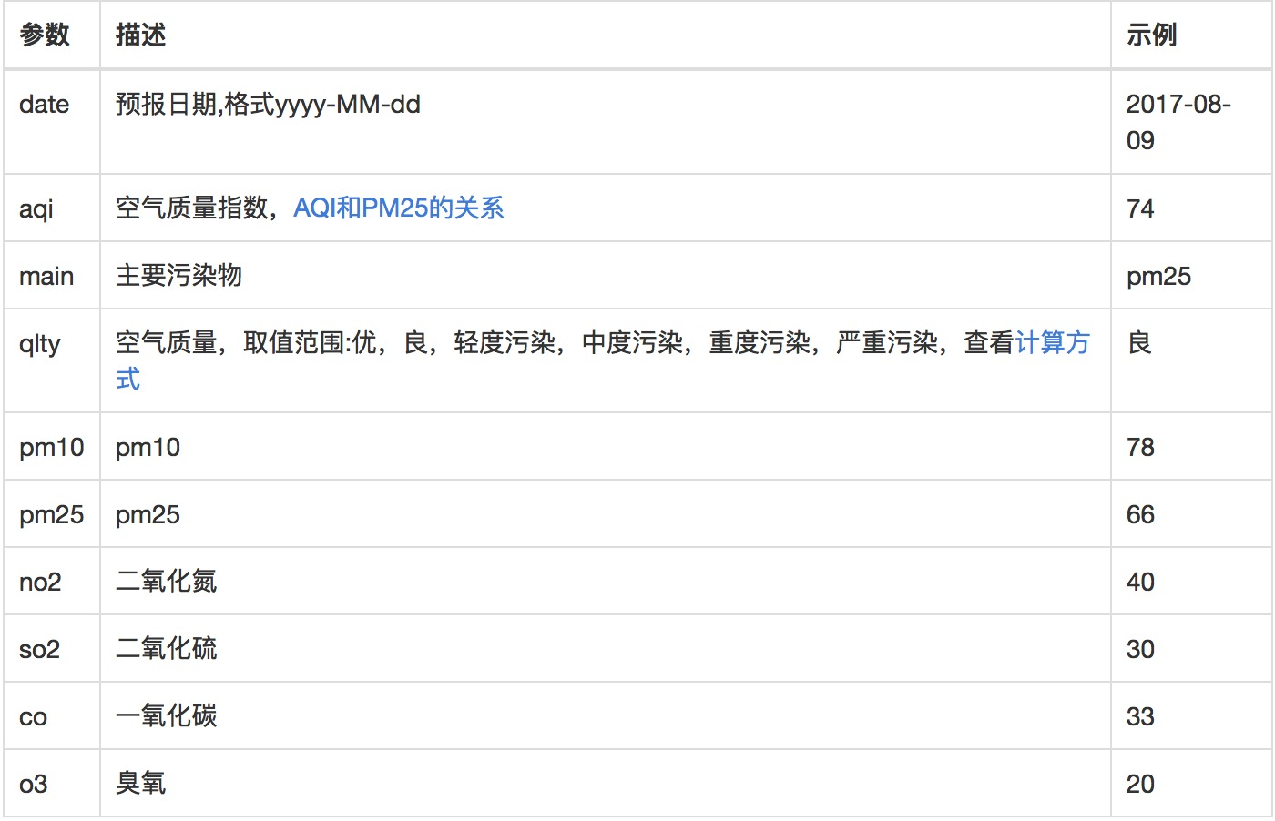

2.2学院网站主页信息爬取展示模块

功能概述

学院网站主页信息爬取展示模块主要对用户提供学院网站主页信息的爬取和展示，主要通过网页爬虫技术爬取学院网站主页信息，包含了学院网站主页中的学院新闻、通知公告和学术讲座等信息，动态更新展示每部分最近发布的10篇的内容，以便用户可以获取准确、及时的学院新闻和通知，方便用户进行有关学习安排。

学院新闻

列出学院网站主页中学院新闻的信息目录，并提供详细情况展示。

通知公告

列出学院网站主页中通知公告的信息目录，并提供详细情况展示。

学术讲座

列出学院网站主页中学术讲座的信息目录，并提供详细情况展示。

2.3快递查询模块

功能概述

提供通过国内快递公司的邮单号进行查询，显示对应快递物品的物流信息；提供对应查询快递物品的包裹动态的自动提醒

单号查询功能

用户输入需要查询的快递信息的邮单号，可查询出快递物品的物流运输的具体信息，包括快递的物流路线、物流预计到达时间等；

包裹信息提醒功能

对于用户查询过的快递物品，系统自动对于其快递物流信息进行间隔时段的提醒，帮助用户掌握快递物流信息的动态变化，避免错过快递到达的信息。

3可行性分析

技术可行性分析

本次网站整体架构基于经典的MVC（Model、View、Controller）体系模式，该模式已成为当今设计交互式应用程序的一个标准，可以直接借鉴。

本次网站的天气预报功能的天气数据可以通过和风天气API进行获取，学院网站信息可以利用爬虫技术进行爬取。

操作可行性分析

本系统界面友好，操作简单，任何人都可以很快掌握操作原理并使用。

软件主界面如下所示：

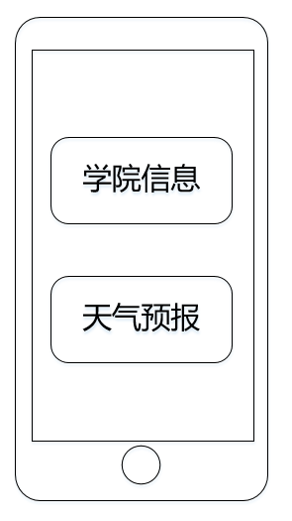

点击“天气预报”按钮后可进入天气信息展示页面，此处不做过多介绍。点击“学院信息”按钮后可进入如下界面：

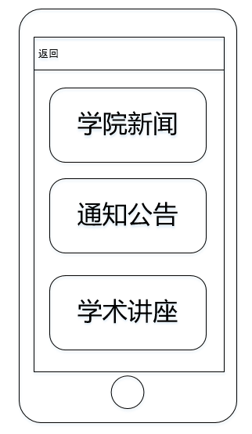

点击“学院新闻”、“通知公告”或“学术讲座”按钮后，会展示最近10篇相关内容。界面如下所示：

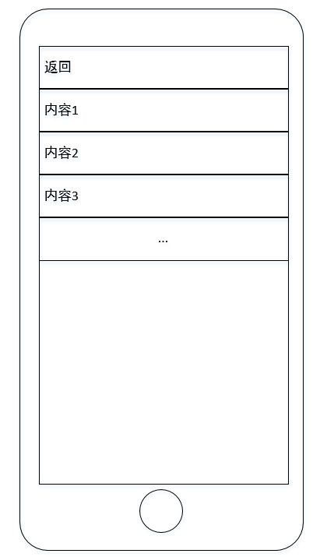

继续点击相应内容后可查看相关内容信息。