CEOXiME: Theta

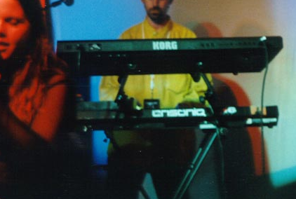
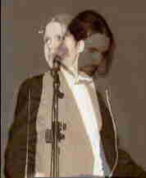
Theta is the final installment of original works of CEOXiME, an 8 year running project of Tatiana and hEADaCHE. Their works have appeared on over 15 compilations, reviewed in over 20 magazines; and played with such notable bands such as Pigface, Gravity Kills, gODHEAD and Mindless Faith. So if you have had your ear to the ground, you would have heard of CEOXiME. Theta was picked up by one of the longest running industrial labels, Invisible, and released as MP3. Now you can have this and Vibrant Grey all on 1 CD.

Excerpts from the upcoming Darksonus interview:

So why release Theta now? Hasn’t CEOXiME been dead for a couple of years?

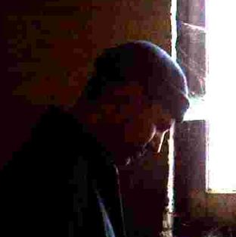
Yes, CEOXiME ended at the end of 2005. I never felt quite complete with the project though, and I had assembled a nice final CD and delivered it to Invisible. I was always quite proud of this material and I wanted to see it all on CD. Invisible opted to only do MP3 sales of the album, which omitted the extras that I had put with the CD – the artwork and the multimedia portion of the CD. So I thought it would be good to finally put these things together for myself and all who supported CEOXiME. All in all, its over 2 hrs of really good music, mostly originals, but also some of the best remixes from Kritikal, King Rhythm, Interface, Function13 and Christ Analogue.

What’s in the multimedia portion?
The full and complete Vibrant Grey encoded in 192 kbps, the complete color artwork of Vibrant Grey, and a few surprise extras as well.

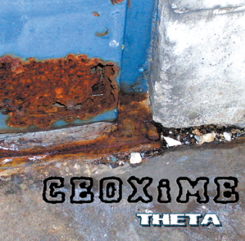Track list:
1. One:15
2. Stop in Your Tracks
3. Beg'n'Plead
4. Dirty and Used
5. Seems to Be
6. Tears
7. Sister Sin (oxicodone mix)
8. Stop in Your Tracks (Christ Analogue remix)
9. Dirty'n'Used (King Rhythm remix)
10. Seems To Be (Kritikal remix)

Out now on Uncoiled Loops: http://www.ceoxime.com/uncoiledloops

