IT PBL

Cryptography

|  |  |  |  |
| --- | --- | --- | --- |
| Sr.No | Name | Roll.No. | PRN |
| 1 | Pratiksha Andhare | 223003 | 22110793 |
| 2 | Siddhant Ankar | 223004 | 22110700 |
| 3 | Prasad Bhosale | 223011 | 22110876 |

**INTRODUCTION**

Cryptography is a technique to achieve confidentiality of messages. The term has a specific meaning in Greek: “secret writing”. Nowadays, however, the privacy of individuals and organizations is provided through cryptography at a high level, making sure that information sent is secure in a way that the authorized receiver can access this information.

Everyone needs communication to express their feelings or opinion or for information passing. Normal people will communicate by speaking and deaf and dumb people by using sign language. Morse code is a type of sign language which is very useful for secret communication and this type of communication is important in army, navy, and air force departments why because in those departments there is so much sensitive information which shouldn't be reviled to others and that information should not be understandable by others. So, they prefer a separate way of communication, which is called the Morse Code.

**ABSTRACT**

Cryptography is the practice of secure communication in the presence of third parties. It involves various techniques for encoding and decoding information to protect it from unauthorized access. One such technique is the use of Morse code, a system of dots and dashes that represent letters and numbers. Morse code was developed in the early 19th century and is still used today in various applications, including aviation and amateur radio communication. The use of cryptography and Morse code is crucial in many fields, including military operations, financial transactions, and data privacy. This abstract provides a brief overview of these important topics and their significance in modern communication.

**LIBRARIES**

**TKINTER**

* Tkinter is the Python interface to the Tk GUI toolkit shipped with Python
* It is the standard GUI library for Python.
* Python when combined with Tkinter provides a fast and easy way to create GUI applications.
* It provides a powerful object-oriented interface to the Tk GUI toolkit.

**BASE64**

* Base64 is a group of similar binary-to-text encoding schemes that represent binary data in an ASCII string format by translating it into a radix-64 representation. The term Base64 originates from a specific MIME content transfer encoding.
* Base64 encoding schemes are commonly used when there is a need to encode binary data that needs to be stored and transferred over media that are designed to deal with ASCII. This is to ensure that the data remain intact without modification during transport. Base64 is commonly used in a number of applications including email via MIME, and storing complex data in XML.
* One common application of Base64 encoding on the web is to encode binary data so it can be included in a data.

**ALGORITHM**

* Import the necessary libraries – base64 and Tinker.
* Take the choice from user cryptography or morse code.
* If cryptography, then take the input as a message and password if password is wrong end, else take choice encrypt or decrypt.
* if encrypt convert the message in encoded form the display the value.
* if decrypt decode the data using base64 and display the actual value.
* If morse code take the user input text as message take the choice Eng-morse or morse-Eng .
* If Eng-morse convert the message into morse code with the help of morse dict.
* If morse-Eng convert the message into real message with the help of morse dict.
* End

**FlowChart:-**

**OUTPUT**

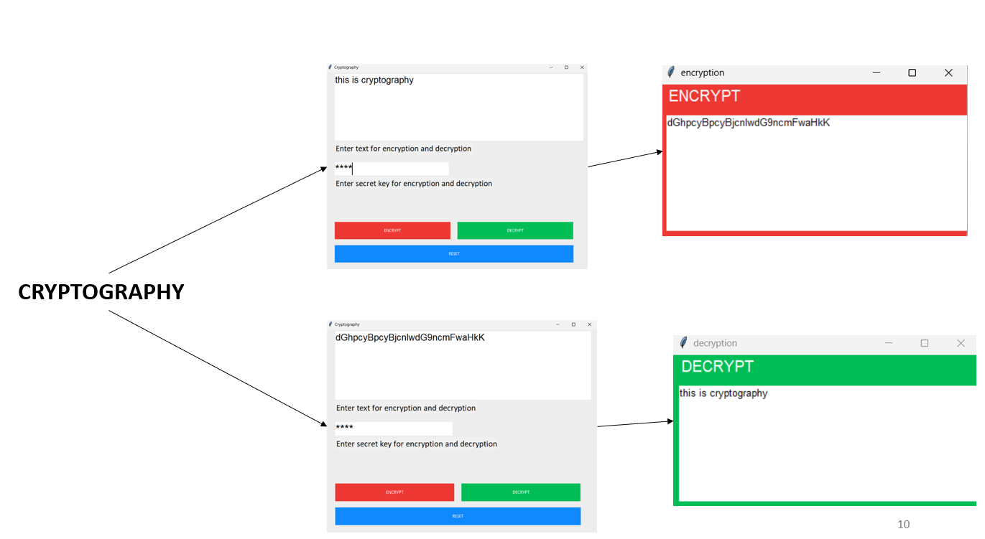

**Conclusion**

Cryptography plays a vital and critical role in achieving the primary aims of security goals, such as authentication, integrity, confidentiality, and no-repudiation. Cryptographic algorithms are developed in order to achieve these goals. Cryptography has the important purpose of providing reliable, strong, and robust network and data security.

Cryptography will continue to emerge with IT and business plans in regard to protecting personal, financial, medical, and ecommerce data and providing a respectable level of privacy. The existing system was quite complicated and people working on this system must have to remember a lot. whereas our system has resolved the complicated issues and added predictive power to it. But the only flaw in the proposed system is that the time limit is associated with dots and dashes. So, in the future, we can improve the model by removing the time limits and implementing advanced machine learning algorithms such as Neural Networks. This model could also be extended to words and sentences and even for paragraphs.

**REFERENCES**

1. *https://developer.mozilla.org/en-US/docs/Glossary/Base64*
2. *https://www.geeksforgeeks.org/cryptography-and-its-types/*
3. *https://www.researchgate.net/publication/352040167_An_Approach_for_Morse_Code_Translation_from_Eye_Blinks_Using_Tree_Based_Machine_Learning_Algorithms_and_OpenCV*
4. [*https://www.researchgate.net/publication/334418542_A_Review_Paper_on_Cryptography*](https://www.researchgate.net/publication/334418542_A_Review_Paper_on_Cryptography)