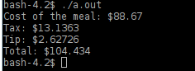
Chris Taylor
C++ Chapter 2

Programming Challenge 4

#include <iostream>

using namespace std;

int main(int argc, const char * argv[]) {
const double TAX_RATE = 6.75;
const double TIP_RATE = 0.2;
double charge = 8.867E1;
double tax = charge / TAX_RATE;
double tip = tax * TIP_RATE;

cout << "Cost of the meal: $" << charge << endl;
cout << "Tax: $" << tax << endl;
cout << "Tip: $" << tip << endl;
cout << "Total: $" << charge + tax + tip << endl;
return 0;
}

