Chris Taylor
C++
Chapter 12

/*
* 12.03 - Punch Line
*
* Reads a joke from a text file and outputs the content to stdout. The
* punchline is read from the last line of a second file, which is also
* outputted to stdout.
*/

#include <iostream>
#include <fstream>
#include <string>
#include <vector>

using namespace std;

void showJoke(const string fileName)
{
fstream file(fileName.c_str(), ios::in);
if (!file)
{
cout << "Error opening file " << fileName << endl;
return;
}

string line;
while (getline(file, line))
{
cout << line << endl;
}
file.close();
}

void showLastLine(const string fileName)
{
fstream file(fileName.c_str(), ios::in);
if (!file)
{
cout << "Error opening file " << fileName << endl;
return;
}

vector<string> lines;
string line;
while (getline(file, line))
{
lines.push_back(line);
}
cout << lines[lines.size() - 1] << endl;
file.close();
}

int main()
{
const string JOKE_FILE = "joke.txt";
const string PUNCHLINE_FILE = "punchline.txt";

showJoke(JOKE_FILE);
cout << endl;
showLastLine(PUNCHLINE_FILE);
return 0;
}

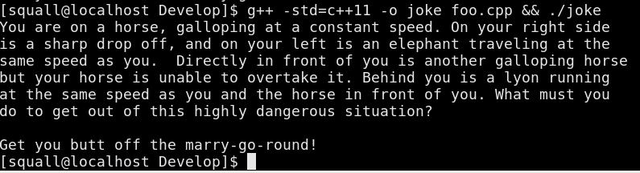

# Here is the same program written in Python
from sys import stdout

with open("joke.txt") as joke:
for line in joke:
stdout.write(line)
print("")
with open("punchline.txt") as pl:
lines = pl.readlines()
stdout.write(lines[-1])

