|  |
| --- |
|  |
| **Module** | **Number of bits** | **1** | **8** | **32** | **64** | **128** | **256** | **1024** |
| Timer/Counter0 | 8 | 16u | 128u | -- | 1m | -- | 4m | 16.3m |
| Timer/Counter1 | 16 | 4m | 32m | -- | 262m | -- | 1s | 4.2s |
| Timer/Counter2 | 8 | 16u | 128u | 512u | 1m | 2m | 4m | 16.3m |

| **Module** | **Operation** | **I/O register(s)** | **Bit(s)** |
| --- | --- | --- | --- |
| Timer/Counter0 | Prescaler  8-bit data value Overflow interrupt enable | TCCR0B  TCNT0H  TCNT0L  TIMSK0 | CS02,CS01,CS00  (000: stopped, 001: 1, 010: 8, 011: 64, 100: 256, 101: 1024)  TCNT0[7:0] TOIE0 (1: enable, 0: disable) |
| Timer/Counter1 | Prescaler  16-bit data value Overflow interrupt enable | TCCR1B  TCNT1H, TCNT1L TIMSK1 | CS12, CS11, CS10 (000: stopped, 001: 1, 010: 8, 011: 64, 100: 256, 101: 1024) TCNT1[15:0] TOIE1 (1: enable, 0: disable) |
| Timer/Counter2 | Prescaler  8-bit data value Overflow interrupt enable | TCCR2B  TCNT2H, TCNT2L TIMSK2 | CS22,CS21,CS20  (000: stopped, 001: 1, 010: 8, 011: 32, 100: 64, 101: 128,110:256, 111:1024)  TCNT2[7:0] TOIE2 (1: enable, 0: disable) |

|  |
| --- |
|  |
| **Program address** | **Source** | **Vector name** | **Description** |
| 0x0000 | RESET | -- | Reset of the system |
| 0x0002 | INT0 | INT0_vect | External interrupt request number 0 |
| 0x0004 | INT1 | INT1_vect | External Interrupt Request 1 |
| 0x0006 | PCINT0 | PCINT0_vect | Pin Change Interrupt Request 0 |
| 0x0008 | PCINT1 | PCINT1_vect | Pin Change Interrupt Request 1 |
| 0x000A | PCINT2 | PCINT2_vect | Pin Change Interrupt Request 2 |
| 0x000C | WDT | WDT_vect | Watchdog Time-out Interrupt |
| 0x0012 | TIMER2_OVF |  | Timer/Counter2 Overflow |
| 0x0018 | TIMER1_COMPB | TIMER1_COMPB_vect | Compare match between Timer/Counter1 value and channel B compare value |
| 0x001A | TIMER1_OVF | TIMER1_OVF_vect | Overflow of Timer/Counter1 value |
| 0x0020 | TIMER0_OVF | TIMER0_OVF_vect | Timer/Counter0 Overflow |
| 0x0024 | USART_RX | USART_RX_vect | USART Rx Complete |
| 0x002A | ADC | ADC_vect | ADC Conversion Complete |
| 0x0030 | TWI | TWI_vect | 2-wire Serial Interface |

|  |
| --- |
|  |
| **Module** | **Description** | **MCU pin** | **Arduino pin** |
| Timer/Counter0 | OC0A | PD6 | 6 |
|  | OC0B | PD5 | 5 |
| Timer/Counter1 | OC1A | PB1 | 6 |
|  | OC1B | PB2 | 10 |
| Timer/Counter2 | OC2A | PB3 | 11 |
|  | OC2B | PD3 | 3 |

**Timer.h**

#ifndef TIMER_H

#define TIMER_H

/***********************************************************************

*

* Timer library for AVR-GCC.

* ATmega328P (Arduino Uno), 16 MHz, AVR 8-bit Toolchain 3.6.2

*

* Copyright (c) 2019-2020 Tomas Fryza

* Dept. of Radio Electronics, Brno University of Technology, Czechia

* This work is licensed under the terms of the MIT license.

*

**********************************************************************/

/**

* @file timer.h

* @brief Timer library for AVR-GCC.

*

* @details

* The library contains macros for controlling the timer modules.

*

* @note

* Based on Microchip Atmel ATmega328P manual and no source file is

* needed for the library.

*

* @copyright (c) 2019-2020 Tomas Fryza

* Dept. of Radio Electronics, Brno University of Technology, Czechia

* This work is licensed under the terms of the MIT license.

*/

/* Includes ----------------------------------------------------------*/

#include <avr/io.h>

/* Defines -----------------------------------------------------------*/

/* @brief Defines prescaler CPU frequency values for Timer/Counter0.

* @note F_CPU = 16 MHz

*/

#define TIM0_stop() TCCR0B &= ~((1<<CS02) | (1<<CS01) | (1<<CS00));

#define TIM0_overflow_16u() TCCR0B &= ~((1<<CS02) | (1<<CS01)); TCCR0B |= (1<<CS00);

#define TIM0_overflow_128u() TCCR0B &= ~((1<<CS02) | (1<<CS00)); TCCR0B |= (1<<CS01);

#define TIM0_overflow_1m() TCCR0B &= ~(1<<CS02); TCCR0B |= (1<<CS01) | (1<<CS00);

#define TIM0_overflow_4m() TCCR0B &= ~((1<<CS01) | (1<<CS00)); TCCR0B |= (1<<CS02);

#define TIM0_overflow_16m() TCCR0B &= ~(1<<CS01); TCCR0B |= (1<<CS02) | (1<<CS00);

/**

* @brief Defines prescaler CPU frequency values for Timer/Counter1.

* @note F_CPU = 16 MHz

*/

#define TIM1_stop() TCCR1B &= ~((1<<CS12) | (1<<CS11) | (1<<CS10));

#define TIM1_overflow_4ms() TCCR1B &= ~((1<<CS12) | (1<<CS11)); TCCR1B |= (1<<CS10);

#define TIM1_overflow_33ms() TCCR1B &= ~((1<<CS12) | (1<<CS10)); TCCR1B |= (1<<CS11);

#define TIM1_overflow_262ms() TCCR1B &= ~(1<<CS12); TCCR1B |= (1<<CS11) | (1<<CS10);

#define TIM1_overflow_1s() TCCR1B &= ~((1<<CS11) | (1<<CS10)); TCCR1B |= (1<<CS12);

#define TIM1_overflow_4s() TCCR1B &= ~(1<<CS11); TCCR1B |= (1<<CS12) | (1<<CS10);

/**

* @brief Defines prescaler CPU frequency values for Timer/Counter2.

* @note F_CPU = 16 MHz

*/

#define TIM2_stop() TCCR2B &= ~((1<<CS22) | (1<<CS21) | (1<<CS20));

#define TIM2_overflow_16u() TCCR2B &= ~((1<<CS22) | (1<<CS21)); TCCR2B |= (1<<CS20);

#define TIM2_overflow_128u() TCCR2B &= ~((1<<CS22) | (1<<CS20)); TCCR2B |= (1<<CS21);

#define TIM2_overflow_512u() TCCR2B &= ~(1<<CS22); TCCR2B |= (1<<CS21) | (1<<CS20);

#define TIM2_overflow_1m() TCCR2B &= ~((1<<CS21) | (1<<CS20)); TCCR2B |= (1<<CS22);

#define TIM2_overflow_2m() TCCR2B &= ~(1<<CS21); TCCR2B |= (1<<CS22) | (1<<CS20);

#define TIM2_overflow_4m() TCCR2B &= ~(1<<CS20); TCCR2B |= (1<<CS22) | (1<<CS21);

#define TIM2_overflow_16m() TCCR2B |= (1<<CS22) | (1<<CS20) | (1<<CS22);

/**

* @brief Defines interrupt enable/disable modes for Timer/Counter1.

*/

#define TIM1_overflow_interrupt_enable() TIMSK1 |= (1<<TOIE1);

#define TIM1_overflow_interrupt_disable() TIMSK1 &= ~(1<<TOIE1);

#define TIM0_overflow_interrupt_enable() TIMSK0 |= (1<<TOIE0);

#define TIM0_overflow_interrupt_disable() TIMSK0 &= ~(1<<TOIE0);

#define TIM2_overflow_interrupt_enable() TIMSK2 |= (1<<TOIE2);

#define TIM2_overflow_interrupt_disable() TIMSK2 &= ~(1<<TOIE2);

#endif

**Main.c**

/***********************************************************************

*

* Control LEDs using functions from GPIO and Timer libraries. Do not

* use delay library any more.

* ATmega328P (Arduino Uno), 16 MHz, AVR 8-bit Toolchain 3.6.2

*

* Copyright (c) 2018-2020 Tomas Fryza

* Dept. of Radio Electronics, Brno University of Technology, Czechia

* This work is licensed under the terms of the MIT license.

*

**********************************************************************/

/* Defines -----------------------------------------------------------*/

#define LED_D1 PB5

#define LED_D2 PB4

#define LED_D3 PB3

/* Includes ----------------------------------------------------------*/

#include <avr/io.h> // AVR device-specific IO definitions

#include <avr/interrupt.h> // Interrupts standard C library for AVR-GCC

#include "gpio.h" // GPIO library for AVR-GCC

#include "timer.h" // Timer library for AVR-GCC

/* Function definitions ----------------------------------------------*/

/**

* Main function where the program execution begins. Toggle three LEDs

* on Multi-function shield with internal 8- and 16-bit timer modules.

*/

int main(void)

{

/* Configuration of three LEDs */

GPIO_config_output(&DDRB, LED_D2);

GPIO_write_low(&PORTB, LED_D2);

// WRITE YOUR CODE HERE

GPIO_config_output(&DDRB, LED_D1);

GPIO_write_low(&PORTB, LED_D1);

GPIO_config_output(&DDRB, LED_D3);

GPIO_write_low(&PORTB, LED_D3);

/* Configuration of 8-bit Timer/Counter0 */

// WRITE YOUR CODE HERE

TIM0_overflow_1m();

TIM0_overflow_interrupt_enable();

/* Configuration of 16-bit Timer/Counter1

* Set prescaler and enable overflow interrupt */

TIM1_overflow_33ms();

TIM1_overflow_interrupt_enable();

/* Configuration of 8-bit Timer/Counter2 */

// WRITE YOUR CODE HERE

TIM2_overflow_4m();

TIM2_overflow_interrupt_enable();

// Enables interrupts by setting the global interrupt mask

sei();

// Infinite loop

while (1)

{

/* Empty loop. All subsequent operations are performed exclusively

* inside interrupt service routines ISRs */

}

// Will never reach this

return 0;

}

/* Interrupt service routines ----------------------------------------*/

/**

* ISR starts when Timer/Counter1 overflows. Toggle LED D2 on

* Multi-function shield. */

ISR(TIMER1_OVF_vect)

{

GPIO_toggle(&PORTB,LED_D2);

}

// ISR starts when Timer/Counter0 overflows. Toggle LED D1 on

ISR(TIMER0_OVF_vect)

{

GPIO_toggle(&PORTB,LED_D1);

}

// ISR starts when Timer/Counter0 overflows. Toggle LED D3 on

ISR(TIMER2_OVF_vect)

{

GPIO_toggle(&PORTB,LED_D3);

}

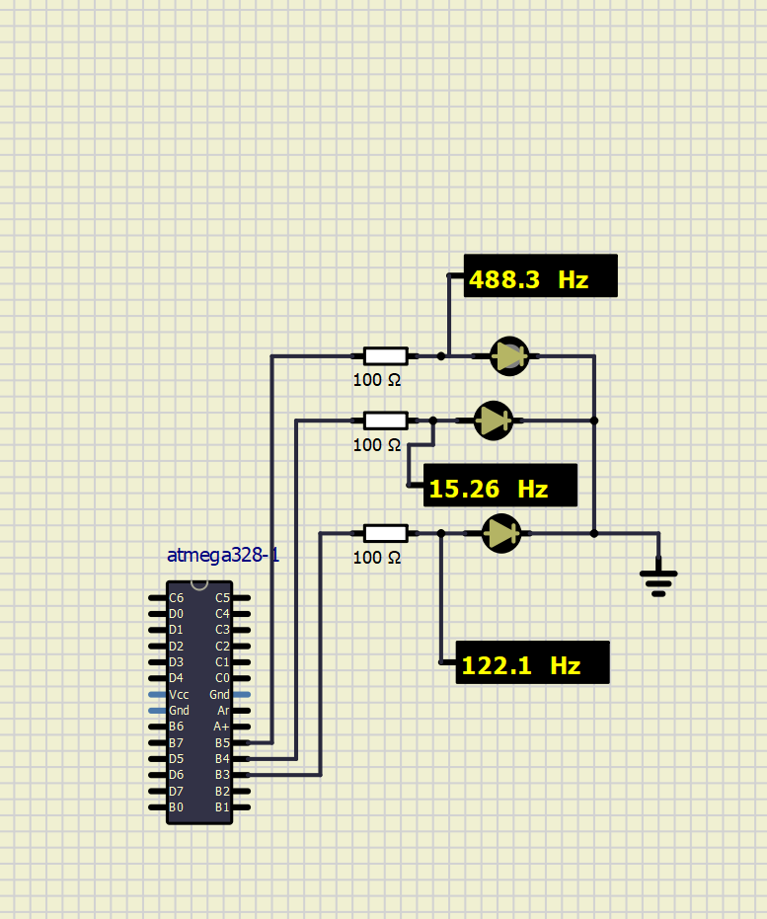

**Otázky**

* Rutina přerušení se volá automaticky vždy po vyvstanutí daného přerušení jejím argumentem je vždy dané přerušení, obyčejnou funkci lze volat kdykoliv z těla program, nicméně pokud v té době dojde k přerušení nastává čas zpracovat rutinu přerušení, jelikož má přednost.
* Fast PWM využívá pro kódování celé periody pouze period jedinného přetečení časovače, proto může mít dvojnásobnou frekvenci oproti fázově korektnímu PWM. Střída se nastavuje hodnotou komparačního registru OCRXA