Insert your centre number, name and candidate number into the header above.
Save this evidence document as evidence_ followed by your centre number_ candidate number. For example: evidence_ zz999_9999
Screenshots or program listings must be copied into appropriate cells in the following table.
Examiners must be able to read the contents including any screenshots without the use of a magnifying glass. Answers that are not readable or missing will not be awarded any marks.
Save this evidence document at regular intervals, for example every 10 minutes.
Question 1
Part 1(a)
#global, in main program
StackData=[None]*10 #array of INTEGER
StackPointer=0

Part 1(b)
def OutputAll():
global StackData, StackPointer
print(StackData, "are values of StackData")
print("StackPointer value is",StackPointer)

Part 1(c)
def Push(value): #value : INTEGER
global StackData, StackPointer
if StackPointer>9:
return False
else:
StackData[StackPointer]=value
StackPointer +=1
return True

Part 1(d)(i)
#in main program
for i in range(0,11):
userValue=int(input("please enter an integer: "))
if Push(userValue)==True:
print("number pushed successfully")
else:
print("Stack is full, could not push number")
OutputAll()

Part 1(d)(ii)
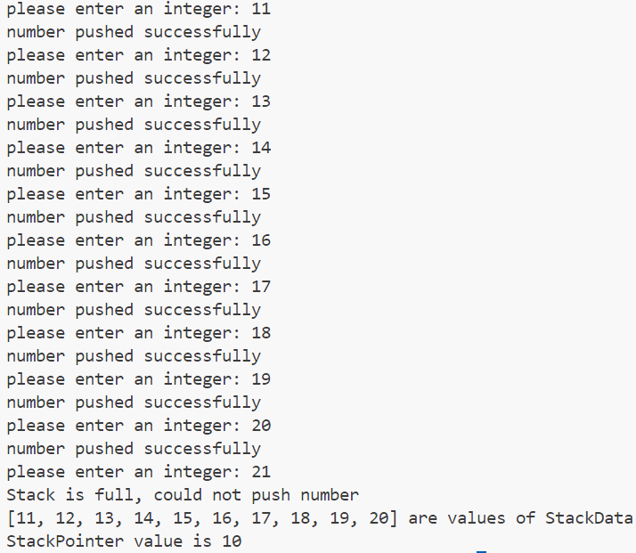
Part 1(e)(i)
def Pop():
global StackData, StackPointer
if StackPointer==0:
return -1
else:
StackPointer-=1
return StackData[StackPointer]

Part 1(e)(ii)
Show prior inputs

Question 2
Part 2(a)
import random
ArrayData=[[random.randint(1,100) for i in range(0,10)] for j in range(0,10)]

Part 2(b)(i)
ArrayLength=10
for x in range(0,ArrayLength):
for y in range(0,ArrayLength-1):
for z in range(0,ArrayLength-y-1):
if ArrayData[x][z]>ArrayData[x][z+1]:
TempValue=ArrayData[x][z]
ArrayData[x][z]=ArrayData[x][z+1]
ArrayData[x][z+1]=TempValue

Part 2(b)(ii)
def OutputArray():
global ArrayData
for row in ArrayData:
line=""
for value in row:
if value<10:
line = line + " " + str(value)
elif value<100:
line = line + " " + str(value)
else:
line = line + " " + str(value)
print(line)

print("before")
OutputArray()

ArrayLength=10
for x in range(0,ArrayLength):
for y in range(0,ArrayLength-1):
for z in range(0,ArrayLength-y-1):
if ArrayData[x][z]>ArrayData[x][z+1]:
TempValue=ArrayData[x][z]
ArrayData[x][z]=ArrayData[x][z+1]
ArrayData[x][z+1]=TempValue

print("after")
OutputArray()

Part 2(b)(iii)
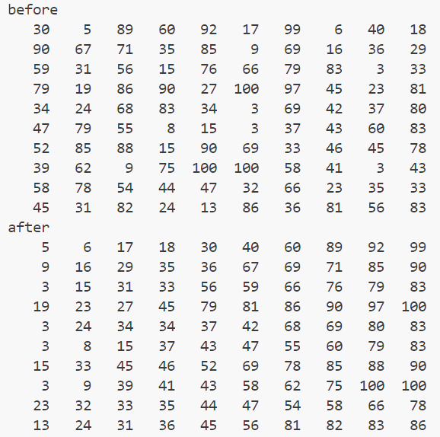
Part 2(c)(i)
def BinarySearch(SearchArray,lower,upper,SearchValue):
if upper>=lower:
mid=(lower+upper-1)//2
if SearchArray[0][mid]== SearchValue:
return mid
else:
if SearchArray[0][mid]>SearchValue:
return BinarySearch(SearchArray,lower,mid-1,SearchValue)
else:
return BinarySearch(SearchArray,mid+1,upper,SearchValue)
return -1

Part 2(c)(ii)
{Copy and paste the screenshot for Question 2(c)(ii) here}

Question 3
Part 3(a)
class Card():
def __init__(self,color,number):
self.__number=number #self.__number : INTEGER
self.__color=color #self.__color : STRING

Part 3(b)
def GetNumber(self):
return self.__number

def GetColour(self):
return self.__colour

Part 3(c)
CardArray=[None]*30 #of type Card
try:
Myfile=open("PastPapers\s22p42\CardValues.txt",'r')
for i in range(0,30):
Number1=int(Myfile.readline().strip())
Color1=Myfile.readline().strip()
CardArray[i]=Card(Color1,Number1)
Myfile.close()
except IOError:
print("error: file not found")

Part 3(d)
{Copy and paste the program code listing for Question 3(d) here}

Part 3(e)(i)
{Copy and paste the program code listing for Question 3(e)(i) here}

Part 3(e)(ii)
{Copy and paste the screenshot for Question 3(e)(ii) here}

