Screenshots or program listings must be copied into appropriate cells in the following table.
Save this evidence document as evidence_ followed by your centre number_ candidate number, for example, evidence_ zz999_9999 and insert your name, centre number and candidate number into the header above.
Examiners must be able to read the contents including any screenshots without the use of a magnifying glass. Answers that are not readable or are missing will not be awarded any marks.
Save this evidence document at regular intervals, for example every 10 minutes.
Question 1
Part 1(a)(i)
DataArray=[] #type ARRAY of INTEGER of 25 elements

Part 1(a)(ii)
f1=open("Data.txt",'r')
for line in f1:
DataArray.append(int(line.strip()))
Closefile?
Exception handling (if file doesn’t exist)

Part 1(b)(i)
def PrintArray(array):
output=""
for item in array:
output=output+str(item)+ " "
print(output)

Part 1(b)(ii)
PrintArray(DataArray)

Part 1(b)(iii)
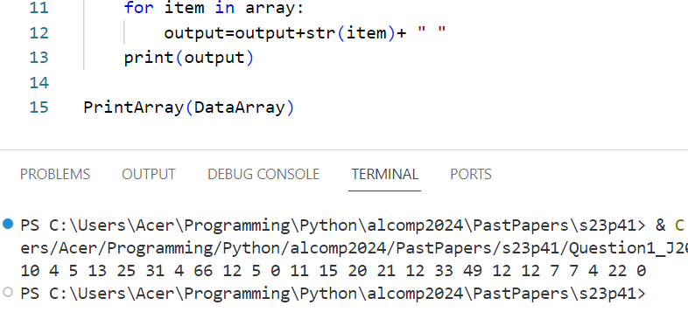

Part 1(c)
def LinearSearch(array,searchVal):
counter=0
for element in array:
if element==searchVal:
counter=counter+1
return counter

Part 1(d)(i)
num=int(input("please enter a number from 0 to 100 inclusive "))
while num<=0 or num>=100:
num=int(input("wrong input. please only enter a number from 0 to 100 inclusive "))
print("The number",num,"is found",LinearSearch(DataArray,num),"times")

Part 1(d)(ii)
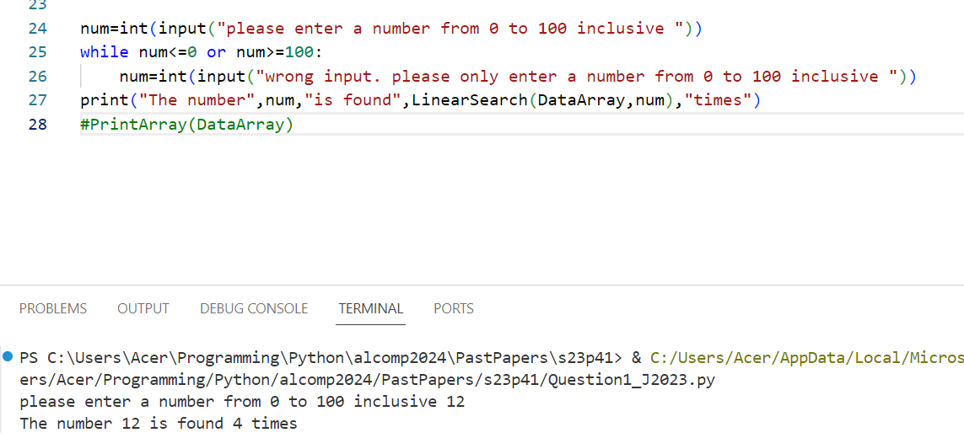

Question 2
Part 2(a)(i)
class Vehicle():
def __init__(self,pID,pMaxSpeed,pIncreaseAmount):
self.__ID=pID #self.__ID : STRING
self.__MaxSpeed=pMaxSpeed # self.__MaxSpeed : INTEGER
self.__CurrentSpeed=0 #self.__CurrentSpeed : INTEGER
self.__IncreaseAmount=pIncreaseAmount #self.__IncreaseAmount : INTEGER
self.__HorizontalPosition=0 #self.__HorizontalPosition : INTEGER

Part 2(a)(ii)
def GetCurrentSpeed(self):
return self.__CurrentSpeed

def GetIncreaseAmount(self):
return self.__IncreaseAmount

def GetMaxSpeed(self):
return self.__MaxSpeed

def GetHorizontalPosition(self):
return self.__HorizontalPosition

Part 2(a)(iii)
def SetCurrentSpeed(self,speed):
self.__CurrentSpeed=speed

def SetHorizontalPosition(self,position):
self.__HorizontalPosition=position

Part 2(a)(iv)
def IncreaseSpeed(self):
self.__CurrentSpeed += self.__IncreaseAmount
if self.__CurrentSpeed>self.__MaxSpeed:
self.__CurrentSpeed= self.__MaxSpeed
self.__HorizontalPosition += self.__CurrentSpeed

Part 2(b)(i)
class Helicopter(Vehicle):
def __init__(self,pID,pMaxSpeed,pIncAmount,pVerticalChange,pMaxHeight):
super().__init__(pID,pMaxSpeed,pIncAmount)
self.__VerticalChange=pVerticalChange #self.__VerticalChange : INTEGER
self.__MaxHeight=pMaxHeight #self.__MaxHeight : INTEGER
self.__VerticalPosition=0 #self.__VerticalPosition : INTEGER

Part 2(b)(ii)
def IncreaseSpeed(self):
self.__VerticalPosition += self.__VerticalChange
if self.__VerticalPosition>self.__MaxHeight:
self.__VerticalPosition= self.__MaxHeight
super().IncreaseSpeed()

Part 2(c)
#FOR Q c, under class Vehicle
def OutputInfo(self):
print("For vehicle with ID: ",self.__ID)
print("Horizontal Position: ",self.__HorizontalPosition)
print("Speed: ",self.__CurrentSpeed)

#for Q c, under class Helicopter
def OutputInfo(self):
super().OutputInfo()
print("vertical position: ",self.__VerticalPosition)

Part 2(d)(i)
#main program, d)
car=Vehicle("Tiger",100,20)
helicopter=Helicopter("Lion",350,40,3,100)
car.IncreaseSpeed()
car.IncreaseSpeed()
car.OutputInfo()
helicopter.IncreaseSpeed()
helicopter.IncreaseSpeed()
helicopter.OutputInfo()

Part 2(d)(ii)
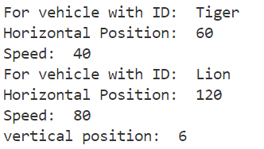

Question 3
Part 3(a)
Animal=[None]*20 #ARRAY of 20 STRING elements
Colour=[None]*10 #ARRAY of 10 STRING elements
AnimalTopPointer=0 #INTEGER
ColourTopPointer=0 #INTEGER

Part 3(b)(i)
def PushAnimal(DataToPush):
global AnimalTopPointer,Animal
if AnimalTopPointer==20:
return False
else:
Animal[AnimalTopPointer]=DataToPush
AnimalTopPointer+=1
return True

Part 3(b)(ii)
def PopAnimal():
global Animal,AnimalTopPointer
if AnimalTopPointer==0:
return ""
else:
ReturnData=Animal[AnimalTopPointer-1]
AnimalTopPointer -=1
return ReturnData

Part 3(b)(iii)
def ReadData():
try:
f1=open("AnimalData.txt",'r')
for line in f1:
PushAnimal(line.strip())
f1.close()
except IOError:
print("Error: File not found")

Part 3(b)(iv)
def PushColor(DataToPush):
global Color,ColourTopPointer
if ColourTopPointer==10:
return False
else:
Colour[ColourTopPointer]=DataToPush
ColourTopPointer +=1
return True

def PopColor():
global Colour,ColourTopPointer
if ColourTopPointer==0:
return ""
else:
ReturnData=Color[ColourTopPointer-1]
ColourTopPointer -=1
return ReturnData

Part 3(b)(v)
def ReadData():
try:
f1=open("AnimalData.txt",'r')
for line in f1:
PushAnimal(line.strip())
f1.close()
except IOError:
print("Error: Animal Data File not found")

try:
f2=open("ColourData.txt",'r')
for line in f2:
PushColor(line.strip())
f1.close()
except IOError:
print("Error: Color Data file not found")

Can combine both into one Try block.

Part 3(c)
def OutputItem():
myColour=PopColour()
myAnimal=PopAnimal()
if myColour=="": #nothing in Colour
PushAnimal(myAnimal)
print("No colour")
elif myAnimal=="": #nothing in animal
PushColour(myColour)
print("No animal")
else:
print(myColour,myAnimal)

Part 3(d)(i)
ReadData()
for i in range(0,4):
OutputItem()

Part 3(d)(ii)
