Screenshots or program listings must be copied into appropriate cells in the following table.
Save this evidence document as evidence_ followed by your centre number_ candidate number, for example, evidence_ zz999_9999 and insert your name, candidate number and centre number into the header above.
Examiners must be able to read the contents including any screenshots without the use of a magnifying glass. Answers that are not readable or are missing will not be awarded any marks.
Save this evidence document at regular intervals, for example every 10 minutes.
Question 1
Part 1(a)(i)
StackVowel=[None]*100 #StackVowel : ARRAY of 100 CHAR
StackConsonant=[None]*100 #StackConsonant : ARRAY of 100 CHAR

Part 1(a)(ii)
VowelTop=0 #VowelTop : INTEGER
ConsonantTop=0 #ConsonantTop : INTEGER

Part 1(b)(i)
def PushData(letter):
global VowelTop,ConsonantTop,StackVowel,StackConsonant
if letter=='a' or letter=='e' or letter=='i' or letter=='o' or letter=='u':
#vowel
if VowelTop==100:
print("vowel stack is full, could not push")
else:
StackVowel[VowelTop]=letter
VowelTop+=1

else:
#consonant
if ConsonantTop==100:
print("consonant stack is full, could not push")
else:
StackConsonant[ConsonantTop]=letter
ConsonantTop+=1

Part 1(b)(ii)
def ReadData():
try:
f1=open("StackData.txt",'r')
while True:
line=(f1.readline()).strip()
if line=="":
break
else:
PushData(line)

except IOError:
print("file not found / file does not exist")

Part 1(c)
def PopVowel():
global VowelTop,StackVowel
if VowelTop==0:
return("No data")
else:
VowelTop-=1
return StackVowel[VowelTop]

def PopConsonant():
global ConsonantTop,StackConsonant
if ConsonantTop==0:
return("No data")
else:
ConsonantTop-=1
return StackConsonant[ConsonantTop]

Part 1(d)(i)
ReadData()

store=""

for i in range(0,5):
letter=str(input("please enter a vowel or consonant of your choice "))

if letter=='a' or letter=='e' or letter=='i' or letter=='o' or letter=='u':
temp=PopVowel()
if temp=="No data":
print("Vowel stack is empty.")
store=store+temp
else:
temp=PopConsonant()
if temp=="No data":
print("Consonant stack is empty.")
store=store+temp

print(store)

Notes: Could use a flag and stop the loop when no data remains in one of the stacks.

Part 1(d)(ii)
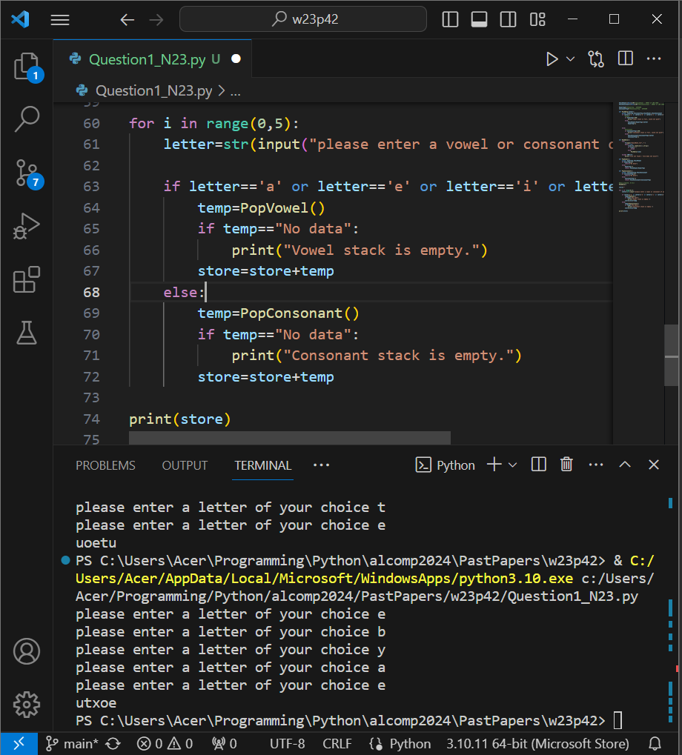

Question 2
Part 2(a)(i)
def IterativeCalculate(Number):
ToFind=Number
Total=0
while Number!=0:
if ToFind%Number==0:
Total=Total+Number
Number-=1
return Total

Part 2(a)(ii)
print(IterativeCalculate(10))

Part 2(a)(iii)
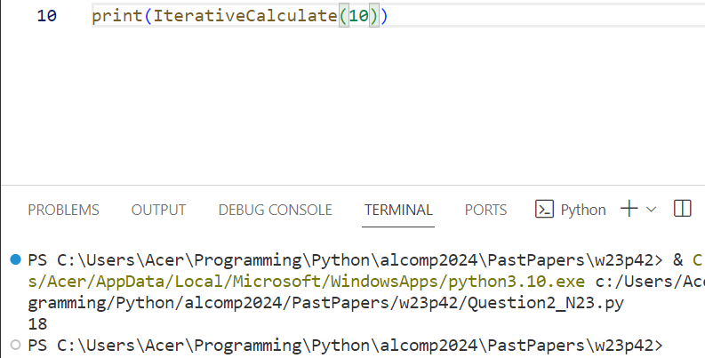

Part 2(b)(i)
def RecursiveValue(Number,ToFind):
if Number==0:
return 0
else:
if ToFind%Number==0:
return Number+RecursiveValue(Number-1,ToFind)
else:
return RecursiveValue(Number-1,ToFind)

Part 2(b)(ii)
print(RecursiveValue(50,50))

Part 2(b)(iii)
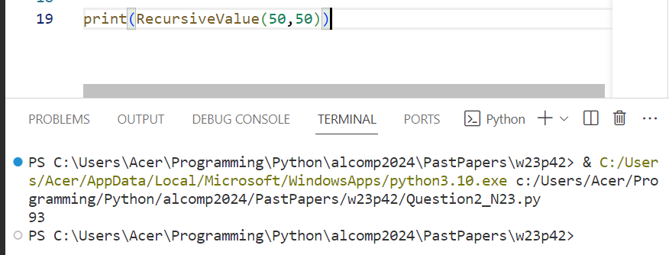

Question 3
Part 3(a)(i)
class Character():
def __init__(self,charName,dateOfBirth,intel,speed):
self.__CharacterName=charName #self.__CharacterName : STRING
self.__DateOfBirth=dateOfBirth #self.__DateOfBirth : DATE
self.__Intelligence=intel #self.__Intelligence : REAL
self.__Speed=speed #self.__Speed : INTEGER

Part 3(a)(ii)
def GetIntelligence(self):
return self.__Intelligence

def GetName(self):
return self.__CharacterName

Part 3(a)(iii)
def setIntelligence(self,pIntel):
self.__Intelligence=pIntel

Part 3(a)(iv)
def Learn(self):
self.__Intelligence=self.__Intelligence*1.1

Part 3(a)(v)
import datetime
def ReturnAge(self):
return (2023-self.__DateOfBirth.year)

Part 3(b)(i)
FirstCharacter=Character("Royal",datetime.date(2019,1,1),70,30)

Part 3(b)(ii)
FirstCharacter.Learn()
print("Name of character is",FirstCharacter.GetName())
print("age of this character is",FirstCharacter.ReturnAge())
print("intelligence of this character is",FirstCharacter.GetIntelligence())

Part 3(b)(iii)
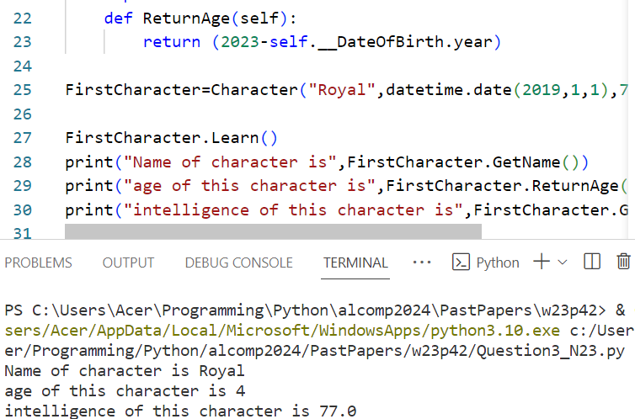

Part 3(c)(i)
class MagicCharacter(Character):
def __init__(self,Element,CharName,DateBirth,Intel,Speed):
super().__init__(CharName,DateBirth,Intel,Speed)
self.__Element=Element #self.__Element : STRING

Part 3(c)(ii)
def Learn(self):
if self.__Element.lower()=="fire" or self.__Element.lower()=="water":
super().setIntelligence(super().GetIntelligence()*1.2)
elif self.__Element.lower()=="earth":
super().setIntelligence(super().GetIntelligence()*1.3)
else:
super().Learn()

Part 3(d)(i)
FirstMagic=MagicCharacter("fire","Light",datetime.date(2018,3,3),75,22)

Part 3(d)(ii)
FirstMagic=MagicCharacter("fire","Light",datetime.date(2018,3,3),75,22)
FirstMagic.Learn()
print("Name of character is",FirstMagic.GetName())
print("age of this character is",FirstMagic.ReturnAge())
print("intelligence of this character is",FirstMagic.GetIntelligence())

Part 3(d)(iii)
