Screenshots or program listings must be copied into appropriate cells in the following table.
Save this evidence document as evidence_ followed by your centre number_ candidate number, for example, evidence_ zz999_9999 and insert your name, candidate number and centre number into the header above.
Examiners must be able to read the contents including any screenshots without the use of a magnifying glass. Answers that are not readable or are missing will not be awarded any marks.
Save this evidence document at regular intervals, for example every 10 minutes.
Question 1
Part 1(a)(i)
def IterativeVowel(value): #value: STRING
Total=0
LengthString=len(value)
for x in range (0,LengthString):
FirstCharacter=value[0]
if FirstCharacter=='a' or FirstCharacter=='e' or FirstCharacter=='i' or FirstCharacter=='o' or FirstCharacter=='u':
Total=Total+1
value=value[1:(len(value))]
return Total

Part 1(a)(ii)
print(IterativeVowel("house"))

Part 1(a)(iii)
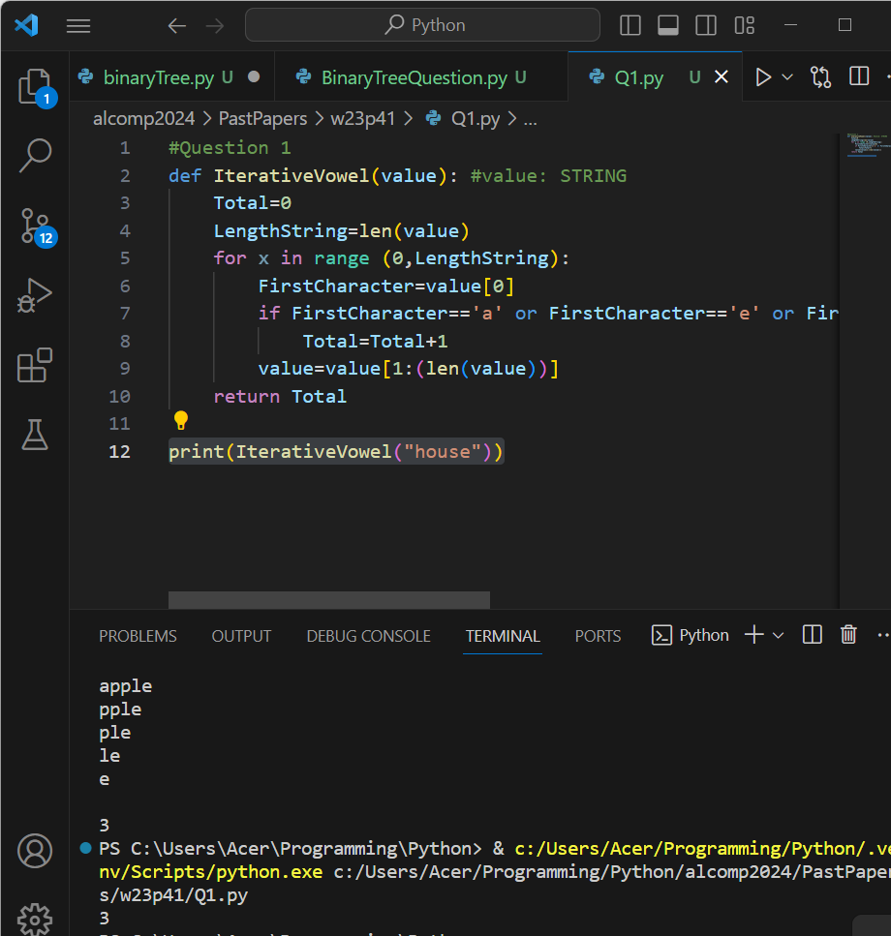

Part 1(b)(i)
def RecursiveVowels(value):
print(value)
if value=="":#base case
return 0
else:
FirstCharacter=value[0]
if FirstCharacter=='a' or FirstCharacter=='e' or FirstCharacter=='i' or FirstCharacter=='o' or FirstCharacter=='u':
return 1+RecursiveVowels(value[1:(len(value))])
else:
return 0+RecursiveVowels(value[1:(len(value))])

Part 1(b)(ii)
print(RecursiveVowels("imagine"))

Part 1(b)(iii)
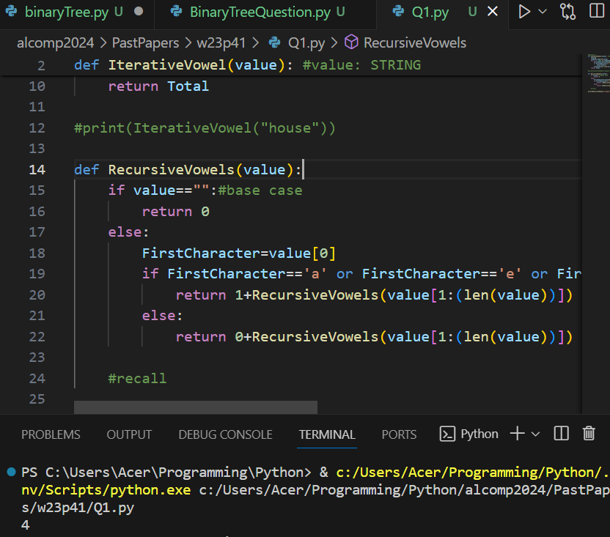

Question 2
Part 2(a)(i)
Queue=[None]*50 #Queue: ARRAY of STRING
HeadPointer=-1 #INTEGER
TailPointer=0 #INTEGER

Part 2(a)(ii)
def Enqueue(string):
global Queue, HeadPointer,TailPointer
if TailPointer>49:
print("queue is full")
else:
Queue.append(string)
TailPointer=TailPointer+1
HeadPointer=0

Part 2(a)(iii)
def Dequeue():
global Queue, HeadPointer,TailPointer
if HeadPointer==-1:
print("queue is empty, cannot dequeue")
return "Empty"
else:
HeadPointer+=1
return Queue[HeadPointer-1]

Part 2(b)
def ReadData():
myFile=open(r"C:\Users\Acer\Programming\Python\alcomp2024\PastPapers\w23p41\QueueData.txt",'r')
while True:
line=str(myFile.readline())
if line=="":
break
else:
Enqueue(line.strip())
myFile.close()

Part 2(c)(i)
class RecordData():
def __init__(self,ID,Total):
self.ID=ID
self.Total=Total

Part 2(c)(ii)
Records=[] #50 elements array of type RecordData
NumberRecords=0 #Integer

Part 2(c)(iii)
def TotalData():
DataAccessed=Dequeue() #type STRING
flag=False #Boolean
if NumberRecords==0:
Records[NumberRecords]=RecordData(DataAccessed,1)
flag=True
NumberRecords=NumberRecords+1
else:
for x in range(0,NumberRecords):
if Records[x].ID==DataAccessed:
Records[x].Total+=1
flag=True
if flag==False:
Records[NumberRecords]=RecordData(DataAccessed,1)
NumberRecords=NumberRecords+1

Part 2(d)
def OutputRecords():
global Records
for element in Records:
print("ID ", element.ID," Total ",element.Total)

Part 2(e)(i)
ReadData()
for element in Queue:
TotalData()
OutputRecords()

Part 2(e)(ii)
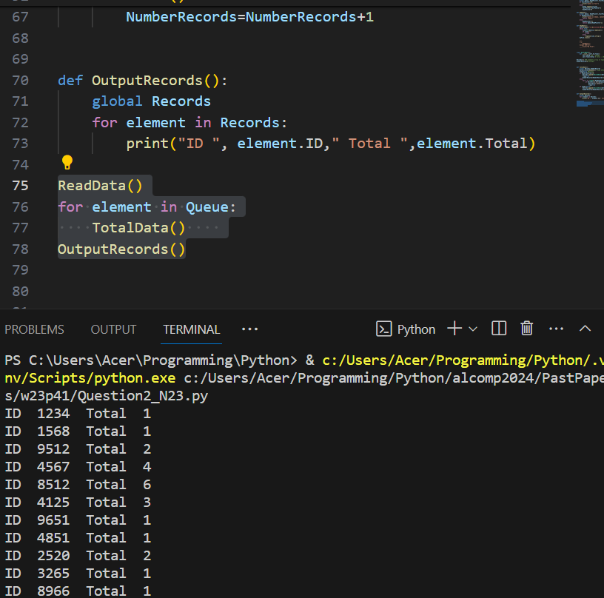

Question 3
Part 3(a)(i)
class Character():
def __init__(self,name,xPosition,yPosition):
self.__Name=name #self.__Name : String
self.__XPosition=xPosition #self.__XPosition : Integer
self.__Yposition=yPosition #self.__YPosition : Integer

Part 3(a)(ii)
def GetXPosition(self):
return self.__XPosition

def GetYPosition(self):
return self.__YPosition

Part 3(a)(iii)
def SetXPosition(self,X):
print("hello")
X=X+self.__XPosition
print(X)
if X>10000:
self.__XPosition=10000
elif X<0:
self.__XPosition=0
else:
self.__XPosition=X

def SetYPosition(self,Y):
Y=Y+self.__YPosition
if Y>10000:
self.__YPosition=10000
elif Y<0:
self.__YPosition=0
else:
self.__YPosition=Y

Part 3(a)(iv)
def Move(self,direc): #string parameters up,down,left right
if direc=="up":
self.__YPosition +=10
elif direc=="down":
self.__YPosition -=10
elif direc=="left":
self.__YPosition -=10
elif direc=="right":
self.__YPosition +=10
else:
print("wrong input")

Part 3(b)
Jack=Character('Jack',50,50)

Part 3(c)(i)
class BikeCharacter(Character):
def __init__(self,name,xPosition,yPosition):
super().__init__(name,xPosition,yPosition)

Part 3(c)(ii)
def Move(self,direc): #string parameters up,down,left right
if direc=="up":
super().SetYPosition(20)
elif direc=="down":
super().SetYPosition(-20)
elif direc=="left":
super().SetXPosition(-20)
elif direc=="right":
super().SetXPosition(20)
else:
print("wrong input")

Part 3(d)
Karla=BikeCharacter("Karla",100,50)

Part 3(e)(i)
name=input("please enter the name of the character you want to move ").lower()
while name!='jack' and name!='karla':
name=input("You can only enter Jack or Karla. Please re-enter name ").lower()

direction=input("enter direction you would like to move ").lower()
while direction!='up' and direction!='down' and direction!='left' and direction!='right':
direction=input("please re-enter valid direction: up, down, left, or right only ").lower()

if name=="jack":
Jack.Move(direction)
print("Jack's new position is X=",Jack.GetXPosition()," Y=",Jack.GetYPosition())
else:
Karla.Move(direction)
print("Karla's new position is X=",Karla.GetXPosition()," Y=",Karla.GetYPosition())

Part 3(e)(ii)
