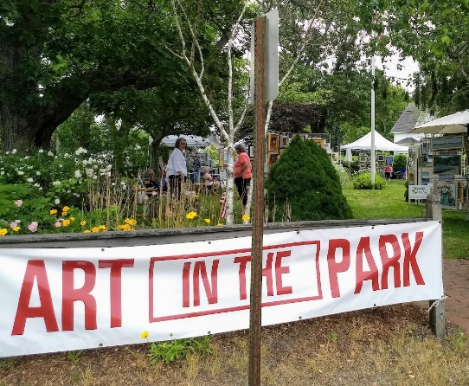
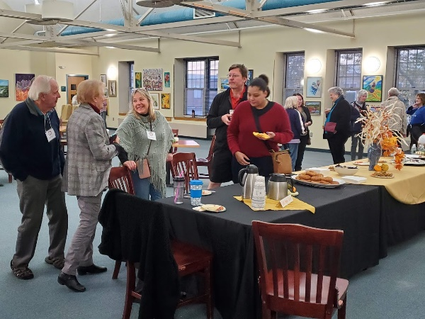
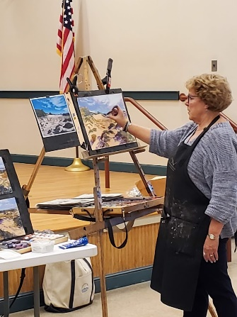
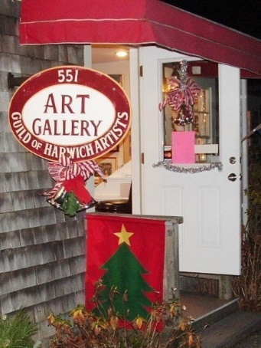
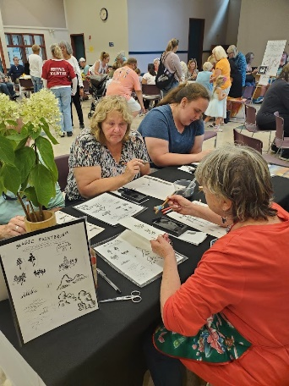
Seasonal Art Shows Painting Demos Member Socials Community Paint Juried Gallery

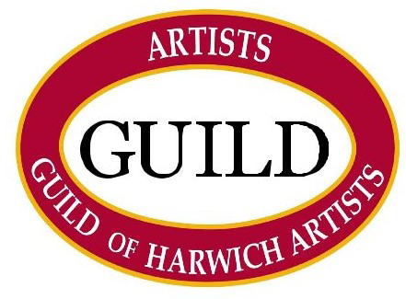

Established in 1979, the Guild of Harwich Artists has become a vital member of the growing local arts and cultural fabric for which the Cape Cod town of Harwich is becoming known. Over the years it has been art that brings us together, but it is our supportive community of established and emerging artists that binds us together. Membership is open to all Cape Cod residents.

