**David L. Katz is a doctor who has a wide online presence and has his own website. He is the most influential people in health and fitness**

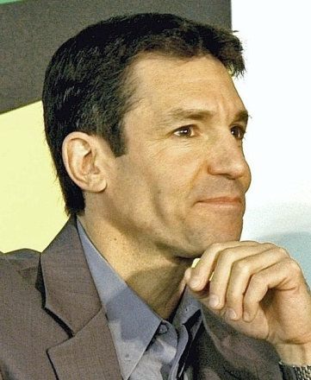

A widely supported nominee for the position of U.S. Surgeon General, Dr. Katz has been recognized by Greatist.com as one of the 100 most influential people in health and fitness in the world for the past 3 years (2013).

He has made important contributions in the areas of lifestyle interventions for health promotion; nutrient profiling; behavior modification; holistic care; and evidence-based medicine.

David L. Katz is a founder of True Health Initiative. He has published roughly 200 scientific articles and textbook chapters, and 15 books to date, including multiple editions of leading textbooks in both Preventive Medicine, and nutrition.

**Background**

   

**Likes: 10,249**

**Followers: 737,262**

**Followers: 1174**

**Followers: 30.3K**

**Following: 100**

**Tweets: 15.6k**

**Location:** Derby, Connecticut

**Director: Yale Prevention Research Center, Founder: True Health Initiative, Doctor**, MD, MPH, FACPM, FACP, And FACLM

**Joined Twitter:** Feb’10

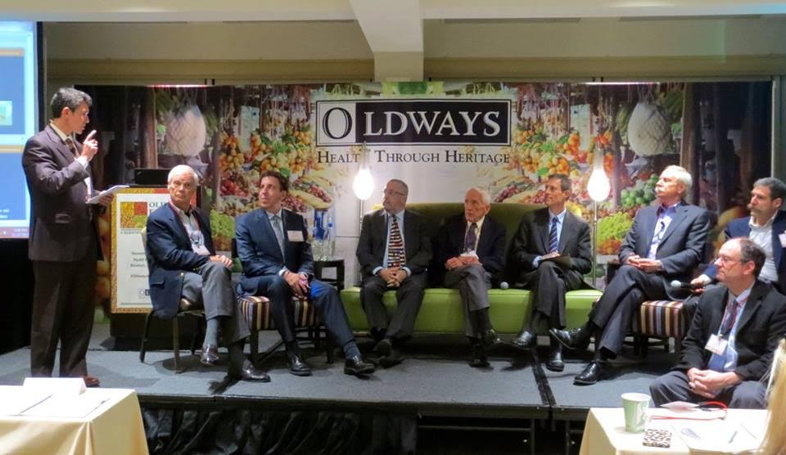  


He is recognized globally for expertise in nutrition, weight management and the prevention of chronic disease, and has a social media following of well over half a million. He has delivered addresses in numerous countries on four continents, and has been acclaimed by colleagues as the “poet laureate” of health promotion. In 2015, Dr. Katz established the True Health Initiative to help convert what we know about lifestyle as medicine into what we do about it, in the service of adding years to lives and life to years around the globe.

**Videos posted by David on Face-book regarding healthy Lifestyle**



**True Health Initiative Video: Inspiring Video by David to fight against diseases**

**https://www.youtube.com/watch?v=cp4X5umfpbQ&feature=youtu.be**