**Bret Michael is a famous singer and musician who is suffering from T1D and has a wide online presence and also has his own website**



**Likes: 1,779,612**

**Followers: 305K**

**Following: 969**

**Tweets: 10.5k**

**Followers: 53.7K**

  

**Bret’s Advice for Kids**: “**I use diabetes just as one more challenge in my life. You have to accept it because there is no other choice. You either do well with it or it will take over your life, and then it’s not going to be so great.”**

**At the age of six** he fell ill, and during a three-week stay in the hospital, he was diagnosed with **Type 1 diabetes.** Now 53 years old, he's a twenty-year veteran of the rock and roll scene as the lead singer of the eighties band “Poison.”

Bret Michaels is an American singer-songwriter and musician. He first gained fame as the [lead vocalist](https://en.wikipedia.org/wiki/Lead_vocalist) of the [glam metal](https://en.wikipedia.org/wiki/Glam_metal) band [Poison](https://en.wikipedia.org/wiki/Poison_(American_band))  who has sold over 45 million records worldwide and 15 million records in the US alone.

**Background**

**Location:** USA

**American singer-songwriter, musician and T1D patient**

**Joined Twitter:** Dec’08

* Bret takes three injections a day, at breakfast, again at dinner, and then a little bit at night. In the morning he usually takes about six units of NPH; his dose of fast-acting Humalog depends on his blood sugar
* If he’s at 78 mg/dl, he’ll take about four units; if it’s 220, he’ll take eight or ten
* Bret has 2 meters: he usually uses a FreeStyle Flash, but he also has an old LifeScan meter “the size of a brick” that he keeps with him all the time as a good luck talisman. He usually checks his blood glucose 4-6 times a day



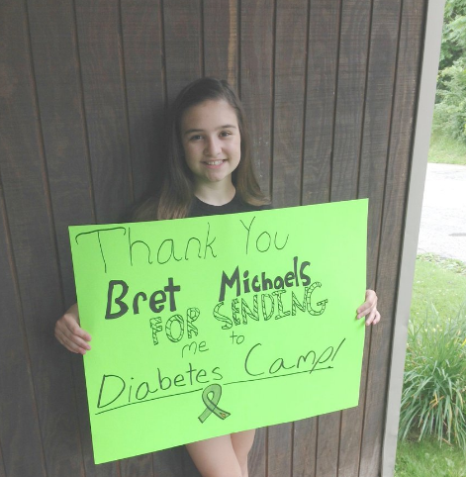

**Spreading awareness among people**

**(Join Bret 2 fight #diabetes by donating @JDRFHeartland Promise Gala (#CouncilBluffs/ #Omaha) Sat. 2/25/17 http://jdrf-omaha.ejoinme.org/60189)**



**Bret Michaels Introduces New Themed Emojis and Lyrics App**